A STUDY ON TEACHING SPEAKING USING A
SERIES PICTURE ABOUT DAILY ACTIVITIES
TO THE SEVENTH YEAR STUDENTS OF
SMP N I KUNJANG KEDIRI

THESIS

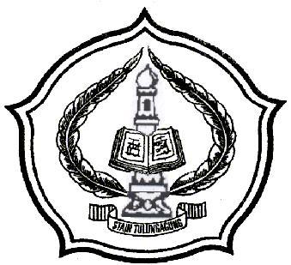

By:
ERMA TRIANA MUFLIHATIN
NIM. 3216073305

ENGLISH EDUCATION PROGRAM
DEPARTMENT OF ISLAMIC EDUCATION
STATE ISLAMIC COLLEGE
(STAIN) TULUNGAGUNG
2010

