Appendix 1
THE FORM OF PRE TEST
A Clever Rabbit
A little rabbit is picking mushrooms in a forest. A wolf is coming. He is very hungry. “ oh, a little rabbit, my favorite food ! “ he is happy to see the rabbit.
The rabbit is not afraid when she sees the wolf. She pretends to be poisoned by eating the mushroom. The wolf is thinking, “ She is poisoned, if I eat her, I will die too!” so he goes away sadly
The wolf leaves away, the rabbit is very happy. She goes on picking the Mushroom
Kelinci yang Cerdik
Seekor kelinci kecil sedang memetik jamur di sebuah hutan. Seekor srigala dating mendekat. Dia sangatlapar, “ Oh, kelinci kecil makanan kesukaanku !” dia senang melihat kelinci.
Kelinci itu tidak takut ketika ia melihat srigala. Dia berpura – pura keracunan karena makan jamur. Srigala berfikir “Dia keracunan, Kalau aku memakan dia, aku akan mati juga !” Maka dia pergi dengan sedih.
Srigala itu pergi, si kelinci sangat gembira. Dia meneruskan memetik jamur.
Answer the Question below !
- Who is the actor in the story ?
- Where is the place ?
- What does the rabbit eat ?
- Why the wolf leave the rabbit ?
- Does the rabbit afraid to the wolf ?
Write B if the statement is true and S if the statement is false!
- ( ) The rabbit is picking the mushroom when the wolf is coming
- ( ) Mushroom is the wolf’s favorite food
- ( ) The rabbit is afraid when she sees the wolf
- ( ) The rabbit is poisoned by eating the mushroom
- ( )If the wolf eats the rabbit, He will die.
Appendix 2
THE FORM OF LESSON PLAN

LESSON PLAN
Subject : English
Topic : Narrative text
Sub topic : Short Story (fable)
Class : 5 (five)
Semester : 2 (two)
Meeting : First meeting
Time duration : 2 X 45 minutes

- Standard Competence
To Understand the simple narrative text ( Fable ) In daily life context

- Based Competence
To respond the meaning of narrative ( Fable ) story by using appropriate, accuracy, written language in daily life context

- Indicators
- Students are able to read the text with the right pronunciation and intonation
- Students are able to mention the actor of the text
- Students are able to take the information from the Fable Story
- Objectives
- Students are able to read The fable story “ A Clever rabbit“ with the right pronunciation and Intonation
- The students are able to mention the actors of fable text “ A clever rabbit “.
- Students are able to take the information from the fable story “ A clever rabbit“
- Materials
Read the text loudly !
A Clever Rabbit
A little rabbit is picking mushrooms in a forest. A wolf is coming. He is very hungry. “ oh, a little rabbit, my favorite food ! “ he is happy to see the rabbit.
The rabbit is not afraid when she sees the wolf. She pretends to be poisoned by eating the mushroom. The wolf is thinking, “ She is poisoned, if I eat her, I will die too!” so he goes away sadly
The wolf leaves away, the rabbit is very happy. She goes on picking the Mushroom
Kelinci yang Cerdik
Seekor kelinci kecil sedang memetik jamur di sebuah hutan. Seekor srigala dating mendekat. Dia sangatlapar, “ Oh, kelinci kecil makanan kesukaanku !” dia senang melihat kelinci.
Kelinci itu tidak takut ketika ia melihat srigala. Dia berpura – pura keracunan karena makan jamur. Srigala berfikir “Dia keracunan, Kalau aku memakan dia, aku akan mati juga !” Maka dia pergi dengan sedih.
Srigala itu pergi, si kelinci sangat gembira. Dia meneruskan memetik jamur.
Answer the Question below !
- Who is the actor in the story ?
- Where is the place ?
- What does the rabbit eat ?
- Why the wolf leave the rabbit ?
- Does the rabbit afraid to the wolf ?
Write B if the statement is true and S if the statement is false!
- ( ) The rabbit is picking the mushroom when the wolf is coming
- ( ) Mushroom is the wolf’s favorite food
- ( ) The rabbit is afraid when she sees the wolf
- ( ) The rabbit is poisoned by eating the mushroom
- ( )If the wolf eats the rabbit, He will die.

- Method
- Lecturing
- Students Interaction
- Discussing

- Activities

No | Teaching activities | Student activities | Time
I | Opening:  - Greeting  - Praying  - Checking attendance | - Answer greeting  - Demonstration  - Praying attention& answer  - Answer the question | 5
II | Main activities:  - The teacher gives fable story  - Several students read the text loudly  - The teacher explain about the story while translate into bahasa Indonesia  - The teacher gives Questionto the students  - Teacher gives evaluation sheet | - The students get the fable story from the teacher  - students listen to the teacher explain and they may ask Question if they have Question  - students answer the questions together  - Students do the evaluation Individually | 50
III | Closing:  - Teacher gives conclusion about the material given  - Teacher ask to the students weather they understand about the material or not | - Students attention to the teacher explanation  - Students ask question if they have Question | 15

- Source
Basic English Lesson for Elementary school
English Story for kids ( Bilingual )

- Scoring

Kind of Scoring : Written
Form of Scoring : Subjective and Objective Written

  - Instrument

Read the text Loudly !
The foolish cat
Long long ago, there was a young cat. he likes eating fish very much, but he was also very lazy.
One day he went to pond for fishing. The cat sat at the side of the pond. He started to fish. Suddenly, he saw a fish jumping out of the water. He rushed there and caught he fish.
From then on the young cat didn’t go fishing any more. He was just waiting for the fish at the same place. But several days passed, he got nothing at all. Poor cat, he was very hungry and he was ill now.Rrrrrrrrrrrrrr…RRrrrrr…rrr, He said sadly.

KucingTolol
Dahulu kala, ada seekor kucing muda. Dia sangat suka makan ikan, tetapi dia juga sangat malas.
Suatu hari, dia pergi ke kolam untuk memancing.Sang kucing duduk di tepi kolam. Dia mulai memancing. Tiba – Tiba, dia melihat seekor ikan melompat dari dalam air. Dia bergegas kesana dan menangkap ikan itu. Sejak saat itu, kucing kecil itu tidak pergi memancing lagi. Dia hanya menunggu ikan di tempat yang sama. Tetapi beberapa hari berlalu. Dia sama sekali tidak mendapatkan apa – apa. Kucing yang malang. Dia sangat lapar dan dia sakit sekarang. RRRRRRr……..RRRRRR…… RRR..rr, dia merintih dengan sedih.
Answer the Question below !
    - How many actors play in the text ? Who are they ?
    - Where is the story probably take place?
    - What does the cat do ?
    - Why the cat will not fishing any more ?
    - Does the cat sad ?Why ?

Write B if the statement is true and S if the statement is false !
- ( ) The cat likes eating fish very much
- ( ) The cat was very lazy
- ( ) Several days later, the cat got many Fish
- ( ) The cat was very clever
- ( ) The cat healthy and happy

LESSON PLAN

Subject : English
Topic : Narrative text
Sub topic : Short Story (fable)
Class : 5 (five)
Semester : 2 (two)
Meeting : Second meeting
Time duration : 2 X 45 minutes

- Standard Competence
To Understand the simple narrative text (Fable) in daily life context

- Based Competence
To respond the meaning of narrative (Fable) story by using appropriate, accuracy, written language in daily life context

- Indicators
- Students are able to read the text with the right pronunciation and intonation
- Students are able to mention the actor of the text
- Students are able to take the information from the Fable Story
- Objectives
- Students are able to read The fable story “ A Clever rat“ with the right pronunciation and Intonation
- The students are able to mention the actors of fable text “ A clever rat “.
- Students are able to take the information from the fable story “ A clever rat“
- Materials
Read the text loudly !
A Clever Rat
A folder is in the room, a fish is on it. A rat is comes out, he sees the fish. The cat is in the room too. He sees the rat and come at the rat.
“ Don’t eat me “ says the rat to the cat,” you like fish. I have a nice fish for you. Look, there it is”.
The cat lets the rat go. He comes up to the fish. Oh, the folder catches one of his paw.
Tikus yang cerdik
Sebuah jebakan ada di dalam ruangan, seekor ikan di atasnya. Seekor tikus datang, dia melihat ikan itu.
Seekor kucing juga di dalam ruangan, dia mendekati tikus dan dating mendekati tikus.
“Jangan makan aku “, kata tikus kepada kucing. “ kamu suka ikan”. Aku punya ikan yang enak untuk mu.Lihat, itu dia “.
Kucing itu membiarkan tikus pergi. Dia menghampiri ikan. Oh, jebakan itu menjepit salah satu cakarnya.
Write B if the statement is true and S if the statement is false!
- ( ) A fish is on the folder
- ( ) The fish is the rat’s
- ( ) The cat eats the rat
- ( ) The cat likes the fish
- ( ) The folder catches one of the rat’s leg

Answer the questions below !
- Who is the actor in the story ?
- Where is the story probably take place ?
- What does the cat want to eat ?
- Why the cat leave the rat ?
- Does the rat afraid to the cat ?which statement prove that ?

Key Answer
- 1. B
2. S
3. S
4. B
5. S

B. 6. The rat and the cat
7. A house
8. The fish
9. Because the rat showed the fish to the cat
10. Yes, he does. The statement is“ Don’t eat me “ says the rat to the cat,”

- Method
- Lecturing
- Students Interaction
- Discussing

- Activities

No | Teaching activities | Student activities | Time
I | Opening:  - Greeting  - Praying  - Checking attendance | - Answer greeting  - Demonstration  - Praying attention& answer  - Answer the question | 5
II | Main activities:  - The teacher gives fable story  - Several students read the text loudly  - The teacher explain about the story while translate into bahasa Indonesia  - The teacher gives Question to the students  - Teacher gives evaluation sheet | - The students get the fable story from the teacher  - students listen to the teacher explain and they may ask Question if they have Question  - students answer the questions together  - Students do the evaluation Individually | 50
III | Closing:  - Teacher gives conclusion about the material given  - Teacher ask to the students weather they understand about the material or not | - Students attention to the teacher explanation  - Students ask question if they have Question | 15

- Source
Basic English Lesson for Elementary school
English Story for kids ( Bilingual )

- Scoring
  - Kind Of Scoring : Written
  - Form Of Scoring : Subjective and Objective Written
  - Instrument

Read the text Loudly !

A Crow and Oriole
There was a crow named Lulu who lives in the big forest. The crow was very ugly, so she always thought that she worse than others. One day, Lulu heard on Oriole singing in the tree. She thought it was the most beautiful song in the world. But Lulu can’t sing at all. So she decided to learn from the Oriole. The other crows all persuaded Lulu not to sing. But Lulu believed that she could sing well, so in the following day, Lulu stood behind the tree and sing after the oriole. Several days later, she still couldn’t sing at all and her throat couldn’t make any sounds. At last, the crow could only make the sound of “ wawawa…”

BurungGagakdanBurungKepodang
Ada seekor burung gagak bernama Lulu yang tinggal di sebuah hutan yang besar. Burung gagak ini sangat jelek. Jadi dia selalu berfikir bahwa dia lebih buruk daripada yang lain. Suatu hari, Lulu mendengar seekor burung kepodang bernyanyi di atas pohon. Dia berfikir itu adalah lagu terindah di dunia.Tetapi Lulu tidak dapat bernyanyi sama sekali. Maka dia memutuskan untuk belajar dari burung kepodang. Semua gagak membujuk Lulu untuk tidak bernyanyi. Tetapi Lulu percaya bahwa dia bisa bernyanyi dengan baik. Maka pada hari – hari berikutnya, Lulu berdiri di belakang pohon dan bernyanyi mengikuti burung kepodang. Beberapa hari kemudian, dia masih tidak bisa bernyanyi dan tenggorokannya tidak dapat mengeluarkan suara. Akhirnya, si burung gagak membuat suara “wawaww…. “

- Write B if the statement is true and S if the statement is false !
- ( ) Lulu was the name of Oriole
- ( ) The crow and the Oriole don’t live in the jungle
- ( ) The Oriole can sing a beautiful song
- ( ) In the following day, Lulu stood in front of the tree and sing after the Oriole
- ( ) At last, the crow can’t sing

- Answer the Question below !
- Who is Lulu ?
- How does she look like ?
- Who can sing beautiful song based on the text ?
- Does Lulu learn to sing from the oriole ?
- What happen to Lulu’s throat ?

Key answer
- 1. S
2. S
3. B
4. S
5. B

- 1. Lulu was a crow who lived in the big forest
2. She is Ugly
3. The Oriole
4. Yes, She does
5. Her throat can’t make any sound

LESSON PLAN
Subject : English
Topic : Narrative text
Sub topic : Short Story (fable)
Class : 5 (five)
Semester : 2 (two)
Meeting : Third meeting
Time duration : 2 X 35 minutes

- Objectives
- Students are able to understand the story
- Students are able to answer the questions given
- Method
- Task based language teaching

- Activities

No | Teaching activities | Student activities | Time
I | Opening:  - Greeting  - Praying  - Checking attendance | - Answer greeting  - Demonstration  - Praying attention& answer  - Answer the question | 5
II | Main activities:  - The teacher reminds to the students about their previous task and make sure that every students ready to get their evaluation  - The teacher gives Questions sheet to students | - students listen to the teacher explain and they may ask Question if they have Question  - Students do the evaluation Individually | 50
III | Closing:  - Te teacher asks the students to submit their works | - Students submit their works | 15

- Evaluation
Read the text loudly !
A Silly Buffalo
A buffalo named Dodo come to see Tori, a goat after lunch. When they were talking, it begin to rain. Tori looked out of the window and said, “it is raining hard, Do. You must stay here for long time”.
“Ok”. Said Dodo. But a few minutes later, he went out. When he returned, he was all wet through.
“ Where have you been?” asked Tori. “ I have been home,” said Dodo, “ I went to tell my mother I must stay at your home because of the rain”.

]Kerbau yang Dungu
Seekor kerbau bernama Dodo mengunjungi Tori seekor kambing setelah makan siang. Ketika mereka sedang bercakap – cakap, hujan mulai turun. Tori melihat keluar jendela dan berkata, “ Hujan lebat do. Kamu harus tinggal disini lebih lama.
“ Baiklah,” kata Dodo. Tapi beberapa menit kemudian dia keluar. Ketika dia kembali dia basah kuyup.
“Kemana saja kamu?” Tanya Tori. “Aku baru saja pulang”, kata Dodo, “ aku pulang untuk memberi tahu ibuku kalau aku harus tinggal di rumahmu karena hujan”
Answer the Question below !
- What is the story tell us about ?
- When did the story probably take place ?
- Why did Dodo leave Tori for awhile ?
- How is dodo look like when he is back ?
- Why is Dodo called as silly buffalo?
Write B if the statement is true and S if the statement is false!
- ( ) Dodo came to see Tori after dinner
- ( ) It was raining hard, Dodo must stay for long time
- ( ) Tori is a good friend
- ( ) Dodo went to tell his mother he must stay at Tori’s house because of the rain.
- ( ) Dodo isn’t silly buffalo

Key Answer
- 1. The story tells us about Dodo as a silly buffalo
2. In the afternoon
3. To tell his mother that he must stay at Tori’s home because of the rain
4. He is all wet through.

5. Because he went home from Tori’s in the hard raining day to get his mother permission to stay at Tori’s house and come back to Tori’s house in te wet condition.

- 1. F
2. T
3.T
4. T
5. F
- Source
Basic English Lesson for Elementary school
English Story for kids ( Bilingual )

LESSON PLAN

Subject : English
Topic : Narrative text
Sub topic : Short Story (fable)
Class : 5 (five)
Semester : 2 (two)
Meeting : Fourth Meeting
Time duration : 2 X 45 minutes

- Standard Competence
To understand the simple narrative text (Fable) in daily life context

- Based Competence
To respond the meaning of narrative ( Fable ) story by using appropriate, accuracy, written language in daily life context

- Indicators
- Students are able to read the text with the right pronunciation and intonation
- Students are able to mention the actor of the text
- Students are able to take the information from the Fable Story
- Objectives
- Students are able to read The fable story “ A Smart Tortoise“ with the right pronunciation and Intonation
- The students are able to mention the actors of fable text “ A Smart Tortoise “.
- Students are able to take the information from the fable story “ A smart tortoise“

- Materials
Read the text loudly !
A Smart Tortoise
A tiger is hungry, he is looking for food. He sees a frog in front of him.
“ ha..ha..ha! a frog ! my dinner !” so he rushes at the frog. Behind the tiger, there is a tortoise. The little tortoise sees it, and he bites the tiger’s tail. “ouhh !” cries the tiger and looks back. The frog hears the voice then jumps into water. “ thank you little tortoise”, says the frog. But the tiger is very angry, “bother it ! I will throw you to the sky !”
“Thank you, I like flying in the sky”, says the tortoise. The tiger stop “ I will throw you into the river”. “Oh no! I can’t swim, I will die if you throw me into the water”.
The tiger throw the tortoise into the water quickly. “ Thank you Mr. Tiger,bye.. bye..”.
The tortoise and the frog swim away together.

Kura – kura yang cerdik
Seekor harimau sedang lapar, dia sedang mencari makanan. Dia melihat seekor kodok di depannya.
“ haha..ha!, seekor kodok! Makan malamku.” Maka dia menyerang si kodok.
Di belakang si harimau ada seekor kura-kura. Kura – kura melihat hal itu, dan dia mengigit ekor si harimau.
“Aduh!” teriak si harimau dan dia menoleh ke belakang. Si kodok mendengar teriakan itu dan kemudian meloncat ke dalam air.
“terima kasih, kura-kura kecil,” kata si kodok.
Tetapi si harimau sangat marah, “ menganggu saja! Aku akan melemparmu ke angkasa!”
“ Terima kasih, aku suka terbang di angkasa,” kata si kura –kura. Harimau itu berhenti,” aku akan melemparmu ke sungai.”
“Oh, jangan! Aku tidak bisa berenang, aku akan mati kalau kamu melemparku ke dalam air.” Harimau melempar kura – kura ke dalam air dengan cepat,
“ terima kasih, Tuan harimau. Selamat tinggal.” Kura – kura dan kodok berenang bersama.

Answer the Question below !
- How many actors in that story ? who are they ?
- Where is the story probably take place ?
- Why the tiger rushes the frog ?
- What did the tortoiso do to the tiger ?
- Does the tiger fail to get his dinner ?
Write B if the statement is true and S if the statement is false!
- ( ) The frog and the tortoise were swimming when the tiger came
- ( ) The tiger was hungry
- ( ) The tortoise helped the frog
- ( ) The Tiger threw the tortoise to the sky
- ( ) The frog and the tortoise safe from the tiger
Key Answer
- 1. There are three, they are tiger, frog, and tortoise
2. In the side of river
3. Because the tiger was hungry
4. The tortoise bites the tiger’s tail
5. Yes, he does

- 1. F
2. T
3.T
4. F
5. T

- Method
- Lecturing
- Students Interaction
- Discussing

- Activities

No | Teaching activities | Student activities | Time
I | Opening:  - Greeting  - Praying  - Checking attendance | - Answer greeting  - Demonstration  - Praying attention& answer  - Answer the question | 5
II | Main activities:  - The teacher gives fable story  - Several students read the text loudly  - The teacher explain about the story while translate into bahasa Indonesia  - The teacher gives Questions to other students  - Teacher gives evaluation sheet | - The students get the fable story from the teacher  - students listen to the teacher explain and they may ask Question if they have Question  - students answer the questions together  - Students do the evaluation Individually | 50
III | Closing:  - Teacher gives conclusion about the material given  - Teacher ask to the students weather they understand about the material or not | - Students attention to the teacher explanation  - Students ask question if they have Question | 15

- Source
Basic English Lesson for Elementary school
English Story for kids ( Bilingual )

- Scoring

  - Kind Of Scoring : Written
  - Form Of Scoring : Subjective and Objective Written

  - Instrument

Read the text Loudly !
The Tiger’s Dinner
Tiger : Good afternoon, Mrs. Goat.. let me eat you
Goat : Don’t eat me, Mr. Tiger. I’m old. That deer is Younger than me. ( The goat runs away ).
Tiger : Miss Deer, Miss Deer, let me eat you.
Deer : Oh, No. Many birds are standing over there ( The deer runs away )
Tiger : Birds, I will eat you. You are my dinner.
Birds : You are bad. We can fly, can you ? ( The birds fly away )
Tiger : No, I can’t. But where is my dinner ?

Makan malam Harimau
Harimau : Selamat sore nyonya kambing. Ijinkan aku memakanmu.
Kambing : Jangan makan aku, Tuan Harimau. Aku sudah tua, Rusa itu lebih muda dari aku. (Kambing melarikan diri )
Harimau : Nona rusa, Nona Rusa. Ijinkan aku memakanmu.
Rusa : Oh, Tidak. Banyak burung sedang hinggap disana. ( rusa melarikan diri )
Harimau : Burung – burung, aku akan memakan kalian, kalian adalah makan malamku.
Burung : Kamu jahat. Kami bisa terbang, apa kamu bisa ? ( burung – burung menjauh )
Harimau : Tidak, aku tidak bisa terbang. Tetapi mana makan malamku ?
Answer the Question below !
    - What is the story tell us about ?
    - When did the story happen ?
    - Why The tiger doesn’t eat the goat ?
    - Can the tiger fly?
    - Does the tiger have dinner at last ?
Write B if the statement is true and S if the statement is false !
- ( ) The tiger is hungry
- ( ) The tiger doesn’t like a goat
- ( ) The goat is older than the deer
- ( ) The tiger can’t fly
- ( ) The birds escape the tiger
Key Answer
- 1. The story tell us about the tiger’s dinner
2. In the afternoon
3. Because the goat said that She is old
4. No, he can’t
5. No, he doesn’t

- 1. T
2. F
3. T
4. T
5. T
LESSON PLAN

Subject : English
Topic : Narrative text
Sub topic : Short Story (fable)
Class : 5 (five)
Semester : 2 (two)
Meeting : fifth meeting
Time duration : 2 X 35 minutes

- Objectives
- Students are able to understand the story
- Students are able to answer the questions given
- Method
- Task based language teaching

- Activities

No | Teaching activities | Student activities | Time
I | Opening:  - Greeting  - Praying  - Checking attendance | - Answer greeting  - Demonstration  - Praying attention& answer  - Answer the question | 5
II | Main activities:  - The teacher reminds to the students about their previous task and make sure that every students ready to get their evaluation  - The teacher gives Questions sheet to students | - students listen to the teacher explain and they may ask Question if they have Question  - Students do the evaluation Individually | 50
III | Closing:  - Te teacher asks the students to submit their works | - Students submit their works | 15

- Evaluation
Read the text loudly !
The Bear and the Snake
One day, a bear is going to look for food. The wind blew hard. He felt very cold. On his way, he saw a snake. The snake was frozen. “Oh, how poor the snake is!” he picked up the snake and put into his chest. The bear tried to warm it. After a while, the snake became a warm and active. It bited the bear’s chest with its poisonous teeth, and the bear was dead.
Before the bear dead, he said,” I’m so silly to look at an enemy as a friend. I’m deserved to die”.

Beruang dan ular
Suatu hari, seekor beruang pergi mencari makan. Angin bertiup kencang. Dia merasa sangat dingin. Dalam perjalannya dia melihat seekor ular. Ular itu membeku. “Oh betapa malang nya ular itu!”. Dia mengambil ular itu dan meletakkan di dadanya. Dia mencoba menghangatkannya. Tidak lama kemudian, ular itu menjadi hangat dan aktif. Ular itu menggigit dada si beruang dengan giginya yang beracun, dan beruang itu meniggal.
Sebelum meninggal, beruang itu berkata,” aku begitu bodoh untuk menganggap musuh sebagai teman, aku pantas mati’.

Answer the Question below !
- What is the bear going to do ?
- Why the snake is frozen ?
- What is the bear do to save the snake ?
- What is the snake do to the bear ?
- What is massage from the story?
Write B if the statement is true and S if the statement is false!
- ( ) The bear is going to work
- ( ) The bear wants to save the snake
- ( ) The snake bites the bear’s hand with its poisonous teeth
- ( ) The bear dead at last
- ( ) It’s silly to look at an enemy as friend

Key Answer
- 1. The bear is going to look for the food
2. Because the weather is very cold
3. The bear picked up the snake and put into his chest, the bear tried to warm it
4. The snake bites the bear’s chest with its poisonous teeth
5. Don’t look at enemy as friend
B. 1. F
2. T
3.F
4. T
5. T
- Source
Basic English Lesson for Elementary school
English Story for kids ( Bilingual )

Appendix 3
TEACHING LEARNING PROCESS
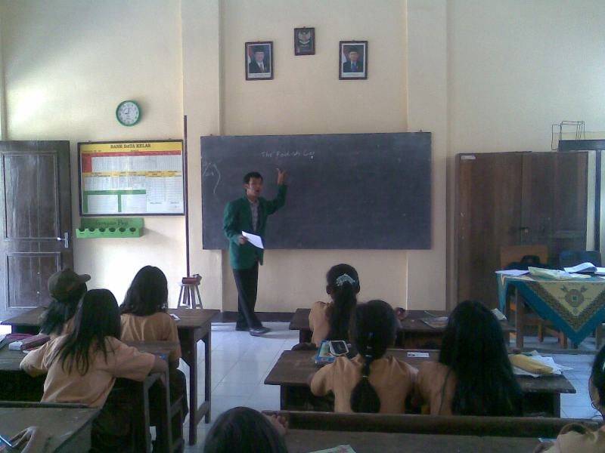
The picture of the teacher explains bilingual fable

The picture of teacher shows the fable picture
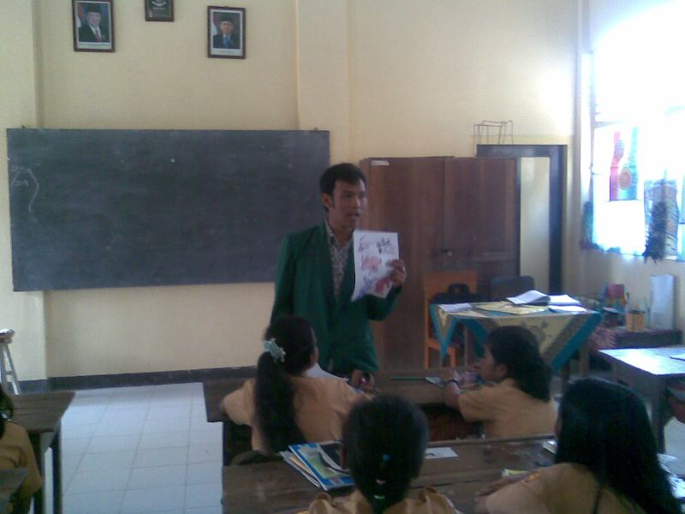
The picture of the students practice using bilingual fable with picture
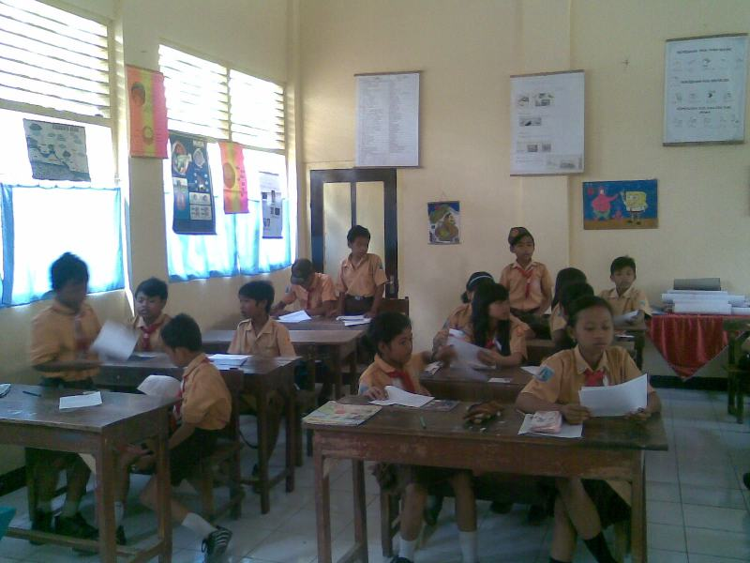

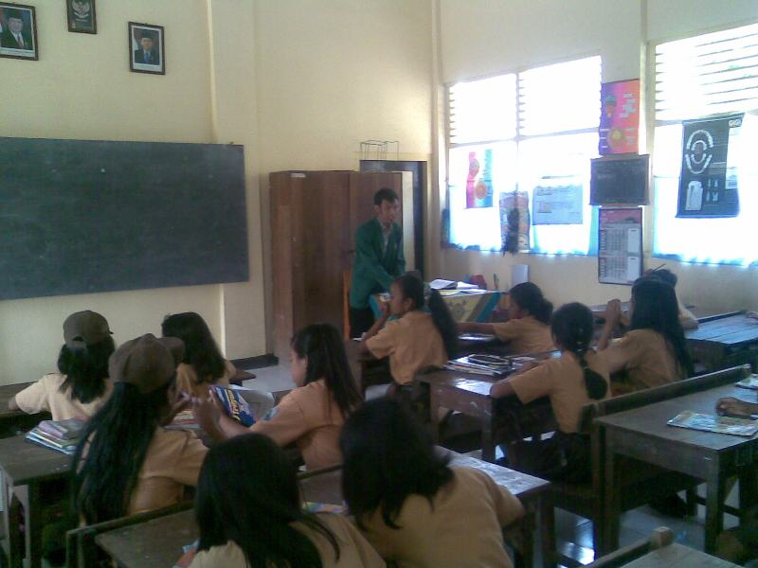
The picture of teaching learning process

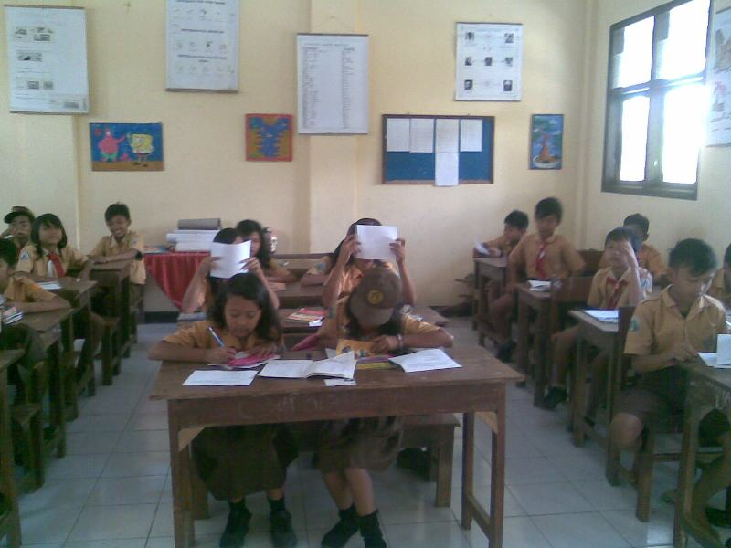

The picture of the students pays full attention
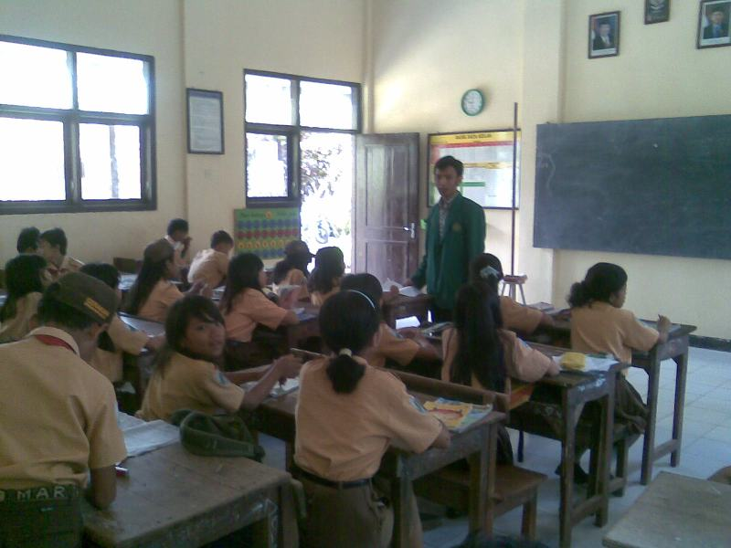

Appendix 4
THE OBSERVATION SHEET

OBSERVATION CHECKLIST FOR THE STUDENT

Meeting : ………………………………….
Topic : ………………………………….
Class : ………………………………….

No. | Teaching Learning Process | Yes | No | Note
1 | Siswa sering mengacungkan tangan untuk menjawab pertanyaan
2 | Siswa menggunakan bahasa inggris atau campuran bahasa inggris dan bahasa Indonesia dalam menjawab pertanyaan
3 | Siswa masih melakukan kesalahan dalam menjawab dan bertanya dengan menggunakan bahasa inggris
4 | Siswa cenderung berinteraksi dengan teman lain
5 | Siswa dituntut banyak menghafal
6 | Siswa lebih mudah mengerti dan memahami bacaan dengan menggunakan cerita binatang bergambar (fable with picture)
7 | Siswa termotivasi untuk giat belajar bahasa inggris
8 | Siswa dapat mengikuti teknik yang dilakukan oleh guru
9 | Siswa aktif dalam kelas
10 | Siswa lebih senang dan atraktif belajar dengan menggunakan cerita bergambar (fable with picture) dibanding dengan tidak menggunakannya

Appendix 5
THE QUESTIONNAIRE SHEET

QUESTIONNAIRE FOR THE STUDENTS

Petunjuk pengisian:
- Jawablah pertanyaan dibawah ini sesuai dengan kondisi yang ada pada saat ini
- Questionnaire ini tidak mempengaruhi nilai pelajaran bahasa inggris
- Sebelum mengisi, harap dibaca dengan baik pertanyaan yang ada
- Pada jawaban yang dianggap benar berilah tanda checklist (√)

No. | Questionnaire | Yes | No
1 | Apa kalian tertarik belajar bahasa inggris dengan menggunakan cerita binatang bergambar (fable with picture) ?
2 | Apakah cerita binatang bergambar tersebut memotivasi kalian untuk belajar bahasa inggris ?
3 | Apakah cerita binatang bergambar tersebut dapat membantu kalian dalam mengingat pelajaran yang telah disampaikan ?
4 | Apakah gambar dalam fabel menarik perhatian kalian?
5 | Apakah belajar bahasa inggris dengan menggunakan cerita binatang bergambar lebih menarik daripada belajar hanya dengan menggunakan buku atau LKS ?
6 | Apakah guru bahasa inggris yang menggunakan cerita binatang bergambar dapat menyampaikan pelajaran dengan baik ?
7 | Apakah kalian merasa bosan belajar bahasa inggris menggunakan cerita binatang bergambar ?
8 | Apakah kalian bisa mengerti dan memahami cerita dan pesan moral yang disampaikan oleh cerita binatang bergambar tersebut ?
9 | Apakah belajar menggunakan fable bergambar membuang waktu kalian ?
10 | Apakah guru bahasa inggris kalian sering menggunakan cerita bergambar dalam pelajaran membaca ?
Appendix 6
THE FORM OF FIELD NOTE

FIELD NOTE

Meeting : 2nd
Topic : Reading
Date : July 25th, 2011
The Notes :

- Some students know the vocabulary before they are taught by the teacher
- If they can’t answer the question, they are silent.
- The students do the task independently, but at the limited time, they ask to their friends
- The students are not make any noise situation
- The teacher give spirit to the students who can answer the question, such as: “good, ok, and give applause.”

