APPENDIX I
Vocabulary Test (Pre-Test)
Nama :
Waktu : 60 menit
Nilai :
A. Choose the correct answer by crossing a, b, c or d!

- What is it? 8. This is not apple, this is………
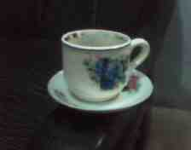
  - Sourcer a. Guava
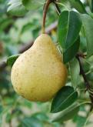
  - Bowl b. Water melon
  - Plate c. Pear
  - Frying pan d. Orange
- What is in dining room? 9. I don’t like durian, I like………
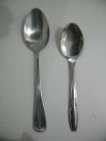
  - Fork a. Guava
  - Spoon b. Pear
  - Knife c. Jack fruit
  - Sourcer d. Strawberry
- We eat rice in the………….. 10. What is it?
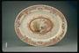
  - Plate a. Rambutan
  - Bowl b. Mango
  - Sourcer c. Grape
  - Frying pan d. Strawberry
- We eat noodles in the…………… 11. What is it?
  - Plate a. Cock
  - Bowl b. Hen
  - Sourcer c. Calf
  - Spoon d. Chick
- What is it? 12. What is it?
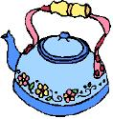
  - Glass a. Cock
  - Tea pot b. Hen
  - Dipper c. Calf
  - Sources d. Chick
- 6. A: Do you like…………..? 13. A: What animal do you like?
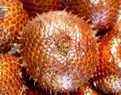
B: Yes I do. B: I like……………
  - Water melon a. Cow
  - Durian b. Buffalo
  - Zallaca c. Horse
  - Mangos teen d. Calf

- What is it…………..? 14. A: Is this goat?
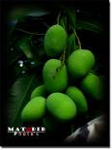
B: No, it is…………….
a. Mango a. Calf
b. Guava b. Cow
c. Water melon c. Buffalo
d. Pear d. Horse
15. The…………is on tree
a. Pigeon
b. Goose
c. Duck
d. Swan

B. Translate these words into Indonesia!
1. Goose :
2. Pigeon :
3. Swan :
4. Zallaca :
5. Jack fruit :
6. Water melon :
7. Knife :
8. Dipper :
9. Fork :
10. Frying pan :

APPENDIX II
Vocabulary Test (Post-Test)
Nama :
Waktu : 60 menit
Nilai :

A. Choose the correct answer by crossing a, b, c or d!

- What is it…………………..
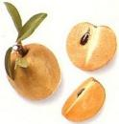
  - Chiku
  - Water melon
  - Grape
  - Star fruit
- A: Do you like…………..?
B: Yes I do.
  - Water melon
  - Papaya
  - Banana
  - Mangosteen
- This is not papaya, this is……………..
  - Guava
  - Water melon
  - Pear
  - Orange
- I don’t like pineapple, I like……………
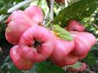
  - Guava
  - Pear
  - Grape
  - Strawberry
- What is it…………..?
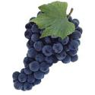
a. Grape
b. Banana
c. Water melon
d. Papaya

- This is not horse, it is………………
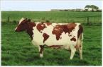
  - Cow
  - Buffalo
  - Hen
  - Goat

- A: Is this goat?
B: No, it is…………….
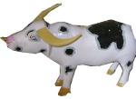
  - Cow
  - Buffalo
  - Horse
  - Dog

- What animal do you like?
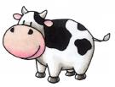
  - Goat
  - Calf
  - Buffalo
  - Horse

- What is it?
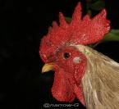
  - Cock
  - Hen
  - Calf
  - Chick
- What is it?
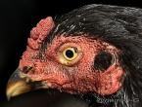
  - Cock
  - Hen
  - Calf
  - Chick

- We eat meatball in the……………
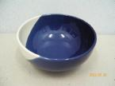
  - Plate
  - Bowl
  - Sourcer
  - Spoon

- We eat rice in the…………..
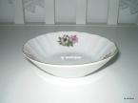
  - Plate
  - Bowl
  - Sourcer
  - Spoon

- What is in dining room?
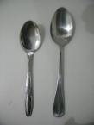
  - Fork
  - Spoon
  - Knife
  - Sourcer

- What is it?
  - Sourcer
  - Bowl
  - Plate
  - Frying pan
- What is it?
  - Dipper
  - Spoon
  - Fork
  - Knife

B. Match! ( Jodohkanlah! )

1. Goose a. Angsa
2. Pigeon … b. Merpati
3. Swan c. Itik
4. Grape d. Anggur
5. Zallaca e. Salak
6. Water melon f. Semangka
7. Gas stove g. Kompor gas
8. Frying pan h. Wajan
9. Tea pot i. Ceret/teko
10. Knife j. Pisau

APPENDIX IV

The Key Answer of Pre-test

A. 1. A 6. C 11. A
2. B 7. A 12. B
3. A 8. C 13. D
4. B 9. C 14. B
5. B 10. A 15. A

B. 1. Angsa
2. Merpati
3. Itik
4. Salak
5. Nangka
6. Semangka
7. Pisau
8. Gayung
9. Garbu
10. Wajan

APPENDIX V

The Key Answer of Post-test

A. 1. A 6. A 11. B
2. D 7. B 12. A
3. C 8. B 13. B
4. A 9. A 14. A
5. A 10. B 15. A

B. 1. I 6. H
2. D 7. C
3. G 8. F
4. B 9. A
5. J 10. E

APPENDIX VI
The Names of Third Year Students at SDN Talun 02
Blitar

No. | Names | Gender
No. | Names | Male | Female
1. | Ahmad Nizamur Riski | √
2. | Aji Wahyu Pratama | √
3. | Akhsa Restu Ariyanu | √
4. | Alan Dio Nazaq | √
5. | Amy Nurhaliza |  | √
6. | Ayu Hani R |  | √
7. | Diki Faturahman | √
8. | Ferdian Wahyu Dianto | √
9. | Hanifa Sofia | √
10. | Havid Wirayuda | √
11. | Jiko Maulana | √
12. | Laila Ika Nihaya |  | √
13. | Mery Ainun K |  | √
14. | M. Fais Maulana | √
15. | M. Imron K.Z | √
16. | Nungke Graha A.P |  | √
17. | Puguh Tri Prayoga | √
18. | Raka Yoga Sukmahadi | √
19. | Rike Cahya P |  | √
20. | Satrio Ramadani | √
21. | Zulfa Laili H.Q |  | √

BIOGRAPHY

The writer of the thesis entitled “The Effectiveness of Realia for Teaching English Vocabulary to the Third Year Students at SDN Talun 02 Blitar” is Erfina Ulfa. She was born in Blitar, October 13, 1987. She lives at Talun Blitar.
She was started her education from RA Hidayatullah Bendosewu. At the same year, she continues to SD Bendosewu 03 graduated at 2000. Next, she continues to MTsN Jabong Blitar and graduated at 2003. Then, her education continues to MAN Wlingi Blitar. She graduated from the school at 2006. In same year, she joined in English Education Program Department of Islamic Education State Islamic College (STAIN) Tulungagung up to now.
As a university student to finish her academic in STAIN Tulungagung in practical fulfillment of the requirements for the degree of Sarjana Pendidikan Islam, she presents her thesis under the title “The Effectiveness of Realia for Teaching English Vocabulary to the Third Year Students at SDN Talun 02 Blitar”.

