THE USE OF MAKE A MATCH BOARD GAME TO IMPROVE THE FIFTH YEAR STUDENTS’ VOCABULARY MASTERY AT MI MIFTAHUL HUDA WONOREJO GANDUSARI TRENGGALEK

THESIS

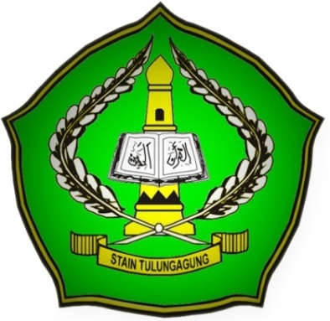

By:
UMI NASHIHAH
NIM.3213073107

ENGLISH EDUCATION PROGRAM
DEPARTMENT OF ISLAMIC EDUCATION
STATE ISLAMIC COLLEGE (STAIN)
TULUNGAGUNG
2011

