A STUDY ON TEACHERS’ ACTIVITIES IN FACILITATING STUDENTS’ LEARNING OF ENGLISH OF “MARDI PUTRA” KINDERGARTEN IN BOYOLANGU

THESIS

By:
FALINDA HARWI
NIM. 3213113070

ENGLISH EDUCATION DEPARTMENT
FACULTY OF TARBIYAH AND TEACHER TRAINING
STATE ISLAMIC INSTITUTE (IAIN)
OF TULUNGAGUNG
July 2015

A STUDY ON TEACHERS’ PRACTICES IN FACILITATING STUDENTS LEARNING OF ENGLISH OF “MARDI PUTRA” KINDERGARTEN IN BOYOLANGU

THESIS
Presented to
State Islamic Institute of Tulungagung in partial fulfillment of the requirements for the degree of Sarjana Pendidikan Islam in English Education

By:
FALINDA HARWI
NIM. 3213113070

ENGLISH EDUCATION DEPARTMENT
FACULTY OF TARBIYAH AND TEACHER TRAINING
STATE ISLAMIC INSTITUTE (IAIN)
OF TULUNGAGUNG
July 2015
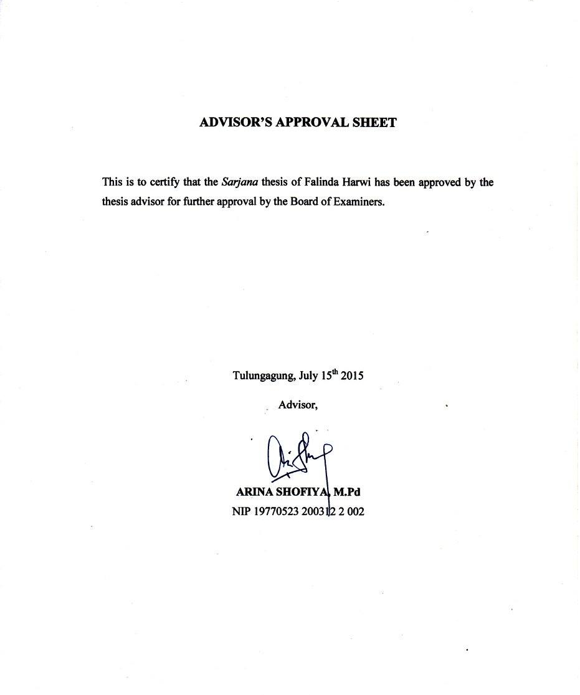

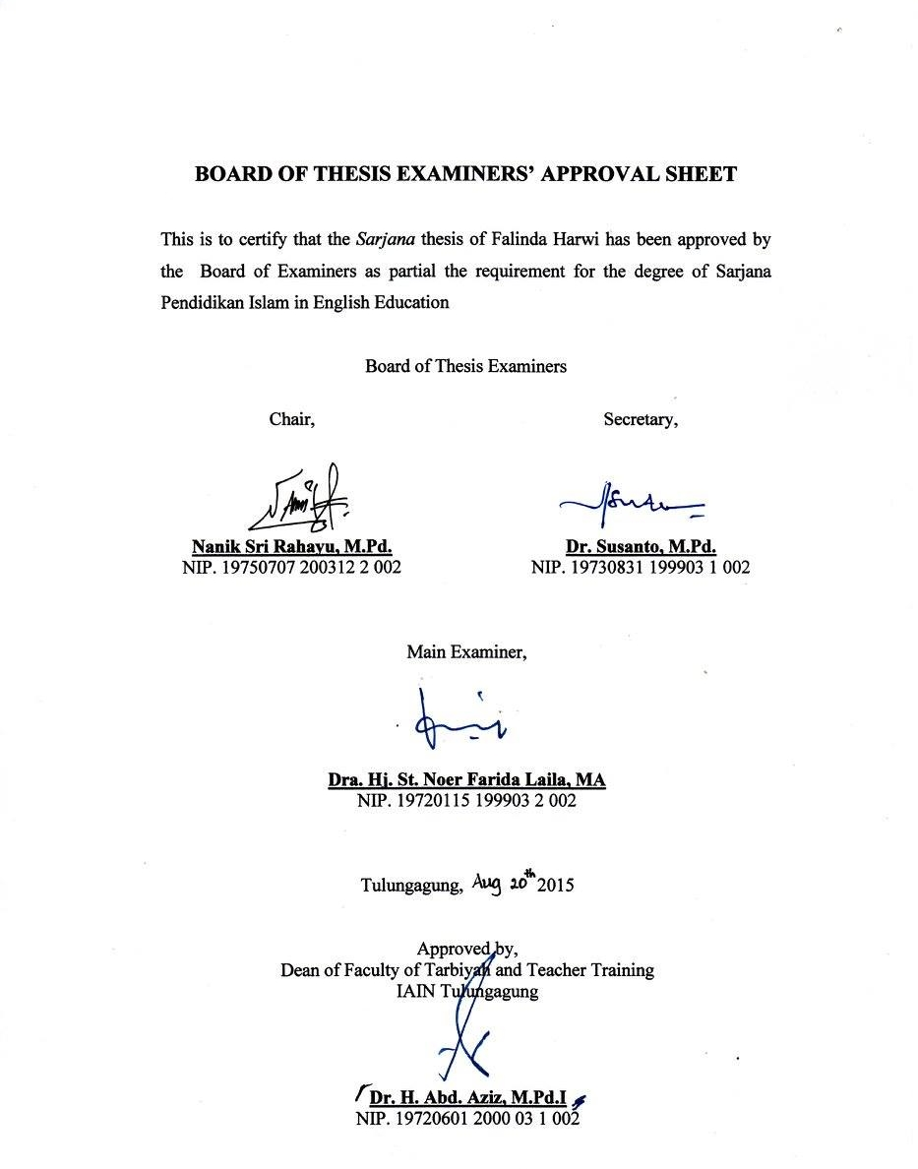

MOTTO

“Verily, with every difficulty, there is relief.”
-Quran (94: 5)

DEDICATION
I would like to dedicate this thesis to:
- First and foremost, my parents, Dwi Pangastuti and Suharyanto. Thank you very much for everything you have done for me. For your prayers and the facilities provided to finish this thesis. I’m sorry for not being a better daughter.
- My sisters and brother, as well as all of my big family.
- All of my friends, especially my classmates, TBI-C.
- My best friend, who had helped me through all the process of finishing this thesis.
- The readers of this thesis. I hope this thesis will be useful for all of you.

DECLARATION OF AUTHORSHIP

Name : FALINDA HARWI
NIM : 3213113070
Faculty : Tarbiyah and Teacher Training (FTIK)
Program : English Education Department (TBI)
Date of birth : Tulungagung, August 12th 1992
Address : R.T 002 / R.W 002 Lk. 08 Ds. Ngunut
Kec. Ngunut – Kab. Tulungagung

States that the thesis I wrote to fulfill the partial of the requirement for the degree of Sarjana Pendidikan Islam entitled:
“A Study on Teachers’ Activities in Facilitating Students’ Learning of English of Mardi Putra Kindergarten in Boyolangu” is my original work. It does not corporate and plagiarize any material previously written or published by another person, except those indicate in quotations and references. Due to the fact that I am the only person who takes responsibility for the thesis if there is any objection or clam.

Tulungagung, July 15th 2015

FALINDA HARWI

ABSTRACT
Harwi, Falinda. Student Registered Number: 3213113070. 2015. A Study on Teachers’ Activities in Facilitating Students’ Learning of English of “Mardi Putra” Kindergarten in Boyolangu. Sarjana Thesis. English Education Department. Faculty of Tarbiyah and Teacher Training. State Islamic Institute (IAIN) of Tulungagung. Advisor: Arina Shofiya, M.Pd.

Keywords: teaching activities, facilitating learning

In order to keep up with the development of modern era, English is being taught to the younger and younger learners. Children in their kindergarten years have been introduced to English even though it is not included in the curriculum. High dedication to teach English is required for the teacher of young learner, because teaching English to young learners is different to the adult. Since children have certain characteristics, the practice of English teaching in kindergarten level should be appropriate to their interest.
This research proposed several questions based on the statement above. Those research questions were formulated as: 1) What are the activities to facilitate learning process? 2) How do the teachers give feedback to the students' performances? 3) How do the teachers’ effort to create supportive learning environment for the students?
Based on the research questions formulated above, the purposes of this research are: 1) To describe the activities to facilitate learning process. 2) To investigate how the teachers give feedback to the students’ performances. 3) To know how the teachers’ effort to create supportive learning environment for the students.
The design of this research is descriptive qualitative. The subjects of this research are two English teachers of “Mardi Putra” Kindergarten in Boyolangu. The data collected were in the form of interview transcripts and field notes. In order to collect the data for the research problems, the researcher applied two methods of data collection: observation and interview. The data then were analyzed using Miles and Huberman theory of Qualitative Data Analysis.
The finding of this study showed that to facilitate students learning of English, the English teachers of Mardi Putra Kindergarten provide some activities to the students. Those activities were singing English songs, listen and repeat, straight copying, and fine motor skill activities. The teachers would also give feedback to the students' performance and works. The feedback given during the classroom activities were in the form or corrective feedback, strategic feedback, evaluative feedback, and positive feedback. And the finding on the last research problem is the teachers manage the seating arrangement, decorate the classroom walls, establish routines, and also give clear instruction for each task as their effort to create supportive learning environment.

ABSTRAK
Harwi, Falinda. Nomor Induk Mahasiswa: 3213113070. 2015. Studi tentang Aktivitas Mengajar Guru dalam Menfasilitasi Pembelajaran Bahasa Inggris Siswa di TK Mardi Putra Boyolangu. Skripsi S1. Jurusan Tadris Bahasa Inggris. Fakultas Tarbiyah dan Ilmu Keguruan. Institut Agama Islam Negeri (IAIN) Tulungagung. Pembimbing: Arina Shofiya, M.Pd.

Kata kunci: aktivitas mengajar, memfasilitasi pembelajaran

Dalam rangka menyesuaikan dengan perkembangan era modern, Bahasa Inggris diajarkan kepada peserta didik pada usia yang semakin muda. Anak-anak TK telah diperkenalkan kepada Bahasa Inggris meskipun tidak termasuk dalam kurikulum. Dedikasi tinggi untuk mengajar Bahasa Inggris diperlukan oleh guru pembelajar muda, karena mengajar bahasa Inggris kepada pembelajar muda berbeda dengan orang dewasa. Karena anak-anak memiliki karakteristik tertentu, praktek mengajar bahasa Inggris di tingkat TK harus sesuai dengan kepentingan mereka.
Berdasarkan pernyataan diatas, peneliti merumuskan beberapa pertanyaan. Pertanyaan-pertanyaan tersebut dirumuskan sebagai berikut: 1) Apa saja kegiatan untuk memfasilitasi proses pembelajaran Bahasa Inggris? 2) Bagaimana guru memberikan umpan balik kepada hasil kerja siswa? 3) Bagaimana upaya guru untuk menciptakan lingkungan belajar yang mendukung bagi pembelajaran siswa?
Berdasarkan rumusan pertanyaan di atas, tujuan penelitian ini adalah: 1) Untuk mendeskripsikan kegiatan untuk memfasilitasi proses pembelajaran Bahasa Inggris. 2) Untuk menyelidiki bagaimana guru memberikan umpan balik kepada hasil kerja siswa. 3) Untuk mengetahui bagaimana upaya guru untuk menciptakan lingkungan belajar yang mendukung bagi siswa.
Desain penelitian ini adalah deskriptif kualitatif. Subyek penelitian ini adalah dua guru bahasa Inggris dari TK Mardi Putra di Boyolangu. Data yang dikumpulkan adalah dalam bentuk transkrip wawancara dan catatan lapangan. Dalam rangka untuk mengumpulkan data, peneliti menerapkan dua metode pengumpulan data, yaitu observasi dan wawancara. Data tersebut kemudian dianalisis dengan menggunakan teori Miles dan Huberman tentang Kualitatif Analisis Data.
Temuan penelitian ini menunjukkan bahwa untuk memfasilitasi pembelajaran Bahasa Inggris siswa, beberapa kegiatan dilakukan. Kegiatan-kegiatan tersebut adalah menyanyikan lagu Bahasa Inggris, mendengarkan dan mengulangi, menyalin, dan beberapa kegiatan keterampilan motorik halus. Para guru juga akan memberikan umpan balik terhadap kinerja dan karya siswa. Umpan balik yang diberikan selama kegiatan kelas adalah dalam bentuk korektif, strategis, evaluatif, dan umpan balik positif. Dan temuan pada masalah penelitian terakhir adalah guru mengatur posisi duduk siswa, menghiasi dinding kelas, membuat rutinitas, dan juga memberikan instruksi yang jelas untuk setiap tugas sebagai upaya mereka untuk menciptakan lingkungan belajar yang mendukung pembelajaran Bahasa Inggris.

ACKNOWLEDGEMENT
In the name of Allah SWT The Most Beneficent and The Most Merciful. All praises are to Allah SWT for all His bless so that the researcher can finish this thesis. In addition, may peace and salutation be given to the prophet Muhammad (pbuh) who has taken all human being from the Darkness to the Lightness.
The researcher would like to express her genuine gratitude to:
- Dr. H. Abd. Aziz, M.Pd.I, as the Dean of Faculty of Tarbiyah and Teacher Training.
- Arina Shofiya, M.Pd, as the Head of English Education Department as well as my thesis advisor, for giving me advices and suggestion so that I could finish this thesis.
- Lectures in English Education Department of Faculty of Tarbiyah and Teacher Training for valuable knowledge, guidance, and advices during the years of my study.
- Sukaryati, S.Pd, as the headmaster of TK Mardi Putra Boyolangu, for giving me her permission to conduct a study in the school.
- Miss Yessyka and Miss Rinda, as the English teachers of TK Mardi Putra, for letting me intruded their classes to conduct observations and providing their time to answer all of my questions.
Hopefully, may Allah SWT always blesses those mentioned above and all their sacrifice becomes their merciful deeds to help them gain a success in their future life. The researcher realizes that this research is far from being perfect. Therefore, any constructive criticism and suggestion will be gladly accepted. Finally, it is expected that this thesis will be beneficial for the readers.

Tulungagung, July 15th 2014

Writer

TABLE OF CONTENT
Cover i
Logo ii
Thesis Title iii
Advisor’s Approval Sheet iv
Board of Examiners’ Approval Sheet v
Motto vi
Dedication vii
Declaration of Authorship viii
Abstract ix
Acknowledgement xiii
Table of Content xv
List of Appendices xviii
CHAPTER I INTRODUCTION
- Background of the Research 1
- Statement of Research Problems 6
- Objective of The Research 6
- Significance of The Research 7
- Scope and Limitation of The Research 8
- Definition of Key Terms 8
CHAPTER II REVIEW OF RELATED LITERATURE
- Teaching English for Young Learners 9
- Young Learners Characteristics 9
- Facilitating Students’ Learning 12
- Teaching Activities 14
- Teaching Spoken Language 14
- Teaching Literacy Skills 16
- Feedbacks 18
- Learning Environment 21
- Creating Classroom Atmosphere 22
- Arranging Desk 23
- Grouping Students 24
- Previous Study 28
CHAPTER III RESEACH METHOD
- Research Design 30
- Data and Data Sources 31
- Time and Place of The Study 31
- Technique of Data Collection 32
- Technique of Data Verification 33
- Data Analysis 34
CHAPTER IV RESEARCH FINDING
- Data Presentation 36
- Learning activities for the kindergarten students 36
- Feedbacks on the students’ performance 41
- Teachers’ efforts to create a supportive learning environment 42
- The Findings of Research 45
- Findings on the Activities to Facilitate English Learning 45
- Findings on the Feedbacks Given for the Students’ Performance 47
- Findings on the Teachers’ Effort to Create A Supportive Learning Environment 48
CHAPTER V DISCUSSION
- Discussion on the Activities to Facilitate English Learning 50
- Discussion on the Feedbacks Given for the Students’ Performance 52
- Discussion on the Teachers’ Effort to Create A Supportive Learning Environment 53
CHAPTER VI CONCLUSION AND SUGGESTIONS
- Conclusion 56
- Suggestion 57
REFERENCES 59
APPENDICES 61
CURRICULUM VITAE 85

LIST OF APPENDICES
Appendix I : Interview Guide
Appendix II : Interview transcript with teacher of class B
Appendix III : Interview transcript with teacher of class A
Appendix IV : Observation field note of class B
Appendix V : Observation field note of class A

