CHAPTER III
RESEARCH METHOD
This chapter discusses the research design, research setting and subject of the study, preliminary procedure, data and sources of data, data collection method, data analysis and the criteria of success.

- Research Design
Research design refers to the systematic scheduling or time at with treatments are administered to subject and at with observation are made of the performance of the subject. Based on the background of the study, the research design of this study is Classroom Action Research (CAR). According to Ary et al. (2010:515) Action research is a planed, systematic, and cyclical approach to understanding the learning process to analyzing educational places of work. The goal of Classroom Action Research is to improve classroom practice or to improve practices in the school. It involves teachers in their classroom, can involve groups of teachers examining common issues.
In this study, classroom action research was conducted to solve students’ problem in understanding vocabulary. In this classroom action research, the researcher performed cycles, namely:
- Planning
- Acting / implementing
- Observing, and
- Reflecting
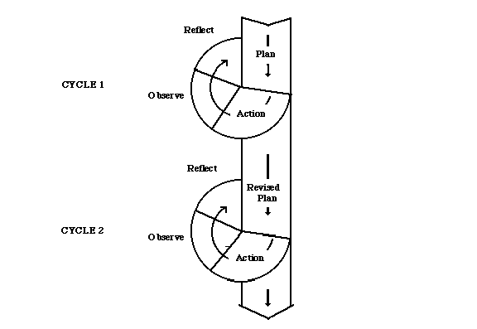
By doing the cycles, the researcher expected to bring the students in developing their skill in vocabulary mastery and they can reach the criteria of success which have been prepared in advance.

- Subject and Setting of Study
The subject in this study was the fifth year students at elementary school Mergayu 1 in the academic year 2014/2015 consisting of 18 students. The students got difficulties in vocabulary mastery. Most of them were difficult to memorize vocabulary. It suited to the researcher’s strategy, modified domino card. Thus, the researcher implemented modified domino card to overcome that problem.
- Procedures of The Research
The procedures of CAR in this study was divided into four steps as follows:

- Planning
Planning is developed for taking action and / or for gathering information and data in order to observe or capture the experience or monitor the practice. It is in the phase that the research questions and methods are explicated (Ary et al. , 2010: 515). The intructional strategy in this study was based on the belief that the strategy could theoretically solve the problem. In planning, there were some steps including providing the suitable strategy, designing lesson plan, and preparing the criteteria of success.

  - Providing the Suitable Strategy
In this research, the researcher implemented modified domino card to improve vocabulary mastery. Modified domino card here means matching words and picture, or matching word to their definition. The researcher believed that by using modified domino cards, the students would be more interested in learning vocabulary. It gave a way to make teaching vocabulary easy, effective, and enjoyable. According to Baker and Westrup (2000: 38) student could play different matching games with domino cards, for example: They could match words and picture or match the words in their first language to the words in English, or match words to their definitions. The researcher believed this strategy could help the students in learning vocabulary mastery. The procedure of implementing modified domino cards is as follows :
- Teacher divided students into 3 groups
- Each group was given a set of modified domino cards
- Each group matched each picture with the definition provided in the cards
- The quickest group in matching all cards correctly became the winner in this game

  - Lesson Plan
The researcher designed the lesson plan before conducting this research. At the end of the study the students were expected to be able to memorize vocabularies related to things around them, and students will be able to understand the meaning of each word through picture and definition provided in the card. In this research the lesson plan contained of(1) identity of school, (2)standard and basic competence stated in the curriculum, (3)instructional objective, media, and method, (4)teaching and learning activity, (5) material resource. The complete form of the lesson plan can be seen by appendix.

  - Criteria of Success
The criteria of success in this study were emphasized on teaching and learning process during on the students’ score from paper works given by the teacher. According to the English teacher of Elementary school MERGAYU 1, the criteria of success was 80% among whole member of the students in the class. The standard value was 70. So, the students who scored more was classified into pass and the less than 70 was classified into failed. The researcher compared the test score with criteria of success. If the students who passed the test are less than 80%, he made reflection from the previous cycle to decide and plan the next cycle. He tried to prepare the second cycle to reach the criteria of success.
The table 3.2 the criteria for the score of the action of vocabulary learning as follow:
No | Test Score | Category | Score
1. | 90-100 | Excellent | A
2. | 70-89 | Good | B
3. | 45-69 | Fail | C
4. | 0-44 | Poor | D

- Implementing
In this stage, the researchers applied modified domino card in increasing students’ vocabulary mastery. In implementing the strategy, the researcher conducted the first cycle according to the criteria of success decided in advance.
- Observing
Observing is a step for collecting data. The data to be collected are determined by targeted criteria of success to be achieved. In this study, the researcher collected the data that represent the achievement of the criteria of success. The researcher used the data of observation in reflection process whether one more cycle is needed or not. The data to be collected are indicators of the result of the implementation of the strategy. In collecting the data, the researchers used some instruments diveloped by resercher in collecting data.

- Observation Sheet
Observation involves recording the behavioral pattern of people, object and events in a systematic manner (Thames Valley, 2008) the researcher used observation sheet in this research. Observation sheet was printed to record students’ participation during the teaching and learning process. It showed the students names and a kinds of participation performed. Besides that it was intended to know whether the action was in line with the planning that had been before. The collaborator was needed to give certain mark in the participation column to record students’ participation.

- Questionnaire
The researcher got all information that he wanted to know through questionnaire. Questionnaire was supposed to give some information dealing with the students’ personal learning experience before and after the implementation of technique. The researcher used questionnaire in order to know the students respond related to vocabulary learning through modified domino cards.

- Test
Test is series of questions, problem or physical responses designed to determine knowledge, intelligence, or ability (Heritage: 2003). The researcher gave writing preliminary test and evaluation test for the students. Preliminary test was intended to know how well the students had mastered the vocabulary mastery before they are taught by using modified domino cards. It was given in the preliminary study. While evaluation test was aimed at knowing the students’ ability on vocabulary after taught by using modified domino cards. The result of evaluation test was compared with criteria of success to know whether the students got improvement in vocabulary mastery.

- Interview
Interview guide was used to interview both teacher and students. The researcher used interview to know some information related with the research. He interviewed the teacher to get information about the english lesson in the school. He also interviewed some of the students to know their response in learning vocabulary through modified domino cards.

- Reflection
Reflection is the process of analyzing data to determine how far the data collected have shown the success of the strategy in solving the problem. In this stage, the researcher used the reflection of the data to determine what part of strategy needs improvement. If the criteria of success were not achieved yet, the researcher used the reflection to find out how maximum improvement could be made so that when doing implementation in the next cycles the criteria of success could be achieved.

