KORESPONDENSI ARTIKEL JURNAL INTERNATIONAL
Judul : Quality Control Management Of Madrasah Education in International Standart
Penulis : Indah Komsiyah
Accept Submission
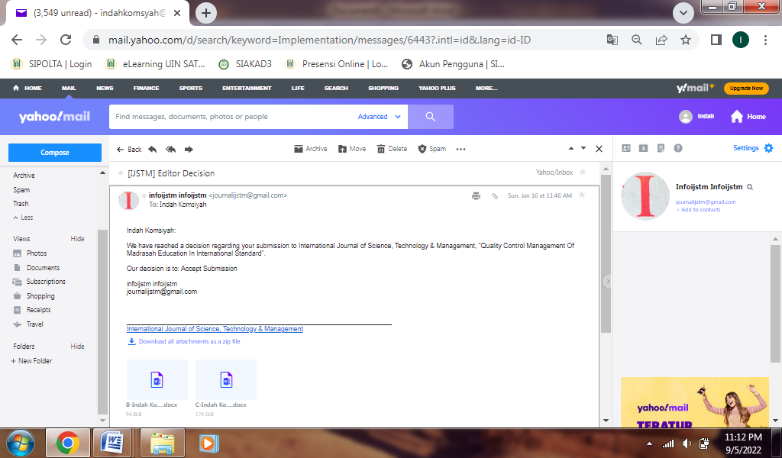
Revision Required
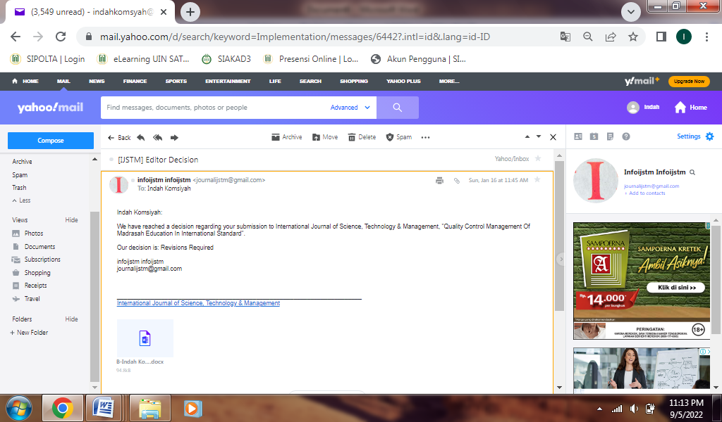
Paper Acceptance Letter
