Korespondensi Artikel Jurnal Sinta 2
Judul Subbmit: Madrasa Internal quality Assurance to improve the quality of education.
Revisi Judul : Implementation of Internal Quality Assurance to Improve the Quality of Islamic Education
Penulis : Indah Komsiyah
Revisi : 27 November 2021
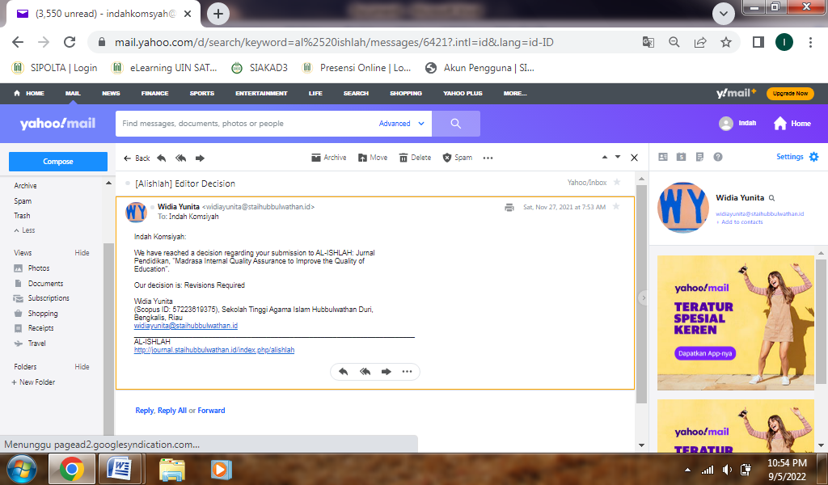
Article Acceptance Letter : 10 Desember 2021
