KORESPONDENSI ARTIKEL JURNAL SINTA 2

Judul : The challenge of Zoom Cloud Meeting in Online learning Process

Penulis ; Indah komsiyah

Manuscrib URL : 18 juli 2021

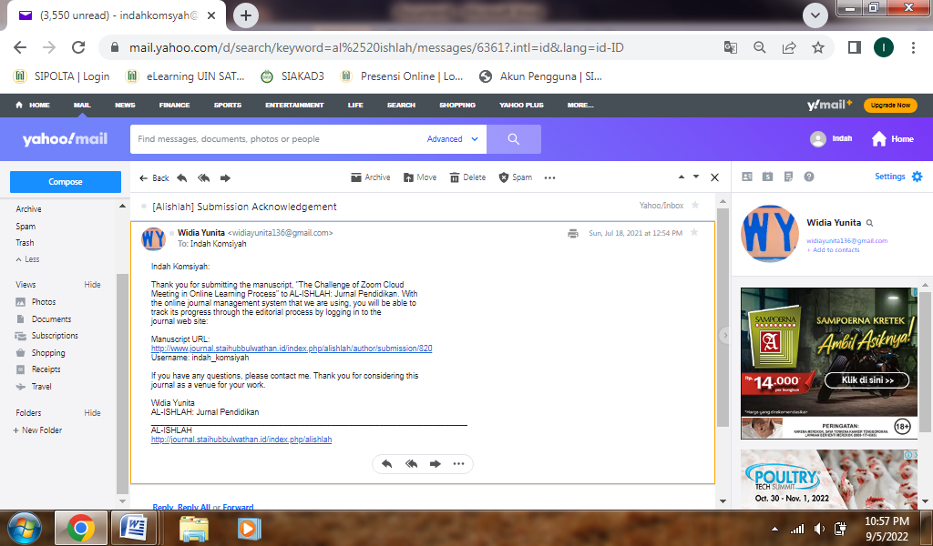

Submission ; 29 Juli 2021

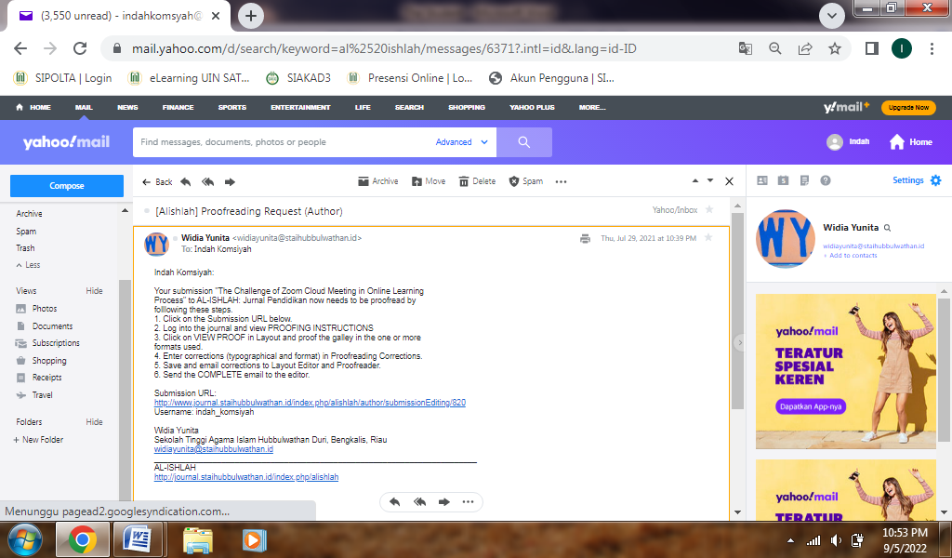

Accept Submission : 29 Juli 2021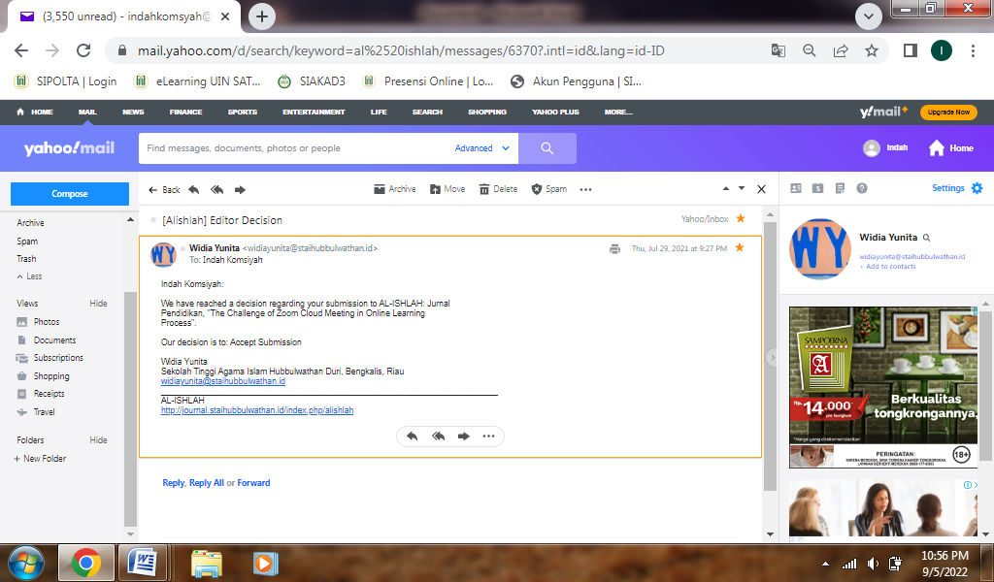

Article Acceptance Letter ; 30 agustus 2021

