IMPROVING STUDENTS’ SPEAKING ABILITY THROUGH PROBLEM SOLVING TECHNIQUE TO THE VIII GRADERS AT MTS TARBIYATUL ULUM PANGGUNGASRI PANGGUNGREJO BLITAR
THESIS
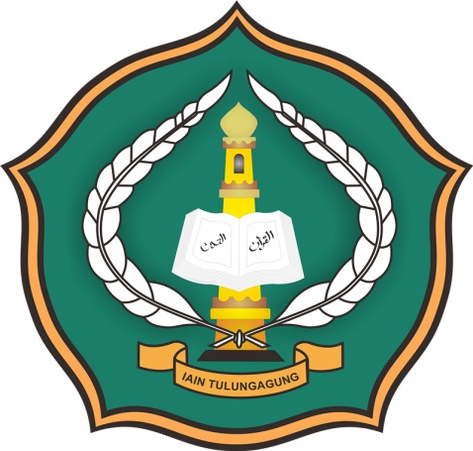

by :
USWATUN HASANAH
NIM. 3213103143

ENGLISH EDUCATION DEPARTEMENT
FACULTY OF EDUCATION AND TEACHER TRAINING
(FTIK)
STATE ISLAMIC OF INSTITUTE (IAIN) TULUNGAGUNG
2014

