BUKTI KORESPONDENSI ARTIKEL JURNAL INTERNASIONAL BEREPUTASI SINTA 1
Judul | : | Muslim Women Emancipation Discourse: Analyzing the Legal Thoughts of Muhammad Quraish Shihab
Jurnal | : | Ulumuna: Journal of Islamic studies
Penulis | : | Kutbuddin Aibak

No | Penilaian | Tanggal
1 | Bukti Konfirmasi Submit Artikel dan artikel yang di submit | 2 Februari 2022
2 | Bukti Konfirmasi dan LOA serta Invoice dan similarity | 20 Juni 2023
3 | Bukti Konfirmasi review dan hasil review pertama | 5 November 2023
4 | Bukti Konfirmasi submit revisi Pertama, respon pada reviewer dan artikel yang di resubmit | 12 November 2023
5 | Bukti Konfirmasi Review kedua dan bukti proofreader | 20 November 2023
6 | Bukti Konfirmasi Submit revisi kedua, respon kepada reviewer, dan artikel yang di resubmit | 27 November 2023
7 | Bukti Konfirmasi artikel Accepted | 10 November 2023
8 | Bukti Konfirmasi artikel Published online | 01 Januari 2024

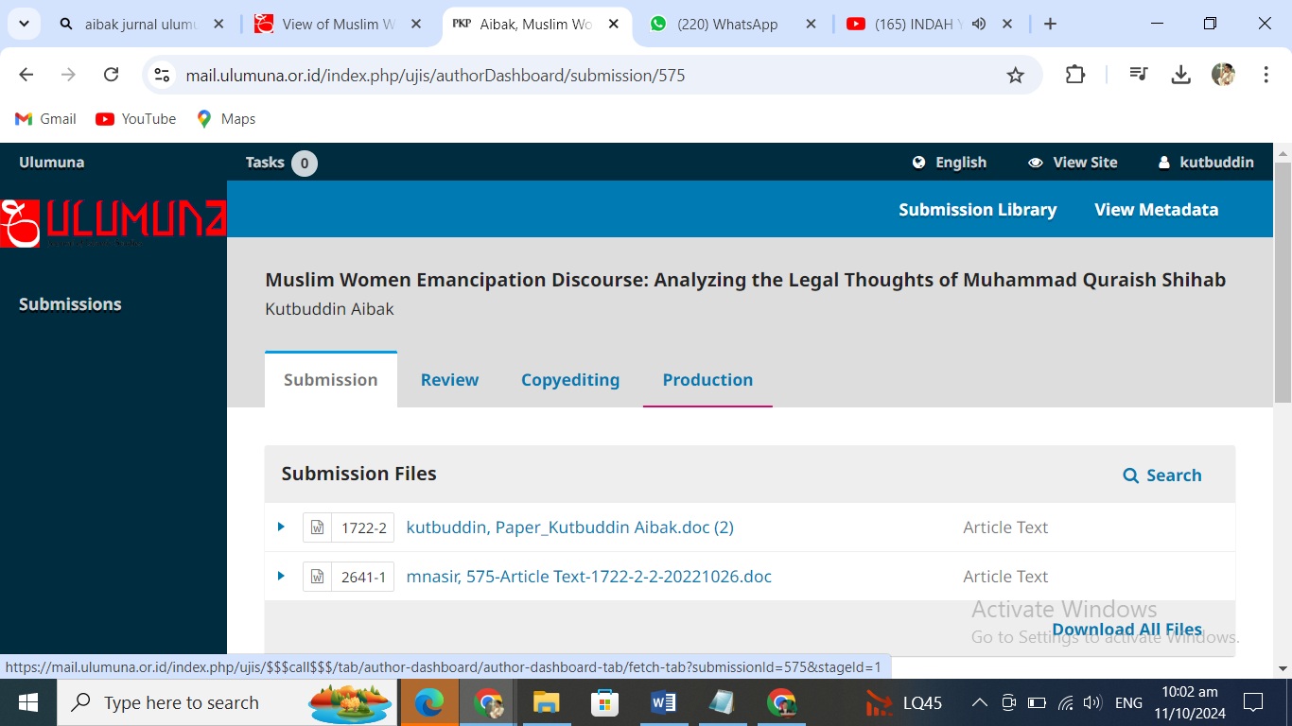
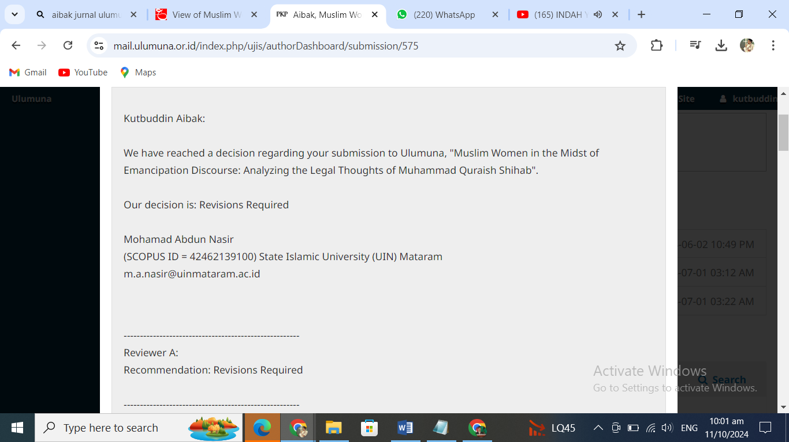
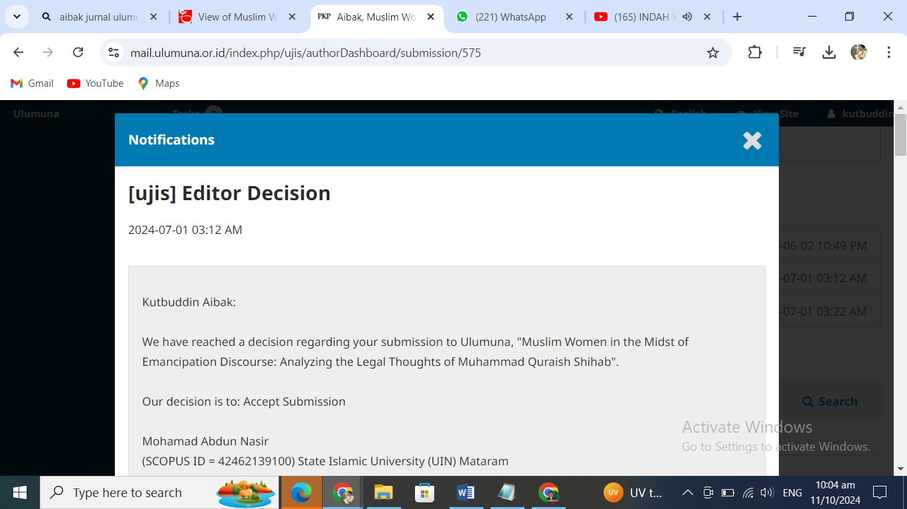
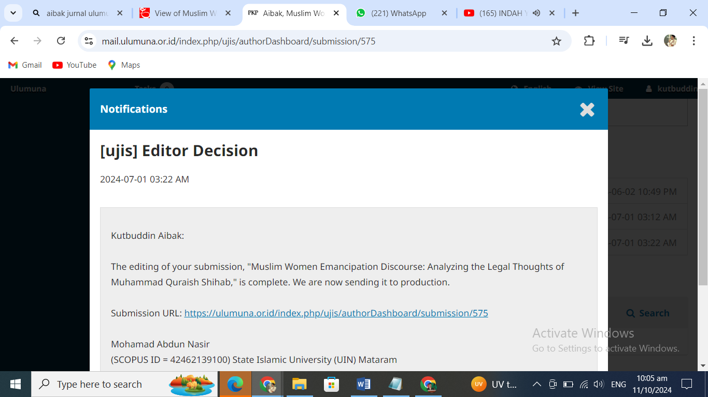
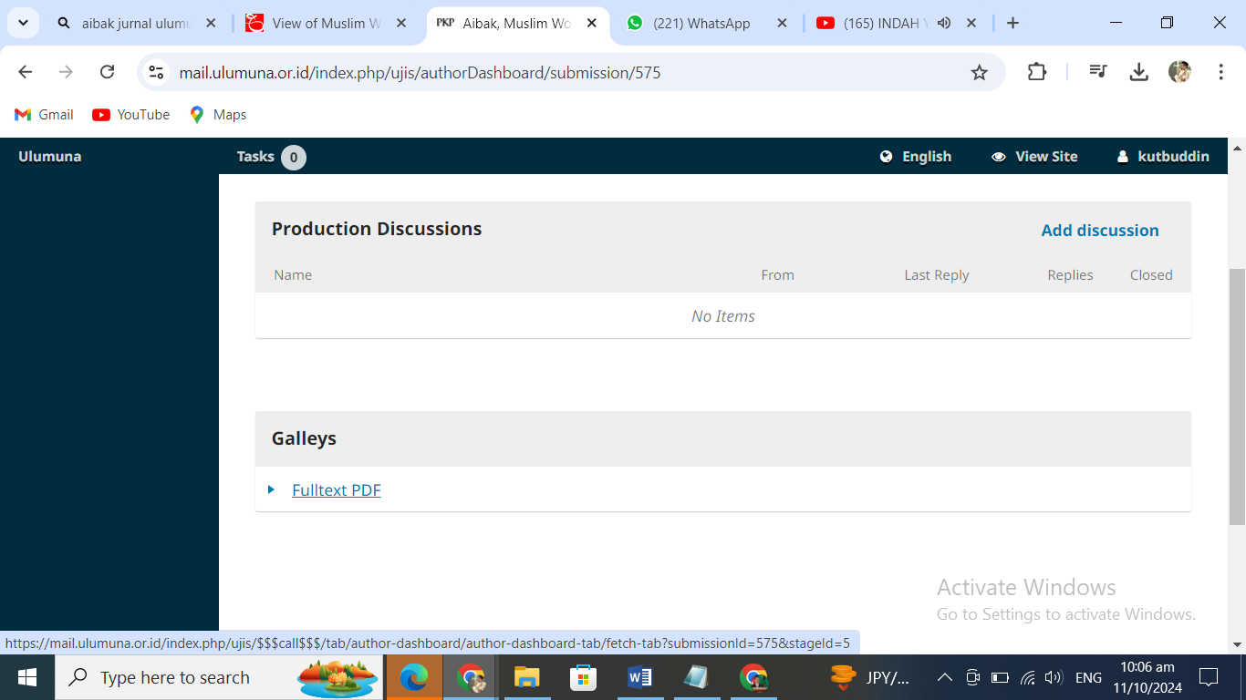
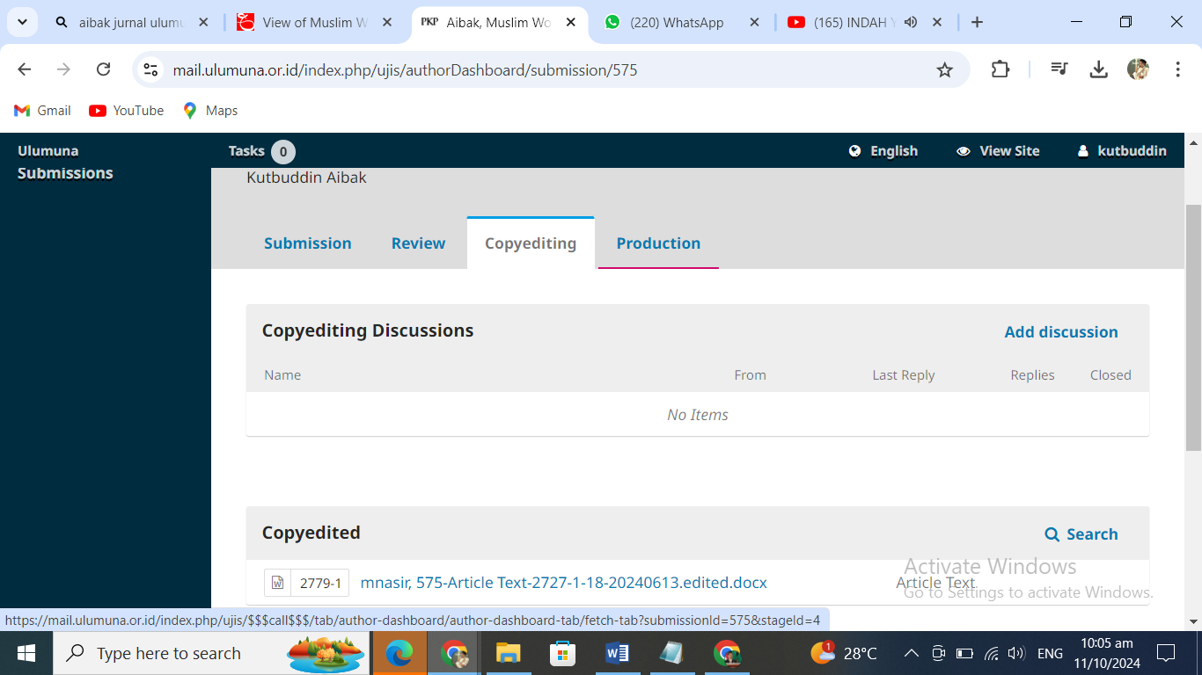
Kutbuddin Aibak:

We have reached a decision regarding your submission to Ulumuna, "Muslim Women in the Midst of Emancipation Discourse: Analyzing the Legal Thoughts of Muhammad Quraish Shihab".

Our decision is: Revisions Required

Mohamad Abdun Nasir
(SCOPUS ID = 42462139100) State Islamic University (UIN) Mataram
m.a.nasir@uinmataram.ac.id

------------------------------------------------------
Reviewer A:
Recommendation: Revisions Required

------------------------------------------------------

Title (Overal Evaluation)

Concise, Clear

Abstract (Overal Evaluation)

Excellent

Keywords (Overal Evaluation)

Relevant, Complete

Method (Overal Evaluation)

Clear, Detail

Data (Overal Evaluation)

Excellent

Conclusion (Overal Evaluation)

Excellent

References (Overal Evaluation)

Excellent

The technicality aspects

Please give clear and detailed comments on the manuscript assigned, which may include the language/clarity, writing and reference style, and lengthy (6.000-8.000 words, or 10.000 maximum) structure.

see notes in the manuscript
The substance aspects

Please give clear and detailed comments on the manuscript assigned, including the method, data, approach, theory, depth-ness/sharpness of analysis, bibliographies, and novelty/contribution to the topic/theme being discussed.

To improve the structure and substance of this article, the following suggestions can be implemented:
1). Add brief information about Shihab's academic life, career and works before discussing his thoughts on the fatwa on women. This will help the reader understand the context of Shihab's thinking and how it influences his views on the fatwa.
2) Organise each section clearly. Ensure that each section has a purposeful focus and is easy to understand. Explain briefly what is being discussed and why it is important.
------------------------------------------------------

------------------------------------------------------
Reviewer B:
Recommendation: Revisions Required

------------------------------------------------------

Title (Overal Evaluation)

Concise, Clear

Abstract (Overal Evaluation)

Excellent

Keywords (Overal Evaluation)

Relevant, Complete

Method (Overal Evaluation)

Clear, Detail

Data (Overal Evaluation)

Excellent

Conclusion (Overal Evaluation)

Excellent

References (Overal Evaluation)

Excellent

The technicality aspects

Please give clear and detailed comments on the manuscript assigned, which may include the language/clarity, writing and reference style, and lengthy (6.000-8.000 words, or 10.000 maximum) structure.

-
The substance aspects

Please give clear and detailed comments on the manuscript assigned, including the method, data, approach, theory, depth-ness/sharpness of analysis, bibliographies, and novelty/contribution to the topic/theme being discussed.

The paper seeks to exaplian a contemporary Indonesian Muslim scholar/mufassir in interpreting several issues regarding women. It uses primary sources from Shihab’s work and related references. Although the element of the paper is complete but it lacks of explaining some issues, such as the reviews on the previous studies, the questions, and the method.
The Introduction must include the method, at least stating the sources of the data and how they are collected. It also needs more previous relevant studies about Shihab to review since the studies on him are abundant.

The other issue is about the organization. Explian clearly in the beginning what is going to be discussed in the sections. For example, the first part after introduction is about Shihab’s life and work. Next is his method of tafsir of issuing fatwa, floowed by the example of this interpretation/fatwa regarding women.
Then do not stop there. The author must discuss the finding about Shihab’s fatwa with the ongoing discourse about women by other Muslim scholars and elucidate the similarities/diffferences amongst them in terms of opinion and method.
By adding this element, the paper will look better and critical.
Kutbuddin Aibak:

We have reached a decision regarding your submission to Ulumuna, "Muslim Women in the Midst of Emancipation Discourse: Analyzing the Legal Thoughts of Muhammad Quraish Shihab".

Our decision is to: Accept Submission

Mohamad Abdun Nasir
(SCOPUS ID = 42462139100) State Islamic University (UIN) Mataram
m.a.nasir@uinmataram.ac.id

------------------------------------------------------
Reviewer A:
Recommendation: Revisions Required

------------------------------------------------------

Title (Overal Evaluation)

Concise, Clear

Abstract (Overal Evaluation)

Excellent

Keywords (Overal Evaluation)

Relevant, Complete

Method (Overal Evaluation)

Clear, Detail

Data (Overal Evaluation)

Excellent

Conclusion (Overal Evaluation)

Excellent

References (Overal Evaluation)

Excellent

The technicality aspects

Please give clear and detailed comments on the manuscript assigned, which may include the language/clarity, writing and reference style, and lengthy (6.000-8.000 words, or 10.000 maximum) structure.

see notes in the manuscript
The substance aspects

Please give clear and detailed comments on the manuscript assigned, including the method, data, approach, theory, depth-ness/sharpness of analysis, bibliographies, and novelty/contribution to the topic/theme being discussed.

To improve the structure and substance of this article, the following suggestions can be implemented:
1). Add brief information about Shihab's academic life, career and works before discussing his thoughts on the fatwa on women. This will help the reader understand the context of Shihab's thinking and how it influences his views on the fatwa.
2) Organise each section clearly. Ensure that each section has a purposeful focus and is easy to understand. Explain briefly what is being discussed and why it is important.
------------------------------------------------------

------------------------------------------------------
Reviewer B:
Recommendation: Revisions Required

------------------------------------------------------

Title (Overal Evaluation)

Concise, Clear

Abstract (Overal Evaluation)

Excellent

Keywords (Overal Evaluation)

Relevant, Complete

Method (Overal Evaluation)

Clear, Detail

Data (Overal Evaluation)

Excellent

Conclusion (Overal Evaluation)

Excellent

References (Overal Evaluation)

Excellent

The technicality aspects

Please give clear and detailed comments on the manuscript assigned, which may include the language/clarity, writing and reference style, and lengthy (6.000-8.000 words, or 10.000 maximum) structure.

-
The substance aspects

Please give clear and detailed comments on the manuscript assigned, including the method, data, approach, theory, depth-ness/sharpness of analysis, bibliographies, and novelty/contribution to the topic/theme being discussed.

The paper seeks to exaplian a contemporary Indonesian Muslim scholar/mufassir in interpreting several issues regarding women. It uses primary sources from Shihab’s work and related references. Although the element of the paper is complete but it lacks of explaining some issues, such as the reviews on the previous studies, the questions, and the method.
The Introduction must include the method, at least stating the sources of the data and how they are collected. It also needs more previous relevant studies about Shihab to review since the studies on him are abundant.

The other issue is about the organization. Explian clearly in the beginning what is going to be discussed in the sections. For example, the first part after introduction is about Shihab’s life and work. Next is his method of tafsir of issuing fatwa, floowed by the example of this interpretation/fatwa regarding women.
Then do not stop there. The author must discuss the finding about Shihab’s fatwa with the ongoing discourse about women by other Muslim scholars and elucidate the similarities/diffferences amongst them in terms of opinion and method.
By adding this element, the paper will look better and critical.
------------------------------------------------------

