**BUKTI KORESPONDENSI**

**ARTIKEL JURNAL INTERNASIONAL BEREPUTASI**

Judul Artikel : Philosophical Perspective of Islam and Java: A Study of Fossil

Rocks of Apak 'Beringin

Jurnal : European Journal For Philosophy Of Religion, 2023, Volume 15,

No. 2, Hlm.71-87.

Penulis : Dr. Teguh, M.Ag.

|  |  |  |
| --- | --- | --- |
| No. | Perihal | Tanggal |
| 1. | Bukti konfirmasi submit artikel dan artikel yang disbumit | 5 Januari 2023 |
| 2. | Bukti konfirmasi review dan hasil review pertama | 25 Januari 2023 |
| 3. | Bukti konfirmasi submit revisi pertama, respon kepada reviewer, dan artikel yang diresubmit | 13 Februari 2023 |
| 4. | Bukti konfirmasi artikel accepted | 19 April 2023 |
| 5. | Bukti konfirmasi artikel published online | 16 Juni 2023 |

1. **Bukti Konfirmasi Submit Artikel dan Artikel yang Disubmit (5 Januari 2023)**

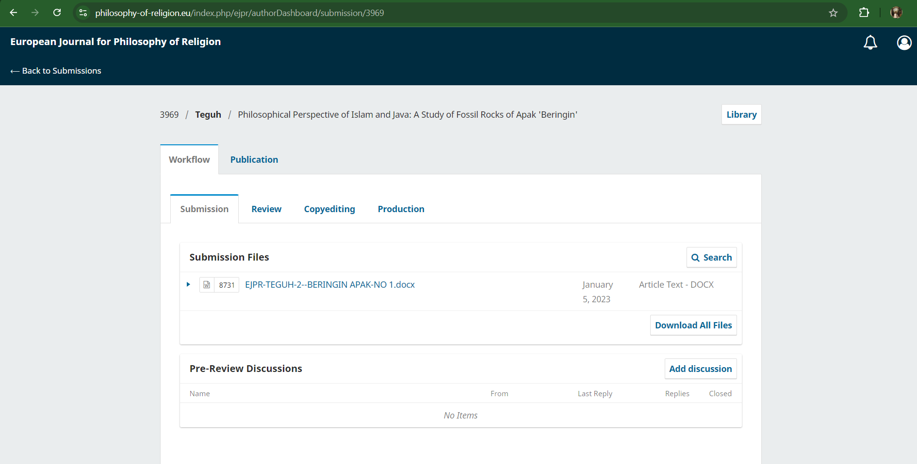

**Philosophical Perspective of Islam and Java:**  **A Study of Fossil Rocks of** ***Apak*** **'Beringin'**

**ABSTRACT**

This study aims to investigate the perspective of Javanese Islamic philosophy on the Apak 'Beringin' rock fossil and its impact on the level of spirituality and community behavior. This study uses a qualitative descriptive method with a phenomenological approach. Data analysis techniques were carried out using observation, interviews, and literature studies focusing on textual and contextual interpretations of the 'Beringin' Apak Fossil Rock. The main data sources come from the book of philosophy *otak-athik gathuk* (Javanese Islamic philosophical thought) by Damardjati Supadjar and the book of commentary as-Sulami by Imam Abu Abd. Muhammad bin Husayn as-Sulami. The findings reveal that in Javanese Islamic philosophy, the symbolization of the universe depicted in the form of fossilized rocks aims to train the soul in understanding the origin and purpose of everything in the universe or known as *'sangkan paraning damadi'*. This is a manifestation of the Javanese Muslim community's way of knowing God or what is known as divine awareness ‘*ilahiyah*’. In the rock fossils that have been found, there are lafadz Allah and lafadz Muhammad considered by the Javanese as a natural permit that is only obtained by people who reach certain *maqam*. The conclusion is that based on the elaboration of the meaning of the natural text which is symbolized in the form of the 'Beringin' Fossil rock, it is a reflection of oneself to always be close to Allah SWT.

**Keywords:** Islamic Philosophy**,** Javanese Islamic Philosophy, Fossil Rocks Musty 'Beringin'

**Introduction**

For millions of years, humans have been in the universe for a long time. Without ruling out the existence of human history shows that our ancestors actually left many relics. These historical relics can be in the form of statues, artifacts, temples, ancient objects, writings, even fossils, and so on (Bowler, 2020). Talking about historical relics in the form of fossils can be interpreted as objects of natural history that have a wide and varied scope. Where fossils can also be formed naturally by nature, it cannot be denied that this event was also accompanied by the power and will of God. Such is the self-disclosure of God in human history. Therefore, the formation of fossils by nature is difficult to naturalize by human reason (Rudwick, 2021).

The development of the Islamic view of God and the universe took about two centuries (Cotesta, 2021). According to Nakissa (2020), based on the cognitive science of religion and Islamic theology by al Ghazali, the main focus is on the oneness of God as the main cause that brings the universe into existence, some knowledge of God independently of the scriptures through human nature (*fitrah*) and reason, and the God of benefit and harm who rewards, punishes, tests, and blesses mankind. In Islamic studies, humans always want to understand and research the mysteries of nature that encourage the search for identity (Lafrarchi, 2020). This has led to the emergence of Muslim scholars' religious thoughts about the concept of God and its relationship with the universe. For example, in the literature that presents the Qur'an as a source of knowledge in the perspective of the science of *munasabah* which is able to motivate Muslims to explore the miracles of the Qur'an. Based on the perspective of *isyari* interpretation, the Qur'an views objects that have natural elements as symbols of the universe that are oriented towards depicting Allah's creation in the context of realizing human nature (Prakoso, 2019). This *isyari* interpretation grows from the experience of understanding God's creation in the form of a symbol of the universe (*ma siwallah*) which consists of parts or series of universal natural structures, including the ocean (*bahr*), sun (*syams*), moon (*qamar*), and land ( *bar*) (Septiawadi, 2019). Other research explores the concept of God and the symbolization of the universe with a religious text approach using Islamic astronomy (*al-falaq*) as the key (Safiai et al., 2016), Said Nursi's approach which reflects the signs of the universe to contemplate the greatness of Allah (Fatimah et al., 2021), and the Islamic worldview, the universe with its beauty and order as a manifestation and power of God (Zeren, 2018).

In Indonesia, there is a mixing of Javanese culture and Islam into Javanese Islam or better known as *Kejawen* Islam, viewing fossils as such, namely not only as historical objects but also Islamic spiritual objects which have a meaning about the universe as a manifestation of the oneness of God. The fossil itself is proof of a natural diploma or *ageman* for the Javanese Islamic community, so not everyone can have or interpret it (Putro, et. al., 2021). One of those who study fossils from the perspective of Javanese Islam is the Apak 'Beringin' fossil. Several researchers who have discussed this tree are (Wardoyo & Sulaeman (2017) studied the banyan tree as a symbol of the Yogyakarta palace. Beratha et al. (2018) studied the Function and Symbolic Meaning of the Banyan Tree (a symbol of Javanese culture) in Community Life. This is different from the results of the following researchers who studied banal trees from a scientific point of view (scientific content of trees) and tree physics, namely *Suaibatul*. Aslamiah & Haryadi (2013) who studied by identifying the chemical content of banyan tree leaves (*Ficus Benyamina L*.) as traditional medicine. Dahlan (2014) studied the physical characteristics of the banyan tree and its effect on the microclimate (a case study in urban forests and green open space in the city.

The various study backgrounds, making the focus points of the discussion different, the possibility of giving rise to a religious perspective. Therefore, this study is important to deepen knowledge about the concept of God and its relationship to the universe which is symbolized by the Javanese Islamic community in the form of the Apak 'Beringin' fossil. This research shows the novelty that the Apak 'Beringin' fossil is one of the ways for humans to understand the oneness of God and the universe from an Islamic philosophical point of view. In contrast to other research on the Apak fossil, 'Beringin' according to the philosophy of the Javanese people, especially the Yogyakarta Palace, has the meaning of *bering hak pengayoman*, justice, and eternal nature which also relies on *'manunggaling kawula Gusti'* (union of man with his God' or the union of the people with their leader'. dangling from top to bottom (ground) that humans must always remember where they came from (Jogjaprov, 2020). Another study is about *Ronggowarsito's* Javanese Islamic thought in *Serat Sabdajati* which teaches about the values ​​of *Aqidah* and *Akhalaq* that can radiate within humans and throughout the universe (Fauziyyah, 2018).

A previous study conducted by Peebles (2020) recommended further research so that humans can understand the universe correctly so that there are no errors in understanding the meaning contained in it. Based on the studies above, specifically that research on fossils as verse a lam in the perspective of Islam and Java has never been done. Therefore, this study focuses on fossils as verses of nature or as a sign of God's greatness. Where indeed the universe that was created on this earth is as evidence or an indication that only God has the right to be worshiped. In this study, the Islamic philosophical text approach is used to understand the element of the 'banyan' tree as the philosophy of Javanese society. The purpose of this study is to examine how Islam interprets the existence of stone fossils inscribed with the words Allah and Muhammad, then how the Javanese interpret these fossils, whether there is a harmony of understanding between Islam and Java.

**Research Questions**

1) What universal symbols are represented in philosophy of Islamic Java in the fossil rock of Apak beringin?

2) How are philosophical values present in the 'Beringin' Fossil Rocks in the Perspective of Javanese Islamic Philosophy?

**Methods**

The approach in this paper uses a phenomenological-qualitative approach referring to the theory of Donalek (2004) because the data produced is descriptive data in the form of written statements or words derived from books and data sources that are observed or studied. To conduct this research, the author uses Literature Studies that are relevant to the object under study. Sources of data in this paper are primary and secondary data. The primary data in this writing is the result of interviews or interviews with several sources who are natives of Java. While secondary data in this writing is in the form of written data sources such as books, journals, articles, and so on. From these two sources, the researchers found a connection and harmony of meaning so that it would produce the same understanding result.

The approach used for reading the verses of nature from an Islamic perspective is a Sufi-based approach. In other words, for the users of this approach, argue that the Qur'an actually has two levels of meaning, namely the outer meaning and the inner meaning. The meaning of Birth is the meaning of freedom which is spoken by the commentators in general, while the inner meaning is the hidden message behind the words. This inner meaning is special, which can only be grasped through revelation (Kashif) experienced by those who have reached a certain level until Allah gives intuitive knowledge. Just as Islam interprets the verses of nature using the interpretive approach in the Qur'an, so does Java. The interpretation of the verses of nature in Java can only be done by certain people, namely those who have reached the highest level.

**Results and Discussion**

**Symbolic Universal of Bringin Apak in the Perspective of Islamic Philosophy**

The findings reveal that fossils in the perspective of Islamic philosophy are a form of symbolizing the universe that is oriented towards depicting the means by which God introduces Himself to humans. Humans must use their minds to analyze, examine the universe created by God. This finding refers to the verses of the Koran which is the holy city of Muslims in which it discusses various affairs of the world and the hereafter so that it is very comprehensive in discussing the universe. The verses of the Qur'an about the symbolization of the universe used are those interpreted by Sufism experts and Islamic philosophies. Reflecting on the history of Islam when the Prophet Muhammad visited the cave of Hiro, it also shows that stones are one of God's media in giving lessons to His creatures, especially humans. Because by visiting the cave (in a not too short time which is about 11 years) the Prophet finally got a revelation from Allah SWT. The symbolization of the universe is also a creation of God that has extraordinary resilience, that's why the legacy (in the form of a cave-shaped house) of the Prophet still exists today. In the interpretation of *isyari*, the Qur'an views objects that have natural elements as symbols of the universe that are oriented towards depicting Allah's creation in the context of realizing human nature (Prakoso, 2019). This is the reason the researchers say that fossils are essentially a symbolic form of the universe (*ma siwallah*) which consists of parts or series of universal natural structures. If examined based on the concept of God and the symbolism of the universe with the religious text approach of Said Nursi's approach, fossils reflect signs of the universe to contemplate the greatness of God with its beauty and order as a manifestation and power of God (Fatimah et al., 2021; Zeren, 2018). The interpretation of natural verses in the form of fossils as Allah explains His power in Yasin's letter which reads:

ا ا ادَ ا لَ لَهُ (٨٢)

“*He commands when he wants something. He just said to her: "Be!" So be it. (Q.S. Yasin verse 82)*

Quoting Qatadah's account of the interpretation of verse 82, al-Thabari explained that this verse is a form of embodiment of evidence of God's power. for the people of Mecca at that time. More deeply, the term nature has similarities to ilm in Arabic which also shows that there is a close relationship with the concept of knowledge with the obligation to explore the universe (Ali, 2012). The choice of *lafadz 'kun'* is in accordance with the context of Arab society who uses the word to express something that is considered easy. Fakhruddin al-Razi argues that the use of parables about Allah's creation. Lafaz 'kun' in verse 82 indicates that the Qur'an corresponds to the intellectual level of the Meccan polytheists, who were not yet capable of understanding non-empirical knowledge. The Meccan polytheists at that time thought that the creation process had to use sensory tools or intermediaries, and were closely related to time and place. Allah, according to al-Razi, does not go into time or place (Mustofa, 2015).

*“And indeed, We have glorified Adam's posterity, and We have transported them on land and at sea, and We have given them sustenance from the good and We have made them above the many creatures that We have created with perfect advantage.”* (Al-Isra': 70). According to the tafsir of Al-Muyassar/ The Ministry of Religious Affairs of Saudi Arabia, it also gives a similar understanding: "And part of Allah's mercy for His servants is to glorify them, "*Truly We have glorified the descendants of Adam, and We have subservied them the animals of the land and the ships of the sea so that they may ride and transport the goods they possess. And We have given them halal and delicious food and drink. And We have exaggerated them from many other creatures with great advantages*.”

From this verse, it is clear that God created man with glory and advantages that are so abundant. In addition, God has also created man with the most perfect physical and non-physical (Q.S at-Tin: 4-6). Not only the five senses are perfect, but also the heart that serves to weigh and make decisions (Q.S. an-Nahl: 78). All the glory and advantages of this man, in accordance with his duties on earth, namely as caliph (Q.S. al-Baqarah: 30). So we should use all of God's grace to continue to learn about many things, especially to draw closer to Him. One of them is by getting to know the environment and the objects in our environment. As God taught Adam directly, it signifies that we are also capable of direct contact with God because there is a *Godly spirit* within us.

لَّمَ الْأَسْمَاءَ لَّهَا لَى الْمَلَائِكَةِ الَ اءِ لَاءِ ادِقِينَ (٣١)

*“And He taught Adam the names of all of them, and He showed them to the angels, saying, "Tell me the names of all these things, if you are truthful!*.” (QS al-Baqarah: 31)

From the interpretations obtained from many commentators, there is sufficient evidence to show that humans are the most noble creatures with various gifts from God. Even the first humans were taught directly by God, so there is no such thing as impossible for anyone who wants to have a direct relationship with God. In fact, what can be directly related to God is the human spirit, where by His power humans are given a lot of knowledge about God's secrets when they have reached the highest level of proverb. In another maximal concept, there is an understanding that the relationship between the quality of the results of self-understanding is very close to the depth of our understanding of Allah SWT. Imam Al-Ghazali's term is *man 'arafa nafsahu 'arafa rabbahu* (whoever is able to understand himself will be able to understand his own common sense then he is able to understand the truth of his Lord) (Sudan, 2017). So indirectly, as humans, we should start trying to understand who we really are until we are given a great gift. In fact, we get the task of being a caliph on earth, which shows how capable we are to rule, manage, and guard the entire earth. Another plus is the reason that God gave is also a means for us to think. Be sensitive to what God has given us in our lives, including all of His creation, even inanimate objects. With all the guidance that Allah has given, through the Apostles or Prophets, the sahabiyat, Tabi'in, to the saints and also the Sunans in Java, we must be able to lead us to our essence as God's creatures.

ادَمَ لَىٰٓ لَسْتُ الُوا۟ لَىٰ لُوا۟ لْقِيَٰمَةِ ا ا ا لِينَ

And remember, O Messenger of Allah and people of understanding, when Allah brought out from the tribes of the Bani Adam their descendants and made them children from generation to generation; and when Allah brought them out of the belly of their mother and the bones of their father; Then God made them his Lord by making it in their nature that He was their Lord, Creator and Ruler. He said, "Am I not your Lord, Sovereign, and Sovereign?" They replied: "Yes, we testify to ourselves with confidence and pleasure that you are our Lord and Creator, there is no God but you. Because of your grace and strength, we promise this testimony." Allah mentions the reason for this testimony, so that they do not say on the Day of Resurrection as a reason for self-determination: "We were negligent and did not know your oneness and divinity.

ا۟ لْعَهْدِ لْعَهْدَ انَ لًا

*““...... and keep the promise; Surely the promise must be answered." (Q.S. al-Isra': 34) And fulfill the covenant that prevails between you and Allah, or between you and His other servants without undoing or neglecting them, for on the Day of Resurrection Allah will surely ask those who make covenants; Does he keep it so that he may reward him, or neglect it so that he may punish him*?.”

ا لْنَا لذِّكْرَ ا لَهُۥ لَحَٰفِظُونَ

*"* *We have sent down the Qur'an, and We have kept it."* (QS al-Hijr: 9)

To prove the truth of the prophet Muhammad's confession that the verses he delivered really came from Allah, he said, we are the ones who sent down the Qur'an through the intercession of the angel gabriel which the disbelievers doubted, and surely we are also with the angel gabriel and the believers who always maintain His authenticity, holiness, and eternity until the end of time. The falsehood experienced by the prophet Muhammad also happened to the previous apostles. Allah declared, and indeed, we have sent several apostles before we sent you, O prophet Muhammad. We have sent them to the ancient people. (Hidayatul Insan bi Tafsiril Qur'an/Ustadz Marwan Hadidi bin Musa, M.Pd.I). Examined from previous studies, Nakissa (2020) reveals al Ghazali's work on the oneness of God as the main cause that brought the universe into existence. Thus, it is clear that the symbolism of the universe in the form of fossils is the oneness of God which is intended to bring benefits, have wisdom, and bless mankind. Therefore, it is very important to learn about the symbolization of the universe to get closer to Him. This can also contribute to building *'baldatun tayyibatun wa rabbun ghafur*'. Because in essence humans always want to understand and research the mysteries of nature which encourage the search for identity and are expected to treat nature fairly.

**'Beringin' Fossil Rocks in the Perspective of Javanese Islamic Philosophy**

The second finding reveals that the Apak 'Beringin' fossil is not only a historical object but also an Islamic spiritual object which means about the universe as a manifestation of the oneness of God. Ringin Apak plant elements then harden and petrify due to natural processes and time that God wants. The Javanese interpret it as wewaton (*tetenger*). In Indonesia, *wewaton* is defined as a sign or benchmark. In Islam, we have *hijr aswad* and *hijr ismail*. This shows that the meaning of the Javanese language is correct and in accordance with or in harmony with Islam. Because this *aswad* punishment is the benchmark or sign or center of worship for Muslims in performing prayers. This is why fossils are evidence of a natural certificate or ageman for the Javanese Islamic community (Putro et al., 2021). The next interesting thing is the fossil element, namely the banin tree. This plant with the Latin name *Ficus benjamina .L* has different names in each region. The Sunda area is called "*caringin*", the Javanese call it "banyan" and for the Malays it is known as "*waringin*". This tree can grow to about 20-25m and on its upright trunk grows blackish brown hanging roots. The Javanese interpret the *bann* tree as a true symbol of worship (Aslamiah & Haryadi, 2013).

Javanese people have used the Apak 'Beringin' fossil as a *wewaton* or a cultural symbol of the palace or kingdom (Beratha et al., 2018; Wardoyo & Sulaeman, 2017). The leaves are oval in shape with a length of 3-6cm and a width of 2-4cm, able to grow thickly blocking the sunlight to get to the ground. A tree that is indeed large and can be said to be shady or shady can finally shade, protect, and most importantly protect anyone under it. Banin tree is also a tough plant that holds extraordinary water, even its vines can also store clear water (in an instant if we split it will release drinkable water). In addition, it is also a hope for the kingdom to plant banal trees at its entrance (Putro et al., 2021). One of those who study fossils from the perspective of Javanese Islam is the Apak 'Beringin' fossil. Sukiman (2020) explains in his book that God is *Kuwaos* without tools, so he concludes that the way back to God is also without tools. So when seeking knowledge or knowledge directly from Allah, *tan punya kinaya ngapa* (cannot be explained by anything) and learns without equipment (without using tools). Except by *manunggaling kawula Gusti*. In addition, according to Sufi-Javanese, a deep understanding of the true reality of selflessness. All the physical features that are called "existent" must begin to be understood and realized constantly as "non-existent." What does not exist is actually a creature, because he created God from nothing to be "presumed" to exist (Haq, 2013).

In Javanese terms, interpreting and studying the symbolization of the universe is called "Ngelmu", then in Indonesian it is called "science". The word "*ngelmu*" is an abbreviation of two syllables, namely *ngel* from the word angel (difficult, difficult, etc.). Whereas you come from the word *tine* (difficult to understand or difficult to know). In conclusion, *ngel kamu* for Javanese people is your angel, which in Indonesian is defined as something that is difficult to understand or know. *Ngelmu* means "secret teaching of the grip of life". In the view of Islam called Sufism is a way to seek and unite with God, in Javanese teachings it is called *Suluk*. The meaning of the words science and knowledge in the perspective of Islam and Java, has a difference. In contrast to the word science which comes from the Arabic 'alima, which means knowledge (Soesilo, 2000). From this meaning, it shows that science is the knowledge that is both systematic and structured based on a certain methodology using reason or logic. While Ngelmu can be known based on the five senses and personal imagination, not brain activity or thought. To gain knowledge as it is done in Javanese, Islam must be able to pass through four stages of the human journey to the perfection of life.

In order to gain knowledge in understanding the fossil of Apak 'Beringin, one also goes through a stage of the journey called full-fledged *ngelmu*. In Javanese philosophy, perhaps we will find the term *ngudi kasampurnan* where God is the absolute goal for humans. The first is the stage of physical worship (body exercises) to increase faith, *dumunung ing eneng*. Faith, indecisiveness: kuwasa. It means believing in the nature (power) of the Almighty. Second, Worship of the Heart *(lakuning ati).* The place for this level is called tokid, dumunung ana ing ening. *Tokid, muhung sawiji, resigned, marang iradat: karsa*. It means to unite, surrender to all forms of God's will or provisions. Third, spiritual worship (practice of life). The place for this level is called *Makrifat, dumunung ana ing awas. Makrifat, waskita ing ngelmu anguningani dununing Dat, Sifat, Asmaa,* and *Af'al*. Has the meaning of knowing knowledge, will put *Substances, Attributes, Asthma, Af'al*. Fourth, worship of taste (taste training). The place for this level is called Islam, *dumunung ana ing eling. Islam, slamet hayate, urip, dumunung ana ing sifat jalal, agung; jamal; Cantik; kahar; bijaksana; kamal*. Based on the values ​​contained in the Javanese philosophy *'Serat Wirid Hidayat Jatii*, the ultimate goal of worship is to return to God or oneness and become "*waskitaing sampurnaning sangkan paran*" which means knowing the beginning of life. The path to God is detailed with the application of the means of *Makrifat* Science, the means of upholding the Divine Essence, the path to true death (*kasidan jati*), through moral practice and meditation (*manekung*) (Ciptoprawiro, 2000).

The existence of these four phases does not mean that it is impossible for every human being to be able to do it. Because Allah has even explained in the Qur'an that humans were created with the best possible conditions and given many advantages. So that every human being can certainly be willing to be perfect, and make God an absolute goal for himself. Increasing faith in the presence of these fossils is also a part of order (*lakuning ati*) and nature (practiceoflife), because seeing their findings and interpretations will be one of the reasons we believe in the power of God. As Allah explains in QS al-Jatsiyah verse 3, which explains that the creation of all that is in the heavens and on earth (there are signs of Allah's power and oneness) for those who believe. So, by looking at God's evidence. For the Javanese people, doing these four levels is a form of *Kasampurnan* Science. Where prayer aims to establish a relationship with the essence of God (Soesilo, 2000). So in this phase we will not find the word "impossible", if someone who has reached this level is given your title by God. As Allah showed His greatness when He revealed Surah Al-Alaq verses 1-5 to Prophet Muhammad (SAW).

اقْرَأْ اسْمِ الَّذِي لَقَ ( ) لَقَ الْإِنْسَانَ لَقٍ (٢) اقْرَأْ الْأَكْرَمُ (٣) الَّذِي لَّمَ الْقَلَمِ (٤) لَّمَ الْإِنْسَانَ ا لَمْ لَمْ (٥)

*“Read by the name of your God Who Created, He created man from a lump of blood. Read, and it is your Merciful Lord who teaches by the way of kalam, He teaches man what he does not know.”*

Without ruling out the importance of learning from the letter, we can draw another conclusion, that God actually teaches what is unknown to man (Qutub, 2011: 1342). So that all the facilities and infrastructure that we have or get are actually only intermediaries.

The discovery of the rock fossils of the 'Beringin' Apak shaped like a bull riding animal in this study, similar to the ride of a character named Ang in the cartoon titled "avatar". (See Figure 1).

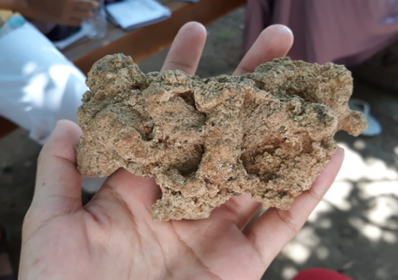

Figure 1. Fossil shaped one-horned rhino or tiger with a crown

From Figure 1, the discovery of this bull-like animal form is the result of the existence of Javanese completeness, so that this animal is shown as a physical embodiment of rock fossils. Animals with six legs are a symbol of the pillars of faith in Islam. Although this animal with the name "*Appa*" does not have wings but can fly high, it shows us the nature of faith. The achievement of perfect faith is when we can truly believe in the six pillars of faith, so that nothing is impossible to be granted by God. The request of his faithful servant. This fossil written with lafadz was found in Tulungagung Regency, precisely in Glotan Village, Campurdarat District.

The Javanese Islamic community believes that there are other types of bodies that will not be damaged if the word (died) is in a fossil. The body is none other than the plant body, which is capable of creating fossils from any part of the plant body by the Power of God. In the land of Java, there are three types or types of fossils that have various forms according to the level of the recipient of the fossil and the will of God. First*, Ghana* fossils formed from the core part of the plant body called "galih", which would later create "*Ghana*". For Javanese people who can already read nature, this type of fossil can no longer find cafatan (original nature) from the plant that formed it. So that it can only be interpreted based on the shape or appearance of the material. Second, Mestika Fossils are formed from outside the body of plants, but in fact can also be formed from animal parts; water and so on. Examples are pomegranate red mustika which comes from petrified (crystallized) pomegranate seeds and pearl mustika from shells. Third, Ghana Mustika which is more special because it is formed from a combination of Ghana and Mustika. Example: benthic, comes from the benthic tree in the form of benthic fruit. (See Figure 2).

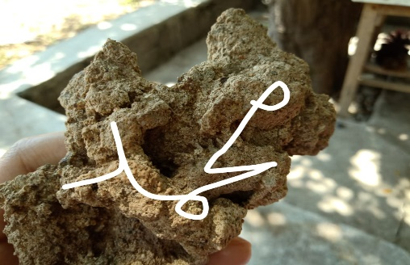 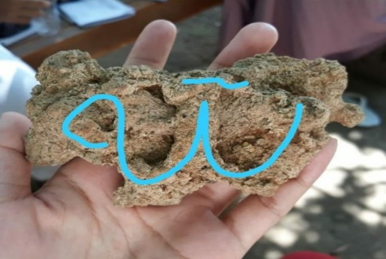

Figure 2. The discovery of the words of Allah and Muhammad in fossils)

In Figure 2, regarding Allah's *lafadz* will still show the same and similar principle that is Allah SWT. It starts from eliminating "ا" so that only lafadz (لله) remains, which reads "... *lillaahi*  *maa*  *fissamaawaati*  *wal*  *ardh...* "It means "The possession of God is all that is in heaven and what is on earth." Next, we remove one more letter to (له) so that it reads, *"lahu*  *maa*  *fissamaawaati*  *wal*  *ardh"* has almost the same meaning that is "his" What is in heaven and on earth." Then, when there is one letter left, it is actually an abbreviation of the word(هو). Because when we read the word (هو) waqaf then the letter (و)is not read so that all that is read is a letter (ه). This is Q.S. al-Baqarah verse 255 which reads (ٱللَّهُ لَآ إِلَٰلَ إِلَّا لُوَ ٱلْحَىُّ ٱلْقَيُّومُ. .. then allahu  *laa*  *ilaha*  *illahu* (there is no God but Allah), only if we will continue then it must reappear "هو" so it reads  *hual*  *hayyul*  *qayyumu* which means "Heis the One who lives". When all the letters are removed, there will be nothing. Everything that is invisible is called the unseen. Therefore, Allah has explained in Q.S. al-Baqarah verse 3 which reads *"alladzinayu'minunabil*  *ghaib",*and "ghaib" here still shows to the same dzat that Allah swt . If we compare it with any word and in anylanguage, there will be no match for the meaning of Allah's asthma. From its name alone there is already such a great miracle, how will we refuse not to acknowledge and believe that He is god who deserves to be worshipped. Furthermore, the description of the greatness of God is also listed in the next verse in surat al-Ikhlas.

Next is the description of *lafadz* Muhammad, the creature most loved by Allah. Before the creation of man*(al-Man),*Allah had created NurMuhammad.  As the concept in the book of Barzanji about  *Nur Muhammad,*  shows the glory of the Prophet who became the closing for the prophets and messengers.

لي لم لى النور الموصوف التقدم الأوليه

Literally the phrase means "I say shalawat and greetings for the light that is earlier and early"(al-Barzanji, 4). In the midst of various polemics about the concept of Nur *Muhammad,*  some scholars one of them is nusantara ulama, Sheikh Muhammad Nawawi Banten actually responded simply. The scholar, who is even recognized by middle eastern scholars, said that this shalawat actually just wants to convey that his fellow Nur *Muhammad* was the first creature created before Allah created other creatures. Sheikh M. Nawawi Banten also conveyed about a hadith of Jabir history which became one of the basic concepts of Nur *Muhammad.*

"As it is in the hadith of the narration of the companions of Jabir RA that when asked about the first creature created by Allah, the Prophet replied, 'Indeed, Allah created your Prophet Nur before all things'. God *made* it work by The Power of God according to His will. There was no sea, no sea, heaven, hell, angels, man, jinn, earth, sky, sun, and moon. On this basis, *it* is a substance, not an axiden." (Nawawi, 4)

The discovery of the two *lafadz* that Allah and Muhammad have an ultimate harmony and bond, both of which show the greatness of Allah regarding the creation of beings. So the fossil object that has both  *lafadz,* Namely Allah and Muhammad, is believed to have great power or power. Despite its immense power, only certain people can feel and use it. The Javanese who have a natural ijasah are also not without reason, but they have indeed reached the highest level in *the science of kasampurnan,* namely ma'rifat. Where they get the grace to know God better, the beauty of God, even secrets about things related to Godhood.

Suparlan (1996) tried to view the relationship between makrifat and unity as the "most original perspective" of the Javanese. Which there is a fundamental and very important fact that it turns out that the Javanese are not actually ancestors or inanimate objects (animism-dynamism), but they tend to have a main principle called awareness of *sankan paraning dumadi* (the historicality of creation) that questions about where man came from, who he really is, and where the purpose of life is lived. So that the discovery of this stone can be easily interpreted by the chosen people who are native Javanese. The Javanese are also seen as more universal in looking at things, as evidenced by the belief that fossils come not only from humans but also from other creations of God. It is mentioned that there are three fossils, namely  *ghana, mustika,*  and ghana *mustika.* The three types of fossils also show the level of maqam of people who receive ijasah, and provide an understanding of what advantages the recipient has.

The concept of seeking knowledge in Javanese Islamic philosophy is actually a unity and has the same spiritual meaning. Islam calls it a sharia order, order, fitrah and maxim. While the Javanese call it physical worship (badanlakuning), heart worship (lakuning ati), spiritual worship (life practice), and taste worship (rasalakuning). After studying the four stations more deeply, we will find that this whole phase is not a level but an order. So that to achieve the perfect knowledge, every human being must be able to go through the four phases that have been mentioned so that true belief (faith) will arise. Because after arriving at the maximal phase or the practice of feeling, we will get the reasons for our true beliefs. Therefore, the Javanese have the privilege of having a deep taste for anything. A deep understanding of nature is a means of knowing God. So don't be surprised if this kind of fossil discovery can be found easily in Java. In Islamic teachings, there are even many things that are similar to what is understood by the Javanese, although in different terms, they actually have a harmonious understanding. This finding has revealed the novelty of fossils as a symbol of the universe and the concept of God using an Islamic philosophical approach. This is different from previous research which studied the concept of God and the universe using *Ronggowarsito's* Javanese Islamic thought in *Sabdajati* Fiber which teaches about the values ​​of Aqidah and Akhalaq that can radiate within humans and the entire universe (Fauziyyah, 2018). In the end, as humans who were created as noble beings, we must be able to use this discovery as a means to strengthen our faith and belief in God. With extraordinary strengths and capacities, of course, all humans have the same opportunity to know more about their God, as well as find the reasons for their faith.

**Conclusion**

In summary, Javanese Islamic philosophy uses symbolization of the universe in this study is represented in the form of fossilized rocks. It symbolizes the soul to see the origin and purpose of the life that is as *'sangkan paraning damadi'* from and where the soul goes. This is a manifestation of the Javanese Muslim community's way of knowing God or what is known as divine awareness ‘*ilahiyah*’. In the rock fossils there are letters of Allah and Muhammad stating a natural permit for man having high level of religiosity or *maqam*. The elaboration of the meaning of the natural text which is symbolized in the form of the 'Beringin' Fossil rock, reflects one who is closed to Allah SWT.

**References**

Ali, M. (2012). Creation of the Universe By Al-Qur’an Analysis of QS. Al-Anbiya: 30 and Its Relevance to the Theory of Science. *Madania*, *2*(2), 167–184.

Aslamiah, S., & Haryadi, H. (2013). Identifikasi Kandungan Kimia Daun Pohon Beringin (Ficus Benyamina L.) sebagai Obat Tradisional. *Jurnal Anterior*, *13*(1), 19–23. Retrieved from http://www.eldis.org/vfile/upload/1/document/0708/DOC23587.pdf%0Ahttp://socserv2.socsci.mcmaster.ca/~econ/ugcm/3ll3/michels/polipart.pdf%0Ahttps://www.theatlantic.com/magazine/archive/1994/02/the-coming-anarchy/304670/%0Ahttps://scholar.google.it/scholar?

Beratha, N. L. S., Rajeg, I. M., & Sukarini, N. W. (2018). Fungsi dan Makna Simbolik Pohon Beringin dalam Kehidupan Masyarakat Bali. *J. Kaji. Bali*, *8*, 33–52.

Bowler, P. J. (2020). The Pre-evolutionary Worldview. In *Evolution* (pp. 27–47). California: University of California Press.

Ciptoprawiro, A. (2000). *Filsafat Jawa*. Jakarta: PT. Aula Perpustakaan.

Cotesta, V. (2021). God , the Universe and the World According to Islam. In *The Heavens and the Earth: Graeco-Roman, Ancient Chinese, and Mediaeval Islamic Images of the World* (pp. 310–315). United Kingdom: Brill. https://doi.org/https://doi.org/10.1163/9789004464728_027

Dahlan, E. N. (2014). Karakter Fisik Pohon dan Pengaruhnya terhadap Iklim Mikro (Studi Kasus di Hutan Kota dan RTH Kota Semarang). *Forum Geografi*, *28*(1), 83–90. Retrieved from https://publikasiilmiah.ums.ac.id/handle/11617/4792

Donalek, J. G. (2004). Phenomenology as Qualitative Resreach Method. *Urologic Nursing*, *24*(Desember), 516–517.

Fatimah, S., Tawil, M., & Akar, C. (2021). Exploring the Repository of Religious Texts to Explore the Universe: Risale-i Nur Approaches. *The Journal of Risale-i Nur Studies*, *4*(1), 28–39.

Fauziyyah, F. I. (2018). International Journal of Multicultural and Multireligious Understanding Ronggowarsit o ’ s Concept of Islamic Theosophy in Serat Sabdajati, 177–184.

Haq, Z. (2013). *Ajaran Penuntun Jiwa Jawa*. Sidorejo: Penciptaan Wacana.

Jogjaprov. (2020). Beringin: Mitos dan Filosofinya Bagi Masyarakat Jawa. *Jogjaprov.Go.Id*. Retrieved from http://kehati.jogjaprov.go.id/detailpost/beringin-mitos-dan-filosofinya-ba-masyarakat-jawa

Lafrarchi, N. (2020). Assessing Islamic Religious Education Curriculum in Flemish Public Secondary Schools. *REligions*, *11*(3), 110.

Mustofa, I. (2015). Kritik Fakhruddin al-Razi terhadap Emanasi Ibnu Sina. *Kalimah*, *13*(2), 311. https://doi.org/10.21111/klm.v13i2.291

Nakissa, A. (2020). The Cognitive Science of Religion and Islamic Theology: An Analysis Based on the Works of al-Ghazlī. *Journal of the American Academy of Religion*, *88*(4), 1087–1120. https://doi.org/10.1093/jaarel/lfaa059

Peebles, J. (2020). Have we got the universe right ? *New Scientist*, *246*(3285), 30–35. https://doi.org/10.1016/S0262-4079(20)31040-X

Prakoso, T. J. (2019). Theoretical Science in Munasabah Discurse: Discovering Mountain Facts in the Quran. *Journal of Islam and Science*, *6*(1), 41–49.

Putro, R. P., Rohmadi, M., & Rakhmawati, A. (2021). Islamic Religiusity In Serat Wedhatama Pupuh Gambuh. *IBDA: Jurnal Kajian Islam Dan Budaya*, *19*(2), 335–350.

Rudwick, M. J. (2021). Nature’s Own Antiquities. In *Earth’s Deep History* (pp. 31–54). Chicago, IL This: University of Chicago Press.

Safiai, M. H., Ibrahim, I. A., Islam, U., & Sharif, S. (2016). Islamic Perspectives on Science and Technology. *Islamic Perspectives on Science and Technology*, (January). https://doi.org/10.1007/978-981-287-778-9

Septiawadi, S. (2019). Simbolisasi Alam Semesta Dalam Ajaran Tasawuf (Perspektif Penafsiran Isyari). *Al-Dzikra: Jurnal Studi Ilmu Al-Qur’an Dan Al-Hadits*, *12*(2), 189–210. https://doi.org/10.24042/al-dzikra.v12i2.3894

Soesilo. (2000). *Sekilas Tentang Ajaran Kejawen*. Surabaya: PT. Kesaint Blanc Indah Corp.

Sudan, S. A. (2017). Principles of Islamic counseling and psychotherapy. *Asian Journal of Management Sciences & Education*, *6*(3), 129–138. Retrieved from http://irep.iium.edu.my/62402/

Sukiman, U. (2020). Neology of Arabic in Indonesia. *Jurnal Al Bayan: Jurnal Jurusan Pendidikan Bahasa Arab*, *12*(2), 357–376. https://doi.org/10.24042/albayan.v12i2.6071

Suparlan, P. (1996). *Kampung Jawa Tondano: Religion and Cultural Identity*. Yogyakarta: Gadjah Mada University Press.

Wardoyo, C., & Sulaeman, A. (2017). *Etnolinguistik pada Penamaan Nama-Nama Bangunan di Keraton Yogyakarta* (Vol. 14).

Zeren, M. E. (2018). Türklerde Budizm ve İslâm Tasavvuffunda Tanrı ve Evren Anlayışı. *Journal of Turkish Studies*, *13*(Volume 13 Issue 2), 127–144. https://doi.org/10.7827/turkishstudies.13007

1. **Bukti Konfirmasi dan Hasil Review Pertama (25 Januari 2023)**

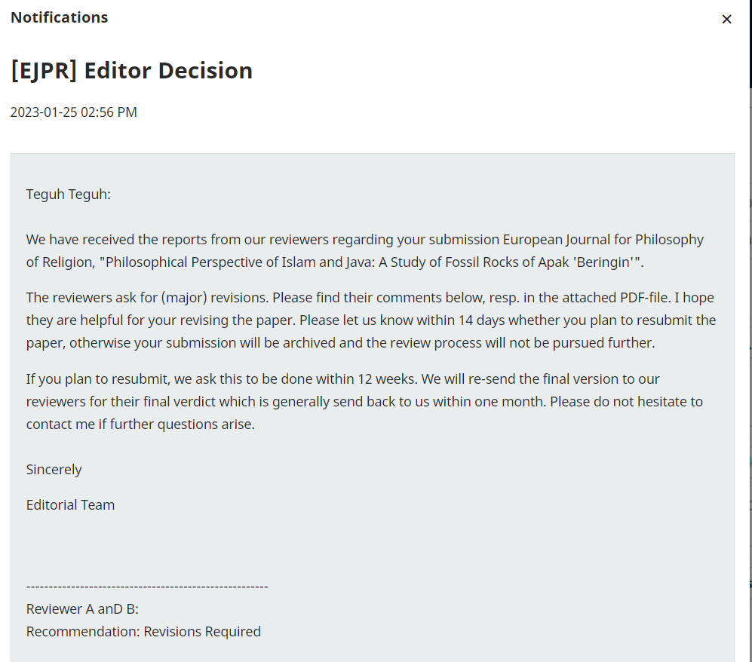

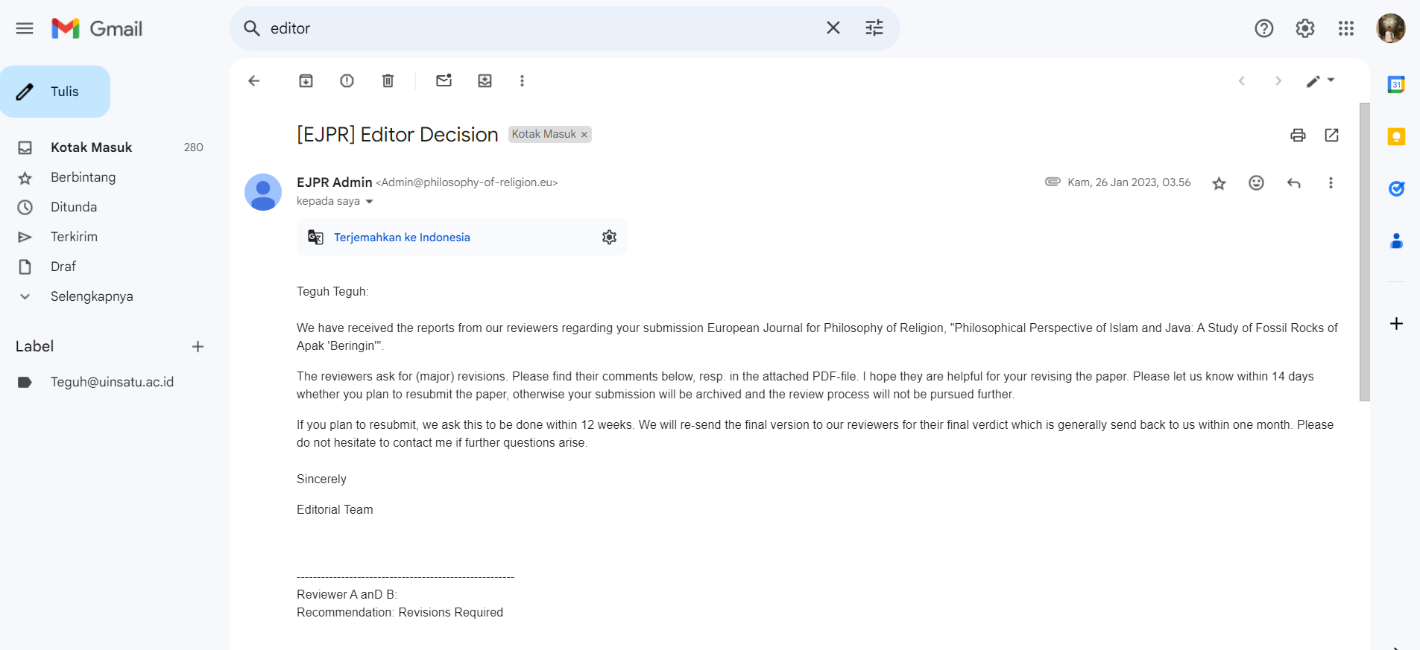

**Philosophical Perspective of Islam and Java:**  **A Study of Fossil Rocks of** ***Apak***  **'Beringin'**

**ABSTRACT**

This study aims to investigate the perspective of Javanese Islamic philosophy on the Apak 'Beringin' rock fossil and its impact on the level of spirituality and community behavior. This study uses a qualitative descriptive method with a phenomenological approach. Data analysis techniques were carried out using observation, interviews, and literature studies focusing on textual and contextual interpretations of the 'Beringin' Apak Fossil Rock. The main data sources come from the book of philosophy *otak-athik gathuk* (Javanese Islamic philosophical thought) by Damardjati Supadjar and the book of commentary as-Sulami by Imam Abu Abd. Muhammad bin Husayn as-Sulami. The findings reveal that in Javanese Islamic philosophy, the symbolization of the universe depicted in the form of fossilized rocks aims to train the soul in understanding the origin and purpose of everything in the universe or known as *'sangkan paraning damadi'*. This is a manifestation of the Javanese Muslim community's way of knowing God or what is known as divine awareness ‘*ilahiyah*’. In the rock fossils that have been found, there are words Allah and Muhammad considered by the Javanese as a natural permit that is only obtained by people who reach certain *maqam*. The conclusion is that based on the elaboration of the meaning of the natural text which is symbolized in the form of the 'Beringin' Fossil rock, it is a reflection of oneself to always be close to Allah SWT.

**Keywords:** Islamic Philosophy**,** Javanese Islamic Philosophy, Fossil Rocks Musty 'Beringin'

**Introduction**

For millions of years, humans have been in the universe for a long time. Without ruling out the existence of human history shows that our ancestors actually left many relics. These historical relics can be in the form of statues, artifacts, temples, ancient objects, writings, even fossils, and so on (Bowler, 2020). Talking about historical relics in the form of fossils can be interpreted as objects of natural history that have a wide and varied scope. Where fossils can also be formed naturally by nature, it cannot be denied that this event was also accompanied by the power and will of God. Such is the self-disclosure of God in human history. Therefore, the formation of fossils by nature is difficult to naturalize by human reason (Rudwick, 2021).

The development of the Islamic view of God and the universe took about two centuries (Cotesta, 2021). According to Nakissa (2020), based on the cognitive science of religion and Islamic theology by al Ghazali, the main focus is on the oneness of God as the main cause that brings the universe into existence, some knowledge of God independently of the scriptures through human nature (*fitrah*) and reason, and the God of benefit and harm who rewards, punishes, tests, and blesses mankind. In Islamic studies, humans always want to understand and research the mysteries of nature that encourage the search for identity (Lafrarchi, 2020). This has led to the emergence of Muslim scholars' religious thoughts about the concept of God and its relationship with the universe. For example, in the literature that presents the Qur'an as a source of knowledge in the perspective of the science of *munasabah* which is able to motivate Muslims to explore the miracles of the Qur'an. Based on the perspective of *isyari* interpretation, the Qur'an views objects that have natural elements as symbols of the universe that are oriented towards depicting Allah's creation in the context of realizing human nature (Prakoso, 2019). This *isyari* interpretation grows from the experience of understanding God's creation in the form of a symbol of the universe (*ma siwallah*) which consists of parts or series of universal natural structures, including the ocean (*bahr*), sun (*syams*), moon (*qamar*), and land ( *bar*) (Septiawadi, 2019). Other research explores the concept of God and the symbolization of the universe with a religious text approach using Islamic astronomy (*al-falaq*) as the key (Safiai et al., 2016), Said Nursi's approach which reflects the signs of the universe to contemplate the greatness of Allah (Fatimah et al., 2021), and the Islamic worldview, the universe with its beauty and order as a manifestation and power of God (Zeren, 2018).

In Indonesia, there is a mixing of Javanese culture and Islam into Javanese Islam or better known as *Kejawen* Islam, viewing fossils as such, namely not only as historical objects but also Islamic spiritual objects which have a meaning about the universe as a manifestation of the oneness of God. The fossil itself is proof of a natural diploma or *ageman* for the Javanese Islamic community, so not everyone can have or interpret it (Putro, et. al., 2021).

One of those who study fossils from the perspective of Javanese Islam is the Apak 'Beringin' fossil. Several researchers who have discussed this tree are (Wardoyo & Sulaeman (2017) studied the banyan tree as a symbol of the Yogyakarta palace. Beratha et al. (2018) studied the Function and Symbolic Meaning of the Banyan Tree (a symbol of Javanese culture) in Community Life. This is different from the results of the following researchers who studied banal trees from a scientific point of view (scientific content of trees) and tree physics, namely *Suaibatul*. Aslamiah & Haryadi (2013) who studied by identifying the chemical content of banyan tree leaves (*Ficus Benyamina L*.) as traditional medicine. Dahlan (2014) studied the physical characteristics of the banyan tree and its effect on the microclimate (a case study in urban forests and green open space in the city.

The various study backgrounds, making the focus points of the discussion different, the possibility of giving rise to a religious perspective. Therefore, this study is important to deepen knowledge about the concept of God and its relationship to the universe which is symbolized by the Javanese Islamic community in the form of the Apak 'Beringin' fossil. This research shows the novelty that the Apak 'Beringin' fossil is one of the ways for humans to understand the oneness of God and the universe from an Islamic philosophical point of view. In contrast to other research on the Apak fossil, 'Beringin' according to the philosophy of the Javanese people, especially the Yogyakarta Palace, has the meaning of *bering hak pengayoman*, justice, and eternal nature which also relies on *'manunggaling kawula Gusti'* (union of man with his God' or the union of the people with their leader'. dangling from top to bottom (ground) that humans must always remember where they came from (Jogjaprov, 2020). Another study is about *Ronggowarsito's* Javanese Islamic thought in *Serat Sabdajati* which teaches about the values ​​of *Aqidah* and *Akhalaq* that can radiate within humans and throughout the universe (Fauziyyah, 2018).

A previous study conducted by Peebles (2020) recommended further research so that humans can understand the universe correctly so that there are no errors in understanding the meaning contained in it. Based on the studies above, specifically that research on fossils as verse a lam in the perspective of Islam and Java has never been done. Therefore, this study focuses on fossils as verses of nature or as a sign of God's greatness. Where indeed the universe that was created on this earth is as evidence or an indication that only God has the right to be worshiped. In this study, the Islamic philosophical text approach is used to understand the element of the 'banyan' tree as the philosophy of Javanese society. The purpose of this study is to examine how Islam interprets the existence of stone fossils inscribed with the words Allah and Muhammad, then how the Javanese interpret these fossils, whether there is a harmony of understanding between Islam and Java.

**Research Questions**

1) What universal symbols are represented in philosophy of Islamic Java in the fossil rock of Apak beringin?

2) How are philosophical values present in the 'Beringin' Fossil Rocks in the Perspective of Javanese Islamic Philosophy?

**Methods**

The approach in this paper uses a phenomenological-qualitative approach referring to the theory of Donalek (2004) because the data produced is descriptive data in the form of written statements or words derived from books and data sources that are observed or studied. To conduct this research, the author uses Literature Studies that are relevant to the object under study. Sources of data in this paper are primary and secondary data. The primary data in this writing is the result of interviews or interviews with several sources who are natives of Java. While secondary data in this writing is in the form of written data sources such as books, journals, articles, and so on. From these two sources, the researchers found a connection and harmony of meaning so that it would produce the same understanding result.

The approach used for reading the verses of nature from an Islamic perspective is a Sufi-based approach. In other words, for the users of this approach, argue that the Qur'an actually has two levels of meaning, namely the outer meaning and the inner meaning. The meaning of Birth is the meaning of freedom which is spoken by the commentators in general, while the inner meaning is the hidden message behind the words. This inner meaning is special, which can only be grasped through revelation (Kashif) experienced by those who have reached a certain level until Allah gives intuitive knowledge. Just as Islam interprets the verses of nature using the interpretive approach in the Qur'an, so does Java. The interpretation of the verses of nature in Java can only be done by certain people, namely those who have reached the highest level.

**Results and Discussion**

**Symbolic Universal of Bringin Apak in the Perspective of Islamic Philosophy**

The findings reveal that fossils in the perspective of Islamic philosophy are a form of symbolizing the universe that is oriented towards depicting the means by which God introduces Himself to humans. Humans must use their minds to analyze, examine the universe created by God. This finding refers to the verses of the Koran which is the holy city of Muslims in which it discusses various affairs of the world and the hereafter so that it is very comprehensive in discussing the universe. The verses of the Qur'an about the symbolization of the universe used are those interpreted by Sufism experts and Islamic philosophies. Reflecting on the history of Islam when the Prophet Muhammad visited the cave of Hiro, it also shows that stones are one of God's media in giving lessons to His creatures, especially humans. Because by visiting the cave (in a not too short time which is about 11 years) the Prophet finally got a revelation from Allah SWT. The symbolization of the universe is also a creation of God that has extraordinary resilience, that's why the legacy (in the form of a cave-shaped house) of the Prophet still exists today. In the interpretation of *isyari*, the Qur'an views objects that have natural elements as symbols of the universe that are oriented towards depicting Allah's creation in the context of realizing human nature (Prakoso, 2019). This is the reason the researchers say that fossils are essentially a symbolic form of the universe (*ma siwallah*) which consists of parts or series of universal natural structures. If examined based on the concept of God and the symbolism of the universe with the religious text approach of Said Nursi's approach, fossils reflect signs of the universe to contemplate the greatness of God with its beauty and order as a manifestation and power of God (Fatimah et al., 2021; Zeren, 2018). The interpretation of natural verses in the form of fossils as Allah explains His power in Yasin's letter which reads:

ا ا ادَ ا لَ لَهُ (٨٢)

“*He commands when he wants something. He just said to her: "Be!" So be it. (Q.S. Yasin verse 82)*

Quoting Qatadah's account of the interpretation of verse 82, al-Thabari explained that this verse is a form of embodiment of evidence of God's power. for the people of Mecca at that time. More deeply, the term nature has similarities to ilm in Arabic which also shows that there is a close relationship with the concept of knowledge with the obligation to explore the universe (Ali, 2012). The choice of *lafadz 'kun'* is in accordance with the context of Arab society who uses the word to express something that is considered easy. Fakhruddin al-Razi argues that the use of parables about Allah's creation. Lafaz 'kun' in verse 82 indicates that the Qur'an corresponds to the intellectual level of the Meccan polytheists, who were not yet capable of understanding non-empirical knowledge. The Meccan polytheists at that time thought that the creation process had to use sensory tools or intermediaries, and were closely related to time and place. Allah, according to al-Razi, does not go into time or place (Mustofa, 2015).

*“And indeed, We have glorified Adam's posterity, and We have transported them on land and at sea, and We have given them sustenance from the good and We have made them above the many creatures that We have created with perfect advantage.”* (Al-Isra': 70). According to the tafsir of Al-Muyassar/ The Ministry of Religious Affairs of Saudi Arabia, it also gives a similar understanding: "And part of Allah's mercy for His servants is to glorify them, "*Truly We have glorified the descendants of Adam, and We have subservied them the animals of the land and the ships of the sea so that they may ride and transport the goods they possess. And We have given them halal and delicious food and drink. And We have exaggerated them from many other creatures with great advantages*.”

From this verse, it is clear that God created man with glory and advantages that are so abundant. In addition, God has also created man with the most perfect physical and non-physical (Q.S at-Tin: 4-6). Not only the five senses are perfect, but also the heart that serves to weigh and make decisions (Q.S. an-Nahl: 78). All the glory and advantages of this man, in accordance with his duties on earth, namely as caliph (Q.S. al-Baqarah: 30). So we should use all of God's grace to continue to learn about many things, especially to draw closer to Him. One of them is by getting to know the environment and the objects in our environment. As God taught Adam directly, it signifies that we are also capable of direct contact with God because there is a *Godly spirit* within us.

لَّمَ الْأَسْمَاءَ لَّهَا لَى الْمَلَائِكَةِ الَ اءِ لَاءِ ادِقِينَ (٣١)

*“And He taught Adam the names of all of them, and He showed them to the angels, saying, "Tell me the names of all these things, if you are truthful!*.” (QS al-Baqarah: 31)

From the interpretations obtained from many commentators, there is sufficient evidence to show that humans are the most noble creatures with various gifts from God. Even the first humans were taught directly by God, so there is no such thing as impossible for anyone who wants to have a direct relationship with God. In fact, what can be directly related to God is the human spirit, where by His power humans are given a lot of knowledge about God's secrets when they have reached the highest level of proverb. In another maximal concept, there is an understanding that the relationship between the quality of the results of self-understanding is very close to the depth of our understanding of Allah SWT. Imam Al-Ghazali's term is *man 'arafa nafsahu 'arafa rabbahu* (whoever is able to understand himself will be able to understand his own common sense then he is able to understand the truth of his Lord) (Sudan, 2017). So indirectly, as humans, we should start trying to understand who we really are until we are given a great gift. In fact, we get the task of being a caliph on earth, which shows how capable we are to rule, manage, and guard the entire earth. Another plus is the reason that God gave is also a means for us to think. Be sensitive to what God has given us in our lives, including all of His creation, even inanimate objects. With all the guidance that Allah has given, through the Apostles or Prophets, the sahabiyat, Tabi'in, to the saints and also the Sunans in Java, we must be able to lead us to our essence as God's creatures.

ادَمَ لَىٰٓ لَسْتُ الُوا۟ لَىٰ لُوا۟ لْقِيَٰمَةِ ا ا ا لِينَ

And remember, O Messenger of Allah and people of understanding, when Allah brought out from the tribes of the Bani Adam their descendants and made them children from generation to generation; and when Allah brought them out of the belly of their mother and the bones of their father; Then God made them his Lord by making it in their nature that He was their Lord, Creator and Ruler. He said, "Am I not your Lord, Sovereign, and Sovereign?" They replied: "Yes, we testify to ourselves with confidence and pleasure that you are our Lord and Creator, there is no God but you. Because of your grace and strength, we promise this testimony." Allah mentions the reason for this testimony, so that they do not say on the Day of Resurrection as a reason for self-determination: "We were negligent and did not know your oneness and divinity.

ا۟ لْعَهْدِ لْعَهْدَ انَ لًا

*““...... and keep the promise; Surely the promise must be answered." (Q.S. al-Isra': 34) And fulfill the covenant that prevails between you and Allah, or between you and His other servants without undoing or neglecting them, for on the Day of Resurrection Allah will surely ask those who make covenants; Does he keep it so that he may reward him, or neglect it so that he may punish him*?.”

ا لْنَا لذِّكْرَ ا لَهُۥ لَحَٰفِظُونَ

*"* *We have sent down the Qur'an, and We have kept it."* (QS al-Hijr: 9)

To prove the truth of the prophet Muhammad's confession that the verses he delivered really came from Allah, he said, we are the ones who sent down the Qur'an through the intercession of the angel gabriel which the disbelievers doubted, and surely we are also with the angel gabriel and the believers who always maintain His authenticity, holiness, and eternity until the end of time. The falsehood experienced by the prophet Muhammad also happened to the previous apostles. Allah declared, and indeed, we have sent several apostles before we sent you, O prophet Muhammad. We have sent them to the ancient people. (Hidayatul Insan bi Tafsiril Qur'an/Ustadz Marwan Hadidi bin Musa, M.Pd.I). Examined from previous studies, Nakissa (2020) reveals al Ghazali's work on the oneness of God as the main cause that brought the universe into existence. Thus, it is clear that the symbolism of the universe in the form of fossils is the oneness of God which is intended to bring benefits, have wisdom, and bless mankind. Therefore, it is very important to learn about the symbolization of the universe to get closer to Him. This can also contribute to building *'baldatun tayyibatun wa rabbun ghafur*'. Because in essence humans always want to understand and research the mysteries of nature which encourage the search for identity and are expected to treat nature fairly.

**'Beringin' Fossil Rocks in the Perspective of Javanese Islamic Philosophy**

The second finding reveals that the Apak 'Beringin' fossil is not only a historical object but also an Islamic spiritual object which means about the universe as a manifestation of the oneness of God. Ringin Apak plant elements then harden and petrify due to natural processes and time that God wants. The Javanese interpret it as wewaton (*tetenger*). In Indonesia, *wewaton* is defined as a sign or benchmark. In Islam, we have *hijr aswad* and *hijr ismail*. This shows that the meaning of the Javanese language is correct and in accordance with or in harmony with Islam. Because this *aswad* punishment is the benchmark or sign or center of worship for Muslims in performing prayers. This is why fossils are evidence of a natural certificate or ageman for the Javanese Islamic community (Putro et al., 2021). The next interesting thing is the fossil element, namely the banin tree. This plant with the Latin name *Ficus benjamina .L* has different names in each region. The Sunda area is called "*caringin*", the Javanese call it "banyan" and for the Malays it is known as "*waringin*". This tree can grow to about 20-25m and on its upright trunk grows blackish brown hanging roots. The Javanese interpret the *bann* tree as a true symbol of worship (Aslamiah & Haryadi, 2013).

Javanese people have used the Apak 'Beringin' fossil as a *wewaton* or a cultural symbol of the palace or kingdom (Beratha et al., 2018; Wardoyo & Sulaeman, 2017). The leaves are oval in shape with a length of 3-6cm and a width of 2-4cm, able to grow thickly blocking the sunlight to get to the ground. A tree that is indeed large and can be said to be shady or shady can finally shade, protect, and most importantly protect anyone under it. Banin tree is also a tough plant that holds extraordinary water, even its vines can also store clear water (in an instant if we split it will release drinkable water). In addition, it is also a hope for the kingdom to plant banal trees at its entrance (Putro et al., 2021). One of those who study fossils from the perspective of Javanese Islam is the Apak 'Beringin' fossil. Sukiman (2020) explains in his book that God is *Kuwaos* without tools, so he concludes that the way back to God is also without tools. So when seeking knowledge or knowledge directly from Allah, *tan punya kinaya ngapa* (cannot be explained by anything) and learns without equipment (without using tools). Except by *manunggaling kawula Gusti*. In addition, according to Sufi-Javanese, a deep understanding of the true reality of selflessness. All the physical features that are called "existent" must begin to be understood and realized constantly as "non-existent." What does not exist is actually a creature, because he created God from nothing to be "presumed" to exist (Haq, 2013).

In Javanese terms, interpreting and studying the symbolization of the universe is called "Ngelmu", then in Indonesian it is called "science". The word "*ngelmu*" is an abbreviation of two syllables, namely *ngel* from the word angel (difficult, difficult, etc.). Whereas you come from the word *tine* (difficult to understand or difficult to know). In conclusion, *ngel kamu* for Javanese people is your angel, which in Indonesian is defined as something that is difficult to understand or know. *Ngelmu* means "secret teaching of the grip of life". In the view of Islam called Sufism is a way to seek and unite with God, in Javanese teachings it is called *Suluk*. The meaning of the words science and knowledge in the perspective of Islam and Java, has a difference. In contrast to the word science which comes from the Arabic 'alima, which means knowledge (Soesilo, 2000). From this meaning, it shows that science is the knowledge that is both systematic and structured based on a certain methodology using reason or logic. While Ngelmu can be known based on the five senses and personal imagination, not brain activity or thought. To gain knowledge as it is done in Javanese, Islam must be able to pass through four stages of the human journey to the perfection of life.

In order to gain knowledge in understanding the fossil of Apak 'Beringin, one also goes through a stage of the journey called full-fledged *ngelmu*. In Javanese philosophy, perhaps we will find the term *ngudi kasampurnan* where God is the absolute goal for humans. The first is the stage of physical worship (body exercises) to increase faith, *dumunung ing eneng*. Faith, indecisiveness: kuwasa. It means believing in the nature (power) of the Almighty. Second, Worship of the Heart *(lakuning ati).* The place for this level is called tokid, dumunung ana ing ening. *Tokid, muhung sawiji, resigned, marang iradat: karsa*. It means to unite, surrender to all forms of God's will or provisions. Third, spiritual worship (practice of life). The place for this level is called *Makrifat, dumunung ana ing awas. Makrifat, waskita ing ngelmu anguningani dununing Dat, Sifat, Asmaa,* and *Af'al*. Has the meaning of knowing knowledge, will put *Substances, Attributes, Asthma, Af'al*. Fourth, worship of taste (taste training). The place for this level is called Islam, *dumunung ana ing eling. Islam, slamet hayate, urip, dumunung ana ing sifat jalal, agung; jamal; Cantik; kahar; bijaksana; kamal*. Based on the values ​​contained in the Javanese philosophy *'Serat Wirid Hidayat Jatii*, the ultimate goal of worship is to return to God or oneness and become "*waskitaing sampurnaning sangkan paran*" which means knowing the beginning of life. The path to God is detailed with the application of the means of *Makrifat* Science, the means of upholding the Divine Essence, the path to true death (*kasidan jati*), through moral practice and meditation (*manekung*) (Ciptoprawiro, 2000).

The existence of these four phases does not mean that it is impossible for every human being to be able to do it. Because Allah has even explained in the Qur'an that humans were created with the best possible conditions and given many advantages. So that every human being can certainly be willing to be perfect, and make God an absolute goal for himself. Increasing faith in the presence of these fossils is also a part of order (*lakuning ati*) and nature (practiceoflife), because seeing their findings and interpretations will be one of the reasons we believe in the power of God. As Allah explains in QS al-Jatsiyah verse 3, which explains that the creation of all that is in the heavens and on earth (there are signs of Allah's power and oneness) for those who believe. So, by looking at God's evidence. For the Javanese people, doing these four levels is a form of *Kasampurnan* Science. Where prayer aims to establish a relationship with the essence of God (Soesilo, 2000). So in this phase we will not find the word "impossible", if someone who has reached this level is given your title by God. As Allah showed His greatness when He revealed Surah Al-Alaq verses 1-5 to Prophet Muhammad (SAW).

اقْرَأْ اسْمِ الَّذِي لَقَ ( ) لَقَ الْإِنْسَانَ لَقٍ (٢) اقْرَأْ الْأَكْرَمُ (٣) الَّذِي لَّمَ الْقَلَمِ (٤) لَّمَ الْإِنْسَانَ ا لَمْ لَمْ (٥)

*“Read by the name of your God Who Created, He created man from a lump of blood. Read, and it is your Merciful Lord who teaches by the way of kalam, He teaches man what he does not know.”*

Without ruling out the importance of learning from the letter, we can draw another conclusion, that God actually teaches what is unknown to man (Qutub, 2011: 1342). So that all the facilities and infrastructure that we have or get are actually only intermediaries.

The discovery of the rock fossils of the 'Beringin' Apak shaped like a bull riding animal in this study, similar to the ride of a character named Ang in the cartoon titled "avatar". (See Figure 1).



Figure 1. Fossil shaped one-horned rhino or tiger with a crown

From Figure 1, the discovery of this bull-like animal form is the result of the existence of Javanese completeness, so that this animal is shown as a physical embodiment of rock fossils. Animals with six legs are a symbol of the pillars of faith in Islam. Although this animal with the name "*Appa*" does not have wings but can fly high, it shows us the nature of faith. The achievement of perfect faith is when we can truly believe in the six pillars of faith, so that nothing is impossible to be granted by God. The request of his faithful servant. This fossil written with lafadz was found in Tulungagung Regency, precisely in Glotan Village, Campurdarat District.

The Javanese Islamic community believes that there are other types of bodies that will not be damaged if the word (died) is in a fossil. The body is none other than the plant body, which is capable of creating fossils from any part of the plant body by the Power of God. In the land of Java, there are three types or types of fossils that have various forms according to the level of the recipient of the fossil and the will of God. First*, Ghana* fossils formed from the core part of the plant body called "galih", which would later create "*Ghana*". For Javanese people who can already read nature, this type of fossil can no longer find cafatan (original nature) from the plant that formed it. So that it can only be interpreted based on the shape or appearance of the material. Second, Mestika Fossils are formed from outside the body of plants, but in fact can also be formed from animal parts; water and so on. Examples are pomegranate red mustika which comes from petrified (crystallized) pomegranate seeds and pearl mustika from shells. Third, Ghana Mustika which is more special because it is formed from a combination of Ghana and Mustika. Example: benthic, comes from the benthic tree in the form of benthic fruit. (See Figure 2).

 

Figure 2. The discovery of the words of Allah and Muhammad in fossils)

In Figure 2, regarding Allah's *lafadz* will still show the same and similar principle that is Allah SWT. It starts from eliminating "ا" so that only lafadz (لله) remains, which reads "... *lillaahi*  *maa*  *fissamaawaati*  *wal*  *ardh...* "It means "The possession of God is all that is in heaven and what is on earth." Next, we remove one more letter to (له) so that it reads, *"lahu*  *maa*  *fissamaawaati*  *wal*  *ardh"* has almost the same meaning that is "his" What is in heaven and on earth." Then, when there is one letter left, it is actually an abbreviation of the word(هو). Because when we read the word (هو) waqaf then the letter (و)is not read so that all that is read is a letter (ه). This is Q.S. al-Baqarah verse 255 which reads (ٱللَّهُ لَآ إِلَٰلَ إِلَّا لُوَ ٱلْحَىُّ ٱلْقَيُّومُ. .. then allahu  *laa*  *ilaha*  *illahu* (there is no God but Allah), only if we will continue then it must reappear "هو" so it reads  *hual*  *hayyul*  *qayyumu* which means "Heis the One who lives". When all the letters are removed, there will be nothing. Everything that is invisible is called the unseen. Therefore, Allah has explained in Q.S. al-Baqarah verse 3 which reads *"alladzinayu'minunabil*  *ghaib",*and "ghaib" here still shows to the same dzat that Allah swt . If we compare it with any word and in anylanguage, there will be no match for the meaning of Allah's asthma. From its name alone there is already such a great miracle, how will we refuse not to acknowledge and believe that He is god who deserves to be worshipped. Furthermore, the description of the greatness of God is also listed in the next verse in surat al-Ikhlas.

Next is the description of *lafadz* Muhammad, the creature most loved by Allah. Before the creation of man*(al-Man),*Allah had created NurMuhammad.  As the concept in the book of Barzanji about  *Nur Muhammad,*  shows the glory of the Prophet who became the closing for the prophets and messengers.

لي لم لى النور الموصوف التقدم الأوليه

Literally the phrase means "I say shalawat and greetings for the light that is earlier and early"(al-Barzanji, 4). In the midst of various polemics about the concept of Nur *Muhammad,*  some scholars one of them is nusantara ulama, Sheikh Muhammad Nawawi Banten actually responded simply. The scholar, who is even recognized by middle eastern scholars, said that this shalawat actually just wants to convey that his fellow Nur *Muhammad* was the first creature created before Allah created other creatures. Sheikh M. Nawawi Banten also conveyed about a hadith of Jabir history which became one of the basic concepts of Nur *Muhammad.*

"As it is in the hadith of the narration of the companions of Jabir RA that when asked about the first creature created by Allah, the Prophet replied, 'Indeed, Allah created your Prophet Nur before all things'. God *made* it work by The Power of God according to His will. There was no sea, no sea, heaven, hell, angels, man, jinn, earth, sky, sun, and moon. On this basis, *it* is a substance, not an axiden." (Nawawi, 4)

The discovery of the two *lafadz* that Allah and Muhammad have an ultimate harmony and bond, both of which show the greatness of Allah regarding the creation of beings. So the fossil object that has both  *lafadz,* Namely Allah and Muhammad, is believed to have great power or power. Despite its immense power, only certain people can feel and use it. The Javanese who have a natural ijasah are also not without reason, but they have indeed reached the highest level in *the science of kasampurnan,* namely ma'rifat. Where they get the grace to know God better, the beauty of God, even secrets about things related to Godhood.

Suparlan (1996) tried to view the relationship between makrifat and unity as the "most original perspective" of the Javanese. Which there is a fundamental and very important fact that it turns out that the Javanese are not actually ancestors or inanimate objects (animism-dynamism), but they tend to have a main principle called awareness of *sankan paraning dumadi* (the historicality of creation) that questions about where man came from, who he really is, and where the purpose of life is lived. So that the discovery of this stone can be easily interpreted by the chosen people who are native Javanese. The Javanese are also seen as more universal in looking at things, as evidenced by the belief that fossils come not only from humans but also from other creations of God. It is mentioned that there are three fossils, namely  *ghana, mustika,*  and ghana *mustika.* The three types of fossils also show the level of maqam of people who receive ijasah, and provide an understanding of what advantages the recipient has.

The concept of seeking knowledge in Javanese Islamic philosophy is actually a unity and has the same spiritual meaning. Islam calls it a sharia order, order, fitrah and maxim. While the Javanese call it physical worship (badanlakuning), heart worship (lakuning ati), spiritual worship (life practice), and taste worship (rasalakuning). After studying the four stations more deeply, we will find that this whole phase is not a level but an order. So that to achieve the perfect knowledge, every human being must be able to go through the four phases that have been mentioned so that true belief (faith) will arise. Because after arriving at the maximal phase or the practice of feeling, we will get the reasons for our true beliefs. Therefore, the Javanese have the privilege of having a deep taste for anything. A deep understanding of nature is a means of knowing God. So don't be surprised if this kind of fossil discovery can be found easily in Java. In Islamic teachings, there are even many things that are similar to what is understood by the Javanese, although in different terms, they actually have a harmonious understanding. This finding has revealed the novelty of fossils as a symbol of the universe and the concept of God using an Islamic philosophical approach. This is different from previous research which studied the concept of God and the universe using *Ronggowarsito's* Javanese Islamic thought in *Sabdajati* Fiber which teaches about the values ​​of Aqidah and Akhalaq that can radiate within humans and the entire universe (Fauziyyah, 2018). In the end, as humans who were created as noble beings, we must be able to use this discovery as a means to strengthen our faith and belief in God. With extraordinary strengths and capacities, of course, all humans have the same opportunity to know more about their God, as well as find the reasons for their faith.

**Conclusion**

In summary, Javanese Islamic philosophy uses symbolization of the universe in this study is represented in the form of fossilized rocks. It symbolizes the soul to see the origin and purpose of the life that is as *'sangkan paraning damadi'* from and where the soul goes. This is a manifestation of the Javanese Muslim community's way of knowing God or what is known as divine awareness ‘*ilahiyah*’. In the rock fossils there are letters of Allah and Muhammad stating a natural permit for man having high level of religiosity or *maqam*. The elaboration of the meaning of the natural text which is symbolized in the form of the 'Beringin' Fossil rock, reflects one who is closed to Allah SWT.

**References**

Ali, M. (2012). Creation of the Universe By Al-Qur’an Analysis of QS. Al-Anbiya: 30 and Its Relevance to the Theory of Science. *Madania*, *2*(2), 167–184.

Aslamiah, S., & Haryadi, H. (2013). Identifikasi Kandungan Kimia Daun Pohon Beringin (Ficus Benyamina L.) sebagai Obat Tradisional. *Jurnal Anterior*, *13*(1), 19–23. Retrieved from http://www.eldis.org/vfile/upload/1/document/0708/DOC23587.pdf%0Ahttp://socserv2.socsci.mcmaster.ca/~econ/ugcm/3ll3/michels/polipart.pdf%0Ahttps://www.theatlantic.com/magazine/archive/1994/02/the-coming-anarchy/304670/%0Ahttps://scholar.google.it/scholar?

Beratha, N. L. S., Rajeg, I. M., & Sukarini, N. W. (2018). Fungsi dan Makna Simbolik Pohon Beringin dalam Kehidupan Masyarakat Bali. *J. Kaji. Bali*, *8*, 33–52.

Bowler, P. J. (2020). The Pre-evolutionary Worldview. In *Evolution* (pp. 27–47). California: University of California Press.

Ciptoprawiro, A. (2000). *Filsafat Jawa*. Jakarta: PT. Aula Perpustakaan.

Cotesta, V. (2021). God , the Universe and the World According to Islam. In *The Heavens and the Earth: Graeco-Roman, Ancient Chinese, and Mediaeval Islamic Images of the World* (pp. 310–315). United Kingdom: Brill. https://doi.org/https://doi.org/10.1163/9789004464728_027

Dahlan, E. N. (2014). Karakter Fisik Pohon dan Pengaruhnya terhadap Iklim Mikro (Studi Kasus di Hutan Kota dan RTH Kota Semarang). *Forum Geografi*, *28*(1), 83–90. Retrieved from https://publikasiilmiah.ums.ac.id/handle/11617/4792

Donalek, J. G. (2004). Phenomenology as Qualitative Resreach Method. *Urologic Nursing*, *24*(Desember), 516–517.

Fatimah, S., Tawil, M., & Akar, C. (2021). Exploring the Repository of Religious Texts to Explore the Universe: Risale-i Nur Approaches. *The Journal of Risale-i Nur Studies*, *4*(1), 28–39.

Fauziyyah, F. I. (2018). International Journal of Multicultural and Multireligious Understanding Ronggowarsit o ’ s Concept of Islamic Theosophy in Serat Sabdajati, 177–184.

Haq, Z. (2013). *Ajaran Penuntun Jiwa Jawa*. Sidorejo: Penciptaan Wacana.

Jogjaprov. (2020). Beringin: Mitos dan Filosofinya Bagi Masyarakat Jawa. *Jogjaprov.Go.Id*. Retrieved from http://kehati.jogjaprov.go.id/detailpost/beringin-mitos-dan-filosofinya-ba-masyarakat-jawa

Lafrarchi, N. (2020). Assessing Islamic Religious Education Curriculum in Flemish Public Secondary Schools. *REligions*, *11*(3), 110.

Mustofa, I. (2015). Kritik Fakhruddin al-Razi terhadap Emanasi Ibnu Sina. *Kalimah*, *13*(2), 311. https://doi.org/10.21111/klm.v13i2.291

Nakissa, A. (2020). The Cognitive Science of Religion and Islamic Theology: An Analysis Based on the Works of al-Ghazlī. *Journal of the American Academy of Religion*, *88*(4), 1087–1120. https://doi.org/10.1093/jaarel/lfaa059

Peebles, J. (2020). Have we got the universe right ? *New Scientist*, *246*(3285), 30–35. https://doi.org/10.1016/S0262-4079(20)31040-X

Prakoso, T. J. (2019). Theoretical Science in Munasabah Discurse: Discovering Mountain Facts in the Quran. *Journal of Islam and Science*, *6*(1), 41–49.

Putro, R. P., Rohmadi, M., & Rakhmawati, A. (2021). Islamic Religiusity In Serat Wedhatama Pupuh Gambuh. *IBDA: Jurnal Kajian Islam Dan Budaya*, *19*(2), 335–350.

Rudwick, M. J. (2021). Nature’s Own Antiquities. In *Earth’s Deep History* (pp. 31–54). Chicago, IL This: University of Chicago Press.

Safiai, M. H., Ibrahim, I. A., Islam, U., & Sharif, S. (2016). Islamic Perspectives on Science and Technology. *Islamic Perspectives on Science and Technology*, (January). https://doi.org/10.1007/978-981-287-778-9

Septiawadi, S. (2019). Simbolisasi Alam Semesta Dalam Ajaran Tasawuf (Perspektif Penafsiran Isyari). *Al-Dzikra: Jurnal Studi Ilmu Al-Qur’an Dan Al-Hadits*, *12*(2), 189–210. https://doi.org/10.24042/al-dzikra.v12i2.3894

Soesilo. (2000). *Sekilas Tentang Ajaran Kejawen*. Surabaya: PT. Kesaint Blanc Indah Corp.

Sudan, S. A. (2017). Principles of Islamic counseling and psychotherapy. *Asian Journal of Management Sciences & Education*, *6*(3), 129–138. Retrieved from http://irep.iium.edu.my/62402/

Sukiman, U. (2020). Neology of Arabic in Indonesia. *Jurnal Al Bayan: Jurnal Jurusan Pendidikan Bahasa Arab*, *12*(2), 357–376. https://doi.org/10.24042/albayan.v12i2.6071

Suparlan, P. (1996). *Kampung Jawa Tondano: Religion and Cultural Identity*. Yogyakarta: Gadjah Mada University Press.

Wardoyo, C., & Sulaeman, A. (2017). *Etnolinguistik pada Penamaan Nama-Nama Bangunan di Keraton Yogyakarta* (Vol. 14).

Zeren, M. E. (2018). Türklerde Budizm ve İslâm Tasavvuffunda Tanrı ve Evren Anlayışı. *Journal of Turkish Studies*, *13*(Volume 13 Issue 2), 127–144. https://doi.org/10.7827/turkishstudies.13007

1. **Bukti Konfirmasi Submit Review Pertama, Respon Kepada Reviewer dan Artikel yang Diresubmit (13 Februari 2023)**

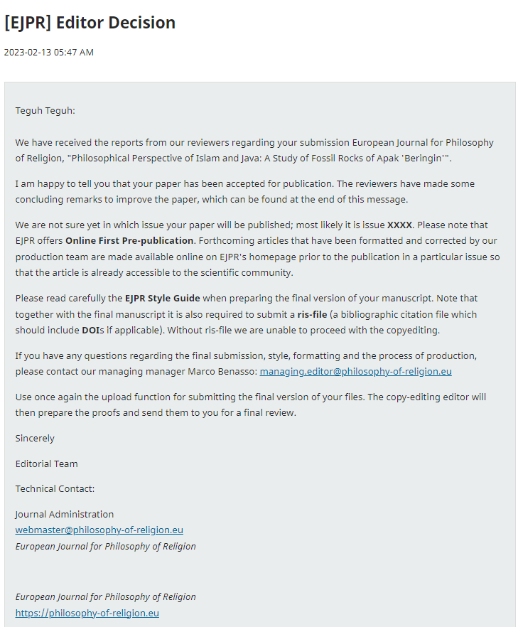

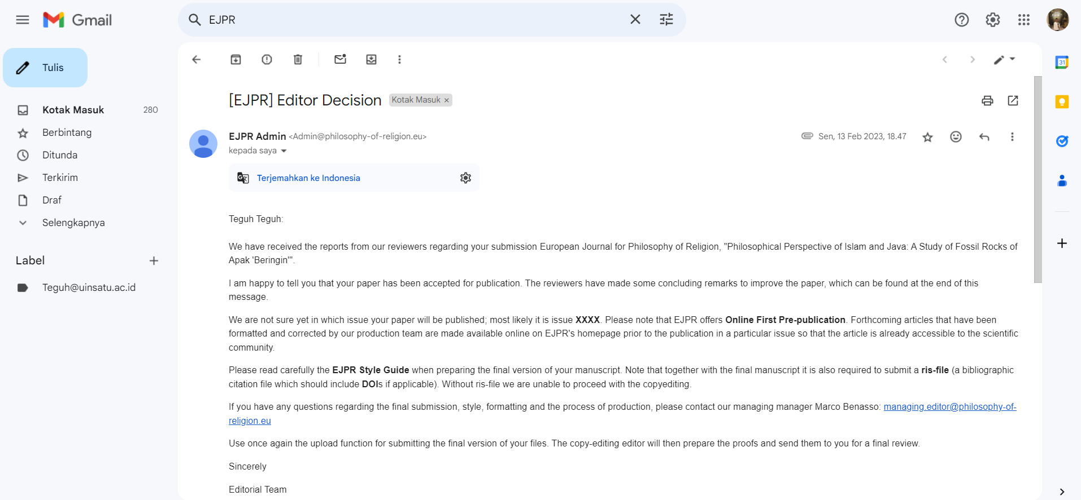

**Philosophical Perspective of Islam and Java:**  **A Study of Fossil Rocks of** ***Apak***  **'Beringin'**

**ABSTRACT**

This study aims to investigate the perspective of Javanese Islamic philosophy on the Apak 'Beringin' rock fossil and its impact on the level of spirituality and community behavior. This study uses a qualitative descriptive method with a phenomenological approach. Data analysis techniques were carried out using observation, interviews, and literature studies focusing on textual and contextual interpretations of the 'Beringin' Apak Fossil Rock. The main data sources come from the book of philosophy *otak-athik gathuk* (Javanese Islamic philosophical thought) by Damardjati Supadjar and the book of commentary as-Sulami by Imam Abu Abd. Muhammad bin Husayn as-Sulami. The findings reveal that in Javanese Islamic philosophy, the symbolization of the universe depicted in the form of fossilized rocks aims to train the soul in understanding the origin and purpose of everything in the universe or known as *'sangkan paraning damadi'*. This is a manifestation of the Javanese Muslim community's way of knowing God or what is known as divine awareness ‘*ilahiyah*’. In the rock fossils that have been found, there are words Allah and Muhammad considered by the Javanese as a natural permit that is only obtained by people who reach certain *maqam*. The conclusion is that based on the elaboration of the meaning of the natural text which is symbolized in the form of the 'Beringin' Fossil rock, it is a reflection of oneself to always be close to Allah SWT.

**Keywords:** Islamic Philosophy**,** Javanese Islamic Philosophy, Fossil Rocks Musty 'Beringin'

**Introduction**

For millions of years, humans have been in the universe for a long time. Without ruling out the existence of human history shows that our ancestors actually left many relics. These historical relics can be in the form of statues, artifacts, temples, ancient objects, writings, even fossils, and so on (Bowler, 2020). Talking about historical relics in the form of fossils can be interpreted as objects of natural history that have a wide and varied scope. Where fossils can also be formed naturally by nature, it cannot be denied that this event was also accompanied by the power and will of God. Such is the self-disclosure of God in human history. Therefore, the formation of fossils by nature is difficult to naturalize by human reason (Rudwick, 2021).

The development of the Islamic view of God and the universe took about two centuries (Cotesta, 2021). According to Nakissa (2020), based on the cognitive science of religion and Islamic theology by al Ghazali, the main focus is on the oneness of God as the main cause that brings the universe into existence, some knowledge of God independently of the scriptures through human nature (*fitrah*) and reason, and the God of benefit and harm who rewards, punishes, tests, and blesses mankind. In Islamic studies, humans always want to understand and research the mysteries of nature that encourage the search for identity (Lafrarchi, 2020). This has led to the emergence of Muslim scholars' religious thoughts about the concept of God and its relationship with the universe. For example, in the literature that presents the Qur'an as a source of knowledge in the perspective of the science of *munasabah* which is able to motivate Muslims to explore the miracles of the Qur'an. Based on the perspective of *isyari* interpretation, the Qur'an views objects that have natural elements as symbols of the universe that are oriented towards depicting Allah's creation in the context of realizing human nature (Prakoso, 2019). This *isyari* interpretation grows from the experience of understanding God's creation in the form of a symbol of the universe (*ma siwallah*) which consists of parts or series of universal natural structures, including the ocean (*bahr*), sun (*syams*), moon (*qamar*), and land ( *bar*) (Septiawadi, 2019). Other research explores the concept of God and the symbolization of the universe with a religious text approach using Islamic astronomy (*al-falaq*) as the key (Safiai et al., 2016), Said Nursi's approach which reflects the signs of the universe to contemplate the greatness of Allah (Fatimah et al., 2021), and the Islamic worldview, the universe with its beauty and order as a manifestation and power of God (Zeren, 2018).

In Indonesia, there is a mixing of Javanese culture and Islam into Javanese Islam or better known as *Kejawen* Islam, viewing fossils as such, namely not only as historical objects but also Islamic spiritual objects which have a meaning about the universe as a manifestation of the oneness of God. The fossil itself is proof of a natural diploma or *ageman* for the Javanese Islamic community, so not everyone can have or interpret it (Putro, et. al., 2021).

One of those who study fossils from the perspective of Javanese Islam is the Apak 'Beringin' fossil. Several researchers who have discussed this tree are (Wardoyo & Sulaeman (2017) studied the banyan tree as a symbol of the Yogyakarta palace. Beratha et al. (2018) studied the Function and Symbolic Meaning of the Banyan Tree (a symbol of Javanese culture) in Community Life. This is different from the results of the following researchers who studied banal trees from a scientific point of view (scientific content of trees) and tree physics, namely *Suaibatul*. Aslamiah & Haryadi (2013) who studied by identifying the chemical content of banyan tree leaves (*Ficus Benyamina L*.) as traditional medicine. Dahlan (2014) studied the physical characteristics of the banyan tree and its effect on the microclimate (a case study in urban forests and green open space in the city.

The various study backgrounds, making the focus points of the discussion different, the possibility of giving rise to a religious perspective. Therefore, this study is important to deepen knowledge about the concept of God and its relationship to the universe which is symbolized by the Javanese Islamic community in the form of the Apak 'Beringin' fossil. This research shows the novelty that the Apak 'Beringin' fossil is one of the ways for humans to understand the oneness of God and the universe from an Islamic philosophical point of view. In contrast to other research on the Apak fossil, 'Beringin' according to the philosophy of the Javanese people, especially the Yogyakarta Palace, has the meaning of *bering hak pengayoman*, justice, and eternal nature which also relies on *'manunggaling kawula Gusti'* (union of man with his God' or the union of the people with their leader'. dangling from top to bottom (ground) that humans must always remember where they came from (Jogjaprov, 2020). Another study is about *Ronggowarsito's* Javanese Islamic thought in *Serat Sabdajati* which teaches about the values ​​of *Aqidah* and *Akhalaq* that can radiate within humans and throughout the universe (Fauziyyah, 2018).

A previous study conducted by Peebles (2020) recommended further research so that humans can understand the universe correctly so that there are no errors in understanding the meaning contained in it. Based on the studies above, specifically that research on fossils as verse a lam in the perspective of Islam and Java has never been done. Therefore, this study focuses on fossils as verses of nature or as a sign of God's greatness. Where indeed the universe that was created on this earth is as evidence or an indication that only God has the right to be worshiped. In this study, the Islamic philosophical text approach is used to understand the element of the 'banyan' tree as the philosophy of Javanese society. The purpose of this study is to examine how Islam interprets the existence of stone fossils inscribed with the words Allah and Muhammad, then how the Javanese interpret these fossils, whether there is a harmony of understanding between Islam and Java.

**Research Questions**

1) What universal symbols are represented in philosophy of Islamic Java in the fossil rock of Apak beringin?

2) How are philosophical values present in the 'Beringin' Fossil Rocks in the Perspective of Javanese Islamic Philosophy?

**Methods**

The approach in this paper uses a phenomenological-qualitative approach referring to the theory of Donalek (2004) because the data produced is descriptive data in the form of written statements or words derived from books and data sources that are observed or studied. To conduct this research, the author uses Literature Studies that are relevant to the object under study. Sources of data in this paper are primary and secondary data. The primary data in this writing is the result of interviews or interviews with several sources who are natives of Java. While secondary data in this writing is in the form of written data sources such as books, journals, articles, and so on. From these two sources, the researchers found a connection and harmony of meaning so that it would produce the same understanding result.

The approach used for reading the verses of nature from an Islamic perspective is a Sufi-based approach. In other words, for the users of this approach, argue that the Qur'an actually has two levels of meaning, namely the outer meaning and the inner meaning. The meaning of Birth is the meaning of freedom which is spoken by the commentators in general, while the inner meaning is the hidden message behind the words. This inner meaning is special, which can only be grasped through revelation (Kashif) experienced by those who have reached a certain level until Allah gives intuitive knowledge. Just as Islam interprets the verses of nature using the interpretive approach in the Qur'an, so does Java. The interpretation of the verses of nature in Java can only be done by certain people, namely those who have reached the highest level.

**Results and Discussion**

**Symbolic Universal of Bringin Apak in the Perspective of Islamic Philosophy**

The findings reveal that fossils in the perspective of Islamic philosophy are a form of symbolizing the universe that is oriented towards depicting the means by which God introduces Himself to humans. Humans must use their minds to analyze, examine the universe created by God. This finding refers to the verses of the Koran which is the holy city of Muslims in which it discusses various affairs of the world and the hereafter so that it is very comprehensive in discussing the universe. The verses of the Qur'an about the symbolization of the universe used are those interpreted by Sufism experts and Islamic philosophies. Reflecting on the history of Islam when the Prophet Muhammad visited the cave of Hiro, it also shows that stones are one of God's media in giving lessons to His creatures, especially humans. Because by visiting the cave (in a not too short time which is about 11 years) the Prophet finally got a revelation from Allah SWT. The symbolization of the universe is also a creation of God that has extraordinary resilience, that's why the legacy (in the form of a cave-shaped house) of the Prophet still exists today. In the interpretation of *isyari*, the Qur'an views objects that have natural elements as symbols of the universe that are oriented towards depicting Allah's creation in the context of realizing human nature (Prakoso, 2019). This is the reason the researchers say that fossils are essentially a symbolic form of the universe (*ma siwallah*) which consists of parts or series of universal natural structures. If examined based on the concept of God and the symbolism of the universe with the religious text approach of Said Nursi's approach, fossils reflect signs of the universe to contemplate the greatness of God with its beauty and order as a manifestation and power of God (Fatimah et al., 2021; Zeren, 2018). The interpretation of natural verses in the form of fossils as Allah explains His power in Yasin's letter which reads:

ا ا ادَ ا لَ لَهُ (٨٢)

“*He commands when he wants something. He just said to her: "Be!" So be it. (Q.S. Yasin verse 82)*

Quoting Qatadah's account of the interpretation of verse 82, al-Thabari explained that this verse is a form of embodiment of evidence of God's power. for the people of Mecca at that time. More deeply, the term nature has similarities to ilm in Arabic which also shows that there is a close relationship with the concept of knowledge with the obligation to explore the universe (Ali, 2012). The choice of *lafadz 'kun'* is in accordance with the context of Arab society who uses the word to express something that is considered easy. Fakhruddin al-Razi argues that the use of parables about Allah's creation. Lafaz 'kun' in verse 82 indicates that the Qur'an corresponds to the intellectual level of the Meccan polytheists, who were not yet capable of understanding non-empirical knowledge. The Meccan polytheists at that time thought that the creation process had to use sensory tools or intermediaries, and were closely related to time and place. Allah, according to al-Razi, does not go into time or place (Mustofa, 2015).

*“And indeed, We have glorified Adam's posterity, and We have transported them on land and at sea, and We have given them sustenance from the good and We have made them above the many creatures that We have created with perfect advantage.”* (Al-Isra': 70). According to the tafsir of Al-Muyassar/ The Ministry of Religious Affairs of Saudi Arabia, it also gives a similar understanding: "And part of Allah's mercy for His servants is to glorify them, "*Truly We have glorified the descendants of Adam, and We have subservied them the animals of the land and the ships of the sea so that they may ride and transport the goods they possess. And We have given them halal and delicious food and drink. And We have exaggerated them from many other creatures with great advantages*.”

From this verse, it is clear that God created man with glory and advantages that are so abundant. In addition, God has also created man with the most perfect physical and non-physical (Q.S at-Tin: 4-6). Not only the five senses are perfect, but also the heart that serves to weigh and make decisions (Q.S. an-Nahl: 78). All the glory and advantages of this man, in accordance with his duties on earth, namely as caliph (Q.S. al-Baqarah: 30). So we should use all of God's grace to continue to learn about many things, especially to draw closer to Him. One of them is by getting to know the environment and the objects in our environment. As God taught Adam directly, it signifies that we are also capable of direct contact with God because there is a *Godly spirit* within us.

لَّمَ الْأَسْمَاءَ لَّهَا لَى الْمَلَائِكَةِ الَ اءِ لَاءِ ادِقِينَ (٣١)

*“And He taught Adam the names of all of them, and He showed them to the angels, saying, "Tell me the names of all these things, if you are truthful!*.” (QS al-Baqarah: 31)

From the interpretations obtained from many commentators, there is sufficient evidence to show that humans are the most noble creatures with various gifts from God. Even the first humans were taught directly by God, so there is no such thing as impossible for anyone who wants to have a direct relationship with God. In fact, what can be directly related to God is the human spirit, where by His power humans are given a lot of knowledge about God's secrets when they have reached the highest level of proverb. In another maximal concept, there is an understanding that the relationship between the quality of the results of self-understanding is very close to the depth of our understanding of Allah SWT. Imam Al-Ghazali's term is *man 'arafa nafsahu 'arafa rabbahu* (whoever is able to understand himself will be able to understand his own common sense then he is able to understand the truth of his Lord) (Sudan, 2017). So indirectly, as humans, we should start trying to understand who we really are until we are given a great gift. In fact, we get the task of being a caliph on earth, which shows how capable we are to rule, manage, and guard the entire earth. Another plus is the reason that God gave is also a means for us to think. Be sensitive to what God has given us in our lives, including all of His creation, even inanimate objects. With all the guidance that Allah has given, through the Apostles or Prophets, the sahabiyat, Tabi'in, to the saints and also the Sunans in Java, we must be able to lead us to our essence as God's creatures.

ادَمَ لَىٰٓ لَسْتُ الُوا۟ لَىٰ لُوا۟ لْقِيَٰمَةِ ا ا ا لِينَ

And remember, O Messenger of Allah and people of understanding, when Allah brought out from the tribes of the Bani Adam their descendants and made them children from generation to generation; and when Allah brought them out of the belly of their mother and the bones of their father; Then God made them his Lord by making it in their nature that He was their Lord, Creator and Ruler. He said, "Am I not your Lord, Sovereign, and Sovereign?" They replied: "Yes, we testify to ourselves with confidence and pleasure that you are our Lord and Creator, there is no God but you. Because of your grace and strength, we promise this testimony." Allah mentions the reason for this testimony, so that they do not say on the Day of Resurrection as a reason for self-determination: "We were negligent and did not know your oneness and divinity.

ا۟ لْعَهْدِ لْعَهْدَ انَ لًا

*““...... and keep the promise; Surely the promise must be answered." (Q.S. al-Isra': 34) And fulfill the covenant that prevails between you and Allah, or between you and His other servants without undoing or neglecting them, for on the Day of Resurrection Allah will surely ask those who make covenants; Does he keep it so that he may reward him, or neglect it so that he may punish him*?.”

ا لْنَا لذِّكْرَ ا لَهُۥ لَحَٰفِظُونَ

*"* *We have sent down the Qur'an, and We have kept it."* (QS al-Hijr: 9)

To prove the truth of the prophet Muhammad's confession that the verses he delivered really came from Allah, he said, we are the ones who sent down the Qur'an through the intercession of the angel gabriel which the disbelievers doubted, and surely we are also with the angel gabriel and the believers who always maintain His authenticity, holiness, and eternity until the end of time. The falsehood experienced by the prophet Muhammad also happened to the previous apostles. Allah declared, and indeed, we have sent several apostles before we sent you, O prophet Muhammad. We have sent them to the ancient people. (Hidayatul Insan bi Tafsiril Qur'an/Ustadz Marwan Hadidi bin Musa, M.Pd.I). Examined from previous studies, Nakissa (2020) reveals al Ghazali's work on the oneness of God as the main cause that brought the universe into existence. Thus, it is clear that the symbolism of the universe in the form of fossils is the oneness of God which is intended to bring benefits, have wisdom, and bless mankind. Therefore, it is very important to learn about the symbolization of the universe to get closer to Him. This can also contribute to building *'baldatun tayyibatun wa rabbun ghafur*'. Because in essence humans always want to understand and research the mysteries of nature which encourage the search for identity and are expected to treat nature fairly.

**'Beringin' Fossil Rocks in the Perspective of Javanese Islamic Philosophy**

The second finding reveals that the Apak 'Beringin' fossil is not only a historical object but also an Islamic spiritual object which means about the universe as a manifestation of the oneness of God. Ringin Apak plant elements then harden and petrify due to natural processes and time that God wants. The Javanese interpret it as wewaton (*tetenger*). In Indonesia, *wewaton* is defined as a sign or benchmark. In Islam, we have *hijr aswad* and *hijr ismail*. This shows that the meaning of the Javanese language is correct and in accordance with or in harmony with Islam. Because this *aswad* punishment is the benchmark or sign or center of worship for Muslims in performing prayers. This is why fossils are evidence of a natural certificate or ageman for the Javanese Islamic community (Putro et al., 2021). The next interesting thing is the fossil element, namely the banin tree. This plant with the Latin name *Ficus benjamina .L* has different names in each region. The Sunda area is called "*caringin*", the Javanese call it "banyan" and for the Malays it is known as "*waringin*". This tree can grow to about 20-25m and on its upright trunk grows blackish brown hanging roots. The Javanese interpret the *bann* tree as a true symbol of worship (Aslamiah & Haryadi, 2013).

Javanese people have used the Apak 'Beringin' fossil as a *wewaton* or a cultural symbol of the palace or kingdom (Beratha et al., 2018; Wardoyo & Sulaeman, 2017). The leaves are oval in shape with a length of 3-6cm and a width of 2-4cm, able to grow thickly blocking the sunlight to get to the ground. A tree that is indeed large and can be said to be shady or shady can finally shade, protect, and most importantly protect anyone under it. Banin tree is also a tough plant that holds extraordinary water, even its vines can also store clear water (in an instant if we split it will release drinkable water). In addition, it is also a hope for the kingdom to plant banal trees at its entrance (Putro et al., 2021). One of those who study fossils from the perspective of Javanese Islam is the Apak 'Beringin' fossil. Sukiman (2020) explains in his book that God is *Kuwaos* without tools, so he concludes that the way back to God is also without tools. So when seeking knowledge or knowledge directly from Allah, *tan punya kinaya ngapa* (cannot be explained by anything) and learns without equipment (without using tools). Except by *manunggaling kawula Gusti*. In addition, according to Sufi-Javanese, a deep understanding of the true reality of selflessness. All the physical features that are called "existent" must begin to be understood and realized constantly as "non-existent." What does not exist is actually a creature, because he created God from nothing to be "presumed" to exist (Haq, 2013).

In Javanese terms, interpreting and studying the symbolization of the universe is called "Ngelmu", then in Indonesian it is called "science". The word "*ngelmu*" is an abbreviation of two syllables, namely *ngel* from the word angel (difficult, difficult, etc.). Whereas you come from the word *tine* (difficult to understand or difficult to know). In conclusion, *ngel kamu* for Javanese people is your angel, which in Indonesian is defined as something that is difficult to understand or know. *Ngelmu* means "secret teaching of the grip of life". In the view of Islam called Sufism is a way to seek and unite with God, in Javanese teachings it is called *Suluk*. The meaning of the words science and knowledge in the perspective of Islam and Java, has a difference. In contrast to the word science which comes from the Arabic 'alima, which means knowledge (Soesilo, 2000). From this meaning, it shows that science is the knowledge that is both systematic and structured based on a certain methodology using reason or logic. While Ngelmu can be known based on the five senses and personal imagination, not brain activity or thought. To gain knowledge as it is done in Javanese, Islam must be able to pass through four stages of the human journey to the perfection of life.

In order to gain knowledge in understanding the fossil of Apak 'Beringin, one also goes through a stage of the journey called full-fledged *ngelmu*. In Javanese philosophy, perhaps we will find the term *ngudi kasampurnan* where God is the absolute goal for humans. The first is the stage of physical worship (body exercises) to increase faith, *dumunung ing eneng*. Faith, indecisiveness: kuwasa. It means believing in the nature (power) of the Almighty. Second, Worship of the Heart *(lakuning ati).* The place for this level is called tokid, dumunung ana ing ening. *Tokid, muhung sawiji, resigned, marang iradat: karsa*. It means to unite, surrender to all forms of God's will or provisions. Third, spiritual worship (practice of life). The place for this level is called *Makrifat, dumunung ana ing awas. Makrifat, waskita ing ngelmu anguningani dununing Dat, Sifat, Asmaa,* and *Af'al*. Has the meaning of knowing knowledge, will put *Substances, Attributes, Asthma, Af'al*. Fourth, worship of taste (taste training). The place for this level is called Islam, *dumunung ana ing eling. Islam, slamet hayate, urip, dumunung ana ing sifat jalal, agung; jamal; Cantik; kahar; bijaksana; kamal*. Based on the values ​​contained in the Javanese philosophy *'Serat Wirid Hidayat Jatii*, the ultimate goal of worship is to return to God or oneness and become "*waskitaing sampurnaning sangkan paran*" which means knowing the beginning of life. The path to God is detailed with the application of the means of *Makrifat* Science, the means of upholding the Divine Essence, the path to true death (*kasidan jati*), through moral practice and meditation (*manekung*) (Ciptoprawiro, 2000).

The existence of these four phases does not mean that it is impossible for every human being to be able to do it. Because Allah has even explained in the Qur'an that humans were created with the best possible conditions and given many advantages. So that every human being can certainly be willing to be perfect, and make God an absolute goal for himself. Increasing faith in the presence of these fossils is also a part of order (*lakuning ati*) and nature (practiceoflife), because seeing their findings and interpretations will be one of the reasons we believe in the power of God. As Allah explains in QS al-Jatsiyah verse 3, which explains that the creation of all that is in the heavens and on earth (there are signs of Allah's power and oneness) for those who believe. So, by looking at God's evidence. For the Javanese people, doing these four levels is a form of *Kasampurnan* Science. Where prayer aims to establish a relationship with the essence of God (Soesilo, 2000). So in this phase we will not find the word "impossible", if someone who has reached this level is given your title by God. As Allah showed His greatness when He revealed Surah Al-Alaq verses 1-5 to Prophet Muhammad (SAW).

اقْرَأْ اسْمِ الَّذِي لَقَ ( ) لَقَ الْإِنْسَانَ لَقٍ (٢) اقْرَأْ الْأَكْرَمُ (٣) الَّذِي لَّمَ الْقَلَمِ (٤) لَّمَ الْإِنْسَانَ ا لَمْ لَمْ (٥)

*“Read by the name of your God Who Created, He created man from a lump of blood. Read, and it is your Merciful Lord who teaches by the way of kalam, He teaches man what he does not know.”*

Without ruling out the importance of learning from the letter, we can draw another conclusion, that God actually teaches what is unknown to man (Qutub, 2011: 1342). So that all the facilities and infrastructure that we have or get are actually only intermediaries.

The discovery of the rock fossils of the 'Beringin' Apak shaped like a bull riding animal in this study, similar to the ride of a character named Ang in the cartoon titled "avatar". (See Figure 1).



Figure 1. Fossil shaped one-horned rhino or tiger with a crown

From Figure 1, the discovery of this bull-like animal form is the result of the existence of Javanese completeness, so that this animal is shown as a physical embodiment of rock fossils. Animals with six legs are a symbol of the pillars of faith in Islam. Although this animal with the name "*Appa*" does not have wings but can fly high, it shows us the nature of faith. The achievement of perfect faith is when we can truly believe in the six pillars of faith, so that nothing is impossible to be granted by God. The request of his faithful servant. This fossil written with lafadz was found in Tulungagung Regency, precisely in Glotan Village, Campurdarat District.

The Javanese Islamic community believes that there are other types of bodies that will not be damaged if the word (died) is in a fossil. The body is none other than the plant body, which is capable of creating fossils from any part of the plant body by the Power of God. In the land of Java, there are three types or types of fossils that have various forms according to the level of the recipient of the fossil and the will of God. First*, Ghana* fossils formed from the core part of the plant body called "galih", which would later create "*Ghana*". For Javanese people who can already read nature, this type of fossil can no longer find cafatan (original nature) from the plant that formed it. So that it can only be interpreted based on the shape or appearance of the material. Second, Mestika Fossils are formed from outside the body of plants, but in fact can also be formed from animal parts; water and so on. Examples are pomegranate red mustika which comes from petrified (crystallized) pomegranate seeds and pearl mustika from shells. Third, Ghana Mustika which is more special because it is formed from a combination of Ghana and Mustika. Example: benthic, comes from the benthic tree in the form of benthic fruit. (See Figure 2).

 

Figure 2. The discovery of the words of Allah and Muhammad in fossils)

In Figure 2, regarding Allah's *lafadz* will still show the same and similar principle that is Allah SWT. It starts from eliminating "ا" so that only lafadz (لله) remains, which reads "... *lillaahi*  *maa*  *fissamaawaati*  *wal*  *ardh...* "It means "The possession of God is all that is in heaven and what is on earth." Next, we remove one more letter to (له) so that it reads, *"lahu*  *maa*  *fissamaawaati*  *wal*  *ardh"* has almost the same meaning that is "his" What is in heaven and on earth." Then, when there is one letter left, it is actually an abbreviation of the word(هو). Because when we read the word (هو) waqaf then the letter (و)is not read so that all that is read is a letter (ه). This is Q.S. al-Baqarah verse 255 which reads (ٱللَّهُ لَآ إِلَٰلَ إِلَّا لُوَ ٱلْحَىُّ ٱلْقَيُّومُ. .. then allahu  *laa*  *ilaha*  *illahu* (there is no God but Allah), only if we will continue then it must reappear "هو" so it reads  *hual*  *hayyul*  *qayyumu* which means "Heis the One who lives". When all the letters are removed, there will be nothing. Everything that is invisible is called the unseen. Therefore, Allah has explained in Q.S. al-Baqarah verse 3 which reads *"alladzinayu'minunabil*  *ghaib",*and "ghaib" here still shows to the same dzat that Allah swt . If we compare it with any word and in anylanguage, there will be no match for the meaning of Allah's asthma. From its name alone there is already such a great miracle, how will we refuse not to acknowledge and believe that He is god who deserves to be worshipped. Furthermore, the description of the greatness of God is also listed in the next verse in surat al-Ikhlas.

Next is the description of *lafadz* Muhammad, the creature most loved by Allah. Before the creation of man*(al-Man),*Allah had created NurMuhammad.  As the concept in the book of Barzanji about  *Nur Muhammad,*  shows the glory of the Prophet who became the closing for the prophets and messengers.

لي لم لى النور الموصوف التقدم الأوليه

Literally the phrase means "I say shalawat and greetings for the light that is earlier and early"(al-Barzanji, 4). In the midst of various polemics about the concept of Nur *Muhammad,*  some scholars one of them is nusantara ulama, Sheikh Muhammad Nawawi Banten actually responded simply. The scholar, who is even recognized by middle eastern scholars, said that this shalawat actually just wants to convey that his fellow Nur *Muhammad* was the first creature created before Allah created other creatures. Sheikh M. Nawawi Banten also conveyed about a hadith of Jabir history which became one of the basic concepts of Nur *Muhammad.*

"As it is in the hadith of the narration of the companions of Jabir RA that when asked about the first creature created by Allah, the Prophet replied, 'Indeed, Allah created your Prophet Nur before all things'. God *made* it work by The Power of God according to His will. There was no sea, no sea, heaven, hell, angels, man, jinn, earth, sky, sun, and moon. On this basis, *it* is a substance, not an axiden." (Nawawi, 4)

The discovery of the two *lafadz* that Allah and Muhammad have an ultimate harmony and bond, both of which show the greatness of Allah regarding the creation of beings. So the fossil object that has both  *lafadz,* Namely Allah and Muhammad, is believed to have great power or power. Despite its immense power, only certain people can feel and use it. The Javanese who have a natural ijasah are also not without reason, but they have indeed reached the highest level in *the science of kasampurnan,* namely ma'rifat. Where they get the grace to know God better, the beauty of God, even secrets about things related to Godhood.

Suparlan (1996) tried to view the relationship between makrifat and unity as the "most original perspective" of the Javanese. Which there is a fundamental and very important fact that it turns out that the Javanese are not actually ancestors or inanimate objects (animism-dynamism), but they tend to have a main principle called awareness of *sankan paraning dumadi* (the historicality of creation) that questions about where man came from, who he really is, and where the purpose of life is lived. So that the discovery of this stone can be easily interpreted by the chosen people who are native Javanese. The Javanese are also seen as more universal in looking at things, as evidenced by the belief that fossils come not only from humans but also from other creations of God. It is mentioned that there are three fossils, namely  *ghana, mustika,*  and ghana *mustika.* The three types of fossils also show the level of maqam of people who receive ijasah, and provide an understanding of what advantages the recipient has.

The concept of seeking knowledge in Javanese Islamic philosophy is actually a unity and has the same spiritual meaning. Islam calls it a sharia order, order, fitrah and maxim. While the Javanese call it physical worship (badanlakuning), heart worship (lakuning ati), spiritual worship (life practice), and taste worship (rasalakuning). After studying the four stations more deeply, we will find that this whole phase is not a level but an order. So that to achieve the perfect knowledge, every human being must be able to go through the four phases that have been mentioned so that true belief (faith) will arise. Because after arriving at the maximal phase or the practice of feeling, we will get the reasons for our true beliefs. Therefore, the Javanese have the privilege of having a deep taste for anything. A deep understanding of nature is a means of knowing God. So don't be surprised if this kind of fossil discovery can be found easily in Java. In Islamic teachings, there are even many things that are similar to what is understood by the Javanese, although in different terms, they actually have a harmonious understanding. This finding has revealed the novelty of fossils as a symbol of the universe and the concept of God using an Islamic philosophical approach. This is different from previous research which studied the concept of God and the universe using *Ronggowarsito's* Javanese Islamic thought in *Sabdajati* Fiber which teaches about the values ​​of Aqidah and Akhalaq that can radiate within humans and the entire universe (Fauziyyah, 2018). In the end, as humans who were created as noble beings, we must be able to use this discovery as a means to strengthen our faith and belief in God. With extraordinary strengths and capacities, of course, all humans have the same opportunity to know more about their God, as well as find the reasons for their faith.

**Conclusion**

In summary, Javanese Islamic philosophy uses symbolization of the universe in this study is represented in the form of fossilized rocks. It symbolizes the soul to see the origin and purpose of the life that is as *'sangkan paraning damadi'* from and where the soul goes. This is a manifestation of the Javanese Muslim community's way of knowing God or what is known as divine awareness ‘*ilahiyah*’. In the rock fossils there are letters of Allah and Muhammad stating a natural permit for man having high level of religiosity or *maqam*. The elaboration of the meaning of the natural text which is symbolized in the form of the 'Beringin' Fossil rock, reflects one who is closed to Allah SWT.

**References**

Ali, M. (2012). Creation of the Universe By Al-Qur’an Analysis of QS. Al-Anbiya: 30 and Its Relevance to the Theory of Science. *Madania*, *2*(2), 167–184.

Aslamiah, S., & Haryadi, H. (2013). Identifikasi Kandungan Kimia Daun Pohon Beringin (Ficus Benyamina L.) sebagai Obat Tradisional. *Jurnal Anterior*, *13*(1), 19–23. Retrieved from http://www.eldis.org/vfile/upload/1/document/0708/DOC23587.pdf%0Ahttp://socserv2.socsci.mcmaster.ca/~econ/ugcm/3ll3/michels/polipart.pdf%0Ahttps://www.theatlantic.com/magazine/archive/1994/02/the-coming-anarchy/304670/%0Ahttps://scholar.google.it/scholar?

Beratha, N. L. S., Rajeg, I. M., & Sukarini, N. W. (2018). Fungsi dan Makna Simbolik Pohon Beringin dalam Kehidupan Masyarakat Bali. *J. Kaji. Bali*, *8*, 33–52.

Bowler, P. J. (2020). The Pre-evolutionary Worldview. In *Evolution* (pp. 27–47). California: University of California Press.

Ciptoprawiro, A. (2000). *Filsafat Jawa*. Jakarta: PT. Aula Perpustakaan.

Cotesta, V. (2021). God , the Universe and the World According to Islam. In *The Heavens and the Earth: Graeco-Roman, Ancient Chinese, and Mediaeval Islamic Images of the World* (pp. 310–315). United Kingdom: Brill. https://doi.org/https://doi.org/10.1163/9789004464728_027

Dahlan, E. N. (2014). Karakter Fisik Pohon dan Pengaruhnya terhadap Iklim Mikro (Studi Kasus di Hutan Kota dan RTH Kota Semarang). *Forum Geografi*, *28*(1), 83–90. Retrieved from https://publikasiilmiah.ums.ac.id/handle/11617/4792

Donalek, J. G. (2004). Phenomenology as Qualitative Resreach Method. *Urologic Nursing*, *24*(Desember), 516–517.

Fatimah, S., Tawil, M., & Akar, C. (2021). Exploring the Repository of Religious Texts to Explore the Universe: Risale-i Nur Approaches. *The Journal of Risale-i Nur Studies*, *4*(1), 28–39.

Fauziyyah, F. I. (2018). International Journal of Multicultural and Multireligious Understanding Ronggowarsit o ’ s Concept of Islamic Theosophy in Serat Sabdajati, 177–184.

Haq, Z. (2013). *Ajaran Penuntun Jiwa Jawa*. Sidorejo: Penciptaan Wacana.

Jogjaprov. (2020). Beringin: Mitos dan Filosofinya Bagi Masyarakat Jawa. *Jogjaprov.Go.Id*. Retrieved from http://kehati.jogjaprov.go.id/detailpost/beringin-mitos-dan-filosofinya-ba-masyarakat-jawa

Lafrarchi, N. (2020). Assessing Islamic Religious Education Curriculum in Flemish Public Secondary Schools. *REligions*, *11*(3), 110.

Mustofa, I. (2015). Kritik Fakhruddin al-Razi terhadap Emanasi Ibnu Sina. *Kalimah*, *13*(2), 311. https://doi.org/10.21111/klm.v13i2.291

Nakissa, A. (2020). The Cognitive Science of Religion and Islamic Theology: An Analysis Based on the Works of al-Ghazlī. *Journal of the American Academy of Religion*, *88*(4), 1087–1120. https://doi.org/10.1093/jaarel/lfaa059

Peebles, J. (2020). Have we got the universe right ? *New Scientist*, *246*(3285), 30–35. https://doi.org/10.1016/S0262-4079(20)31040-X

Prakoso, T. J. (2019). Theoretical Science in Munasabah Discurse: Discovering Mountain Facts in the Quran. *Journal of Islam and Science*, *6*(1), 41–49.

Putro, R. P., Rohmadi, M., & Rakhmawati, A. (2021). Islamic Religiusity In Serat Wedhatama Pupuh Gambuh. *IBDA: Jurnal Kajian Islam Dan Budaya*, *19*(2), 335–350.

Rudwick, M. J. (2021). Nature’s Own Antiquities. In *Earth’s Deep History* (pp. 31–54). Chicago, IL This: University of Chicago Press.

Safiai, M. H., Ibrahim, I. A., Islam, U., & Sharif, S. (2016). Islamic Perspectives on Science and Technology. *Islamic Perspectives on Science and Technology*, (January). https://doi.org/10.1007/978-981-287-778-9

Septiawadi, S. (2019). Simbolisasi Alam Semesta Dalam Ajaran Tasawuf (Perspektif Penafsiran Isyari). *Al-Dzikra: Jurnal Studi Ilmu Al-Qur’an Dan Al-Hadits*, *12*(2), 189–210. https://doi.org/10.24042/al-dzikra.v12i2.3894

Soesilo. (2000). *Sekilas Tentang Ajaran Kejawen*. Surabaya: PT. Kesaint Blanc Indah Corp.

Sudan, S. A. (2017). Principles of Islamic counseling and psychotherapy. *Asian Journal of Management Sciences & Education*, *6*(3), 129–138. Retrieved from http://irep.iium.edu.my/62402/

Sukiman, U. (2020). Neology of Arabic in Indonesia. *Jurnal Al Bayan: Jurnal Jurusan Pendidikan Bahasa Arab*, *12*(2), 357–376. https://doi.org/10.24042/albayan.v12i2.6071

Suparlan, P. (1996). *Kampung Jawa Tondano: Religion and Cultural Identity*. Yogyakarta: Gadjah Mada University Press.

Wardoyo, C., & Sulaeman, A. (2017). *Etnolinguistik pada Penamaan Nama-Nama Bangunan di Keraton Yogyakarta* (Vol. 14).

Zeren, M. E. (2018). Türklerde Budizm ve İslâm Tasavvuffunda Tanrı ve Evren Anlayışı. *Journal of Turkish Studies*, *13*(Volume 13 Issue 2), 127–144. https://doi.org/10.7827/turkishstudies.13007

1. **Bukti Konfirmasi Artikel Accepted (19 April 2023)**

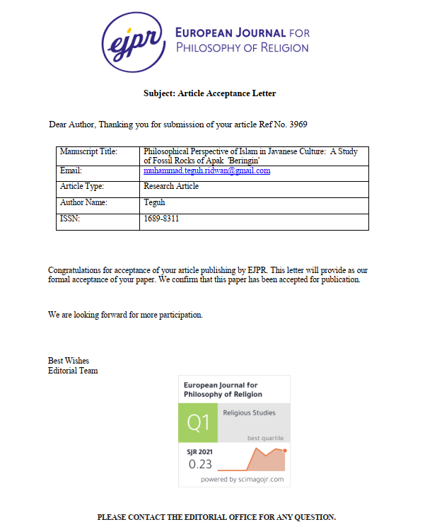

1. **Bukti Konfirmasi Terbit Online**

