**BUKTI KORESPONDENSI**

**ARTIKEL JURNAL INTERNASIONAL BEREPUTASI**

Judul Artikel : A review of misconception in physics: the diagnosis, causes, and

remediation

Jurnal : Journal of Turkish Science Education, 2022, Volume 19,

No. 2, Hlm. 403-427.

Penulis : Gaguk Resbiantoro, Rahyu Setiani, Dwikoranto

|  |  |  |
| --- | --- | --- |
| No. | Perihal | Tanggal |
| 1. | Bukti konfirmasi submit artikel dan artikel yang disubmit | 18 Mei 2020 |
| 2. | Bukti konfirmasi review dan hasil review pertama | 2 Mei 2021 |
| 3. | Bukti konfirmasi submit revisi pertama, respon kepada reviewer, dan artikel yang diresubmit | 19 Juni 2021 |
| 4. | Bukti konfirmasi review dan hasil review kedua | 3 Desember 2021 |
| 5. | Bukti konfirmasi submit revisi kedua, respon kepada reviewer, dan artikel yang diresubmit | 5 Desember 2021 |
| 6. | Bukti konfirmasi artikel accepted serta masuk tahap proofreading and editing | 10 Januari 2022 |
| 7. | Bukti konfirmasi artikel tahap produksi published online | 27 Juni 2022 |
| 8. | Bukti konfirmasi published online | 30 Juni 2022 |

1. **Bukti Konfirmasi Submit Artikel dan Artikel yang Disubmit (18 Mei 2020)**

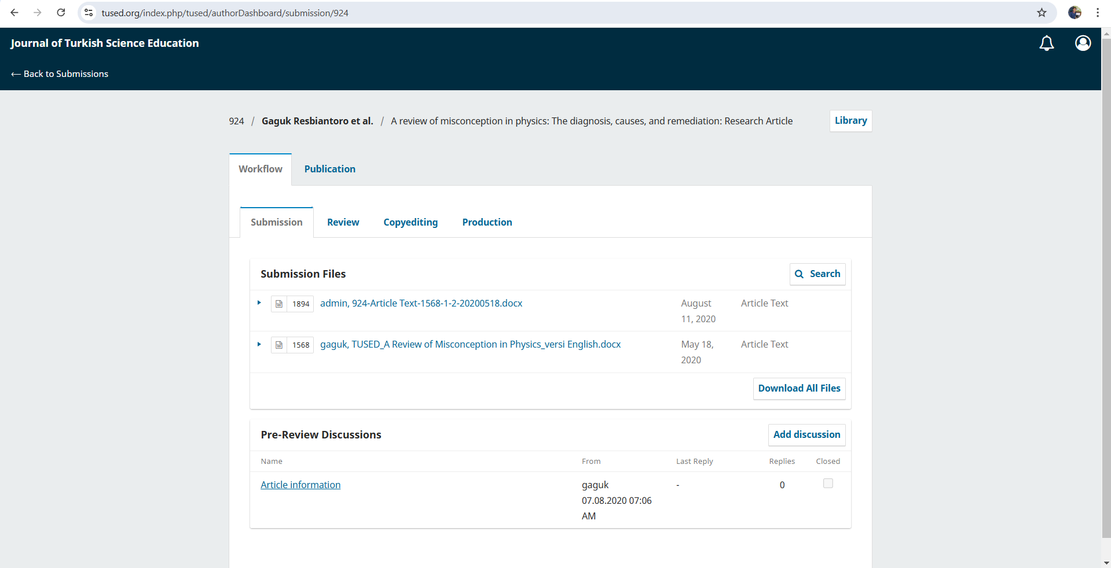

**A Review of Misconception in Physics: The Diagnosis, Causes, and Remediation**

Gaguk Resbiantoro 1), Rahyu Setiani 2), Dwikoranto 3)

1) State Islamic Institute of Tulungagung, Indonesia, *gaguk.resbiantoro@gmail.com*

2) STKIP PGRI Tulungagung, Indonesia, *rahyusetiani@gmail.com*

3) State University of Surabaya, Indonesia, *dwikoranto.unesa@gmail.com*

**Abstract**

The difference between students' ideas and scientific conceptions, called misconceptions, is a barrier to delivering 21st-century learning goals. For achieving that, physics learning needs to be designed by teachers to eradicate misconceptions chief. The incorrect conception will cause failure in the process of critical thinking and problem-solving. This paper provides a review of 70 journal articles on diagnosis methods, causes, and ways of remediating misconceptions. The synthesis was carried out on international studies that have been published for the last fifteen years (2005-2019). The results obtained various diagnostic tools for physics misconceptions: interviews, open-ended tests, multiple-choice tests, and multiple-tier tests. The diagnosis results of misconception are the base for engaging remediation strategies. The remediation is carried out using the conceptual change approach through Simulation-Based Experiments, Conceptual Change Texts, and Inquiry-Based Learning methods. This review will be a reference for future studies and achieve the effectiveness of physics learning. The development of diagnostic tools and remediation methods remains a more challenging topic for future research.

**Keywords:** misconceptions, alternative conceptions, conceptual change

**Introduction**

The constructivist approach in learning emphasizes student activities to construct a conceptual understanding Students construct their knowledge by matching new facts or new concepts obtained in class with mental models based on their life experiences (Allen, 2014; Gomez, 2016; Konicek-Moran & Keeley, 2015). The synchronizing of new facts or concepts with students' mental models becomes a constructive learning challenge. The learning process must consider the internal cognitive structure and external reality to be consistent according to Piaget's Theory with the support of social factors (Jenkins, 2000; Toh et al., 2003; Weil-Barais, 2001; Windschitl, 2002), to form a correct conceptual understanding (Arends, 2012; Seatter, 2003). The difference of existing concepts from scientific concepts (incorrect belief) becomes barriers in learning, called misconceptions (Allen, 2014; Clement et al., 1989; Driver & Easley, 1978; Helm, 1980; Neidorf et al., 2020). Misconceptions are also defined with different terms such as "alternative conceptions" (Klammer, 1998), “naive beliefs” (McCloskey et al., 1980), and “mental models” (Greca & Moreira, 2002).

Students' experiences about physical phenomena in life can raise wrong preconceived ideas of physical concepts or misconceptions (Neidorf et al., 2020). The knowledge construction determined from students' personal experiences tends not inlining with scientific knowledge, that also called as alternative frameworks, intuitive beliefs, preconceptions, spontaneous critical thinking, children's science, and naïve beliefs (Karpudewan et al., 2017). National Research Council (1997) classify misconceptions as preconceived notions, nonscientific beliefs, conceptual misunderstandings, vernacular misconceptions, and factual misconceptions. Misconceptions occur when students deliberate physical phenomena using their minds and confidence of being able to explain them with the right knowledge (Allen, 2014; Krebs, 1999). If their knowledge is interconnected with new facts that make sense according to students, then misconceptions will strengthen and complicated (Allen, 2014). That is, the identification of students' initial knowledge needs to be done before introducing new facts or concepts in learning. It is intended that learning does not complicate misconceptions but can eradicate misconceptions.

Misconceptions brought by students in the learning process will cause cognitive conflict when allowing new empirical concepts or facts (Kang et al., 2010; Labobar et al., 2017; Ramsburg & Ohlsson, 2016). The importance is students can be frustrated and disturbed expectations (Chen et al., 2019). Students become lazy to learn because they are frustrated or become lazy to explore deeper knowledge because of overconfidence (disturbed expectation). This becomes a barrier for students to build and deepen understanding of concepts in learning (Allen, 2014; Chen et al., 2019; Verkade et al., 2017). Indeed worse, misconceptions also have a cumulative impact on students, extending from basic education even to the point where they have a certain level of expertise (Chen et al., 2019; Potvin & Cyr, 2017), for example, these students have become teachers. More critical, the misconception will be transmitted to students again, since one of the sources of misconception is the teacher (Arends, 2012; Resbiantoro & Nugraha, 2017; Skamp, 2012; Soeharto et al., 2019). If students' conceptual understandings are not correct, it will inhibit the ability to invent and not be able to solve problems (Singh, 2007; Vosniadou, 2019). The conceptual understanding, thinking abilities, and problem-solving abilities are the expected outcomes in 21st-century science learning, including physics.

Based on P21 and ATC21S, the frameworks of 21st-century skills include critical thinking and problem-solving as targets for achievement in the cognitive area (Battelle for Kids, 2019; Binkley et al., 2012). If students have any misconceptions, then the conceptual change is required to remediate misconceptions (Chi & Roscoe, 2002; Stump, 2015). Conceptual change is able to bring the ability of analogical thinking (Thagard, 2012), reasoning (Stump, 2015), and critical thinking, so students have a deep understanding (Chi & Roscoe, 2002; Treagust et al., 2017). The remediation of misconceptions can support 21st-century learning goals. Learning must focus on eliminating students' misconceptions, that mean, teacher must obtain a misconception diagnosis before carrying out learning (Ilyas & Saeed, 2018). For conducting a conceptual change approach, teachers must understand misconceptions in physics, from the process of diagnosis, causes, to the remediation process (Gomez-Zwiep, 2008; Qian et al., 2019; Resbiantoro, 2016).

The awareness of misconceptions is needed by teachers and other practitioners because of the complexity consequence, even impeding the attainment of 21st-century skills. The diagnosis of misconception in physics must be known by the teachers for outlining the remediation strategies. This article discusses the diagnostic tools, the causes, and the remediation strategies in physics learning. The authors have reviewed several international papers related to misconceptions in physics for the last fifteen years (2005-2019).

**Method**

**Identifying journal articles**

Identification was performed by exploring various databases for international journals, including ScienceDirect, SpringerLink, Taylor & Francis Online, and Wiley Online Library. Literature was identified in February 2020. The category of publication time queried was 2005-2019. The search keywords were "misconception in physics" and "alternative conceptions in physics". All search results were collected into one database to filter if any duplicated articles. As a result, a total of 91 journal articles were obtained with details 39 in ScienceDirect, 24 in SpringerLink, 13 in Taylor & Francis Online, and 15 in the Wiley Online Library. The next step was the abstract selection process, the author deleted 21 non-research articles (general review and book review) so that the remaining 70 articles were read, analyzed, and coded using a spreadsheet program.

**Coding scheme employed**

The article coding was based on a scheme adapted from a systematic approach for literature review such as Lee, Wu, & Tsai (2009). There are four main categories that the author used to understand each article in the review process, specifically:

* basic data: author, publication year, journal, research location
* research methodology: research approaches, methods, research objects, data collection instruments, analytical methods, and research results
* content analysis: how to diagnose misconceptions, causes of misconceptions, and the process of remediation or elimination of misconceptions
* discussion: the issues discussed, the projected development of the problem, and the author's comments.

Based on these four categories, the author was able to viewed and outlined clearly about trends (trends), problems that arise, and future research directions. The coding scheme was compiled in the form that supports the literature review process (Prasad, 2008).

**Findings of this review**

Of the 70 articles that were reviewed in this study, the largest number was published in 2014 (14%). Over the last five years, from 2014 to 2019, an addition had occurred in the number of articles about physics misconceptions. There was a decline in 2016 and 2018 during that period, but it increased sharply again in 2019. In detail, the number of publications data are shown in Figure 1. Based on that data, misconceptions are still very exciting for educational researchers.

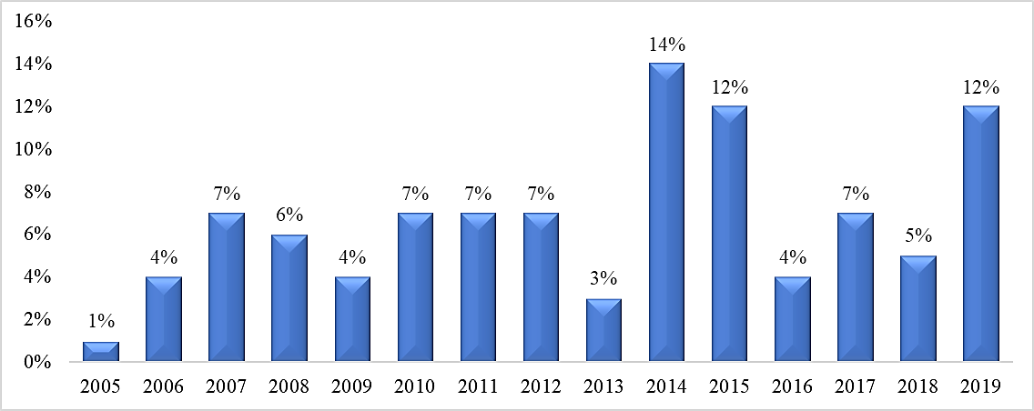

Figure 1. Percentages of studies about misconception across years (2005-2019).

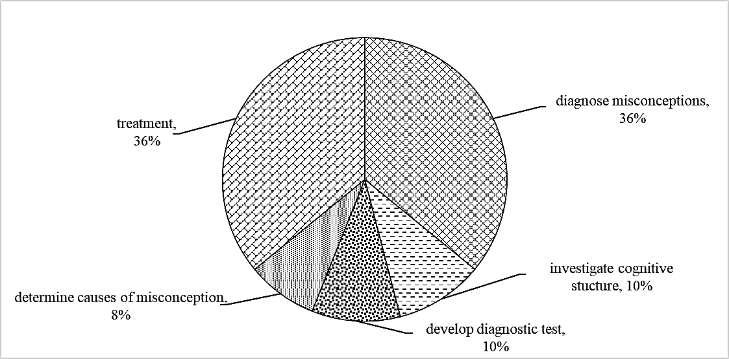

Figure 2. Purposes of the overall studies.

There are five research purposes of the articles as a result of this study, including diagnosing misconceptions, investigating cognitive structures, developing diagnostic tests, determining causes of misconception, and treating misconceptions (remediation). Most of the articles have the aim to diagnose misconceptions and carry out the treatment of misconceptions (remediation of misconceptions). Each of the two objectives is spread over 36% of articles or 25 articles, as shown in Figure 2. The remediation process of misconception is carried out through eight methods in learning, particularly simulation-based experiments, conceptual change texts, inquiry-based learning, multimedia instruction, collaborative learning, laboratory experiments, and concept mapping. The simulation-based experiment is the most widely used method in the remediation process. The number of each method used for remediation of misconceptions is shown in Figure 3.

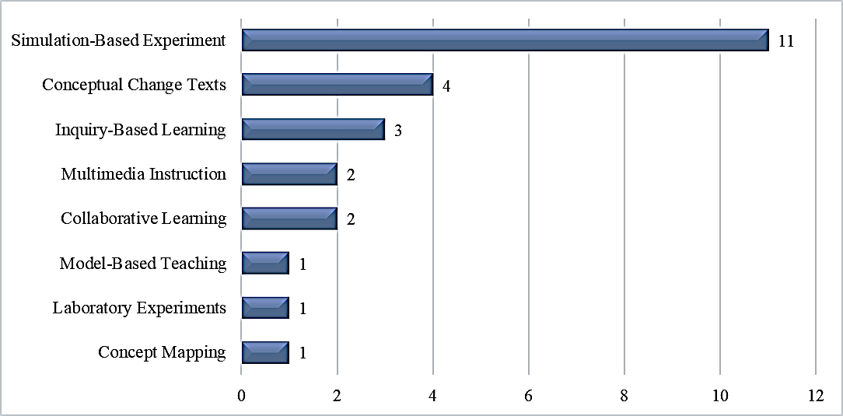

Figure 3. Any treatment methods have used for remediating misconceptions.

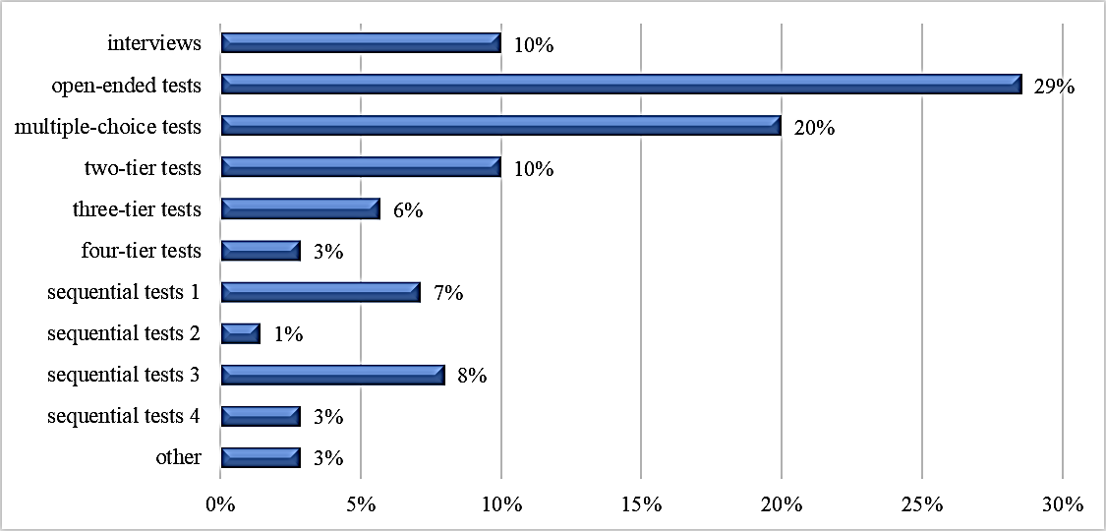

Figure 4. Tools for diagnosing the misconception.

Diagnostic tools become a principal component for investigating student's conceptions in several physics concepts. Based on this review, there are six types of diagnostic tools used, namely interviews, open-ended tests, multiple-choice tests, two-tier tests, three-tier tests, and four-tier tests. The researchers also used sequential tests, i.e. multiple-choice tests followed by open-ended tests (sequence 1), multiple-choice tests followed by interviews (sequence 2), open-ended tests followed by interviews (sequence 3), and interviews continued observations (sequence 4). Open-ended tests are the most widely used tools in 20% of articles, followed by multiple-choice tests in 20% of articles as shown in Figure 4.

The research approaches used in the articles are categorized into three types: qualitative, quantitative, and mixed methods. This review, visualized in Figure 5, shows that 41% use qualitative, 40% quantitative, and only 19% use mixed methods. Most articles use descriptive techniques to diagnose misconceptions and inferential statistics to test the effectiveness of the treatments performed.

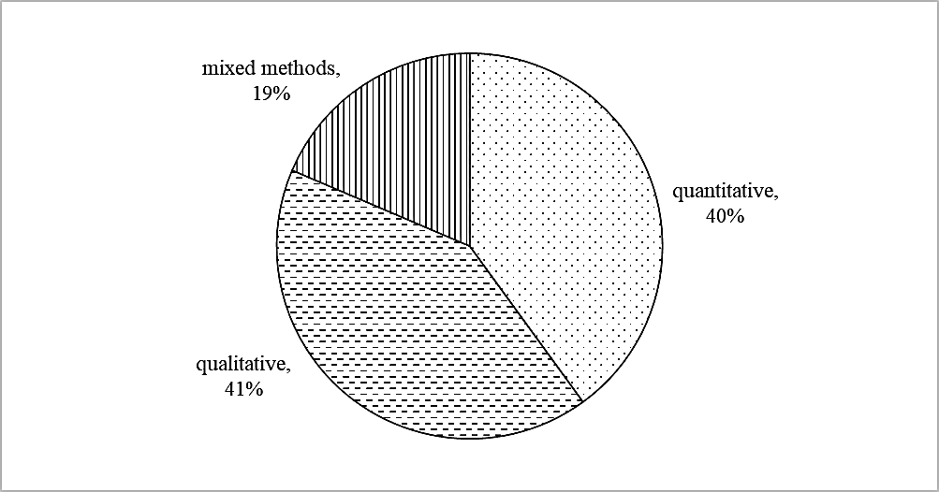

Figure 5. The research methodology of misconception studies.

Various participants are part of the research in the articles that have been reviewed. Participants are categorized into five types: undergraduate students, high school students, elementary school students, pre-service teachers, and in-service teachers. All of the participants (Figure 6) form a chain of misconceptions. That is, misconceptions may occur at one level of education that can continue to be carried at a higher level of education, even when becoming a teacher. Further analysis will be reviewed in the discussion section on causes of misconceptions.

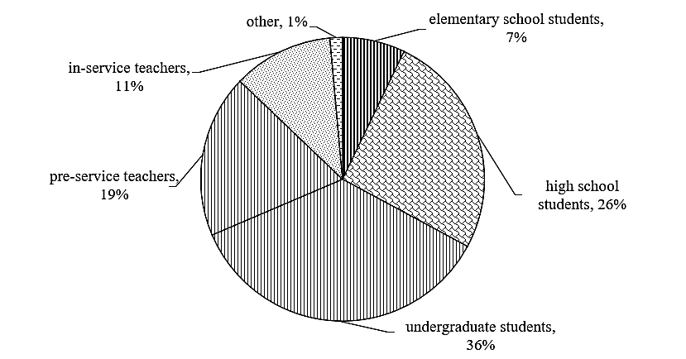

Figure 6. The participants on overall study.

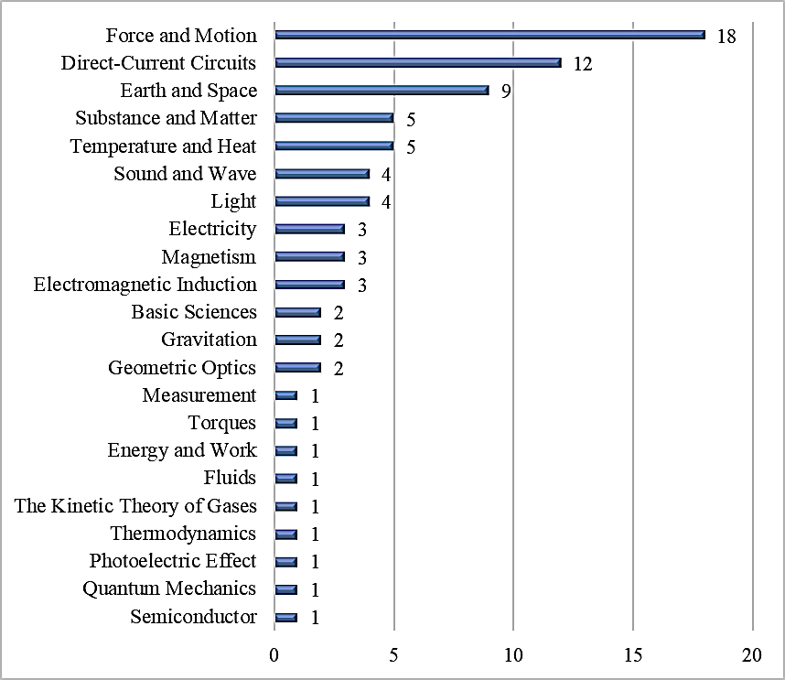

Figure 7. Any topics have analyzed on overall studies.

Figure 7 shows the distribution of physics topics analyzed in articles across the year. Physics topics broadly consist of the following areas: mechanics, oscillations and mechanical waves, thermodynamics, electricity and magnetism, light and optics, modern physics, earth and space. These topics can be separated into several subtopics. Each article exposes misconceptions on topics or subtopics in physics. The most popular subtopic as an object of research is force and motion misconception (18 articels) and followed by direct-current circuits (12 articles). Many subtopics have not been explored in physics misconception research.

**Discussion**

The analysis results of the articles give insights related to international studies of misconceptions in physics over the last fifteen years (2005-2019). Our purposes are exposed to diagnostic tools and remediation strategies for misconceptions, as well as found out the causes of these misconceptions. During the investigation, we obtained facts about research trends, research purposes, research methodology, and the participants in each article. Two other studies conducted a review and served as references in the following discussion. Kumandaş et al. (2019) have addressed misconceptions in biology and Gurel et al. (2015) have addressed the comparison of instruments for the diagnosis of misconceptions in science. Both studies provided additional insights for discussing physics misconceptions in this study.

***Research purposes across years***

Most of the articles in this study (36%) have the purpose to identify or diagnose misconceptions in physics. Most diagnoses were made into undergraduate students (32%) and pre-service teachers (28%). Diagnosis is needed to raise awareness about the existence of misconceptions regarding the students of higher education and the pre-service teachers. The needs of diagnostic tools have been supported by studies that have developed diagnostic tests for misconceptions (10%). The result of instruments can be adapted to diagnose misconceptions according to the topics. Among the diagnostic tests that have developed are multiple-choice tests and multiple-tier tests (two-tier, three-tier, and four-tier). Each of those instruments has different characteristics and is discussed in a separate sub discussion. The diagnosis of misconceptions becomes the initial round of an educator in learning to build scientific conceptions (Nitko & Brookhart, 2014; Seel et al., 2017; Topalsan & Bayram, 2019; Wind & Gale, 2015). The accumulation of the not understood concepts from elementary education to higher education plus daily experiences can trigger misconceptions. Misconceptions can be brought by students from elementary school until they studied at university (Gönen, 2008; Potvin & Cyr, 2017). The remediation of misconceptions needs to be performed before the undergraduate students and the pre-service teachers enroll in a professional career with the provision of 21st-century learning competencies.

Most of the objectives (36%) of the articles in this study are to determine the effective remediation strategies for developing scientific conceptions. The effectiveness were determined by comparing misconceptions before and after the learning process. Misconceptions identification is an important part of remediation because it helps teachers to plan learning strategies accordingly (Knowles et al., 2005). To support that, many studies (10%) have investigated the students' cognitive structures. Cognitive structure investigation gives the teacher with ideas of ​​how students think about a concept, specifically the way students link concepts in their minds (Kumandaş et al., 2019). The largest participant (36%) in the articles were undergraduate students, followed by high school students (26%), and pre-service teachers (19%). At the level of higher education, the undergraduate students tend to have complex thought abstractions. If such thought develops in the realm of science plus daily experiences and common sense concepts without the construction of scientific knowledge, it can lead to misconceptions (Krebs, 1999; Resbiantoro & Nugraha, 2017). In pre-service teachers, misconception is a concern for researchers because it has the potential to be transferred to students when they become teachers later (Kumandaş et al., 2019).

***Diagnostic tools***

Various instruments for diagnosing misconceptions have been developed and used. Diagnostic tools for misconceptions are categorized in interviews, open-ended tests, multiple-choice tests, multiple-tier tests, and sequential tests. Each form of the test has advantages and disadvantages. The test arrangement regards the purposes, participants, and fitness of the material characteristics with the test structure. A diagnosis is a form of assessment that is very precise for identifying misconceptions because it has the purpose of identifying learning outcomes that are not yet understood by students as well as the causes for remediation later (Nitko & Brookhart, 2014). The research development on misconceptions is greatly influenced by the development of diagnostic tests (Mintzes et al., 2005). The distribution of diagnostic tests for physics concepts is still limited in Figure 7, which means it still needs to be developed. The results of the misconception diagnosis will determine the steps of a teacher about their learning going forward (Harlen, 2001; Nitko & Brookhart, 2014).

Open-ended tests were chosen by most researchers (29%). The characteristic of this test is that it can explore students' ideas through the answers or responses provided (Mintzes et al., 2005). Through content analysis of the responses, researchers can identify errors and misconceptions in students (Nitko & Brookhart, 2014). The advantage of open-ended tests is that students can convey their understanding of concepts in their language, and maybe even responses that are unexpected by researchers (Kaltakci-Gurel et al., 2015). Sadler has stated that open-ended tests have the advantage of being able to reveal unexpected errors or misconceptions (Mintzes et al., 2005). While its weakness takes a long time to analyze student responses, including difficulties in scoring and categorizing responses (Kaltakci-Gurel et al., 2015). This reason that causes open-ended tests less appropriate to be employed in research with large numbers of participants. The first use of open-ended tests as diagnostic tools had been published by Andersson & Kärrqvist (1983); Palacios, Cazorla, & Madrid (1989); Langley, Ronen, & Eylon (1997); dan Colin, Chauvet, & Viennot (2002). While the use of open-ended tests in reviewed articles can be seen in the Appendix 1.

Multiple-choice tests (MCT) become the most choices after open-ended tests for diagnosing misconceptions. The form of this test generally consists of two parts, stem (problem to be tested) and a list of possible answers or multiple-choice items (Fisher & Frey, 2007). Multiple-choice items carry correct or best answer choices and distractors for questions or problems that have been submitted in the stem (Nitko & Brookhart, 2014). Distractors are answer choices that seem right for students who lack understanding, even though actually wrong. If students choose the distractors, then indicate students have misconceptions. Many kinds of MCT to identify the conceptual understanding of physics, most of them have been shared on the PhysPort page by the American Association of Physics Teachers (AAPT). An example is for testing the basic concepts of mechanics, Force Concept Inventory (FCI) has been developed in the form of MCT. Hestenes et al. (1992) as the developer has stated that one of the uses of the FCI is to diagnose misconceptions. FCI has been very popular among international researchers for testing the students' conceptual understanding and misconceptions. Many FCI users in their research based on this review are Bayraktar (2009), Martín-blas et al. (2010), Taasoobshirazi et al. (2011), Fazio & Battaglia (2018), dan Franco et al. (2012). FCI is usually adapted and translated by researchers into their language, for instance, Bayraktar (2009) had translated FCI to Turkish. Recently researchers using MCT to identify misconceptions are shown in Appendix 1.

The selection of MCT as a diagnostic tool must consider the advantages as well as weaknesses. Time efficiency for more objective analysis of answers and scoring is an advantage of MCT (Kaltakci-Gurel et al., 2015; Mintzes et al., 2005; Nitko & Brookhart, 2014). So even though the number of participants in the study is very large, the time needed for the analysis of answers will be shorter when compared to open-ended tests. Some weaknesses that need to be noticed from MCT are not being able to investigate students' ideas in depth, there are false answers although they are true, and the difficulty of arranging conforming items (Kaltakci-Gurel et al., 2015; Mintzes et al., 2005; Nitko & Brookhart, 2014). Student ideas cannot be investigated in-depth because of the limited answer choices. That closes the possibility of finding new patterns of misconception. The right answers are not certainly authentic because of any possibility that students only guessed and inadequate to explain the reasons. Likewise, students who answer incorrectly cannot be concluded having misconceptions because of any possibility that students just answered without knowledge. In their publications on FCI, Hestenes et al. (1992) also suggested to follow-up on students' wrong answers through interviews related to reasons for their choice to ensure misconceptions. The arrangement of stem and distractors are a challenge to develop well-constructed items. Stem and distractors are usually in the form of common misconceptions obtained from literature studies, interviews, or open-ended questions that are conducted first, such as Prince et al. (2012), Wind & Gale (2015), Gönen (2008), dan Alwan (2011).

Interviews are a form of diagnostic assessment to identify student understanding, including misconceptions. This diagnostic method is used in 10% of the articles that have been reviewed. Through interviews, students' thinking errors can be detected in more detail (Nitko & Brookhart, 2014). Students' ideas and structure of conceptual understanding also can be revealed by interviews (Fisher & Frey, 2007; Mintzes et al., 2005). Because of those advantages, Hestenes et al. (1992) have said that interviews were able to confirm students' responses for revealing misconceptions. Some interview techniques that had been carried out by previous researchers are Clinical Interviews (Posner & Gertzog, 1982; Ross & Munby, 1991); Interview about Instances (IAI) (Osborne & Gilbert, 1980); Interview about Events (IAE) (Boujaoude, 1991); Individual Demonstration Interviews (Goldberg & Mcdermott, 1986; 1987); Predict-Observe-Explain (POE) (Liew & Treagust, 1995); Teaching Experiment (Komorek & Duit, 2004), and others.

Based on the review, several articles used techniques that resembled interviews conducted by previous researchers, even though they did not mention them specifically. Paik et al. (2007), Kele et al. (2010), and Abrahams et al. (2015) used techniques that resembled Clinical Interviews by asking participants to explain briefly their conceptual understanding of physics. Thong & Gunstone (2008) asked a series of questions about electromagnetic phenomena, which resembled the IAI technique. Bell & Trundle (2008) asked participants to predict, observe the results of computer simulations, and explain the occurrence of these phenomena, in which the whole set of questions resembled the POE technique. Any challenges must be faced in the interviews, including a long time to obtain and analyze data, and require interviewing skills (Fisher & Frey, 2007; Mintzes et al., 2005; Nitko & Brookhart, 2014). If the results will be generalized, then interviews require a large number of participants (Kaltakci-Gurel et al., 2015). The power of interviews is being able to get in-depth information, even being able to find facts (misconceptions) that were unexpected before, such as the findings of Thong & Gunstone (2008).

Multiple-Tier Tests (MTT) develops from two-tier tests (2TT), three-tier tests (3TT), and four-tier tests (4TT). The basic structure of the three types of MTT alike with MCT. There are conceptual questions along with the reasons for answers, including the questions to the answer confidence. All types of MTT have advantages such as MCT: time efficiency, fast and objective scoring, and easy for employing in a large number of participants (Kaltakci-Gurel et al., 2015). The challenges while preparing MTT also alike with MCT, which is for determining the distractors. While the weaknesses of MTT are different for each type. The researchers who utilize MTT based on this study, are shown in Appendix 1.

The first type of MTT is 2TT. That consists of the first tier in the form of conceptual questions (content) and the second tier is the reason for the answer in the first tier (Griffard & Wandersee, 2001; Mintzes et al., 2005; Treagust, 1986). Two-tier tests were first published by Treagust (1986) which was then succeeded by many misconception researchers. As a preliminary test, 2TT can quickly identify misconceptions for planning proper learning. Griffard & Wandersee (2001) have evaluated the use of 2TT for diagnosing misconceptions and obtaining several weaknesses. Since each tier of 2TT is multiple-choice, there are indications that the participant uses the choice of reasoning (in the second tier) by guessing. So it cannot be determined whether the participants have conceptual understandings as a whole (lack of knowledge) or occurring misconceptions (Griffard & Wandersee, 2001; Kaltakci-Gurel et al., 2015). The misconception diagnosis using 2TT might not represent the authentic thinking of students because alternative answers have been prepared by answer items (Chang et al., 2007).

The second type of MTT is 3TT developed for covering the 2TT weaknesses. The lack of knowledge and misconception (overestimate judgment) inadequate to differentiate by 2TT. Interviews must be conveyed to verify answers for specifying the lack of knowledge and misconception. Interviews are inefficient because it needs a longer time for diagnosing. Instead of interviewing, one more tier was added using the Certainty Response Index (CRI). CRI was used for verifying the participant's confidence in answers (Pesman & Eryilmaz, 2010). If the participant answers confidently with the wrong answer on the first or second tier, then it can be said to be a misconception, but if not sure, it is called a lack of knowledge (Turgut et al., 2011). The difference between misconception and lack of knowledge in the participant already be recognized by 3TT. There are still assuming any errors because maybe the participant beliefs of answers are not the same in both tiers (Kaltakci-Gurel et al., 2015). The first tier answer could be sure but the reason in the second tier is not sure, or vice versa.

Based on the lack of 3TT, the third type of MTT has been developed to add one tier more. 4TT eliminates the overestimate judgment category of a lack of knowledge (Kaltakci-gurel et al., 2017). The first tier is MCT with a distractor that leads to misconceptions. The second tier confirms the answer's confidence in the first tier. The third tier is the MCT reason for the answer in the first tier. The fourth tier confirms the confidence of the answer to the third tier. Misconceptions were shown if the students' answer of the first tier was "wrong", the second tier was "sure", the third tier was "wrong", and the fourth tier was "sure" (Kaltakci-gurel et al., 2015; 2017; Kaniawati et al., 2019). Thus 4TT was claimed to provide the most valid misconception judgment than 3TT and 2TT. In general, the development of 4TT has the same challenges as MCT when arranging distractors both in the first tier and third tier. That can be performed by studying literature about misconceptions that have been discovered or conducting initial diagnosis through interviews and open-ended tests.

***Causes of Misconception***

Misconceptions become a barrier to learning physics to achieve scientific conceptions. Besides focusing on the way of diagnosis, researchers must also investigate the causes or factors that contribute to students' misconceptions. Four main factors cause misconceptions, particularly the characteristics of teaching materials, teachers, students, and reference books (Erman, 2017). Halim et al. (2019), states that students, teachers, and teaching methods are the three main causes of misconception. Other beliefs about the factors that cause misconceptions are everyday experiences, language used, teachers, and textbooks (Widiyatmoko & Shimizu, 2018). Factors that cause misconceptions can be students, teachers, language used, teaching methods, characteristics of teaching materials, and reference books, by including everyday experiences into the student area.

Based on this review, researchers focus on teacher factors and teaching methods as causes of misconception. Both of these factors are areas that can be optimized to eradicate misconceptions. In the concept of formal learning, teachers are required to be able to implement teaching methods that present scientific explanations to students (Neidorf et al., 2020). There are several problems found related to those two factors based on this review. Some teachers lack insight into the misconceptions of their students, so they only focus on teaching without trying to apply the conceptual change approach (Gaigher, 2014; Moodley & Gaigher, 2019). Another obstruction that contributes to the occurrence of misconceptions is the lack of adequate learning time management (Aykutlu et al., 2015). This can be caused by a wide range of material as a result of curriculum demands or planning targets of the teachers themselves (Aykutlu et al., 2015). As a result, students only focus on memorizing without the possibility to generate scientific conceptions through the processes of thinking and learning activities.

***Remediation of Misconceptions***

An understanding of diagnostic techniques and causes of misconception is needed to determine remediation strategies. Remediation aims to turn their naive beliefs into scientific conceptions. The determination of remediation strategies is strongly influenced by the teacher's insight related to pedagogical knowledge. Several researchers in this review have given suggestions regarding remediation strategies using the conceptual change approach (see Appendix 2). Conceptual change is a mechanism that underlies meaningful learning processes, so students who initially do not understand become understand a concept (Mayer, 2002). More simply, Mayer (2002) states that conceptual change characteristics include cognitive processes and social processes in which students try to build coherent and useful knowledge. According to a constructivist perspective, knowledge is not transferred from teacher to student but is constructed by individuals through the process of assimilation and accommodation. The accommodation process is the principal mechanism for conceptual change and has been established in a framework called the Conceptual Change Model (CCM) by Posner et al. (1982). This model has been improved by Dole & Sinatra (1998) toward the Cognitive Reconstruction of Knowledge Model (CRKM) through blending the principle of the Elaboration Likelihood Model (ELM) which had previously been developed by Petty & Cacioppo (1986).

The conceptual change approach emphasizes that learning science should not merely convey information, but must guide students to understand their experiences in science (Mayer, 2002). The teacher must alter it into an appropriate science learning method. Based on this study, learning methods that are widely used to remediate misconceptions with a conceptual change approach are Simulation-Based Experiment (11 articles), Conceptual Change Text (4 articles), and Inquiry-Based Learning (3 articles). All of these learning methods focus on student activities, and the teacher guides as they reconstruct knowledge. By understanding the characteristics of that three learning methods, researchers and teachers can perform conceptual change in physics. When referring to CCM, four conditions can be created in the learning method so that concept accommodation can occur, namely dissatisfaction, intelligible, plausible, and fruitfulness (Posner et al., 1982). The dissatisfaction condition occurs if the students are dealing with facts or problems that cannot be solved by understanding the prior concept and feeling that there is something wrong with their concept. Experiences during learning must be able to be used by students to develop scientific conceptions which is inherent (intelligible). That conceptions must be plausible, at least for solving the problems that cannot be solved by prior conceptions. Plausibility is also shown by the consistency of a concept with other knowledge. The last condition is fruitfulness which means new conception relevance to the benefit of research issues that are continuously developing.

Simulation-Based Experiment (SBE) is the most widely used choice for remediation of misconceptions. The application of computer technology in learning continues to grow, along with the development of research in educational technology. Specifically, to support the remediation with the conceptual change approach, simulation is considered to be the most appropriate method. This refers to the characteristics of simulation that are able to advance various learning objectives of science, including science learning motivation, conceptual understanding, science process skills, and understanding the nature of science (National Research Council, 2011). Computer-based simulations offer a virtual learning environment that cannot be practiced or emulated in real conditions (Januszewski & Molenda, 2008). Students can visualize, explore, and formulate scientific explanations for scientific phenomena that would otherwise be impossible to observe and manipulate (National Research Council, 2011). These are experiences offered by digital simulations and are suitable for building intelligible conditions in CCM.

Simulation potentially to be used in various approaches to teaching and learning, as didactical tools, as models and conveyance for complex concepts (Gibson & Baek, 2009), for discovery learning (Van Joolingen & De Jong, 1997), for experiential learning (Kolb, 2015), and predict-observe-explain (Kibirige et al., 2014). The keyword is an SBE able to provide concrete experiences, mediate interactions between learners and natural phenomena, and guide learners to draw conclusions based on the results of experiments. Zietsman & Hewson (1986) have been able to handle misconceptions by integrating microcomputer-based simulations and conceptual change strategies. DYNLAB, computer-based modeling has also been developed by Brna (1987) , and capable of confronting dynamics misconceptions. De Jong & Van Joolingen (1998) have also conducted studies on scientific discovery learning (SDL) with computer simulations. Another intervention has been carried out by Zacharia & Anderson (2003), who performed prior knowledge of computer-based simulations before the students conducted a laboratory experiment. In this case, that aims to establish plausibility conditions according to CCM.

SBE has any advantages if applied to the conceptual change approach. That evidenced by its effectiveness for remediating misconceptions based on the results of existing studies. Implementing SBE is not as simple as imagined because it requires collaboration with software developers and animators. Besides, it needs much detailed planning to develop digital simulations. Any challenges in developing SBE according to Gibson & Baek (2009) include: (1) the complexity of the interface developing and the attainment of the supporting devices; (2) limitations of SBE features that limit students exploration; (3) limited feedback due to the lack of adaptive systems like humans; (4) students must maintain focus because they interact with computers through multi-sensory systems; (5) when playing the simulation, students might not be able to drift into a part of the phenomenon; (6) students with weak computerized skills may be overwhelmed by playing simulations; (7) teachers must give enough direction to learners; and (8) SBE development is costly and difficult. If these challenges are not allowed well, students will miss meaningful experiences.

Conceptual Change Text (CCT) became the second most preferred method for remediating misconceptions. CCT is in the form of text with a CCM approach from Posner et al. (1982). CCT have first developed by Roth (1985) to help students to perform the four Posner conditions. If these four conditions involved in CCT, then students will be advised to obtain the conceptual change when compared to traditional text that only focuses on composing new intelligible conceptions (Roth, 1985). Traditional texts can be formed into CCT by blending the conditions of conceptual change (Chambers & Andre, 1997; Wang & Andre, 1991).

Several sections in the CCT must exist to fulfill the four Posner conditions. The first section is the process of activation or identification of possible student misconceptions. At this segment, phenomenon descriptions or conceptual facts are presented, then students are asked to make predictions or explanations about it. The second section presents narrative texts about any misconceptions, which are commonly occurring in the concept. From both sections, students will undergo cognitive conflict or dissatisfaction conditions. Students will curious to find scientific reasons that are intelligible and plausible. The descriptions are manifested in the third section by adapting from traditional texts. The final section presents a parallel study of misconceptions and scientific conceptions, then be continued by explanations related to future usage of the concept. To this section, a fruitfulness condition does achieve then students will be sure that the new concept will be useful.

CCT might be easier to develop than SBE because it is only based on text with the addition of images. Behind this convenience, many challenges must be allowed in using CCT for remediating misconceptions. Early in the CCT experimentation, Roth (1985) has advised that "poor readers" had a problem learning from texts because they had weak reading strategies. They have a problem with catching the essence of the text addressed. CCT is only effective given to students with much reading skills. That can be improved by class discussions (Guzzetti et al., 1997; Özkan, 2013). Low interest in reading is also a cause of ineffective usage of CCT (Wang & Andre, 1991). Students will feel more bored and tired if only dealing with text features (Chambers & Andre, 1997). The blend of visual elements is needed to overcome this, such as interesting diagrams and illustrations. Therefore, the use of CCT has developed towards digital, such as Computer Supported Conceptual Change (CSCCT) (Çepni, 2010).

Inquiry-Based Learning (IBL) can be the next option for remediating misconceptions. The essential characteristic of IBL is to actively engage students to construct knowledge through identifying problems, predicting solutions, and adapting new information (assimilation) to accommodation knowledge (Arends, 2012). The fundamental principle of IBL is the same as CCM, that's the Piaget's constructivism. Vosniadou (2003) has views on the essential characteristics for learning that are following the CCM to restructure non-scientific conceptions: (1) generates conditions in which students can evaluate experiential evidence that confronts their ideas; (2) provides clear explanations related to scientific conception through modeling or analogy; (3) leads the demonstrations that prove scientific explanations; (4) promote the intentional learning that ensures students about the unities of conception. These features can be interpreted into IBL phases (Trundle et al., 2007). Inquiry allows students to explore their ideas and challenge their ability to explain a concept so that it undergoes the mechanism of conceptual change (Vosniadou, 2003). Through IBL, students will also get a deeper understanding of a concept and be able to apply it in various fields of life sciences (Saunders-Stewart et al., 2015).

**Conclusions**

A misconception is a common issue in learning physics that should not be ignored by teachers. The consequence of misconceptions is critical in reaching the learning objectives. This review shows a lot of scientific publications about misconceptions in physics for the last fifteen years. A high number of publications indicate that the studies in misconceptions are still challenging and exciting for all areas. Three areas in studying misconceptions are identifying misconceptions through diagnostic tests, perceiving the causes, and remediating misconceptions. The diagnosing misconceptions and the treatment for remediating misconceptions become the most popular research areas. Actually, the two research areas support each other, because there is a sequence of the process of diagnosis and remediation of misconceptions. Each has a development of diagnostic tools and remediation methods from across the years.

This review provides several essential points and recommendations for researchers or practitioners to better deal with misconceptions:

* Educational practitioners including teachers, educators, and curriculum developers can adapt the results of misconception research to be applied in physics learning.
* The area of ​​research on misconception is still wide, especially of diagnostic tests, misconception remediation strategies, and some unexplored physics topics.
* Interviews become a powerful technique to find out new misconceptions (which have not been identified previously)
* Four-tier tests are more effective for a large number of participants.
* The most effective of remediation strategies through the conceptual change approach are Simulation-Based Experiment, Conceptual Change Texts, and Inquiry-Based Learning.
* Prospective and pre-service teachers must be targeted for investigation so that they are aware of misconceptions and have an effort to eradicate them. Misconceptions mustn't enter professional careers when becoming teachers.

There are still many other psychological parameters that need to be investigated in future research. The effect of student communication, parenting, and social environment on misconceptions seem to be the topic of future investigations.

**References**

Abrahams, I., Homer, M., Sharpe, R., & Zhou, M. (2015). A comparative cross-cultural study of the prevalence and nature of misconceptions in physics amongst English and Chinese undergraduate students. *Research in Science & Technological Education*, *33*(1), 111–130. https://doi.org/10.1080/02635143.2014.987744

Allen, M. (2014). *Misconceptions in Primary Science 2nd Edition*. New York: Open University Press.

Alwan, A. A. (2011). Misconception of heat and temperature Among physics students Introduction : *Procedia Social and Behavioral Sciences*, *12*, 600–614. https://doi.org/10.1016/j.sbspro.2011.02.074

Andersson, B., & Kärrqvist, C. (1983). How swedish pupils, aged 12‐15 years, understand light and its properties. *European Journal of Science Education*, *5*(4), 387–402. https://doi.org/10.1080/0140528830050403

Arends, R. I. (2012). *Learning to Teach* (9th ed.). New York: McGraw-Hill. Retrieved from http://onlinelibrary.wiley.com/doi/10.1002/cbdv.200490137/abstract

Aykutlu, I., Bezen, S., & Bayrak, C. (2015). Teacher opinions about the conceptual challenges experienced in teaching physics curriculum topics. *Procedia - Social and Behavioral Sciences*, *174*, 390–405. https://doi.org/10.1016/j.sbspro.2015.01.681

Battelle for Kids. (2019). Framework for 21st Century Learning. In *Partnership for 21st century learning*. Retrieved from http://static.battelleforkids.org/documents/p21/P21_Framework_Brief.pdf

Bayraktar, S. (2009). Misconceptions of turkish pre-service teachers about force and motion. *International Journal of Science and Mathematics Education*, *7*, 273–291.

Bell, R. L., & Trundle, K. C. (2008). The Use of a Computer Simulation to Promote Scientific Conceptions of Moon Phases. *Journal of Research in Science Teaching*, *45*(3), 346–372. https://doi.org/10.1002/tea

Binkley, M., Erstad, O., Herman, J., Raizen, S., Ripley, M., Miller-Ricci, M., & Rumble, M. (2012). Defining Twenty-First Century Skills. In *Assessment and Teaching of 21st Century Skills* (pp. 17–66). Springer Science+Business Media. https://doi.org/10.1007/978-94-017-9395-7

Boujaoude, S. B. (1991). A study of the nature of students’ understandings about the concept of burning. *Journal of Research in Science Teaching*, *28*(8), 689–704. https://doi.org/10.1002/tea.3660280806

Brna, P. (1987). Confronting dynamics misconceptions. *Instructional Science*, *16*(4), 351–379. https://doi.org/10.1007/BF00117752

Çepni, S. (2010). Computer supported conceptual change text: Fluid pressure. *Procedia Social and Behavioral Sciences*, *2*, 922–927. https://doi.org/10.1016/j.sbspro.2010.03.127

Chambers, S. K., & Andre, T. (1997). Gender, Prior Knowledge, Interest, and Experience in Electricity and Conceptual Change Text Manipulations in Learning about Direct Current. *Journal of Research in Science Teaching*, *34*(2), 107–123. https://doi.org/10.1002/(SICI)1098-2736(199702)34:2<107::AID-TEA2>3.0.CO;2-X

Chang, H. P., Chen, J. Y., Guo, C. J., Chen, C. C., Chang, C. Y., Lin, S. H., … Tseng, Y. T. (2007). Investigating primary and secondary student’s learning of physics concepts in Taiwan. *International Journal of Science Education*, *29*(4), 465–482. https://doi.org/10.1080/09500690601073210

Chen, C., Sonnert, G., Sadler, P. M., Sasselov, D., & Fredericks, C. (2019). The impact of student misconceptions on student persistence in a MOOC. *Journal of Research in Science Teaching*, 1–32. https://doi.org/10.1002/tea.21616

Chi, M. T. H., & Roscoe, R. D. (2002). The Processes and Challenges of Conceptual Change. In M. Limón & L. Mason (Eds.), *Reconsidering Conceptual Change: Issues in Theory and Practice* (pp. 3–28). New York: Kluwer Academic Publishers.

Clement, J., Brown, D. E., & Zietsman, A. (1989). Not all preconceptions are misconceptions: Finding ‘anchoring conceptions’ for grounding instruction on students’ intuitions. *International Journal of Science Education*, *11*(5), 554–565. https://doi.org/10.1080/0950069890110507

Colin, P., Chauvet, F., & Viennot, L. (2002). Reading images in optics: Students’ difficulties and teachers’ views. *International Journal of Science Education*, *24*(3), 313–332. https://doi.org/10.1080/09500690110078923

De Jong, T., & Van Joolingen, W. R. (1998). Scientific discovery learning with computer simulations of conceptual domains. *Review of Educational Research*, *68*(2), 179–201. https://doi.org/10.3102/00346543068002179

Dole, J. A., & Sinatra, G. M. (1998). Reconceptualizing Change in the Cognitive Construction of Knowledge. *Educational Psychologist*, *33*(3), 109–128. https://doi.org/10.1207/s15326985ep3302&3_5

Driver, R., & Easley, J. (1978). Pupils and paradigms: A review of literature related to concept development in adolescent science students. *Studies in Science Education*, *5*(1), 61–84. https://doi.org/10.1080/03057267808559857

Erman, E. (2017). Factors contributing to students’ misconceptions in learning covalent bonds. *Journal of Research in Science Teaching*, *54*(4), 520–537. https://doi.org/10.1002/tea.21375

Fazio, C., & Battaglia, O. R. (2018). Conceptual Understanding of Newtonian Mechanics Through Cluster Analysis of FCI Student Answers. *International Journal of Science and Mathematics Education*, *17*, 1497–1517. https://doi.org/10.1007/s10763-018-09944-1

Fisher, D., & Frey, N. (2007). *Checking for understanding: formative assessment techniques for your classroom*. Alexandria, Virginia: Association for Supervision and Curriculum Development (ASCD).

Franco, G. M., Muis, K. R., Kendeou, P., Ranellucci, J., Sampasivam, L., & Wang, X. (2012). Examining the influences of epistemic beliefs and knowledge representations on cognitive processing and conceptual change when learning physics. *Learning and Instruction*, *22*(1), 62–77. https://doi.org/10.1016/j.learninstruc.2011.06.003

Gaigher, E. (2014). Questions about Answers : Probing Teachers ’ Awareness and Planned Remediation of Learners ’ Misconceptions about Electric Circuits. *African Journal of Research in Mathematics , Science and Technology Education*, *18*(2), 176–187. https://doi.org/10.1080/10288457.2014.925268

Gibson, D., & Baek, Y. (Eds.). (2009). *Digital simulations for improving education: Learning through artificial teaching environments*. Hershey, PA: Information Science Reference. https://doi.org/10.4018/978-1-60566-322-7

Goldberg, F. M., & Mcdermott, L. C. (1986). Student difficulties in understanding image formation by a plane mirror. *The Physics Teacher*, *24*, 472. https://doi.org/10.1119/1.2342096

Goldberg, F. M., & McDermott, L. C. (1987). An investigation of student understanding of the real image formed by a converging lens or concave mirror. *American Journal of Physics*, *55*(2), 108–119. https://doi.org/10.1119/1.15254

Gomez-Zwiep, S. (2008). Elementary teachers’ understanding of students’ science misconceptions: Implications for practice and teacher education. *Journal of Science Teacher Education*, *19*(5), 437–454. https://doi.org/10.1007/s10972-008-9102-y

Gomez, P. J. S. (2016). Students’ Ideas and Radical Constructivism ´. *Science & Education*, *25*, 629–650. https://doi.org/10.1007/s11191-016-9829-3

Gönen, S. (2008). A study on student teachers’ Misconceptions and scientifically acceptable conceptions about mass and gravity. *Journal of Science Education and Technology*, *17*(1), 70–81. https://doi.org/10.1007/s10956-007-9083-1

Greca, I. M., & Moreira, M. A. (2002). Mental, Physical, and Mathematical Models in the Teaching and Learning of Physics. *Science Education*, *86*(1), 106–121. https://doi.org/10.1002/sce.10013

Griffard, P. B., & Wandersee, J. H. (2001). The two-tier instrument on photosynthesis: What does it diagnose? *International Journal of Science Education*, *23*(10), 1039–1052. https://doi.org/10.1080/09500690110038549

Guzzetti, B. J., Williams, W. O., Skeels, S. A., & Wu, S. M. (1997). Influence of Text Structure on Learning Counterintuitive Physics Concepts. *Journal of Research in Science Teaching*, *34*(7), 701–719.

Halim, A., Lestari, D., & Mustafa. (2019). Identification of the causes of misconception on the concept of dynamic electricity. *J. Phys.: Conf. Ser.*, *1280*, 052060. https://doi.org/10.1088/1742-6596/1280/5/052060

Harlen, W. (2001). *Teaching, learning and assessing science 5-12*. London: Paul Chapman Publishing Ltd.

Helm, H. (1980). Misconceptions in physics amongst South African students. *Physics Education*, *15*(2), 92–105. https://doi.org/10.1088/0031-9120/15/2/308

Hestenes, D., Wells, M., & Swackhamer, G. (1992). Force Concept Inventory. *The Physics Teacher*, *30*(March), 141–158.

Ilyas, A., & Saeed, M. (2018). Exploring Teachers’ Understanding about Misconceptions of Secondary Grade Chemistry Students. *International Journal for Cross-Disciplinary Subjects in Education*, *9*(1), 3323–3328. https://doi.org/10.20533/ijcdse.2042.6364.2018.0444

Januszewski, A., & Molenda, M. (2008). *Educational Technology: A Definition with Commentary*. New York, NY: Taylor & Francis Group, LLC.

Jenkins, E. W. (2000). Constructivism in School Science Education: Powerful Model or the Most Dangerous Intellectual Tendency? *Science & Education*, *9*, 599–610.

Kaltakci-gurel, D., Eryilmaz, A., & Mcdermott, L. C. (2017). Development and application of a four-tier test to assess pre-service physics teachers’ misconceptions about geometrical optics. *Research in Science & Technological Education*, *35*(2), 238–260. https://doi.org/10.1080/02635143.2017.1310094

Kaltakci-Gurel, D., Eryilmaz, A., & McDermott, L. C. (2015). A review and comparison of diagnostic instruments to identify students’ misconceptions in science. *Eurasia Journal of Mathematics, Science and Technology Education*, *11*(5), 989–1008. https://doi.org/10.12973/eurasia.2015.1369a

Kang, H., Scharmann, L. C., Kang, S., & Noh, T. (2010). Cognitive conflict and situational interest as factors influencing conceptual change. *International Journal of Environmental and Science Education*, *5*(4), 383–405.

Kaniawati, I., Fratiwi, N. J., Danawan, A., & Suyana, I. (2019). Analyzing Students’ Misconceptions about Newton’s Laws through Four-Tier Newtonian Test (FTNT). *Journal of Turkish Science Education*, *16*(1), 110–122. https://doi.org/10.12973/tused.10269a

Karpudewan, M., Zain, A. N. M., & Chandrasegaran, A. L. (2017). Introduction: Misconceptions in Science Education: An Overview. In M. Karpudewan, A. N. M. Zain, & A. L. Chandrasegaran (Eds.), *Overcoming Students’ Misconceptions in Science* (pp. 1–8). Singapore: Springer Nature.

Kele, Ö., Erta, H., Uzun, N., & Cans, M. (2010). The understanding levels of preservice teachers ’ of basic science concepts ’ measurement units and devices , their misconceptions and its causes. *Procedia Social and Behavioral Sciences*, *9*, 390–394. https://doi.org/10.1016/j.sbspro.2010.12.170

Kibirige, I., Osodo, J., & Tlala, K. M. (2014). The effect of predict-observe-explain strategy on learners’ misconceptions about dissolved salts. *Mediterranean Journal of Social Sciences*, *5*(4), 300–310. https://doi.org/10.5901/mjss.2014.v5n4p300

Klammer, J. (1998). An Overview of Techniques for Identifying , Acknowledging and Overcoming Alternate Conceptions in Physics Education. *Klingenstein Project Report, Teachers College-Columbia University.* Retrieved from http://files.eric.ed.gov/fulltext/ED423121.pdf

Knowles, M. S., Holton, E. F., & Swanson, R. A. (2005). *The adult learner: the definitive classic in adult education and human resource development* (6th ed.). Amsterdam: Elsevier.

Kolb, D. A. (2015). *Experiential learning: experience as the source of learning and development* (Second). New Jersey: Pearson Education, Inc.

Komorek, M., & Duit, R. (2004). The teaching experiment as a powerful method to develop and evaluate teaching and learning sequences in the domain of non-linear systems. *International Journal of Science Education*, *26*(5), 619–633. https://doi.org/10.1080/09500690310001614717

Konicek-Moran, R., & Keeley, P. (2015). *Teaching for Conceptual Understanding in Science*. Arlington: National Science Teachers Association Press.

Krebs, R. E. (1999). *Scientific development and misconceptions through the ages: a reference guide*. Westport, CT: Greenwood Press.

Kumandaş, B., Ateskan, A., & Lane, J. (2019). Misconceptions in biology: a meta-synthesis study of research, 2000–2014. *Journal of Biological Education*, *53*(4), 350–364. https://doi.org/10.1080/00219266.2018.1490798

Labobar, H., Setyosari, P., Degeng, I. N. S., & Dsna, W. (2017). The Effect of Cognitive Conflict Strategy to Chemical Conceptual Change. *International Journal of Science and Research (IJSR)*, *6*(4), 2350–2352. https://doi.org/10.21275/ART20172970

Langley, D., Ronen, M., & Eylon, B. S. (1997). Light Propagation and Visual Patterns: Preinstruction Learners’ Conceptions. *Journal of Research in Science Teaching*, *34*(4), 399–424. https://doi.org/10.1002/(SICI)1098-2736(199704)34:4<399::AID-TEA8>3.0.CO;2-M

Lee, M., Wu, Y., & Tsai, C. (2009). Research trends in science education from 2003 to 2007: A content analysis of publications in selected journals. *International Journal of Science Education*, *31*(15), 1999–2020. https://doi.org/10.1080/09500690802314876

Liew, C. W., & Treagust, D. F. (1995). A predict-observe-explain teaching sequence for learning about students understand of heat and expansion of liquids. *Australian Science Teachers Journal*, *41*(1), 68–81.

Martín-blas, T., Seidel, L., & Serrano-fernández, A. (2010). Enhancing Force Concept Inventory diagnostics to identify dominant misconceptions in first-year engineering physics. *European Journal of Engineering*, *35*(6), 597–606. https://doi.org/10.1080/03043797.2010.497552

Mayer, R. E. (2002). Understanding Conceptual Change: A Commentary. In M. Limón & L. Mason (Eds.), *Reconsidering Conceptual Change: Issues in Theory and Practice* (pp. 101–111). New York: Kluwer Academic Publishers.

McCloskey, M., Caramazza, A., & Green, B. (1980). Curvilinear Motion in the Absence of External Forces: Naive Beliefs About the Motion of Objects. *Science*, *210*(4474), 1139–1141.

Mintzes, J. J., Wandersee, J. H., & Novak, J. D. (Eds.). (2005). *Assessing Science Understanding: A Human Constructivist View*. San Diego, California: Elsevier Academic Press.

Moodley, K., & Gaigher, E. (2019). Teaching Electric Circuits: Teachers’ Perceptions and Learners’ Misconceptions. *Research in Science Education*, *49*, 73–89. https://doi.org/10.1007/s11165-017-9615-5

National Research Council. (1997). *Science Teaching Reconsidered: A Handbook*. Washington, DC: The National Academies Press. https://doi.org/https://doi.org/10.17226/5287

National Research Council. (2011). *Learning science through computer games and simulations*. (M. A. Honey & M. Hilton, Eds.). Washington, DC: The National Academies Press. https://doi.org/10.1111/j.1467-8535.2011.01247_6.x

Neidorf, T., Arora, A., Erberber, E., & Tsokodayi, Y. (2020). *Student Misconceptions and Errors in Physics and Mathematics: Exploring Data from TIMSS and TIMSS*. Gewerbestrasse: Springer Nature Switzerland AG. https://doi.org/10.1007/978-3-030-30188-0

Nitko, A. J., & Brookhart, S. M. (2014). *Educational Assessment of Students*. London: Pearson Education Limited.

Osborne, R. J., & Gilbert, J. K. (1980). A method for investigating concept understanding in science. *European Journal of Science Education*, *2*(3), 311–321. https://doi.org/10.1080/0140528800020311

Özkan, G. (2013). The use of conceptual change texts as class material in the teaching of “ sound ” in physics. *Asia-Pacific Forum on Science Learning and Teaching*, *14*(1), 1–23.

Paik, S.-H., Cho, B.-K., & Go, Y.-M. (2007). Korean 4- to 11-Year-Old Student Conceptions of Heat and Temperature. *Journal of Research in Science Teaching*, *44*(2), 284–302. https://doi.org/10.1002/tea

Palacios, F. J. P., Cazorla, F. N., & Madrid, A. C. (1989). Misconceptions on geometric optics and their association with relevant educational variables. *International Journal of Science Education*, *11*(3), 273–286. https://doi.org/10.1080/0950069890110304

Pesman, H., & Eryilmaz, A. L. I. (2010). Development of a Three-Tier Test to Assess Misconceptions About Simple Electric Circuits. *The Journal of Educational Research*, *103*, 208–222. https://doi.org/10.1080/00220670903383002

Petty, R. E., & Cacioppo, J. T. (1986). The Elaboration Likelihood Model of Persuasion. *Advances in Experimental Social Psychology*, *19*, 123–205.

Posner, G. J., & Gertzog, W. A. (1982). The clinical interview and the measurement of conceptual change. *Science Education*, *66*(2), 195–209. https://doi.org/10.1002/sce.3730660206

Posner, G. J., Strike, K. A., Hewson, P. W., & Gertzog, W. A. (1982). Accommodation of a Scientific Conception: Toward a Theory of Conceptual Change. *Science Education*, *66*(2), 211–227.

Potvin, P., & Cyr, G. (2017). Toward a durable prevalence of scientific conceptions: Tracking the effects of two interfering misconceptions about buoyancy from preschoolers to science teachers. *Journal of Research in Science Teaching*, *54*(9), 1121–1142. https://doi.org/10.1002/tea.21396

Prasad, B. D. (2008). Content Analysis: A Method in Social Science Research. In D. K. L. Das & V. Bhaskaran (Eds.), *Research Methods for Social Work* (pp. 173–193). New Delhi: Rawat Publications.

Prince, M., Vigeant, M., & Nottis, K. (2012). Development of the Heat and Energy Concept Inventory: Preliminary Results on the Prevalence and Persistence of Engineering Students’ Misconceptions. *Journal of Engineering Education*, *101*(3), 412–438.

Qian, Y., Hambrusch, S., Yadav, A., Gretter, S., & Li, Y. (2019). Teachers’ Perceptions of Student Misconceptions in Introductory Programming. *Journal of Educational Computing Research*, (1800). https://doi.org/10.1177/0735633119845413

Ramsburg, J. T., & Ohlsson, S. (2016). Category change in the absence of cognitive conflict. *Journal of Educational Psychology*, *108*(1), 98–113. https://doi.org/10.1037/edu0000050

Resbiantoro, G. (2016). Self-Efficacies of Prospective Mathematic Teachers ’ Technological Pedagogical Content Knowledge. *VARIDIKA (Varia Pendidikan)*, *28*(2), 102–115. Retrieved from http://journals.ums.ac.id/index.php/varidika/article/download/2735/1963

Resbiantoro, G., & Nugraha, A. W. (2017). Miskonsepsi Mahasiswa pada Konsep Dasar Gaya dan Gerak untuk Sekolah Dasar. *Jurnal Pendidikan Sains (JPS)*, *5*(2), 80–87. https://doi.org/10.26714/jps.5.2.2017.80-87

Ross, B., & Munby, H. (1991). Concept mapping and misconceptions: A study of high‐school students’ understandings of acids and bases. *International Journal of Science Education*, *13*(1), 11–23. https://doi.org/10.1080/0950069910130102

Roth, K. J. (1985). Conceptual Change Learning and Student Processing of Science Texts. In *American Educational Research Association*. Washington, D.C.: Association of American Publishers. Retrieved from https://files.eric.ed.gov/fulltext/ED267980.pdf

Saunders-Stewart, K. S., Gyles, P. D. T., Shore, B. M., & Bracewell, R. J. (2015). Student outcomes in inquiry: students’ perspectives. *Learning Environments Research*, *18*(2), 289–311. https://doi.org/10.1007/s10984-015-9185-2

Seatter, C. S. (2003). Constructivist Science Teaching: Intellectual and Strategic Teaching Acts. *Interchange*, *34*(1), 63–87.

Seel, N. M., Lehmann, T., Blumschein, P., & Podolskiy, O. A. (2017). *Instructional Design for Learning*. Rotterdam: Sense Publishers.

Singh, C. (2007). Effect of misconception on transfer in problem solving. *AIP Conference Proceedings*, *951*, 196–199. https://doi.org/10.1063/1.2820931

Skamp, K. (2012). *Teaching Primary Science*. Australian Academy of Science.

Slavin, R. E. (2018). *Educational Psychology: theory and practice* (Twelfth ed). New York: Pearson.

Soeharto, Csapó, B., Sarimanah, E., Dewi, F. I., & Sabri, T. (2019). A review of students’ common misconceptions in science and their diagnostic assessment tools. *Jurnal Pendidikan IPA Indonesia*, *8*(2), 247–266. https://doi.org/10.15294/jpii.v8i2.18649

Stump, D. J. (2015). *Conceptual Change and the Philosophy of Science*. *Conceptual Change and the Philosophy of Science*. New York: Routledge. https://doi.org/10.4324/9781315712581

Taasoobshirazi, G., Sinatra, G. M., & Angeles, L. (2011). A Structural Equation Model of Conceptual Change in Physics. *Journal of Research in Science Teaching*, *48*(8), 901–918. https://doi.org/10.1002/tea.20434

Thagard, P. (2012). *The Cognitive Science of Science: Explanation, Discovery, and Conceptual Change*. *The Cognitive Science of Science*. Massachusetts: The MIT Press. https://doi.org/10.7551/mitpress/9218.001.0001

Thong, W. M., & Gunstone, R. (2008). Some student conceptions of electromagnetic induction. *Research in Science Education*, *38*(1), 31–44. https://doi.org/10.1007/s11165-007-9038-9

Toh, K., Ho, B., & Chew, C. M. K. (2003). Teaching, Teacher Knowledge and Constructivism. *Educational Research for Policy and Practice*, *2*, 195–204.

Topalsan, A. K., & Bayram, H. (2019). Identifying Prospective Primary School Teachers’ Ontologically Categorized Misconceptions on the Topic of “Force and Motion.” *Journal of Turkish Science Education*, *16*(1), 85–108. https://doi.org/10.12973/tused.10268a

Treagust, D. (1986). Evaluating students’ misconceptions by means of diagnostic multiple choice items. *Research in Science Education*, *16*, 199–207.

Treagust, D. F., Won, M., & McLure, F. (2017). Multiple Representations and Students’ Conceptual Change in Science. In T. G. Amin & O. Levrini (Eds.), *Converging Perspectives on Conceptual Change*. New York: Routledge. https://doi.org/10.4324/9781315467139

Trundle, K. C., Atwood, R. K., & Christopher, J. E. (2007). A Longitudinal Study of Conceptual Change: Preservice Elementary Teachers’ Conceptions of Moon Phases. *Journal of Research in Science Teaching*, *44*(2), 303–326. https://doi.org/10.1002/tea

Turgut, Ü., Gürbüz, F., & Turgut, G. (2011). An investigation 10 th grade students ’ misconceptions about electric current. *Procedia Social and Behavioral Sciences*, *15*, 1965–1971. https://doi.org/10.1016/j.sbspro.2011.04.036

Van Joolingen, W. R., & De Jong, T. (1997). An extended dual search space model of scientific discovery learning. *Instructional Science*, *25*(5), 307–346. https://doi.org/10.1023/A:1002993406499

Verkade, H., Mulhern, T. D., Lodge, Jason, M., Elliot, K., Cropper, S., Rubinstein, B. I. P., … Mulder, R. (2017). *Misconceptions as a trigger for enhancing student learning in higher educationn: A handbook for educators*. Melbourne: The University of Melbourne.

Vosniadou, S. (2003). Exploring the Relationships Between Conceptual Change and Intentional Learning. In G. M. Sinatra & P. R. Pintrich (Eds.), *Intentional conceptual change*. New Jersey: Lawrence Erlbaum Associates, Inc.

Vosniadou, S. (2019). The Development of Students’ Understanding of Science. *Frontiers in Education*, *4*(32), 1–6. https://doi.org/10.3389/feduc.2019.00032

Wang, T., & Andre, T. (1991). Conceptual change text versus traditional text and application questions versus no questions in learning about electricity. *Contemporary Educational Psychology*, *16*, 103–116. https://doi.org/10.1016/0361-476X(91)90031-F

Weil-Barais, A. (2001). Constructivism and Education: Constructivist Approaches and the Teaching of Science. *Prospects*, *XXXI*(2), 187–196.

Widiyatmoko, A., & Shimizu, K. (2018). Literature Review of Factors Contributing to Students ’ Misconceptions in Light and Optical Instruments. *International Journal of Environmental and Science Education*, *13*(10), 853–863.

Wind, S. A., & Gale, J. D. (2015). Diagnostic Opportunities Using Rasch Measurement in the Context of a Misconceptions‐Based Physical Science Assessment. *Science Education*, *99*(4), 721–741. https://doi.org/10.1002/sce.21172

Windschitl, M. (2002). Framing Constructivism in Practice as the Negotiation of Dilemmas: An Analysis of the Conceptual, Pedagogical, Cultural, and Political Challenges Facing Teachers. *Review of Educational Research*, *72*(2), 131–175. https://doi.org/10.3102/00346543072002131

Woolfolk, A. (2016). *Educational Psychology* (13th ed.). London: Pearson Education.

Zacharia, Z., & Anderson, O. R. (2003). The effects of an interactive computer-based simulation prior to performing a laboratory inquiry-based experiment on students’ conceptual understanding of physics. *American Journal of Physics*, *71*(6), 618–629. https://doi.org/10.1119/1.1566427

Zietsman, A. I., & Hewson, P. W. (1986). Simulations and Conceptual Change Strategies on Science Learning. *Journal of Research in Science Teaching*, *23*(1), 27–39.

1. **Bukti konfirmasi review dan hasil review pertama (2 Mei 2021)**

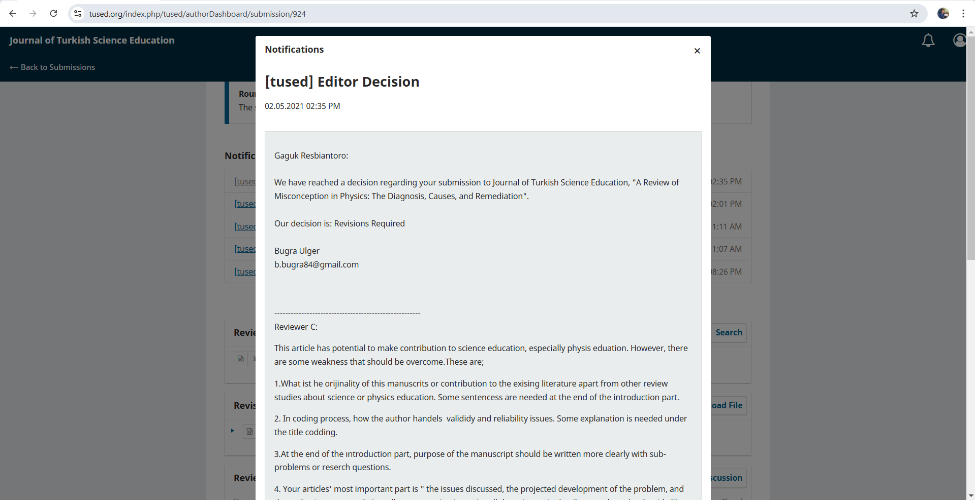

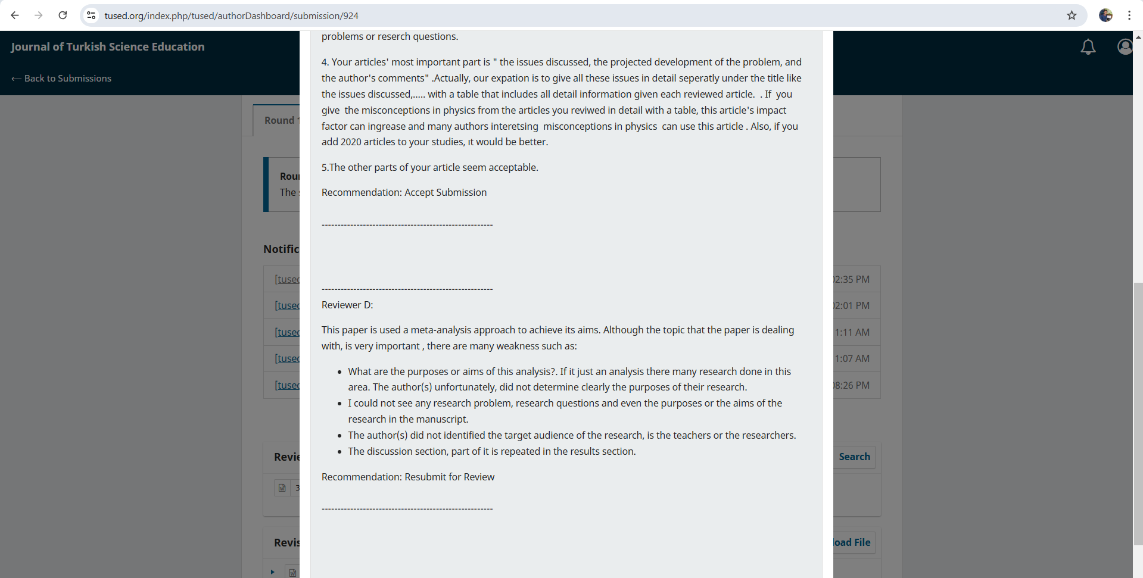

1. **Bukti konfirmasi submit revisi pertama, respon kepada reviewer, dan artikel yang diresubmit (19 Juni 2021)**

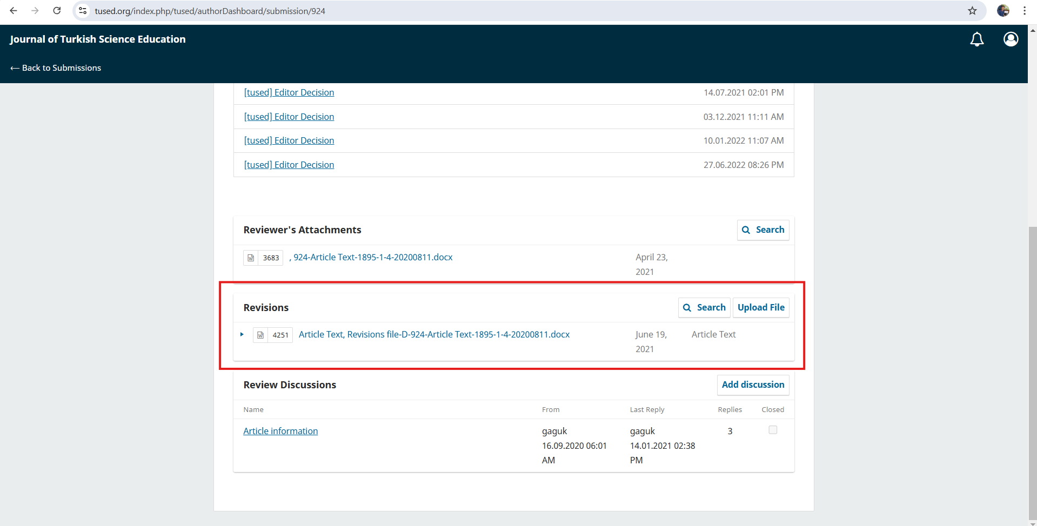

**Reviewer C:**

This article has potential to make contribution to science education, especially physis eduation. However, there are some weakness that should be overcome.These are;

1.What ist he orijinality of this manuscrits or contribution to the exising literature apart from other review studies about science or physics education. Some sentencess are needed at the end of the introduction part.

3. At the end of the ıntroduction part, purpose of the manuscript should be written more clearly with sub-problems or reserch questions.

***Response:***

We update this:

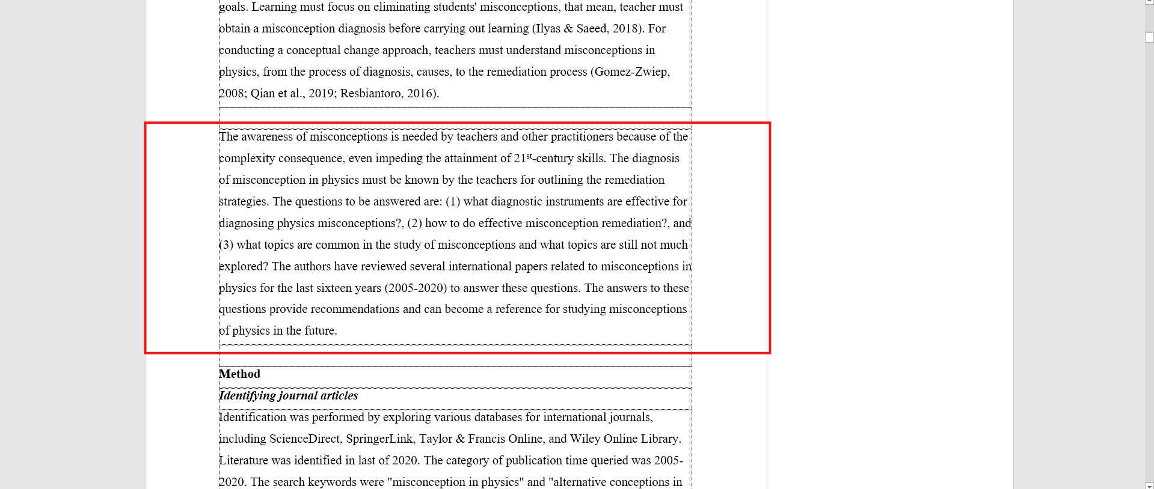

2. In coding process, how the author handels  valididy and reliability issues. Some explanation is needed under the title codding.

***Response:***

We update this:

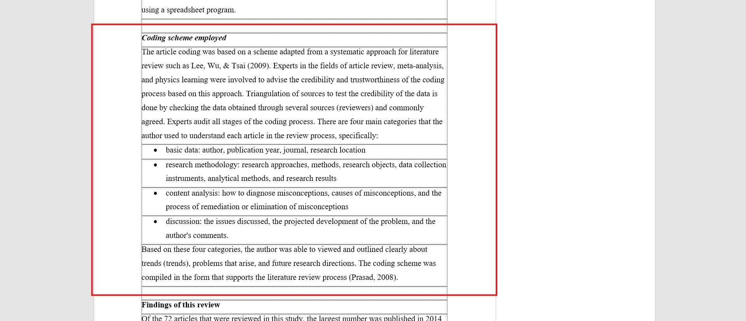

4. Your articles' most important part is " the issues discussed, the projected development of the problem, and the author's comments" .Actually, our expation is to give all these issues in detail seperatly under the title like the issues discussed,..... **with a table that includes all detail information given each reviewed article**.  . If  you give  the misconceptions in physics from the articles you reviwed in detail with a table, this article's impact factor can ingrease and many authors interetsing  misconceptions in physics  can use this article . Also, if you add 2020 articles to your studies, ıt would be better.

5.The other parts of your article seem acceptable.

***Response:***

We update this:

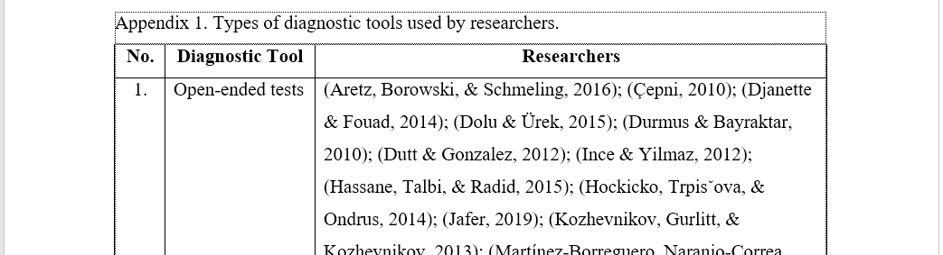

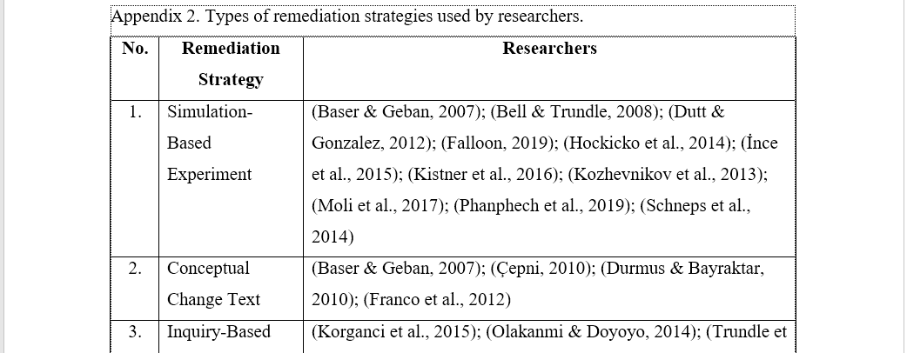

**Reviewer D:**

This paper is used a meta-analysis approach to achieve its aims. Although the topic that the paper is dealing with, is very important , there are many weakness such as:

1. What are the purposes or aims of this analysis?. If it just an analysis there many research done in this area. The author(s) unfortunately, did not determine clearly the purposes of their research.
2. I could not see any research problem, research questions and even the purposes or the aims of the research in the manuscript.
3. The author(s) did not identified the target audience of the research, is the teachers or the researchers.

***Response:***

We update this:



1. The discussion section, part of it is repeated in the results section.

***Response:***

We update this: (expand the discussion with theories, previous researches, and our argumentations.

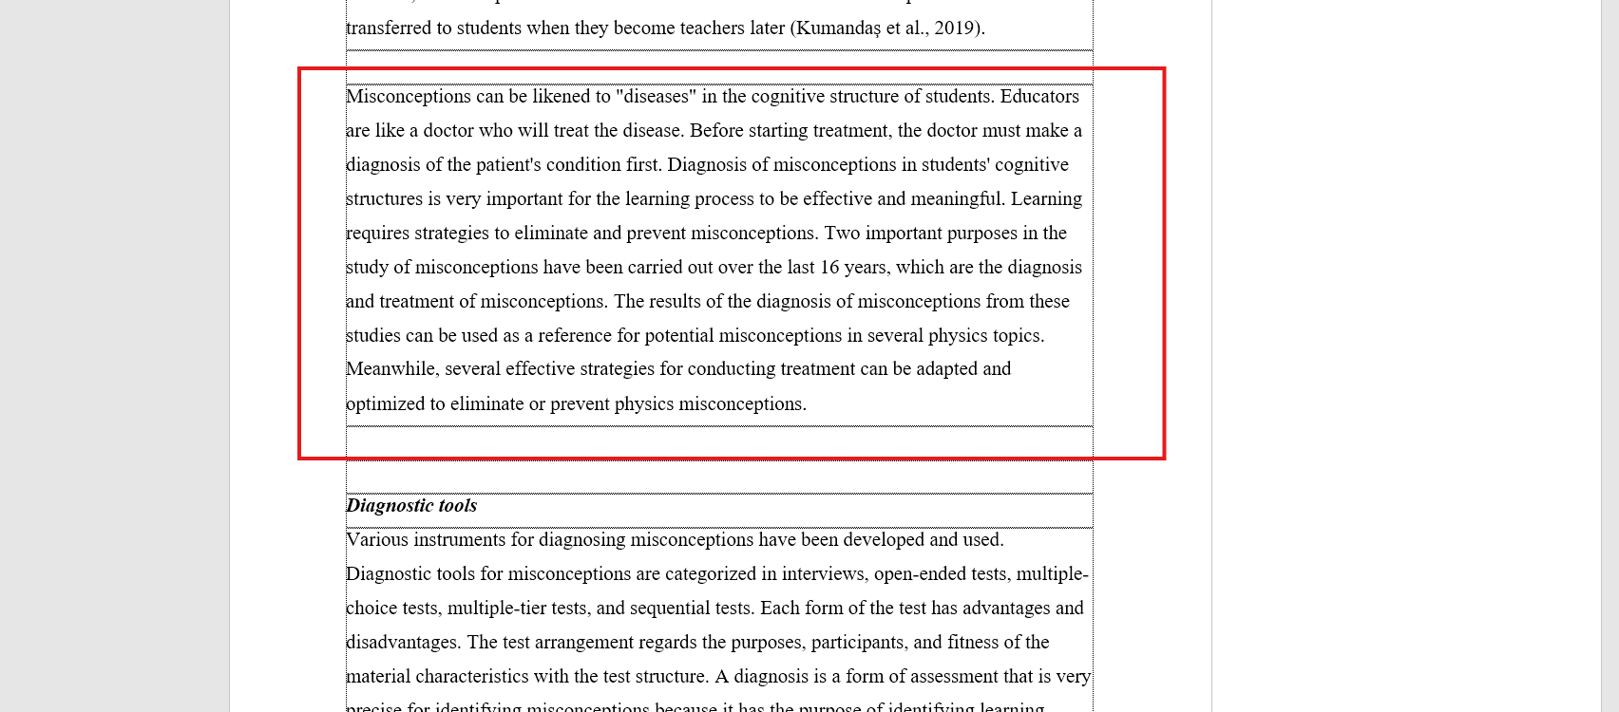

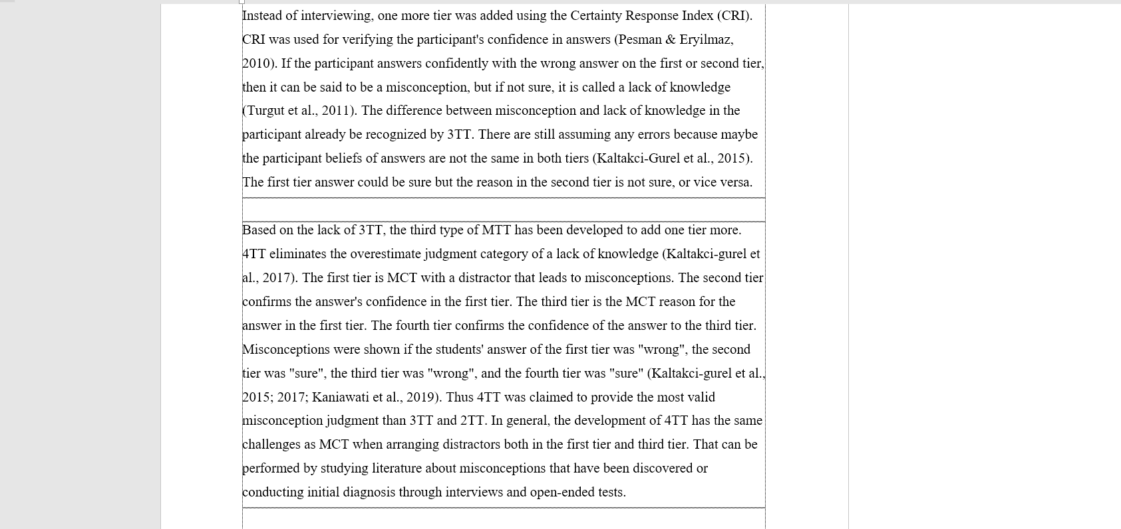

1. **Bukti konfirmasi review dan hasil review kedua (3 Desember 2021)**

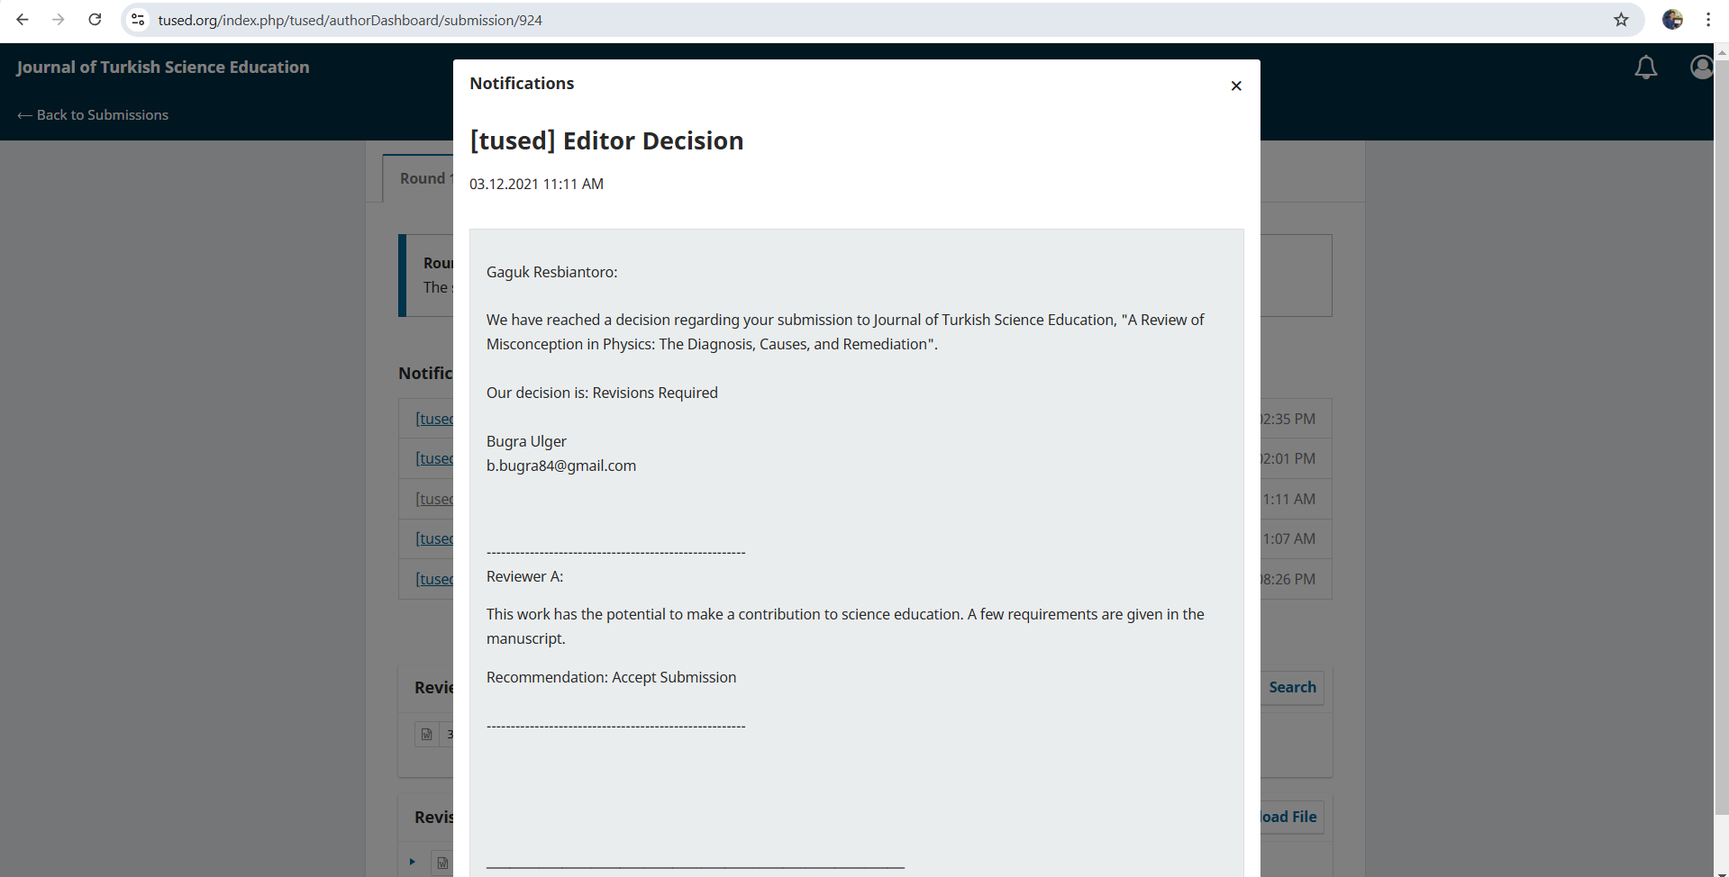

1. **Bukti konfirmasi submit revisi pertama, respon kepada reviewer, dan artikel yang diresubmit (5 Desember 2021)**

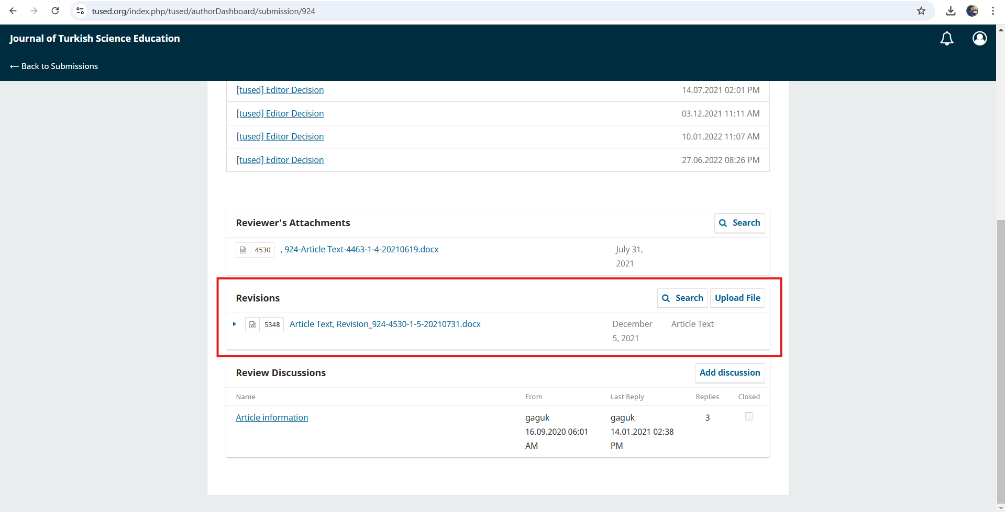

1. **Bukti Konfirmasi Artikel Accepted serta masuk tahap proofreading and editing**

**(10 Januari 2022)**

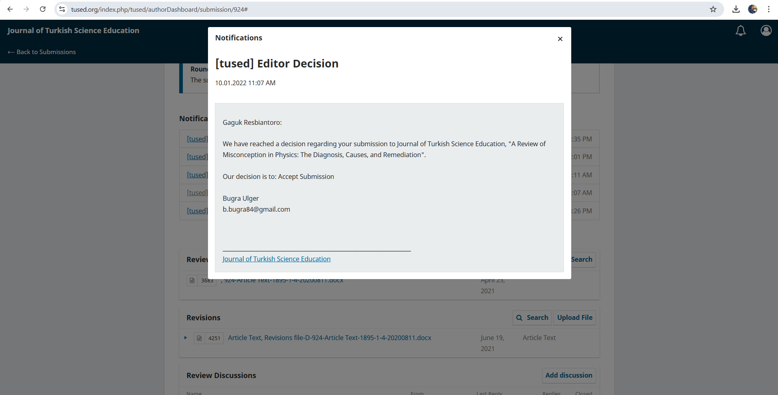

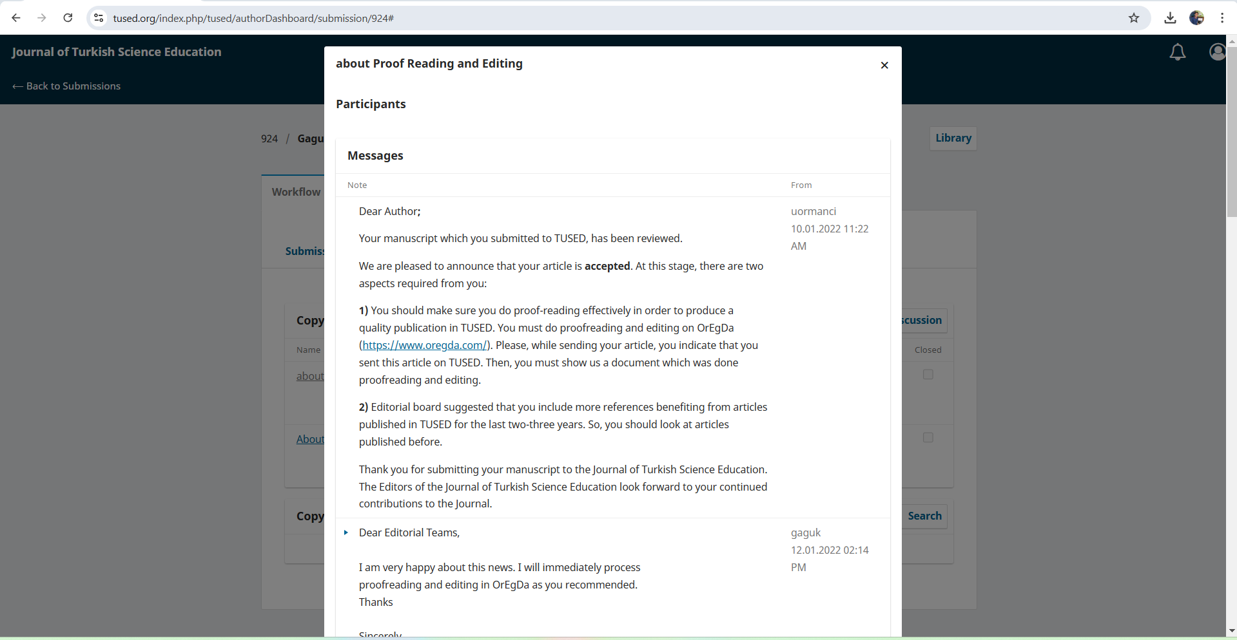

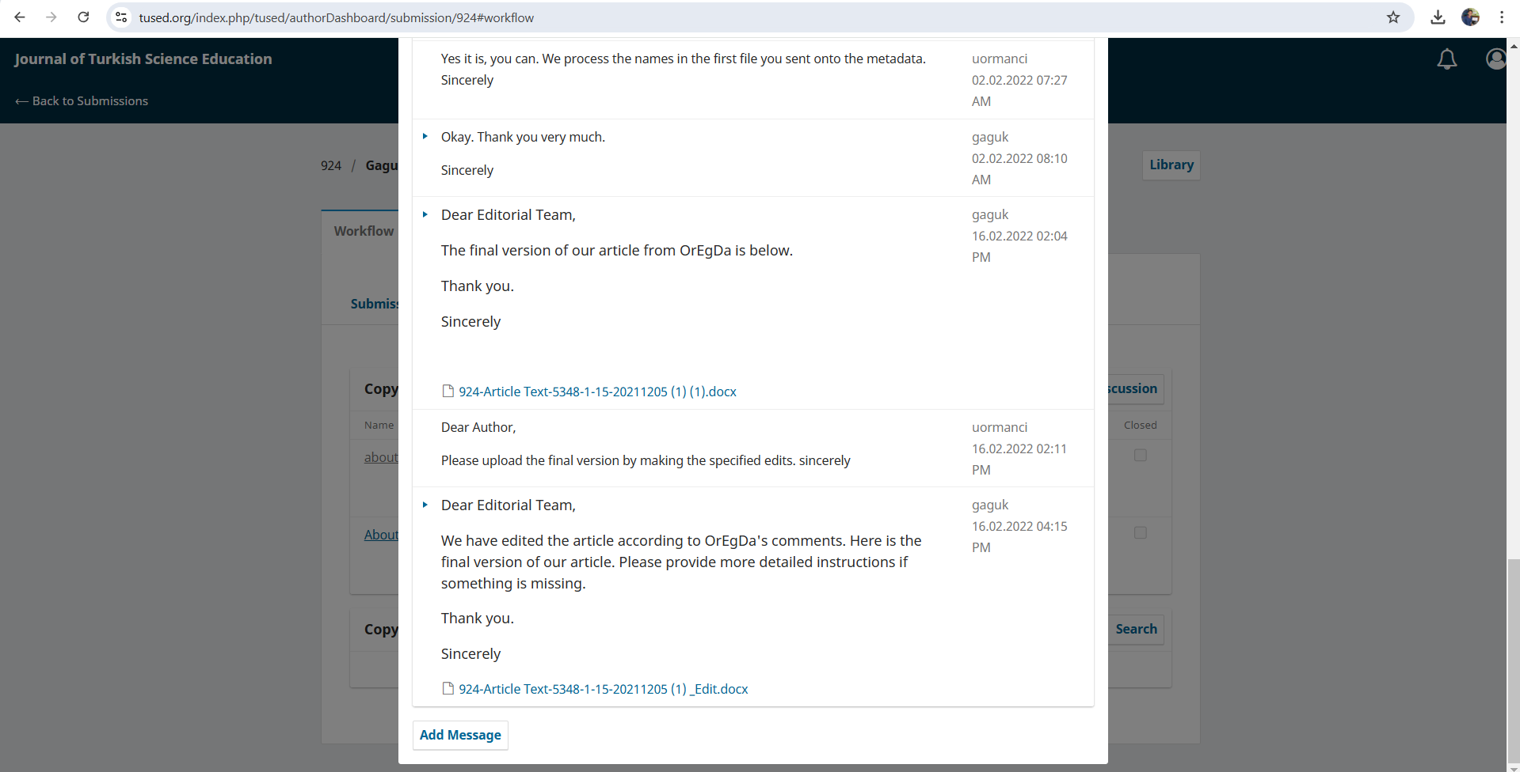

***Result of Proofreading and editing process:***

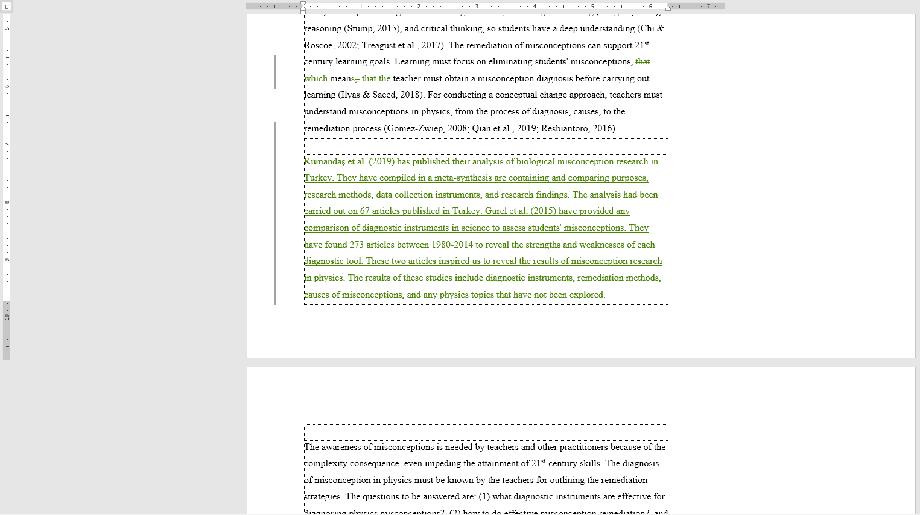

1. **Bukti konfirmasi artikel tahap produksi published online (27 Juni 2022)**

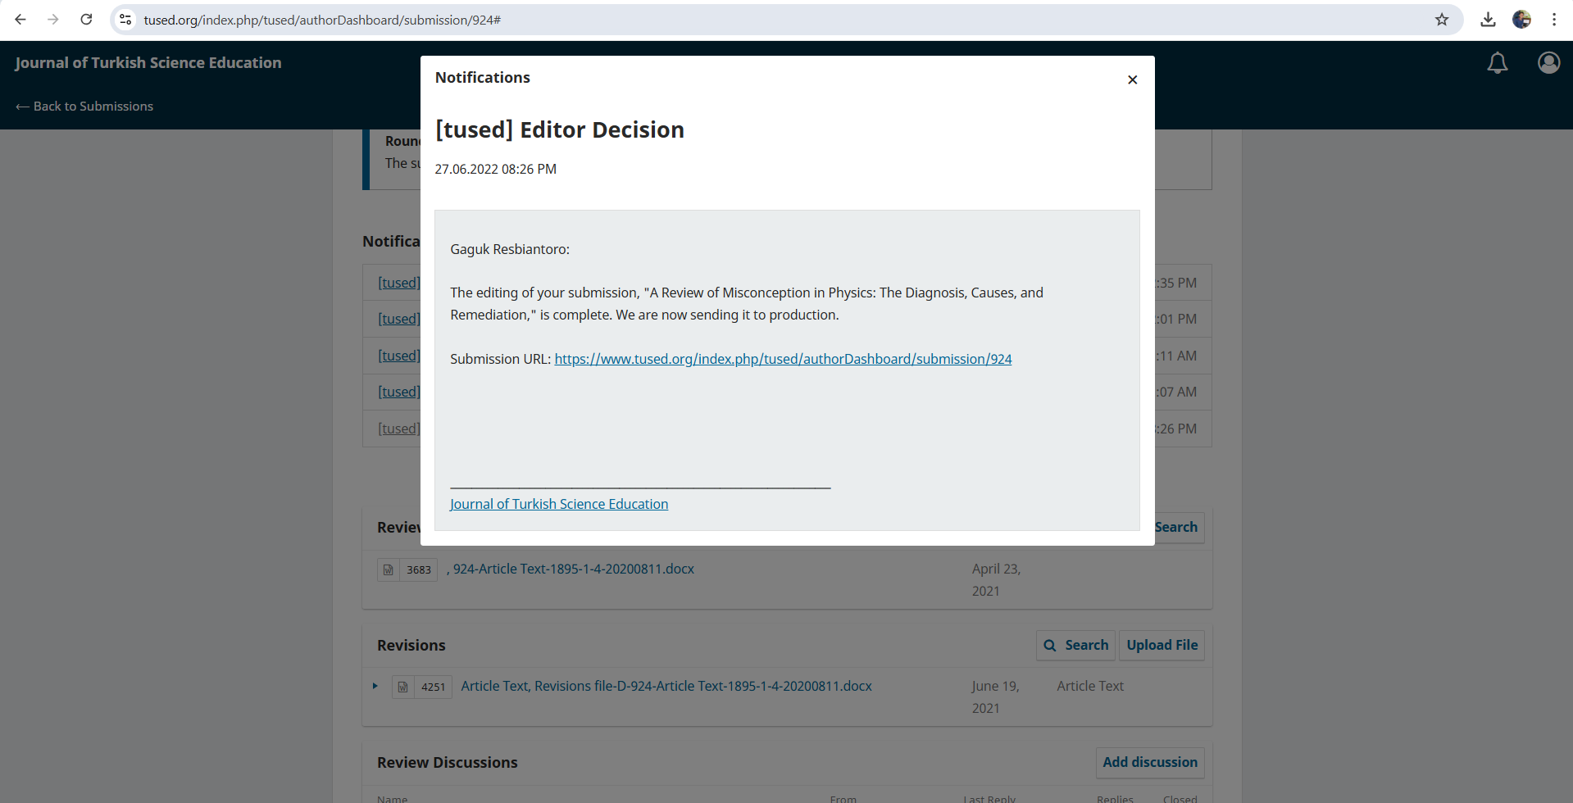

1. **Bukti Konfirmasi Terbit Online (30 Juni 2022)**

