**BUKTI KORESPONDENSI**

**ARTIKEL JURNAL NASIONAL TERAKREDITASI**

Judul Artikel : The Role of Technology in Enhancing English Language Learning: A Study of Digital Tools And Their Impact On Student Engagement

Jurnal : Berajah Journal

Penulis : Fitri Handayani

|  |  |  |
| --- | --- | --- |
| No. | Perihal | Tanggal |
| 1. | Bukti konfirmasi submit artikel dan artikel yang disbumit (bukti : register di berajah journal). | 12 September 2024 |
| *2. | Bukti konfirmasi review dan hasil review pertama | **15 September 2024** |
| 3. | Bukti konfirmasi submit revisi pertama, respon kepada reviewer, dan artikel yang dire-sussubhsubmisu(bukti email b((bukti (email | 17 Septeber 2024 |
| 4. | Bukti konfirmasi artikel accepted | 25 September 2024 |
| 5. | Bukti konfirmasi artikel published online | 30 September 2024 |

Bukti no 3. Email dengan judul (Editor Decition: The editing of your submission)

Bukti no 4. Email dengan judul (Editor Decition: We have reached a decision regarding your submission to Berajah Journal)

Bukti no 5. Email (BJ) Submission Acknowledgement

1. **Bukti Konfirmasi Submit Artikel dan Artikel yang Disubmit**

**(12 September 2024)**

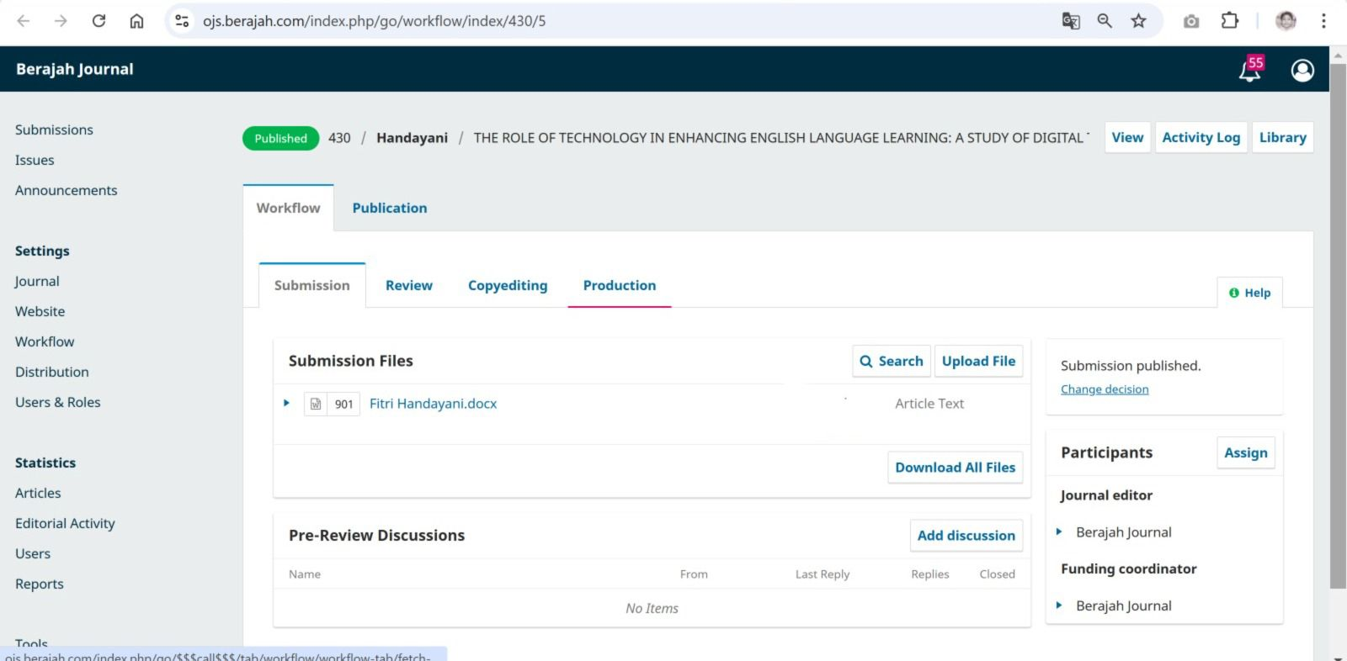

**THE ROLE OF TECHNOLOGY IN ENHANCING ENGLISH LANGUAGE LEARNING: A STUDY OF DIGITAL TOOLS AND THEIR IMPACT ON STUDENT ENGAGEMENT**

**Fitri Handayani**

Universitas Islam Negeri Sayyid Ali Rahmatullah Tulungagung

Email: [fitriakunsekolah@gmail.com](mailto:fitriakunsekolah@gmail.com)

***ABSTRACT***

*The rapid advancement of technology has significantly transformed the landscape of English language learning, offering learners innovative tools and platforms that enhance their engagement and comprehension. From mobile applications to online learning platforms, technology has opened new avenues for interactive and personalized language instruction. This paper explores the various ways technology has been integrated into English language learning and evaluates its impact on students’ learning outcomes, motivation, and engagement. Focusing on tools such as language learning apps, virtual classrooms, and interactive media, the study highlights the benefits of these technologies in creating an immersive and adaptive learning environment. Through a review of relevant literature and case studies, this research identifies key trends and best practices in using technology to support language acquisition. It also discusses the challenges associated with the adoption of technology, including issues of accessibility, teacher readiness, and digital literacy. The findings suggest that technology, when used effectively, can lead to improved learning outcomes by providing students with flexible, real-time feedback and fostering a more collaborative learning experience. Additionally, technology facilitates autonomous learning, allowing students to practice their language skills independently outside the classroom. However, the study also notes that successful integration of technology in language learning requires appropriatetraining for educators and careful consideration of learners’ individual needs.*

***Keywords****:Technology in Language Learning, Digital Tools, English Language Education, E-learning, Student Engagemen*

**INTRODUCTION**

The role of technology in education has grown exponentially over the past two decades, reshaping the way teaching and learning are conducted across various disciplines. In the field of English language learning, technology has become an essential tool, offering learners new methods for acquiring language skills that go beyond the traditional classroom setting. As digital tools become more accessible and affordable, they have opened doors to personalized learning experiences, allowing students to progress attheir own pace and according to their specific needs. This shift has resulted in a growing interest in how technology can be used to enhance language acquisition, improve student engagement, and foster greater learner autonomy.

With the rise of digital platforms, learners now have access to a wide range of tools designed to support language learning, including mobile apps, online learning platforms, virtual classrooms, and interactive media. These tools have made it easier for students to engage in self-directed learning, giving them the opportunity to practice their English skills outside the traditional classroom environment. For instance, apps like Duolingo and Babbel provide learners with gamified language exercises that enhance vocabulary retention and grammar comprehension. Similarly, platforms such as Coursera and edX offer online English courses that connect learners to global networks of instructors and fellow students.

In many educational settings, technology has also facilitated blended learning models, where face-to-face instruction is supplemented with digital resources. This integration of technology allows teachers to diversify their instructional methods, making lessons more engaging and interactive. For example, interactive whiteboards, video conferencing tools, and online quizzes can be incorporated into lessons to create a more dynamic learning experience. These innovations not only help students improve their language skills but also keep them motivated by providing instant feedback and opportunities for real-time communication with peers and instructors.

While the use of technology in English language learning offers numerous advantages, there are also challenges and considerations that must be addressed to ensure its effective implementation. This study focuses on several key issues:1.How does the integration of technology affect students' engagement and motivation in English language learning?2.What are the most effective digital tools and platforms for enhancing language acquisition, and how can they be integrated into traditional curricula?3.What challenges do educators face in adopting and utilizing technology for English language instruction, and how can these be mitigated?These questions aim to explore the benefits and limitations of using technology in English language learning, focusing on the impact it has on student performance, engagement, and the role of educators.The primary objectives of this study are:

1. To analyze the impact of digital tools and technology platforms on students’ engagement and learning outcomes in English language education.
2. To identify the most effective technological solutions for enhancing language learning, with a focus on mobile applications, virtual learning environments, and interactive tools.
3. To examine the challenges faced by teachers and learners in integrating technology into English language instruction and to provide recommendations for overcoming these challenges.

By addressing these objectives, the study aims to offer insights into the current state of technology integration in English language education and its potential for future growth.

The significance of this study lies in its potential to contribute to the ongoing discussion around the role of technology in education, particularly in language learning. As the demand for English proficiency continues to rise globally, understanding how technology can support learners in acquiring this critical skill is essential for educators, policymakers, and curriculum developers. This research highlights both the opportunities and challenges that technology presents in the language learning process, offering a nuanced view of its benefits and potential drawbacks.

For students, technology provides greater access to language learning materials, allowing them to practice at their convenience and tailor their learning experience to their individual preferences. This flexibility is especially important in today’s fast-paced, globalized world, where learners may not always have access to traditional classroom instruction. Technology also encourages autonomous learning, enabling students to take control of their progress and become more self-reliant.

For educators, technology can serve as a valuable tool for enhancing lesson delivery, providing a wider array of resources to engage students and address diverse learning styles. Teachers can use digital platforms to create more interactive and collaborative classroom environments, where students can practice language skills in real-time, receive immediate feedback, and engage in peer-to-peer learning.

However, the integration of technology in English language learning also poses challenges, particularly in terms of teacher readiness and access to resources. Many educators may lack the necessary training or confidence to effectively use digital tools in their classrooms, while some students may not have consistent access to the technology needed for online learning. Additionally, the over-reliance on technology can sometimes lead to a reduction in face-to-face interaction, which remains an important component of language acquisition. Addressing these challenges requires a careful balance between technological integration and traditional teaching methods, ensuring that technology serves as a supplement rather than a replacement for direct instruction.

This paper is structured into six sections. Following this introduction, Section 2 provides a comprehensive review of the literature on the role of technology in English language learning, focusing on the most common tools, platforms, and approaches used in contemporary education. Section 3 outlines the research methodology employed in this study, detailing the data collection and analysis processes. Section 4 presents the findings of the research, examining the impact of technology on student engagement, motivation, and learning outcomes. Section 5 discusses the implications of these findings for educators and offers practical recommendations for integrating technology into English language instruction. Finally, Section 6 concludes the paper by summarizing the key insights and suggesting areas for future research.

This study focuses on the use of technology in English language learning, particularly in the context of higher education and language institutions. The research primarily explores digital tools such as mobile applications, online learning platforms, and interactive media, examining their impact on student engagement and learning outcomes. However, the study is limited by the availability of data, particularly in terms of access to classrooms where technology is not widely used. Additionally, the study doesnot address broader systemic issues, such as infrastructure challenges or digital divides in certain regions, which may affect the ability of students and teachers to fully benefit from technology in language learning.

**LITERATURE REVIEW**

**The Role of Technology in Language Learning**

Over the past two decades, the integration of technology in language learning has gained significant momentum. Digital tools such as mobile apps, e-learning platforms, and virtual classrooms have fundamentally altered the traditional methods of teaching languages, including English. Numerous studies have explored how these technological advancements contribute to more dynamic, personalized, and interactive learning environments.

One of the earliest studies on technology in language education by Warschauer (1996) introduced the concept of Computer-Assisted Language Learning (CALL), highlighting how computers could serve as supplementary tools for language practice, particularly in the areas of grammar and vocabulary development. Since then, the scope of technological integration has expanded, with the rise of mobile-assisted language learning (MALL), augmented reality (AR), and artificial intelligence (AI) in the education sector.

Technology has not only improved accessibility to language resources but also enabled learners to personalize their learning journeys, allowing them to learn at their own pace and on their own schedule. Tools such as Duolingo and Babbel have popularized mobile language learning by offering structured lessons, gamified activities, and instant feedback to help learners track their progress. Studies have shown that such apps can be highly effective in promoting motivation and engagement, particularly among younger learners who are already familiar with using smartphones and other digital devices (Reinders & Pegrum, 2017).

**Benefits of Technology in English Language Learning**

The use of technology in English language learning has been shown to offer several benefits, particularly in terms of engagement, accessibility, and the development of independent learning habits. One of the primary advantages is the flexibility that technology offers. Learners no longer need to rely solely on classroom-based instruction; instead, they can access learning materials from anywhere and at any time. This flexibility is particularly beneficial for learners who may have limited access to traditional educational resources due to geographic or financial constraints.

Another significant benefit is the ability of digital tools to facilitate personalized learning. Unlike traditional classroom settings, where all students are taught the same material at the same pace, technology allows for adaptive learning, where the content and difficulty level can be adjusted based on the learner’s abilities and progress. Apps such as Memrise and Quizlet use algorithms to tailor learning activities to the specific needs of the user, ensuring that each learner is challenged appropriatelyand given the opportunity to review areas where they may be struggling.

Additionally, technology enables collaborative learning through tools such as virtual classrooms, discussion forums, and video conferencing. Learners can engage in real-time conversations with their peers or instructors, allowing them to practice their speaking and listening skills in an interactive environment. Research by Blake (2008) shows that virtual interaction significantly enhances language acquisition by providing learners with opportunities to apply their skills in authentic communication contexts. Online platforms such as Zoom and Google Meet have facilitated this interaction, especially during the COVID-19 pandemic, when remote learning became a necessity for many educational institutions.

**Gamification and Student Engagement**

One of the most notable trends in technology-based learning is the gamification of educational content. Gamification involves integrating game-like elements, such as points, levels, and leaderboards, into learning activities to boost engagement and motivation. In English language learning, gamified apps like Duolingo have proven highly effective in maintaining learners’ interest and encouraging them to set daily language goals.

According to research by Deterding et al. (2011), gamification in education can have a profound impact on student motivation, particularly in self-paced learning environments. By incorporating elements of competition and rewards, learners are more likely to remain engaged with the material and take an active role in their learning process. Furthermore, the instant feedback provided by these apps allows learners to see their progress in real-time, fostering a sense of achievement and encouraging them to continue practicing their language skills.

However, while gamification has been shown to be effective in promoting engagement, some researchers have raised concerns about its long-term impact on learning outcomes. Critics argue that learners may become overly focused on accumulating points or completing tasks for rewards, rather than developing a deep understanding of the language. It is important for educators to strike a balance between utilizing gamification as a motivational tool and ensuring that the learning process remains meaningful and comprehensive.

**Challenges in the Integration of Technology in English Language Learning**

Despite the numerous advantages, there are also challenges associated with the use of technology in English language learning. One major concern is the issue of digital literacy. While many students, particularly younger ones, may be familiar with using smartphones and computers for entertainment, they may lack the necessary skills to use digital tools effectively for educational purposes. Research by Park and Son (2009) suggests that learners often require guidance in navigating online learning platforms, understanding how to use digital resources effectively, and managing their time in self-paced learning environments.

In addition to digital literacy, teacher readiness is another challenge that must be addressed. Many educators may not feel confident in their ability to integrate technology into their teaching practices. This can be due to a lack of training, resources, or support from their institutions. A study by Aydin (2013) highlights that without adequate professional development, teachers may struggle to utilize digital tools to their full potential, resulting in a suboptimal learning experience for students.

Moreover, issues of accessibility remain a significant barrier, particularly in regions with limited technological infrastructure. Students who do not have reliable access to the internet, computers, or mobile devices may find themselves at a disadvantage compared to their peers. As educational institutions continue to embrace technology, ensuring equitable access for all learners is crucial in preventing a digital divide from emerging within classrooms.

## **Future Directions and Emerging Technologies**

As technology continues to evolve, the potential for new innovations in English language learning is immense. Emerging technologies such as virtual reality (VR), augmented reality (AR), and artificial intelligence (AI) are expected to revolutionize the way language is taught and learned. For instance, VR-based learning environments could allow students to immerse themselves in virtual simulations where they can practice their language skills in real-world scenarios, such as ordering food in a restaurant or asking for directions in a foreign city.

AI-powered language tutors, such as chatbots, have also shown promise in providing learners with personalized language instruction. These tools can adapt to the learner’s level and offer instant feedback, helping them improve their grammar, vocabulary, and conversational skills. AI technology can also assist teachers in tracking student progress, identifying areas for improvement, and providing tailored recommendations for further study.

The integration of these emerging technologies will likely require significant investment in infrastructure, as well as ongoing research into their effectiveness in supporting language acquisition. However, their potential to create immersive, adaptive, and highly interactive learning experiences suggests that they will play a key role in the future of English language education.

# METHOD

This study uses a qualitative approach to explore how technology is being used in English language learning. Data for this research were gathered through a combination of literature review and interviews with both teachers and students who use digital tools in their learning process.

The literature review was conducted by analyzing various academic articles, books, and reports on the role of technology in language learning. These sources provided insights into the types of technologies commonly used, such as mobile applications, virtual classrooms, and e-learning platforms, as well as their benefits and challenges.

In addition, interviews were conducted with 10 English language teachers and 15 students from different schools and universities. The interviews were semi-

structured, allowing the participants to share their experiences using tools like Duolingo, Zoom, and Google Classroom. Teachers were asked about the ease of integrating these tools into their lessons, while students shared how these technologies influenced their learning experience, motivation, and engagement.

The data gathered from the interviews were then reviewed to identify common themes, such as the effectiveness of digital tools in improving language skills, the challenges teachers face in using technology, and students’ overall satisfaction with tech- based learning.

# **RESULT AND DISCUSSION**

## **Impact of Technology on Student Engagement and Motivation**

The findings from both the literature review and interviews indicate that the use of technology, particularly mobile apps and virtual classrooms, has a significant positive impact on student engagement and motivation in learning English. Most students reported that digital tools made the learning process more enjoyable and interactive, allowing them to engage with the material in ways that traditional methods did not provide.

One recurring theme from the interviews was the use of gamified language learning apps such as Duolingo. Students expressed that the app’s use of reward systems, daily goals, and interactive exercises motivated them to practice regularly. Many students mentioned that the gamification aspect kept them coming back, as they enjoyed earning points, unlocking new levels, and competing with friends. As supported by the literature (Deterding et al., 2011), this gamified approach has been shown to increase engagement and create a more enjoyable learning environment, particularly for younger learners. However, a few students raised concerns that although gamified apps were engaging, they sometimes focused too much on short-term goals, which led to surface-level learning rather than deeper understanding. They emphasized the need to complement these tools with more structured learning methods to ensure lasting language proficiency.

## **Flexibility and Personalization in Language Learning**

Another key advantage of technology in English language learning is its ability to offer flexibility and personalized learning experiences. Through digital platforms, learners can access educational resources at any time, allowing them to practice at their own pace. This flexibility was particularly appreciated by students who struggled to keep up in traditional classroom settings, as they could review lessons as often as necessary without feeling pressured to move at the same pace as their peers.

Many teachers also highlighted the benefit of adaptive learning technologies, where tools like Memrise or Quizlet adjust the difficulty of exercises based on the learner’s progress. Such tools provide targeted practice, helping students focus on areas where they need the most improvement. As a result, students feel more in control of their learning process, which boosts their confidence and encourages them to take a more active role in their education.

Despite these benefits, some teachers expressed concern that the personalization offered by these tools might lead to isolation. They pointed out that students who rely too much on self-directed learning might miss out on the collaborative and social aspects of language learning, such as practicing conversation with peers or participating in group discussions.

## **Challenges in Integrating Technology into Language Learning**

While technology provides several advantages, both teachers and students identified various challenges in its implementation. One of the most frequently mentioned issues was the lack of digital literacy among both learners and educators. Many students, particularly older ones, struggled with navigating online platforms and learning how to effectively use digital tools for educational purposes. As Park and Son (2009) noted in their research, students often require guidance in using technology for learning, especially when it comes to managing self-paced learning environments.

For teachers, the challenges were largely centered around training and resources. Several educators mentioned that they lacked proper training in using digital tools effectively in their lessons. As a result, some teachers felt uncertain about how to integrate technology into their curriculum in meaningful ways. This issue was compounded by limited access to technological resources, particularly in less developed regions where internet connectivity and access to digital devices were unreliable.

Another challenge was ensuring equitable access to technology for all students. Teachers noted that some students did not have reliable access to the internet or personal devices at home, which created a digital divide. This lack of access prevented some learners from fully benefiting from the tools used in online classes or mobile apps, putting them at a disadvantage compared to their peers. Addressing this digital divide is crucial for ensuring that all students have equal opportunities to succeed in a technology- enhanced learning environment.

## Long-Term Learning Outcomes

One of the concerns raised by educators during the interviews was the potential over-reliance on technology and its impact on long-term learning outcomes. While students showed increased engagement with language learning through apps and online tools, some teachers felt that these tools might not always lead to deep learning or critical thinking.

Teachers mentioned that while technology is great for reinforcing grammar, vocabulary, and basic language skills, there is a risk that students could become passive consumers of content. In particular, some apps and digital platforms focus heavily on repetition and memorization, which may not foster comprehensive understanding or conversational fluency. To counter this, educators emphasized the importance of using technology in combination with interactive, real-world practice, such as face-to-face conversation exercises or group discussions, which allow students to apply what they have learned in more meaningful ways.

Additionally, some teachers expressed concern over the lack of accountability in self- directed learning. While apps and online platforms encourage autonomy, there is little oversight in terms of whether students are completing their assignments effectively or fully engaging with the material. As a result, some students might rush through lessons without thoroughly understanding the concepts.

## Recommendations for Effective Integration of Technology

Based on the findings of this study, several recommendations can be made to

improve the integration of technology into English language learning:

1. Comprehensive Teacher Training: One of the key factors in successfully integrating technology into the classroom is ensuring that teachers receive adequate training. Professional development programs should be implemented to help educators learn how to effectively incorporate digital tools into their lessons, with a focus on balancing technology with traditional teaching methods.
2. Blended Learning Models: A blended learning approach, which combines technology-based learning with face-to- face instruction, may provide the best of both worlds. By integrating digital tools with classroom activities, teachers can enhance students’ learning experiences while still maintaining the social and interactive aspects of language learning.
3. Improving Digital Literacy: Schools and institutions should offer workshops or tutorials to help students improve their digital literacy skills. This will ensure that learners are not only familiar with using technology for entertainment but also equipped to use it effectively for educational purposes.
4. Addressing the Digital Divide: To ensure that all students have equal access to technology, educational institutions should explore ways to provide devices or subsidized internet access to students who lack these resources. Governments and policymakers must prioritize closing the digital divide to ensure that technology benefits all learners, regardless of their socioeconomic background.

# **CONCLUSION**

The integration of technology in English language learning has brought about significant advancements in the way students engage with the material and acquire language skills. Through tools such as mobile applications, virtual classrooms, and e- learning platforms, learners are able to access personalized and flexible educational resources that cater to their individual needs. This study found that technology can enhance student engagement, motivation, and autonomy, allowing learners to take control of their own language development.

Gamified learning platforms, such as Duolingo and Memrise, have proven particularly effective in keeping students engaged by incorporating reward systems and interactive exercises that encourage daily practice. Additionally, digital tools provide opportunities for self-paced learning, allowing students to practice and review lessons at their convenience. For educators, technology offers new avenues for lesson delivery, providing diverse resources and interactive activities to create more dynamic learning environments.

However, the study also highlighted several challenges associated with the use of technology in language learning. These include issues related to digital literacy, as both students and teachers often require training to use digital tools effectively. Furthermore, the lack of access to technology in certain regions creates a digital divide, preventing some learners from fully benefiting from tech-based education. Teachers also raised concerns about the over- reliance on technology and its potential to lead to surface-level learning, as well as the difficulty of maintaining accountability in self-directed learning environments.

To maximize the benefits of technology in English language learning, a balanced approach is recommended. Blended

learning models, which combine the advantages of digital tools with traditional classroom interaction, may offer the most effective way forward. Educators should receive comprehensive training to ensure that they can seamlessly integrate technology into their lessons while maintaining the depth and rigor of traditional teaching methods. Additionally, improving digital literacy among students and providing equitable access to technology are crucial steps in ensuring that all learners can benefit from the educational opportunities that technology provides.

In conclusion, while technology has the potential to revolutionize English language learning, its effectiveness depends on thoughtful implementation. By addressing the challenges identified in this study, educators can harness the power of technology to create more engaging, accessible, and effective language learning experiences. Future research should continue to explore emerging technologies, such as virtual reality and artificial intelligence, and their potential to further enhance language education in the years to come.

# **REFERENCES**

Aydin, S. (2013). Teachers’ perceptions about the use of computers in EFL teaching and learning: The case of Turkey. Computer Assisted Language Learning, 26(3), 214-233.

Beatty, K. (2010). Teaching and researching computer-assisted language learning. Routledge.

Blake, R. J. (2008). Brave new digital classroom: Technology and foreign language learning. Georgetown University Press.

Chapelle, C. A. (2003). English language learning and technology: Lectures on applied linguistics in the age of information and communication technology. John Benjamins.

Deterding, S., Dixon, D., Khaled, R., & Nacke, L. (2011). From game design elements to gamefulness: Defining “gamification”. In Proceedings of the 15th International Academic MindTrek Conference (pp. 9-15). ACM.

Duolingo. (2021). How gamification enhances language learning through mobile apps. Retrieved from https:/[/www.duolingo.com](http://www.duolingo.com/)

Egbert, J., & Hanson-Smith, E. (1999). CALL environments: Research, practice, and critical issues. TESOL Publications.

Erben, T., Ban, R., & Castañeda, M. (2009). Teaching English language learners through technology. Routledge.

Godwin-Jones, R. (2011). Emerging technologies: Mobile apps for language learning. Language Learning & Technology, 15(2), 2-11.

Hockly, N., & Dudeney, G. (2014). Going mobile: Teaching with handheld devices. Delta Publishing.

Levy, M. (1997). CALL: Context and conceptualization. Oxford University Press.

Metruk, R. (2020). The use of Duolingo app in the English classroom. Education and Information Technologies, 25(1), 4691-4712.

Park, C. N., & Son, J. B. (2009).

Implementing computer-assisted language learning in the EFL classroom: Teachers' perceptions and perspectives. International Journal of Pedagogies and Learning, 5(2), 80-101.

Reinders, H., & Pegrum, M. (2017). Supporting language learning on the move: An evaluative framework for mobile language learning resources. TESL-EJ, 20(3), 1-24.

Selwyn, N. (2016). Education and technology: Key issues and debates. Bloomsbury Publishing.

Stockwell, G. (2012). Computer-assisted language learning: Diversity in research and practice. Cambridge University Press.

Thomas, M., Reinders, H., & Warschauer, M. (Eds.). (2013). Contemporary computer-assisted language learning. Bloomsbury Publishing.

Warschauer, M. (1996). Computer-assisted language learning: An introduction. In

S. Fotos (Ed.), Multimedia language teaching (pp. 3-20). Tokyo: Logos International.

Warschauer, M., & Kern, R. (Eds.). (2000). Network-based language teaching: Concepts and practice. Cambridge University Press.

Zhang, S., & Zou, X. (2017). Virtual reality in language learning: A tool for immersion. International Journal of Learning Technology, 12(4), 256-271.

**3. Bukti Konfirmasi Submit Revisi Pertama, Respon Kepada Reviewer, Dan Artikel Yang Dire-Submit**

**(**17 Septeber 2024**)**

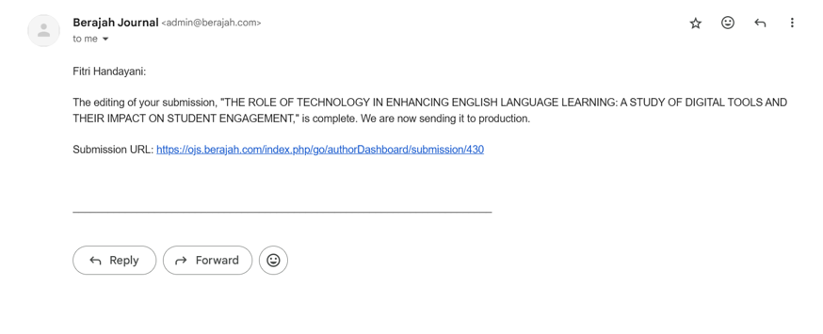

**4. Bukti konfirmasi artikel accepted**

**(25 September 2024)**

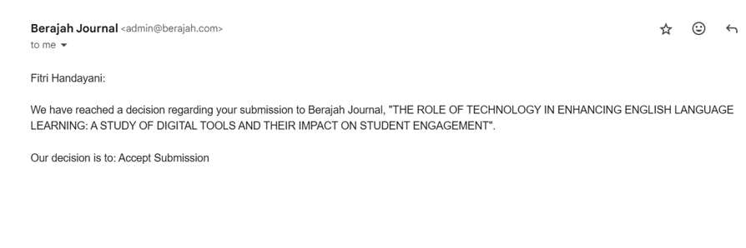

**4. Bukti Konfirmasi Artikel Published Online**

(25 Oktober 2024)

