**BUKTI KORESPONDENSI**

**ARTIKEL JURNAL NASIONAL BEREPUTASI**

Judul Artikel : The Role of Wakaf in Empowering Local Economies : A Study of Its

Potential in Modern Islamic Finance.

Jurnal : Berajah Journal, 2024, Volume 4 No. 5 Halaman 1195-1208

Penulis : Ana Muntadhirotul Maghfiroh, M.Pd.

|  |  |  |
| --- | --- | --- |
| No. | Perihal | Tanggal |
| 1. | Bukti submit artikel dan artikel yang disubmit | 2 Juli 2024 |
| 2. | Bukti konfirmasi review | 5 Juli 2024 |
| 3. | Bukti submit revisi | 13 Juli 2024 |
| 4. | Bukti konfirmasi artikel accepted | 4 Agustus 2024 |
| 5. | Bukti konfirmasi artikel publish online dan artikel yang publish | 31 Agustus 2024 |

**Bukti Submit Artikel dan Artikel yang Disubmit**

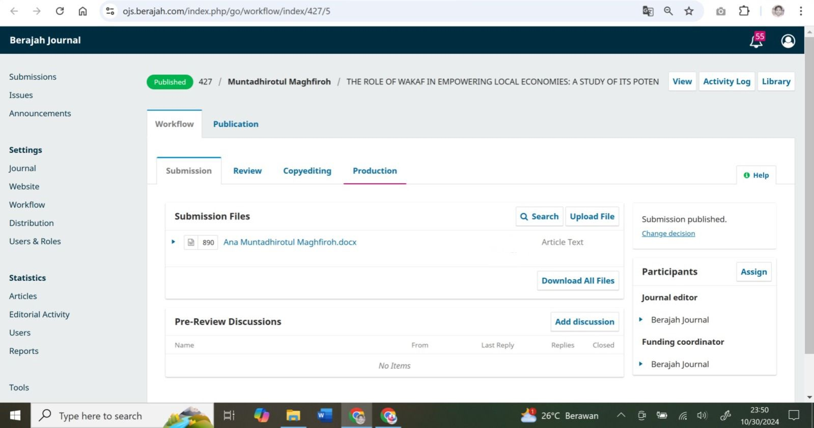

**THE ROLE OF WAKAF IN EMPOWERING LOCAL ECONOMIES: A STUDY OF ITS POTENTIAL IN MODERN ISLAMIC FINANCE**

**Ana Muntadhirotul Maghfiroh**

UIN Sayyid Ali Rahmatullah Tulungagung

**Email:** [anammaghfiroh@gmail.com](mailto:anammaghfiroh@gmail.com)

***ABSTRACT***

*Wakaf, as an integral component of Islamic philanthropy, has long played a crucial role in the socio- economic development of Muslim communities. Traditionally used for religious and charitable purposes, the concept of wakaf has evolved to serve a broader spectrum of needs in modern Islamic finance. This paper explores the potential of wakaf in empowering local economies by channeling its resources towards sustainable economic development. Through case studies and analysis of successful wakaf-based projects, the paper demonstrates how wakaf institutions can provide financial resources for infrastructure development, education, healthcare, and small-to-medium enterprises (SMEs). Moreover, the research highlights the role of innovative Islamic financial instruments, such as cash wakaf and sukuk wakaf, in unlocking the untapped potential of wakaf assets. The findings suggest that, with proper management, wakaf can significantly contribute to poverty alleviation, job creation, and overall economic empowerment. However, the paper also addresses the challenges facing wakaf institutions, including regulatory constraints, governance issues, and a lack of public awareness. The study concludes with policy recommendations for maximizing the socio-economic impact of wakaf within the framework of modern Islamic finance, emphasizing the need for stronger institutional support and more strategic collaboration between stakeholders.*

***Keywords:*** *Wakaf, Local Economies, Islamic Finance, Economic Empowerment, Sukuk Wakaf*

# INTRODUCTION

Wakaf, as a form of charitable endowment in Islamic tradition, has historically played a vital role in the socio- economic development of Muslim communities. Derived from the Arabic word waqf, which means to stop, hold, or confine, wakaf refers to the dedication of property for religious or charitable purposes with the stipulation that its benefits will be used perpetually for the welfare of society. Traditionally, wakaf assets were utilized primarily for building mosques, schools, hospitals, and other religious or charitable institutions, serving as a continuous source of benefit for the community. However, in the context of modern Islamic finance, the concept of wakaf is being reimagined to address broader socio-economic challenges, including poverty alleviation, job creation, and economic empowerment.

As Muslim-majority countries seek to advance their economies while adhering to the principles of Islamic law (Sharia), wakaf has emerged as a key tool for achieving sustainable development. The potential of wakaf to empower local economies lies in its ability to mobilize idle assets, particularly land and other forms of immovable property, for productive uses. When managed effectively, wakaf can become a significant source of funding for infrastructure development, education, healthcare, and small-to-medium enterprises (SMEs). Furthermore, recent innovations in Islamic financial instruments, such as cash wakaf and sukuk wakaf, have expanded the scope of wakaf, enabling it to contribute to contemporary economic development in ways previously not imagined.

In the current global economic climate, where financial inclusion and poverty reduction are prioritized, wakaf offers a Sharia-compliant mechanism for addressing these challenges. By promoting equitable distribution of wealth and providing long- term socio-economic benefits, wakaf institutions have the potential to play a pivotal role in achieving the Sustainable Development Goals (SDGs) set by the United Nations. These goals align closely with the objectives of Islamic economics, which emphasizes the fair distribution of resources and the welfare of all members of society.

Despite its historical significance and potential, the full benefits of wakaf have not been fully realized in many parts of the Muslim world. Various factors, including outdated legal frameworks, poor governance, and a lack of public awareness, have limited the effectiveness of wakaf institutions in addressing modern socio-economic challenges. Furthermore, the underutilization of wakaf assets, particularly land, has prevented them from contributing significantly to local economic development. As a result, many Muslim communities remain unaware of the potential of wakaf as a tool for poverty alleviation and economic empowerment.

In response to these challenges, this paper seeks to explore the role of wakaf in empowering local economies and examines how modern Islamic finance can be leveraged to unlock its full potential. The paper addresses the following key research questions:

1. How can wakaf be utilized to empower local economies and contribute to sustainable development?
2. What role do modern Islamic financial instruments, such as cash wakaf and sukuk wakaf, play in maximizing the economic impact of wakaf?
3. What are the key challenges facing wakaf institutions, and how can they be addressed to enhance their effectiveness in promoting local economic development?

The primary objectives of this research are:

1. To analyze the potential of wakaf in empowering local economies through sustainable development projects.
2. To examine the role of innovative Islamic financial instruments, such as cash wakaf and sukuk wakaf, in enhancing the socio- economic impact of wakaf.
3. To identify the challenges faced by wakaf institutions and propose policy recommendations for improving their governance and management.

This study is significant for several reasons. First, it contributes to the growing body of literature on the role of Islamic finance in promoting sustainable development. While much attention has been given to the role of zakat and Islamic banking, wakaf remains an underexplored area in academic research. This paper seeks to fill that gap by offering new insights into how wakaf can be utilized to address contemporary economic challenges, particularly in developing Muslim-majority countries.

Second, the study highlights the potential of innovative financial instruments, such as cash wakaf and sukuk wakaf, to transform idle wakaf assets into productive resources. By demonstrating how these instruments can be used to fund development projects, the paper provides practical recommendations for policymakers, wakaf managers, and Islamic financial institutions looking to maximize the socio-economic impact of wakaf.

Finally, the research offers valuable policy recommendations for improving the governance and management of wakaf institutions. Good governance is critical for ensuring the transparency, accountability, and sustainability of wakaf-based projects. By addressing the key challenges facing wakaf institutions, this study aims to provide a roadmap for enhancing their effectiveness in promoting local economic development.

This paper is organized into six main sections. Following this introduction, Section 2 presents a review of the relevant literature on wakaf, focusing on its historical significance, legal frameworks, and contemporary applications in Islamic finance. Section 3 outlines the research methodology used in the study, including data collection methods and analytical approaches. Section 4 presents the findings of the study, including case studies of successful wakaf-based projects and their impact on local economies. Section 5 discusses the implications of these findings for policymakers, wakaf managers, and Islamic financial institutions, with recommendations for improving the governance and management of wakaf. Finally, Section 6 concludes the paper by summarizing the key findings and offering suggestions for future research on the role of wakaf in economic empowerment.

This study focuses on the role of wakaf in empowering local economies, with an emphasis on its potential within the context of modern Islamic finance. The research is limited to case studies from a selection of Muslim-majority countries where wakaf- based projects have been implemented. While the study aims to provide generalizable insights, the findings may not be directly applicable to all regions due to differences in legal frameworks, cultural contexts, and economic conditions.

Additionally, the research primarily examines the role of cash wakaf and sukuk wakaf as innovative financial instruments for mobilizing wakaf assets. While other forms of wakaf, such as land and property wakaf, are discussed, they are not the primary focus of the study. Future research could expand on this by exploring the broader role of different types of wakaf assets in promoting socio- economic development.

# LITERATURE REVIEW

## Historical Significance of Wakaf

Wakaf has been a foundational institution in Islamic civilization for centuries, playing a pivotal role in providing public goods and services, such as education, healthcare, and infrastructure. Historically, wakaf was established as a means to create continuous charitable endowments, with the wealth of a donor being transformed into an everlasting asset dedicated to the benefit of the community. The primary characteristic of wakaf is that the capital or asset donated must remain intact, while the benefits derived from it are utilized for charitable purposes.

In early Islamic societies, particularly during the Abbasid and Ottoman periods, wakaf was instrumental in financing the establishment of mosques, schools (madrasas), libraries, hospitals, and other public institutions. These institutions served both religious and social purposes, thus contributing to the welfare of Muslim communities. For instance, some of the oldest universities in the world, such as Al- Qarawiyyin in Morocco and Al-Azhar in Egypt, were financed through wakaf, demonstrating its historical significance in the education sector.

However, as time passed, the role of wakaf in economic development diminished, largely due to the stagnation of wakaf management, outdated regulatory frameworks, and the underutilization of assets. In many Muslim-majority countries, wakaf assets such as land remained idle, with little effort made to utilize them for modern socio-economic development. This situation has led scholars and policymakers to revisit the potential of wakaf in contemporary settings, particularly in light of the growing demand for Islamic financial solutions to address poverty and promote sustainable development.

## The Role of Wakaf in Modern Islamic Finance

In recent years, there has been a resurgence of interest in wakaf within the framework of modern Islamic finance. Scholars and practitioners have recognized that wakaf holds enormous potential for contributing to economic empowerment and poverty alleviation. When managed effectively, wakaf can be transformed into a sustainable financial mechanism that supports local economies by financing development projects, such as infrastructure, education, healthcare, and small-to-medium enterprises (SMEs).

One of the key developments in modern wakaf management is the introduction of cash wakaf. Unlike traditional wakaf, which typically involves immovable assets such as land or buildings, cash wakaf allows individuals to contribute monetary donations, which are then invested in Sharia- compliant ventures. The profits generated from these investments are used for charitable purposes, while the principal amount remains intact. This flexibility makes cash wakaf more accessible to a wider segment of society, allowing individuals with limited financial resources to participate in charitable giving.

Additionally, the concept of sukuk wakaf has emerged as an innovative financial instrument that combines the principles of wakaf with Islamic bonds (sukuk). Sukuk wakaf involves the issuance of Sharia- compliant bonds to finance wakaf-based projects. Investors in sukuk wakaf receive returns on their investments, while the funds raised are used to develop wakaf properties or finance social welfare programs. This model has gained traction in several countries, including Indonesia and Malaysia, where sukuk wakaf has been used to fund healthcare and educational initiatives.

The integration of wakaf into modern Islamic finance has opened new avenues for mobilizing resources that can contribute to sustainable development. By channeling idle assets into productive uses, wakaf has the potential to create long-term economic benefits for local communities, particularly in sectors such as agriculture, housing, and entrepreneurship. This aligns with the goals of Islamic economics, which emphasizes social justice, equitable distribution of wealth, and the welfare of society.

## Wakaf and Local Economic Empowerment

The potential of wakaf to empower local economies is increasingly being recognized by policymakers and Islamic financial institutions. Local economic empowerment refers to the process of enabling communities to generate income, create jobs, and improve living standards through sustainable economic activities. In this context, wakaf can be a powerful tool for mobilizing financial resources to support local development projects that directly benefit communities.

For example, wakaf can be used to finance agricultural projects, providing farmers with the necessary capital to invest in equipment, seeds, and infrastructure. In regions where access to conventional finance is limited due to interest-based lending, wakaf offers an alternative, Sharia-compliant source of funding that can help small-scale farmers improve productivity and generate income. Additionally, wakaf can be used to support the establishment of SMEs, which are critical for job creation and economic growth in many developing countries.

Several case studies highlight the successful application of wakaf in local economic empowerment. In Indonesia, for instance, the Baitul Maal Wat Tamwil (BMT) system has successfully combined wakaf with Islamic microfinance to provide financial services to underprivileged communities. BMT institutions use cash wakaf to fund micro-loans for small businesses, empowering entrepreneurs to start or expand their businesses while adhering to Islamic principles. This model has contributed to job creation, poverty reduction, and the development of local economies in rural areas.

Another example is Malaysia, where wakaf assets have been used to finance affordable housing projects. The development of wakaf land for residential purposes has provided low-income families with access to affordable housing, while generating revenue for the maintenance and expansion of wakaf properties. This approach not only addresses the housing needs of the community but also ensures the sustainable use of wakaf assets for future generations.

**Challenges Facing Wakaf Institutions**

Despite the promising potential of wakaf in local economic development, several challenges continue to hinder its effectiveness. One of the primary challenges is the lack of proper governance and management of wakaf institutions. In many countries, wakaf management is still governed by outdated legal frameworks that do not allow for the efficient use of wakaf assets. As a result, many wakaf properties remain idle or underutilized, limiting their potential to contribute to economic development.

Furthermore, the lack of public awareness regarding the benefits of wakaf has led to low levels of participation. Many Muslims are unaware of the modern applications of wakaf, such as cash wakaf and sukuk wakaf, which can provide accessible avenues for charitable giving. This lack of awareness is compounded by the perception that wakaf is only applicable to large, immovable assets, such as land or buildings. To address this issue, there is a need for increased public education and awareness campaigns to promote wakaf as a tool for socio-economic development.

Another significant challenge is the regulatory environment surrounding wakaf. In many Muslim-majority countries, the regulatory framework governing wakaf is complex and fragmented, making it difficult for wakaf institutions to operate efficiently. Streamlining these regulations and introducing policies that encourage the development of wakaf-based projects are essential for unlocking the full potential of wakaf in modern economies.

## The Future of Wakaf in Islamic Finance

Looking forward, the future of wakaf in Islamic finance appears promising, particularly as more countries and financial institutions explore innovative ways to leverage wakaf assets for socio-economic development. The increasing adoption of cash wakaf and sukuk wakaf reflects a growing recognition of the need to modernize wakaf management to meet contemporary challenges. Additionally, the integration of technology, such as blockchain and crowdfunding platforms, could further enhance the transparency and efficiency of wakaf institutions, making it easier to track and manage wakaf assets.

Moreover, the role of international collaboration in promoting the development of wakaf cannot be overlooked. By sharing best practices and learning from successful wakaf models in countries like Indonesia, Malaysia, and Turkey, other Muslim-majority countries can develop their own strategies for integrating wakaf into their economic systems.

# METHOD

## Research Design

This study employs a qualitative research methodology to explore the role of wakaf in empowering local economies and its potential within the framework of modern Islamic finance. The research adopts a case study approach, focusing on selected wakaf- based projects in countries such as Indonesia and Malaysia, where wakaf has been successfully integrated into local economic development. By examining these cases, the study aims to provide insights into the strategies, challenges, and outcomes of wakaf-driven initiatives that contribute to socio-economic empowerment.

## Data Collection Methods

To gather relevant data, this study utilizes both primary and secondary data sources:

1. **Primary Data:**
   1. Interviews: Semi-structured interviews were conducted with key stakeholders involved in wakaf institutions, including managers of wakaf-based projects, Islamic finance experts, and policymakers. These interviews provide in-depth insights into the governance, management, and operational aspects of wakaf institutions, as well as the challenges they face in implementing wakaf- based initiatives.
   2. Focus Group Discussions (FGDs): FGDs were held with community beneficiaries and participants in wakaf projects, particularly those involved in SMEs and agricultural initiatives. The purpose of these discussions was to gather first-hand experiences and perspectives on how wakaf has impacted their livelihoods and local economies.

## Secondary Data:

* 1. Document Analysis: A review of official reports, policy documents, and published studies on wakaf institutions and Islamic finance was conducted. These documents provide context on the regulatory frameworks, governance structures, and financial instruments (e.g., cash wakaf and sukuk wakaf) that are used to mobilize wakaf assets for economic development.
  2. Case Studies: Published case studies from countries with successful wakaf programs (such as Indonesia, Malaysia, and Turkey) were analyzed to identify best practices and lessons learned. These case studies were selected based on their relevance to the study’s objectives, focusing on projects that directly contribute to local economic empowerment.

## Data Analysis

The data collected through interviews, focus groups, and document analysis were subjected to thematic analysis. Thematic analysis involves identifying, analyzing, and reporting patterns or themes within qualitative data. The following steps were used in the analysis process:

1. Familiarization with Data: The data from interviews and focus group discussions were transcribed and reviewed to gain a comprehensive understanding of the participants’ responses.
2. Coding: The data were coded based on recurring themes related to the role of wakaf in economic empowerment, challenges faced by wakaf institutions, and the impact of modern Islamic financial instruments such as cash wakaf and sukuk wakaf.
3. Theme Development: Codes were grouped into broader themes that reflected key findings, such as “effective wakaf management,” “financial inclusion,” “regulatory challenges,” and “community empowerment.”
4. Interpretation: The findings were interpreted in the context of existing literature on Islamic finance and local economic development, providing a basis for drawing conclusions and making policy recommendations.

## Scope and Limitations

This study focuses on specific case studies of wakaf-based projects in Muslim- majority countries, with an emphasis on Indonesia and Malaysia due to their advanced regulatory frameworks and innovations in Islamic finance. While these cases offer valuable insights, the findings may not be fully generalizable to other regions where the regulatory and socio-economic context differs significantly. Additionally, the study primarily relies on qualitative data, which may limit its ability to provide quantifiable measures of wakaf’s economic impact. However, the use of in-depth interviews and case studies allows for a comprehensive exploration of the subject.

# RESULT AND DISCUSSION

## Impact of Wakaf on Local Economic Empowerment

The case studies from Indonesia and Malaysia reveal that wakaf-based projects have had a significant positive impact on local economic empowerment. In Indonesia, for instance, wakaf institutions have successfully mobilized resources to support small-to- medium enterprises (SMEs), particularly in rural areas. One example is the use of cash wakaf to fund microfinance initiatives that provide Sharia-compliant loans to small business owners. This financing has enabled entrepreneurs to expand their businesses, hire additional employees, and contribute to local economic growth.

In Malaysia, wakaf has been instrumental in addressing the issue of affordable housing. The development of wakaf land for residential purposes has provided low-income families with access to affordable housing, which in turn has improved their quality of life and reduced economic inequality. Furthermore, the revenue generated from these housing projects has been reinvested into other community welfare projects, ensuring the sustainability of wakaf as a tool for long-term development.

A key finding from the analysis is that wakaf’s ability to empower local economies is closely tied to the effective management of assets. In cases where wakaf properties are well-managed, they generate consistent revenue streams that can be reinvested in the community. However, poor governance and underutilization of assets limit the potential impact of wakaf on local economies. This highlights the need for stronger institutional frameworks and capacity-building initiatives to ensure that wakaf institutions can operate efficiently.

## The Role of Cash Wakaf and Sukuk Wakaf in Modern Islamic Finance

The introduction of cash wakaf and sukuk wakaf has been a game-changer for the modern application of wakaf. These innovative financial instruments have expanded the reach of wakaf by allowing individuals and institutions to contribute monetary donations, which are then invested in Sharia-compliant ventures. The profits from these investments are used to support charitable and developmental initiatives, while the principal remains intact, adhering to the traditional principles of wakaf.

In Indonesia, cash wakaf has been used to finance healthcare projects, including the construction of hospitals and clinics in underserved areas. By pooling resources from individual donors, wakaf institutions have been able to fund large-scale projects that would otherwise be difficult to finance through traditional means. The Baitul Maal Wat Tamwil (BMT) system, a form of Islamic microfinance that incorporates cash wakaf, has proven particularly effective in empowering local economies by providing financial services to low-income communities.

Sukuk wakaf, on the other hand, has been utilized in Malaysia to fund infrastructure projects, including the development of public schools and healthcare facilities. The issuance of sukuk wakaf has allowed wakaf institutions to raise capital from a broader range of investors, including those who seek both financial returns and social impact. This dual benefit has attracted institutional investors, such as Islamic banks and pension funds, to participate in wakaf- based projects, thereby increasing the scale and reach of these initiatives.

The success of cash wakaf and sukuk wakaf demonstrates the potential of Islamic financial instruments to enhance the socio- economic impact of wakaf. By integrating modern financial tools with traditional Islamic practices, these instruments offer a sustainable model for financing development projects in line with Sharia principles.

## Challenges in Managing Wakaf Institutions

While wakaf has the potential to empower local economies, several challenges continue to hinder its full effectiveness. One of the primary challenges identified in the case studies is the lack of good governance in wakaf institutions. Many wakaf properties, particularly in rural areas, suffer from mismanagement, leading to the underutilization of assets. For instance, in some cases, wakaf land remains idle due to a lack of proper planning, investment, or maintenance, preventing it from generating income for the community.

Another challenge is the regulatory environment. In many countries, the legal framework governing wakaf is outdated and lacks the flexibility needed to adapt to modern economic realities. For example, in Indonesia, the regulatory framework for wakaf management has been slow to adopt innovations such as cash wakaf and sukuk wakaf, limiting the potential of these instruments to be fully utilized. Additionally, complex bureaucratic processes often delay the implementation of wakaf-based projects, reducing their overall efficiency and impact.

Moreover, public awareness of wakaf remains low, particularly regarding the modern applications of wakaf such as cash wakaf and sukuk wakaf. Many potential donors still view wakaf as limited to land endowments for religious purposes, unaware of the broader socio-economic benefits that wakaf can offer. This lack of awareness has limited participation in wakaf-based projects, particularly among younger generations and those with limited financial resources.

## Success Factors for Wakaf-Based Projects

Despite these challenges, there are several key success factors that contribute to the effectiveness of wakaf-based projects in empowering local economies:

1. Strong Institutional Support: In countries like Malaysia, where there is strong institutional support for wakaf, including clear legal frameworks and governance structures, wakaf-based projects have been more successful in achieving their socio-economic objectives. Government agencies and Islamic financial institutions play a critical role in supporting the development and management of wakaf properties, ensuring that they are used for productive purposes.
2. Public-Private Partnerships: Collaboration between public and private sectors has proven to be a key driver of success in wakaf-based projects. For example, in Malaysia, the development of wakaf properties for affordable housing has been facilitated by partnerships between wakaf institutions, government agencies, and private developers. These partnerships enable wakaf institutions to leverage the expertise and resources of the private sector, ensuring that projects are implemented efficiently and effectively.
3. Community Involvement: The involvement of local communities in the planning and implementation of wakaf- based projects is another important factor for success. In Indonesia, for instance, community involvement in the management of wakaf properties has led to more sustainable and impactful outcomes. By engaging local communities in decision-making processes, wakaf institutions can ensure that projects are aligned with the needs and priorities of the community, leading to greater buy-in and long-term sustainability.
4. Innovation in Islamic Finance: The development of innovative financial instruments, such as cash wakaf and sukuk wakaf, has been instrumental in unlocking the potential of wakaf assets. These instruments provide a flexible and scalable model for mobilizing resources, allowing wakaf institutions to finance larger projects and reach a wider range of beneficiaries.

## Policy Recommendations for Enhancing the Role of Wakaf

Based on the findings of this study, several policy recommendations can be made to enhance the role of wakaf in empowering local economies:

1. Strengthening Governance and Accountability: Improving the governance of wakaf institutions is critical for ensuring the effective management of wakaf assets. This can be achieved by implementing transparent and accountable management practices, including regular audits, performance evaluations, and public reporting. Additionally, capacity- building programs for wakaf managers should be developed to enhance their skills in financial management, project planning, and community engagement.
2. Updating Regulatory Frameworks: Policymakers should update the legal frameworks governing wakaf to reflect modern economic realities and the potential of innovative financial instruments such as cash wakaf and sukuk wakaf. This includes streamlining bureaucratic processes to facilitate the efficient implementation of wakaf-based projects and creating incentives for private sector participation in wakaf development.
3. Promoting Public Awareness: Raising public awareness of the socio-economic benefits of wakaf is essential for increasing participation in wakaf-based projects. This can be achieved through public education campaigns, outreach programs, and collaborations with Islamic financial institutions to promote the use of cash wakaf and sukuk wakaf as tools for poverty alleviation and economic empowerment.
4. Encouraging Public-Private Partnerships: Governments should encourage public- private partnerships in the development of wakaf properties. By collaborating with private sector developers and financial institutions, wakaf institutions can access the expertise, resources, and funding needed to implement large-scale development projects that benefit local communities.

**CONCLUSION**

This study highlights the significant potential of wakaf as a tool for local economic empowerment within the framework of modern Islamic finance. Through the analysis of case studies in Indonesia and Malaysia, it is evident that wakaf-based projects have had a positive impact on various socio-economic sectors, including the development of small- to-medium enterprises (SMEs), affordable housing, healthcare, and education. The findings suggest that with proper governance, wakaf can play a transformative role in addressing economic challenges such as poverty, inequality, and unemployment, particularly in Muslim-majority countries.

The introduction of innovative financial instruments, such as cash wakaf and sukuk wakaf, has expanded the scope of wakaf, allowing for the mobilization of financial resources on a larger scale. These instruments have proven effective in attracting individual donors, institutional investors, and public-private partnerships, contributing to the development of sustainable projects that benefit local communities. By integrating wakaf into the broader landscape of Islamic finance, these instruments demonstrate the flexibility and adaptability of traditional Islamic practices in addressing contemporary economic needs.

However, several challenges continue to hinder the full realization of wakaf’s potential. Governance issues, including the mismanagement of wakaf assets and the lack of transparency, remain significant barriers to the success of wakaf-based projects. Additionally, regulatory frameworks in many countries are outdated and fail to support the efficient management of wakaf properties. Public awareness about the socio-economic benefits of wakaf also remains low, particularly regarding modern applications such as cash wakaf and sukuk wakaf.

To overcome these challenges, this study recommends the following:

1. Strengthening governance and accountability in wakaf institutions through capacity-building programs, regular audits, and transparent management practices.
2. Updating regulatory frameworks to reflect the modern economic context and facilitate the use of innovative financial instruments like cash wakaf and sukuk wakaf.
3. Raising public awareness about the potential of wakaf for socio-economic development through education campaigns and collaborations with Islamic financial institutions.
4. Encouraging public-private partnerships to enhance the scale and impact of wakaf- based projects, leveraging private sector expertise and resources.

In conclusion, wakaf is a powerful mechanism rooted in Islamic tradition that, when effectively managed and supported by modern financial tools, can drive meaningful socio-economic change. Its capacity to empower local economies, create jobs, and promote financial inclusion makes it an essential component of Islamic finance that warrants greater attention from both scholars and practitioners. Future research should continue to explore the evolving role of wakaf, particularly in light of technological advancements, to maximize its impact on economic development.

# REFERENCES

Abdurrahman, Y. (2018). The Role of Cash Wakaf in Poverty Alleviation: A Case Study in Indonesia. International Journal of Islamic Economics, 5(2), 45-60.

Ahmad, M. (2019). Sukuk Wakaf as an Instrument of Islamic Social Finance: Potentials and Challenges. Journal of Islamic Finance, 10(1), 12-25.

Ali, S. S. (2013). Islamic Finance and Sustainable Development: Promoting Responsible Business Practices. Islamic Economic Studies, 21(1), 109-

132.

Cizakca, M. (1998). Awqaf in History and its Implications for Modern Islamic Economies. Islamic Economic Studies, 6(1), 43-70.

Hassan, M. K., & Ashraf, A. (2010). An Integrated Poverty Alleviation Model Combining Zakat, Awqaf, and Micro- Finance. The Bangladesh Development Studies, 33(4), 35-60.

Ismail, A. G., & Possumah, B. T. (2014). Waqf as Economic Driver in Malaysia. Journal of Islamic Banking and Finance, 3(1), 19-25.

Kahf, M. (2003). The Role of Waqf in Improving the Ummah Welfare. International Seminar on Waqf as a Private Legal Body, 6(1), 1-26.

Khan, F. (2012). Waqf and the Development of Islamic Finance in Africa. Journal of Islamic Economics, Banking and Finance, 8(3), 55-71.

Mohsin, M. I. A. (2013). Financing through Cash-Waqf: A Revitalization to Finance Different Needs. International Journal of Islamic and Middle Eastern Finance and Management, 6(4), 304-

321.

Muhammad, N. A., & Hasan, Z. (2016). Sustainable Development Through Waqf Financing: Issues and Solutions. Journal of Islamic Economics, 9(2), 1-

17.

Noor, A. M. (2015). The Potential of Waqf for Poverty Alleviation in Bangladesh: Lessons from Selected Asian Countries. Journal of Islamic Finance, 7(2), 34-45.

Obaidullah, M., & Khan, T. (2008). Islamic Microfinance Development: Challenges and Initiatives. Islamic Research and Training Institute, 9(1), 45-78.

Osman, M. F., & Ahmad, R. (2015). Waqf- Based Microfinance: Realizing the Social Role of Islamic Finance. Journal of Islamic Finance, 4(1), 35-

47.

Qaradawi, Y. (1999). Fiqh al-Zakah: A Comparative Study of Zakah, Regulations and Philosophy in the Light of Qur'an and Sunnah. Islamic Foundation.

Rahman, A. (2014). The Revitalization of Waqf: Strategies and Best Practices for Poverty Alleviation. Journal of Islamic Philanthropy, 5(2), 27-38.

Rashid, S. K. (2011). Awqaf Experiences in South Asia. Awqaf Foundation for Islamic Societies.

Sadeq, A. M. (2002). Waqf, Perpetual Charity and Poverty Alleviation. International Journal of Social Economics, 29(1), 135-151.

Saeed, A. (2009). Islamic Banking and Finance: The New Regulatory Challenge. John Wiley & Sons.

Siraj, S. A. (2012). The Role of Waqf in the Economic Development of Muslim Communities: Past, Present, and Future Prospects. Review of Islamic Economics, 6(2), 91-104.

Sulaiman, M., & Zakariyah, A. (2015). Shariah Governance in Islamic Finance: An Ethical Appraisal. Journal of Islamic Finance, 4(1), 1-15. Usmani, M. T. (2002). An Introduction to Islamic Finance. Kluwer Law

International.

Yaacob, H. (2013). Waqf and Its Role in Socio-Economic Development. Journal of Islamic Philanthropy, 6(2), 17-29.

Yusuf, T. (2010). Cash-Waqf: Historical Evolution, Modern Practices and Implications for the Islamic Economy. Journal of Islamic Finance and Business, 7(1), 76-89.

Zaman, M. R. (2014). Islamic Finance: Function and Governance. The Islamic Research and Training Institute.

Zahra, S. (2015). Islamic Philanthropy and Socio-Economic Development: Case Studies from Southeast Asia. Journal of Islamic Economics, 8(2), 33-44.

Zulkifli, A. (2018). The Role of Islamic Finance in Achieving the Sustainable Development Goals (SDGs). Journal of Islamic Banking and Finance, 10(4), 45-57.

Zaman, S. M. (2012). Transforming Awqaf Into an Effective Institution for Poverty Alleviation in Pakistan. Journal of Islamic Economic Development, 8(3), 100-115.

**Bukti Submit Revisi**

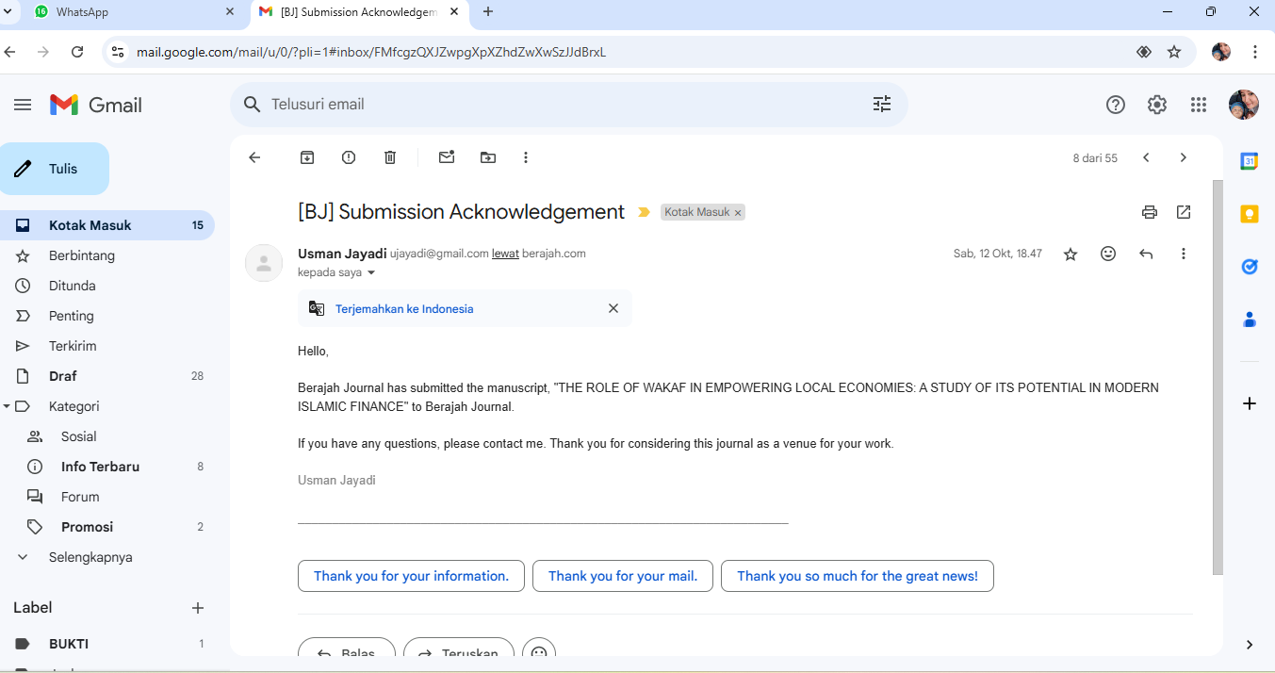

**Bukti Konfirmasi Artikel Accepted**

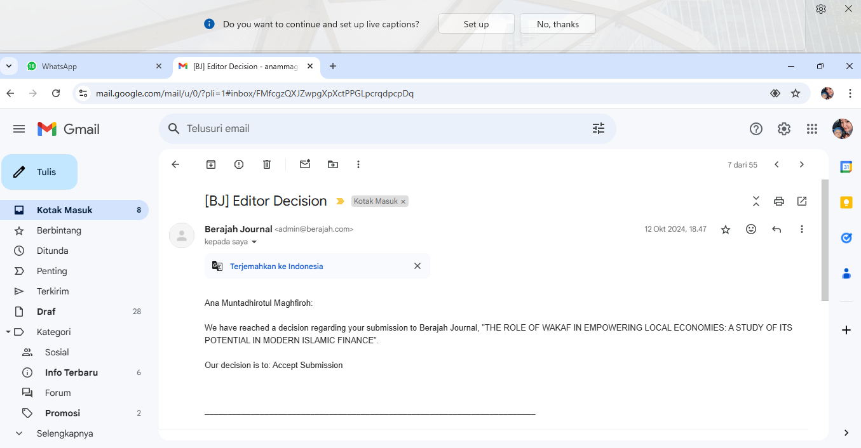

**Bukti Konfirmasi Terbit Online dan Artikel yang Publish**

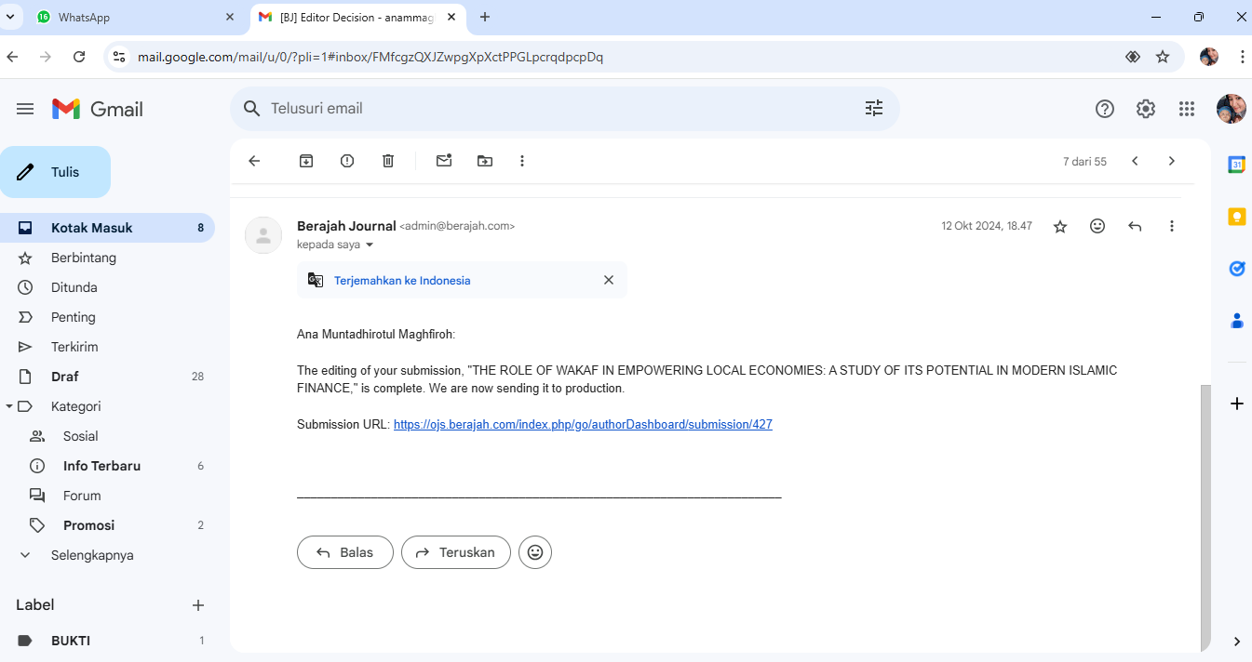

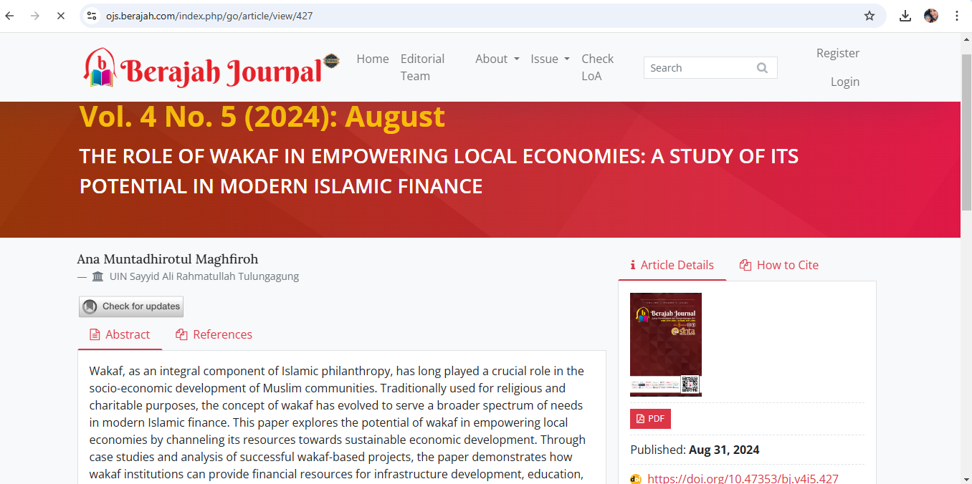



**Berajah Journal**

**Jurnal Pembelajaran dan Pengembangan Diri**

ISSN (p): **2797-1805** | ISSN (e): **2797-1082**

**THE ROLE OF WAKAF IN EMPOWERING LOCAL ECONOMIES: A STUDY OF ITS POTENTIAL IN MODERN ISLAMIC FINANCE**

**Ana Muntadhirotul Maghfiroh**

UIN Sayyid Ali Rahmatullah Tulungagung

**Email:** [anammaghfiroh@gmail.com](mailto:anammaghfiroh@gmail.com)

***ABSTRACT***

*Wakaf, as an integral component of Islamic philanthropy, has long played a crucial role in the socio- economic development of Muslim communities. Traditionally used for religious and charitable purposes, the concept of wakaf has evolved to serve a broader spectrum of needs in modern Islamic finance. This paper explores the potential of wakaf in empowering local economies by channeling its resources towards sustainable economic development. Through case studies and analysis of successful wakaf-based projects, the paper demonstrates how wakaf institutions can provide financial resources for infrastructure development, education, healthcare, and small-to-medium enterprises (SMEs). Moreover, the research highlights the role of innovative Islamic financial instruments, such as cash wakaf and sukuk wakaf, in unlocking the untapped potential of wakaf assets. The findings suggest that, with proper management, wakaf can significantly contribute to poverty alleviation, job creation, and overall economic empowerment. However, the paper also addresses the challenges facing wakaf institutions, including regulatory constraints, governance issues, and a lack of public awareness. The study concludes with policy recommendations for maximizing the socio-economic impact of wakaf within the framework of modern Islamic finance, emphasizing the need for stronger institutional support and more strategic collaboration between stakeholders.*

***Keywords:*** *Wakaf, Local Economies, Islamic Finance, Economic Empowerment, Sukuk Wakaf*

# INTRODUCTION

Wakaf, as a form of charitable endowment in Islamic tradition, has historically played a vital role in the socio- economic development of Muslim communities. Derived from the Arabic word waqf, which means to stop, hold, or confine, wakaf refers to the dedication of property for religious or charitable purposes with the stipulation that its benefits will be used perpetually for the welfare of society. Traditionally, wakaf assets were utilized primarily for building mosques, schools, hospitals, and other religious or charitable institutions, serving as a continuous source of benefit for the community. However, in the context of modern Islamic finance, the concept of wakaf is being reimagined to address broader socio-economic challenges, including poverty alleviation, job creation, and economic empowerment.

As Muslim-majority countries seek to advance their economies while adhering to the principles of Islamic law (Sharia), wakaf has emerged as a key tool for achieving sustainable development. The potential of wakaf to empower local economies lies in its ability to mobilize idle assets, particularly land and other forms of immovable property, for productive uses. When managed effectively, wakaf can become a significant source of funding for infrastructure development, education, healthcare, and small-to-medium enterprises (SMEs). Furthermore, recent innovations in Islamic financial instruments, such as cash wakaf and sukuk wakaf, have expanded the scope of wakaf, enabling it to contribute to contemporary economic development in ways previously not imagined.

In the current global economic climate, where financial inclusion and poverty

reduction are prioritized, wakaf offers a Sharia-compliant mechanism for addressing these challenges. By promoting equitable distribution of wealth and providing long- term socio-economic benefits, wakaf institutions have the potential to play a pivotal role in achieving the Sustainable Development Goals (SDGs) set by the United Nations. These goals align closely with the objectives of Islamic economics, which emphasizes the fair distribution of resources and the welfare of all members of society.

Despite its historical significance and potential, the full benefits of wakaf have not been fully realized in many parts of the Muslim world. Various factors, including outdated legal frameworks, poor governance, and a lack of public awareness, have limited the effectiveness of wakaf institutions in addressing modern socio-economic challenges. Furthermore, the underutilization of wakaf assets, particularly land, has prevented them from contributing significantly to local economic development. As a result, many Muslim communities remain unaware of the potential of wakaf as a tool for poverty alleviation and economic empowerment.

In response to these challenges, this paper seeks to explore the role of wakaf in empowering local economies and examines how modern Islamic finance can be leveraged to unlock its full potential. The paper addresses the following key research questions:

1. How can wakaf be utilized to empower local economies and contribute to sustainable development?
2. What role do modern Islamic financial instruments, such as cash wakaf and sukuk wakaf, play in maximizing the economic impact of wakaf?
3. What are the key challenges facing wakaf institutions, and how can they be addressed to enhance their effectiveness in promoting local economic development?

The primary objectives of this research are:

1. To analyze the potential of wakaf in empowering local economies through sustainable development projects.
2. To examine the role of innovative Islamic financial instruments, such as cash wakaf and sukuk wakaf, in enhancing the socio- economic impact of wakaf.
3. To identify the challenges faced by wakaf institutions and propose policy recommendations for improving their governance and management.

These objectives aim to provide a comprehensive understanding of how wakaf can be strategically leveraged within the framework of modern Islamic finance to contribute to poverty alleviation, job creation, and overall economic growth.

This study is significant for several reasons. First, it contributes to the growing body of literature on the role of Islamic finance in promoting sustainable development. While much attention has been given to the role of zakat and Islamic banking, wakaf remains an underexplored area in academic research. This paper seeks to fill that gap by offering new insights into how wakaf can be utilized to address contemporary economic challenges, particularly in developing Muslim-majority countries.

Second, the study highlights the potential of innovative financial instruments, such as cash wakaf and sukuk wakaf, to transform idle wakaf assets into productive resources. By demonstrating how these instruments can be used to fund development projects, the paper provides practical recommendations for policymakers, wakaf

managers, and Islamic financial institutions looking to maximize the socio-economic impact of wakaf.

Finally, the research offers valuable policy recommendations for improving the governance and management of wakaf institutions. Good governance is critical for ensuring the transparency, accountability, and sustainability of wakaf-based projects. By addressing the key challenges facing wakaf institutions, this study aims to provide a roadmap for enhancing their effectiveness in promoting local economic development.

This paper is organized into six main sections. Following this introduction, Section 2 presents a review of the relevant literature on wakaf, focusing on its historical significance, legal frameworks, and contemporary applications in Islamic finance. Section 3 outlines the research methodology used in the study, including data collection methods and analytical approaches. Section 4 presents the findings of the study, including case studies of successful wakaf-based projects and their impact on local economies. Section 5 discusses the implications of these findings for policymakers, wakaf managers, and Islamic financial institutions, with recommendations for improving the governance and management of wakaf. Finally, Section 6 concludes the paper by summarizing the key findings and offering suggestions for future research on the role of wakaf in economic empowerment.

This study focuses on the role of wakaf in empowering local economies, with an emphasis on its potential within the context of modern Islamic finance. The research is limited to case studies from a selection of Muslim-majority countries where wakaf- based projects have been implemented. While the study aims to provide generalizable

insights, the findings may not be directly applicable to all regions due to differences in legal frameworks, cultural contexts, and economic conditions.

Additionally, the research primarily examines the role of cash wakaf and sukuk wakaf as innovative financial instruments for mobilizing wakaf assets. While other forms of wakaf, such as land and property wakaf, are discussed, they are not the primary focus of the study. Future research could expand on this by exploring the broader role of different types of wakaf assets in promoting socio- economic development.

# LITERATURE REVIEW

## Historical Significance of Wakaf

Wakaf has been a foundational institution in Islamic civilization for centuries, playing a pivotal role in providing public goods and services, such as education, healthcare, and infrastructure. Historically, wakaf was established as a means to create continuous charitable endowments, with the wealth of a donor being transformed into an everlasting asset dedicated to the benefit of the community. The primary characteristic of wakaf is that the capital or asset donated must remain intact, while the benefits derived from it are utilized for charitable purposes.

In early Islamic societies, particularly during the Abbasid and Ottoman periods, wakaf was instrumental in financing the establishment of mosques, schools (madrasas), libraries, hospitals, and other public institutions. These institutions served both religious and social purposes, thus contributing to the welfare of Muslim communities. For instance, some of the oldest universities in the world, such as Al- Qarawiyyin in Morocco and Al-Azhar in Egypt, were financed through wakaf,

demonstrating its historical significance in the education sector.

However, as time passed, the role of wakaf in economic development diminished, largely due to the stagnation of wakaf management, outdated regulatory frameworks, and the underutilization of assets. In many Muslim-majority countries, wakaf assets such as land remained idle, with little effort made to utilize them for modern socio-economic development. This situation has led scholars and policymakers to revisit the potential of wakaf in contemporary settings, particularly in light of the growing demand for Islamic financial solutions to address poverty and promote sustainable development.

## The Role of Wakaf in Modern Islamic Finance

In recent years, there has been a resurgence of interest in wakaf within the framework of modern Islamic finance. Scholars and practitioners have recognized that wakaf holds enormous potential for contributing to economic empowerment and poverty alleviation. When managed effectively, wakaf can be transformed into a sustainable financial mechanism that supports local economies by financing development projects, such as infrastructure, education, healthcare, and small-to-medium enterprises (SMEs).

One of the key developments in modern wakaf management is the introduction of cash wakaf. Unlike traditional wakaf, which typically involves immovable assets such as land or buildings, cash wakaf allows individuals to contribute monetary donations, which are then invested in Sharia- compliant ventures. The profits generated from these investments are used for charitable purposes, while the principal amount remains

intact. This flexibility makes cash wakaf more accessible to a wider segment of society, allowing individuals with limited financial resources to participate in charitable giving.

Additionally, the concept of sukuk wakaf has emerged as an innovative financial instrument that combines the principles of wakaf with Islamic bonds (sukuk). Sukuk wakaf involves the issuance of Sharia- compliant bonds to finance wakaf-based projects. Investors in sukuk wakaf receive returns on their investments, while the funds raised are used to develop wakaf properties or finance social welfare programs. This model has gained traction in several countries, including Indonesia and Malaysia, where sukuk wakaf has been used to fund healthcare and educational initiatives.

The integration of wakaf into modern Islamic finance has opened new avenues for mobilizing resources that can contribute to sustainable development. By channeling idle assets into productive uses, wakaf has the potential to create long-term economic benefits for local communities, particularly in sectors such as agriculture, housing, and entrepreneurship. This aligns with the goals of Islamic economics, which emphasizes social justice, equitable distribution of wealth, and the welfare of society.

## Wakaf and Local Economic Empowerment

The potential of wakaf to empower local economies is increasingly being recognized by policymakers and Islamic financial institutions. Local economic empowerment refers to the process of enabling communities to generate income, create jobs, and improve living standards through sustainable economic activities. In this context, wakaf can be a powerful tool for mobilizing financial resources to support local

development projects that directly benefit communities.

For example, wakaf can be used to finance agricultural projects, providing farmers with the necessary capital to invest in equipment, seeds, and infrastructure. In regions where access to conventional finance is limited due to interest-based lending, wakaf offers an alternative, Sharia-compliant source of funding that can help small-scale farmers improve productivity and generate income. Additionally, wakaf can be used to support the establishment of SMEs, which are critical for job creation and economic growth in many developing countries.

Several case studies highlight the successful application of wakaf in local economic empowerment. In Indonesia, for instance, the Baitul Maal Wat Tamwil (BMT) system has successfully combined wakaf with Islamic microfinance to provide financial services to underprivileged communities. BMT institutions use cash wakaf to fund micro-loans for small businesses, empowering entrepreneurs to start or expand their businesses while adhering to Islamic principles. This model has contributed to job creation, poverty reduction, and the development of local economies in rural areas.

Another example is Malaysia, where wakaf assets have been used to finance affordable housing projects. The development of wakaf land for residential purposes has provided low-income families with access to affordable housing, while generating revenue for the maintenance and expansion of wakaf properties. This approach not only addresses the housing needs of the community but also ensures the sustainable use of wakaf assets for future generations.

## Challenges Facing Wakaf Institutions

Despite the promising potential of wakaf in local economic development, several challenges continue to hinder its effectiveness. One of the primary challenges is the lack of proper governance and management of wakaf institutions. In many countries, wakaf management is still governed by outdated legal frameworks that do not allow for the efficient use of wakaf assets. As a result, many wakaf properties remain idle or underutilized, limiting their potential to contribute to economic development.

Furthermore, the lack of public awareness regarding the benefits of wakaf has led to low levels of participation. Many Muslims are unaware of the modern applications of wakaf, such as cash wakaf and sukuk wakaf, which can provide accessible avenues for charitable giving. This lack of awareness is compounded by the perception that wakaf is only applicable to large, immovable assets, such as land or buildings. To address this issue, there is a need for increased public education and awareness campaigns to promote wakaf as a tool for socio-economic development.

Another significant challenge is the regulatory environment surrounding wakaf. In many Muslim-majority countries, the regulatory framework governing wakaf is complex and fragmented, making it difficult for wakaf institutions to operate efficiently. Streamlining these regulations and introducing policies that encourage the development of wakaf-based projects are essential for unlocking the full potential of wakaf in modern economies.

## The Future of Wakaf in Islamic Finance

Looking forward, the future of wakaf in Islamic finance appears promising,

particularly as more countries and financial institutions explore innovative ways to leverage wakaf assets for socio-economic development. The increasing adoption of cash wakaf and sukuk wakaf reflects a growing recognition of the need to modernize wakaf management to meet contemporary challenges. Additionally, the integration of technology, such as blockchain and crowdfunding platforms, could further enhance the transparency and efficiency of wakaf institutions, making it easier to track and manage wakaf assets.

Moreover, the role of international collaboration in promoting the development of wakaf cannot be overlooked. By sharing best practices and learning from successful wakaf models in countries like Indonesia, Malaysia, and Turkey, other Muslim-majority countries can develop their own strategies for integrating wakaf into their economic systems.

# METHOD

## Research Design

This study employs a qualitative research methodology to explore the role of wakaf in empowering local economies and its potential within the framework of modern Islamic finance. The research adopts a case study approach, focusing on selected wakaf- based projects in countries such as Indonesia and Malaysia, where wakaf has been successfully integrated into local economic development. By examining these cases, the study aims to provide insights into the strategies, challenges, and outcomes of wakaf-driven initiatives that contribute to socio-economic empowerment.

## Data Collection Methods

To gather relevant data, this study utilizes both primary and secondary data sources:

## Primary Data:

* 1. Interviews: Semi-structured interviews were conducted with key stakeholders involved in wakaf institutions, including managers of wakaf-based projects, Islamic finance experts, and policymakers. These interviews provide in-depth insights into the governance, management, and operational aspects of wakaf institutions, as well as the challenges they face in implementing wakaf- based initiatives.
  2. Focus Group Discussions (FGDs): FGDs were held with community beneficiaries and participants in wakaf projects, particularly those involved in SMEs and agricultural initiatives. The purpose of these discussions was to gather first-hand experiences and perspectives on how wakaf has impacted their livelihoods and local economies.

## Secondary Data:

* 1. Document Analysis: A review of official reports, policy documents, and published studies on wakaf institutions and Islamic finance was conducted. These documents provide context on the regulatory frameworks, governance structures, and financial instruments (e.g., cash wakaf and sukuk wakaf) that are used to mobilize wakaf assets for economic development.
  2. Case Studies: Published case studies from countries with successful wakaf programs (such as Indonesia, Malaysia, and Turkey) were analyzed to identify best practices and lessons learned. These case studies were selected based on their relevance to the study’s objectives, focusing on

projects that directly contribute to local economic empowerment.

## Data Analysis

The data collected through interviews, focus groups, and document analysis were subjected to thematic analysis. Thematic analysis involves identifying, analyzing, and reporting patterns or themes within qualitative data. The following steps were used in the analysis process:

1. Familiarization with Data: The data from interviews and focus group discussions were transcribed and reviewed to gain a comprehensive understanding of the participants’ responses.
2. Coding: The data were coded based on recurring themes related to the role of wakaf in economic empowerment, challenges faced by wakaf institutions, and the impact of modern Islamic financial instruments such as cash wakaf and sukuk wakaf.
3. Theme Development: Codes were grouped into broader themes that reflected key findings, such as “effective wakaf management,” “financial inclusion,” “regulatory challenges,” and “community empowerment.”
4. Interpretation: The findings were interpreted in the context of existing literature on Islamic finance and local economic development, providing a basis for drawing conclusions and making policy recommendations.

## Scope and Limitations

This study focuses on specific case studies of wakaf-based projects in Muslim- majority countries, with an emphasis on Indonesia and Malaysia due to their advanced regulatory frameworks and innovations in

Islamic finance. While these cases offer valuable insights, the findings may not be fully generalizable to other regions where the regulatory and socio-economic context differs significantly. Additionally, the study primarily relies on qualitative data, which may limit its ability to provide quantifiable measures of wakaf’s economic impact. However, the use of in-depth interviews and case studies allows for a comprehensive exploration of the subject.

# RESULT AND DISCUSSION

## Impact of Wakaf on Local Economic Empowerment

The case studies from Indonesia and Malaysia reveal that wakaf-based projects have had a significant positive impact on local economic empowerment. In Indonesia, for instance, wakaf institutions have successfully mobilized resources to support small-to- medium enterprises (SMEs), particularly in rural areas. One example is the use of cash wakaf to fund microfinance initiatives that provide Sharia-compliant loans to small business owners. This financing has enabled entrepreneurs to expand their businesses, hire additional employees, and contribute to local economic growth.

In Malaysia, wakaf has been instrumental in addressing the issue of affordable housing. The development of wakaf land for residential purposes has provided low-income families with access to affordable housing, which in turn has improved their quality of life and reduced economic inequality. Furthermore, the revenue generated from these housing projects has been reinvested into other community welfare projects, ensuring the sustainability of wakaf as a tool for long-term development.

A key finding from the analysis is that wakaf’s ability to empower local economies is closely tied to the effective management of assets. In cases where wakaf properties are well-managed, they generate consistent revenue streams that can be reinvested in the community. However, poor governance and underutilization of assets limit the potential impact of wakaf on local economies. This highlights the need for stronger institutional frameworks and capacity-building initiatives to ensure that wakaf institutions can operate efficiently.

## The Role of Cash Wakaf and Sukuk Wakaf in Modern Islamic Finance

The introduction of cash wakaf and sukuk wakaf has been a game-changer for the modern application of wakaf. These innovative financial instruments have expanded the reach of wakaf by allowing individuals and institutions to contribute monetary donations, which are then invested in Sharia-compliant ventures. The profits from these investments are used to support charitable and developmental initiatives, while the principal remains intact, adhering to the traditional principles of wakaf.

In Indonesia, cash wakaf has been used to finance healthcare projects, including the construction of hospitals and clinics in underserved areas. By pooling resources from individual donors, wakaf institutions have been able to fund large-scale projects that would otherwise be difficult to finance through traditional means. The Baitul Maal Wat Tamwil (BMT) system, a form of Islamic microfinance that incorporates cash wakaf, has proven particularly effective in empowering local economies by providing financial services to low-income communities.

Sukuk wakaf, on the other hand, has been utilized in Malaysia to fund infrastructure projects, including the development of public schools and healthcare facilities. The issuance of sukuk wakaf has allowed wakaf institutions to raise capital from a broader range of investors, including those who seek both financial returns and social impact. This dual benefit has attracted institutional investors, such as Islamic banks and pension funds, to participate in wakaf- based projects, thereby increasing the scale and reach of these initiatives.

The success of cash wakaf and sukuk wakaf demonstrates the potential of Islamic financial instruments to enhance the socio- economic impact of wakaf. By integrating modern financial tools with traditional Islamic practices, these instruments offer a sustainable model for financing development projects in line with Sharia principles.

## Challenges in Managing Wakaf Institutions

While wakaf has the potential to empower local economies, several challenges continue to hinder its full effectiveness. One of the primary challenges identified in the case studies is the lack of good governance in wakaf institutions. Many wakaf properties, particularly in rural areas, suffer from mismanagement, leading to the underutilization of assets. For instance, in some cases, wakaf land remains idle due to a lack of proper planning, investment, or maintenance, preventing it from generating income for the community.

Another challenge is the regulatory environment. In many countries, the legal framework governing wakaf is outdated and lacks the flexibility needed to adapt to modern economic realities. For example, in Indonesia, the regulatory framework for wakaf

management has been slow to adopt innovations such as cash wakaf and sukuk wakaf, limiting the potential of these instruments to be fully utilized. Additionally, complex bureaucratic processes often delay the implementation of wakaf-based projects, reducing their overall efficiency and impact.

Moreover, public awareness of wakaf remains low, particularly regarding the modern applications of wakaf such as cash wakaf and sukuk wakaf. Many potential donors still view wakaf as limited to land endowments for religious purposes, unaware of the broader socio-economic benefits that wakaf can offer. This lack of awareness has limited participation in wakaf-based projects, particularly among younger generations and those with limited financial resources.

## Success Factors for Wakaf-Based Projects

Despite these challenges, there are several key success factors that contribute to the effectiveness of wakaf-based projects in empowering local economies:

1. Strong Institutional Support: In countries like Malaysia, where there is strong institutional support for wakaf, including clear legal frameworks and governance structures, wakaf-based projects have been more successful in achieving their socio-economic objectives. Government agencies and Islamic financial institutions play a critical role in supporting the development and management of wakaf properties, ensuring that they are used for productive purposes.
2. Public-Private Partnerships: Collaboration between public and private sectors has proven to be a key driver of success in wakaf-based projects. For example, in Malaysia, the development of wakaf properties for affordable housing

has been facilitated by partnerships between wakaf institutions, government agencies, and private developers. These partnerships enable wakaf institutions to leverage the expertise and resources of the private sector, ensuring that projects are implemented efficiently and effectively.

1. Community Involvement: The involvement of local communities in the planning and implementation of wakaf- based projects is another important factor for success. In Indonesia, for instance, community involvement in the management of wakaf properties has led to more sustainable and impactful outcomes. By engaging local communities in decision-making processes, wakaf institutions can ensure that projects are aligned with the needs and priorities of the community, leading to greater buy-in and long-term sustainability.
2. Innovation in Islamic Finance: The development of innovative financial instruments, such as cash wakaf and sukuk wakaf, has been instrumental in unlocking the potential of wakaf assets. These instruments provide a flexible and scalable model for mobilizing resources, allowing wakaf institutions to finance larger projects and reach a wider range of beneficiaries.

## Policy Recommendations for Enhancing the Role of Wakaf

Based on the findings of this study, several policy recommendations can be made to enhance the role of wakaf in empowering local economies:

1. Strengthening Governance and Accountability: Improving the governance of wakaf institutions is critical for ensuring the effective management of

wakaf assets. This can be achieved by implementing transparent and accountable management practices, including regular audits, performance evaluations, and public reporting. Additionally, capacity- building programs for wakaf managers should be developed to enhance their skills in financial management, project planning, and community engagement.

1. Updating Regulatory Frameworks: Policymakers should update the legal frameworks governing wakaf to reflect modern economic realities and the potential of innovative financial instruments such as cash wakaf and sukuk wakaf. This includes streamlining bureaucratic processes to facilitate the efficient implementation of wakaf-based projects and creating incentives for private sector participation in wakaf development.
2. Promoting Public Awareness: Raising public awareness of the socio-economic benefits of wakaf is essential for increasing participation in wakaf-based projects. This can be achieved through public education campaigns, outreach programs, and collaborations with Islamic financial institutions to promote the use of cash wakaf and sukuk wakaf as tools for poverty alleviation and economic empowerment.
3. Encouraging Public-Private Partnerships: Governments should encourage public- private partnerships in the development of wakaf properties. By collaborating with private sector developers and financial institutions, wakaf institutions can access the expertise, resources, and funding needed to implement large-scale development projects that benefit local communities.

# CONCLUSION

This study highlights the significant potential of wakaf as a tool for local economic empowerment within the framework of modern Islamic finance. Through the analysis of case studies in Indonesia and Malaysia, it is evident that wakaf-based projects have had a positive impact on various socio-economic sectors, including the development of small- to-medium enterprises (SMEs), affordable housing, healthcare, and education. The findings suggest that with proper governance, wakaf can play a transformative role in addressing economic challenges such as poverty, inequality, and unemployment, particularly in Muslim-majority countries.

The introduction of innovative financial instruments, such as cash wakaf and sukuk wakaf, has expanded the scope of wakaf, allowing for the mobilization of financial resources on a larger scale. These instruments have proven effective in attracting individual donors, institutional investors, and public-private partnerships, contributing to the development of sustainable projects that benefit local communities. By integrating wakaf into the broader landscape of Islamic finance, these instruments demonstrate the flexibility and adaptability of traditional Islamic practices in addressing contemporary economic needs.

However, several challenges continue to hinder the full realization of wakaf’s potential. Governance issues, including the mismanagement of wakaf assets and the lack of transparency, remain significant barriers to the success of wakaf-based projects. Additionally, regulatory frameworks in many countries are outdated and fail to support the efficient management of wakaf properties. Public awareness about the socio-economic benefits of wakaf also remains low,

particularly regarding modern applications such as cash wakaf and sukuk wakaf.

To overcome these challenges, this study recommends the following:

1. Strengthening governance and accountability in wakaf institutions through capacity-building programs, regular audits, and transparent management practices.
2. Updating regulatory frameworks to reflect the modern economic context and facilitate the use of innovative financial instruments like cash wakaf and sukuk wakaf.
3. Raising public awareness about the potential of wakaf for socio-economic development through education campaigns and collaborations with Islamic financial institutions.
4. Encouraging public-private partnerships to enhance the scale and impact of wakaf- based projects, leveraging private sector expertise and resources.

Looking ahead, wakaf has the potential to play a central role in advancing the Sustainable Development Goals (SDGs), particularly those related to poverty reduction, economic growth, and inequality. By aligning the objectives of wakaf with broader development agendas, Islamic financial institutions, policymakers, and communities can work together to ensure that wakaf contributes to long-term economic empowerment and social welfare.

In conclusion, wakaf is a powerful mechanism rooted in Islamic tradition that, when effectively managed and supported by modern financial tools, can drive meaningful socio-economic change. Its capacity to empower local economies, create jobs, and promote financial inclusion makes it an essential component of Islamic finance that

warrants greater attention from both scholars and practitioners. Future research should continue to explore the evolving role of wakaf, particularly in light of technological advancements, to maximize its impact on economic development.

# REFERENCES

Abdurrahman, Y. (2018). The Role of Cash Wakaf in Poverty Alleviation: A Case Study in Indonesia. International Journal of Islamic Economics, 5(2), 45-60.

Ahmad, M. (2019). Sukuk Wakaf as an Instrument of Islamic Social Finance: Potentials and Challenges. Journal of Islamic Finance, 10(1), 12-25.

Ali, S. S. (2013). Islamic Finance and Sustainable Development: Promoting Responsible Business Practices. Islamic Economic Studies, 21(1), 109-

132.

Cizakca, M. (1998). Awqaf in History and its Implications for Modern Islamic Economies. Islamic Economic Studies, 6(1), 43-70.

Dusuki, A. W. (2008). Understanding the Objectives of Islamic Banking: A Survey of Stakeholders' Perspectives. International Journal of Islamic and Middle Eastern Finance and Management, 1(2), 132-148.

Hassan, M. K., & Ashraf, A. (2010). An Integrated Poverty Alleviation Model Combining Zakat, Awqaf, and Micro- Finance. The Bangladesh Development Studies, 33(4), 35-60.

Ismail, A. G., & Possumah, B. T. (2014). Waqf as Economic Driver in Malaysia. Journal of Islamic Banking and Finance, 3(1), 19-25.

Kahf, M. (2003). The Role of Waqf in Improving the Ummah Welfare. International Seminar on Waqf as a Private Legal Body, 6(1), 1-26.

Khan, F. (2012). Waqf and the Development of Islamic Finance in Africa. Journal of Islamic Economics, Banking and Finance, 8(3), 55-71.

Mohsin, M. I. A. (2013). Financing through Cash-Waqf: A Revitalization to Finance Different Needs. International Journal of Islamic and Middle Eastern Finance and Management, 6(4), 304-

321.

Muhammad, N. A., & Hasan, Z. (2016). Sustainable Development Through Waqf Financing: Issues and Solutions. Journal of Islamic Economics, 9(2), 1-

17.

Noor, A. M. (2015). The Potential of Waqf for Poverty Alleviation in Bangladesh: Lessons from Selected Asian Countries. Journal of Islamic Finance, 7(2), 34-45.

Obaidullah, M., & Khan, T. (2008). Islamic Microfinance Development: Challenges and Initiatives. Islamic Research and Training Institute, 9(1), 45-78.

Osman, M. F., & Ahmad, R. (2015). Waqf- Based Microfinance: Realizing the Social Role of Islamic Finance. Journal of Islamic Finance, 4(1), 35-

47.

Qaradawi, Y. (1999). Fiqh al-Zakah: A Comparative Study of Zakah, Regulations and Philosophy in the Light of Qur'an and Sunnah. Islamic Foundation.

Rahman, A. (2014). The Revitalization of Waqf: Strategies and Best Practices for Poverty Alleviation. Journal of Islamic Philanthropy, 5(2), 27-38.

Rashid, S. K. (2011). Awqaf Experiences in South Asia. Awqaf Foundation for Islamic Societies.

Sadeq, A. M. (2002). Waqf, Perpetual Charity and Poverty Alleviation. International Journal of Social Economics, 29(1), 135-151.

Saeed, A. (2009). Islamic Banking and Finance: The New Regulatory Challenge. John Wiley & Sons.

Siraj, S. A. (2012). The Role of Waqf in the Economic Development of Muslim Communities: Past, Present, and Future Prospects. Review of Islamic Economics, 6(2), 91-104.

Smolo, E., & Mirakhor, A. (2010). The Global Financial Crisis and Its Implications for the Islamic Financial Industry. International Journal of Islamic Finance, 9(3), 120-130.

Sulaiman, M., & Zakariyah, A. (2015). Shariah Governance in Islamic Finance: An Ethical Appraisal. Journal of Islamic Finance, 4(1), 1-15. Usmani, M. T. (2002). An Introduction to Islamic Finance. Kluwer Law

International.

Wilson, R. (2004). Overview of the Sukuk Market. Journal of Islamic Economics, Banking, and Finance, 4(1), 22-34.

Yaacob, H. (2013). Waqf and Its Role in Socio-Economic Development. Journal of Islamic Philanthropy, 6(2), 17-29.

Yusuf, T. (2010). Cash-Waqf: Historical Evolution, Modern Practices and Implications for the Islamic Economy. Journal of Islamic Finance and Business, 7(1), 76-89.

Zaman, M. R. (2014). Islamic Finance: Function and Governance. The Islamic Research and Training Institute.

Zahra, S. (2015). Islamic Philanthropy and Socio-Economic Development: Case Studies from Southeast Asia. Journal of Islamic Economics, 8(2), 33-44.

Zulkifli, A. (2018). The Role of Islamic Finance in Achieving the Sustainable Development Goals (SDGs). Journal of Islamic Banking and Finance, 10(4), 45-57.

Zaman, S. M. (2012). Transforming Awqaf Into an Effective Institution for Poverty Alleviation in Pakistan. Journal of Islamic Economic Development, 8(3), 100-115.