**BUKTI KORESPONDENSI**

**ARTIKEL JURNAL INTERNASIONAL BEREPUTASI**

Judul Artikel : Improving the Quality of Indonesian Language Education Through the Development of Innovative Teaching Modules

Jurnal : Berajah Journal, 2024, Volume 4,

No. 5, Hlm.1153-1164.

Penulis : Nova Kristian

|  |  |  |
| --- | --- | --- |
| No. | Perihal | Tanggal |
| 1. | Bukti konfirmasi submit artikel dan artikel yang disbumit | 5 Mei 2024 |
| 2. | Bukti konfirmasi review dan hasil review pertama | 25 Mei 2024 |
| 3. | Bukti konfirmasi submit revisi pertama, respon kepada reviewer, dan artikel yang diresubmit | 13 Juni 2024 |
| 4. | Bukti konfirmasi artikel accepted | 19 Juli 2024 |
| 5. | Bukti konfirmasi artikel published online | 31 Agustus 2024 |

**Bukti Submit Artikel dan Artikel yang Disubmit**

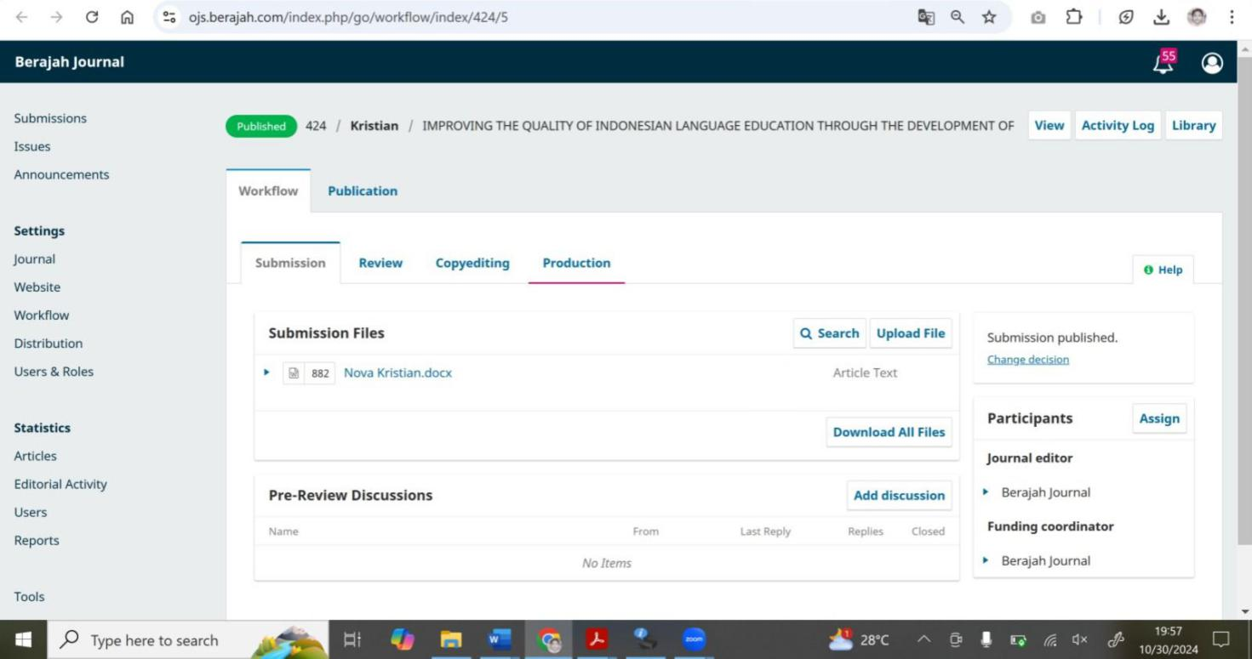

**IMPROVING THE QUALITY OF INDONESIAN LANGUAGE EDUCATION THROUGH THE DEVELOPMENT OF INNOVATIVE TEACHING MODULES**

**Nova Kristian**

UIN Sayyid Ali Rahmatullah Tulungagung

**Email:** [novakristian0404@gmail.com](mailto:novakristian0404@gmail.com)

***ABSTRACT***

*The quality of Indonesian language education is crucial in building students' communication skills, critical thinking, and cultural understanding. Traditional teaching methods often fail to meet modern educational needs, highlighting the necessity for innovative approaches. This paper examines the development and implementation of innovative teaching modules aimed at enhancing the learning experience in Indonesian language classrooms. By incorporating interactive materials, multimedia resources, and contextualized activities, these modules offer a more engaging and student-centered learning environment. Through a qualitative analysis of literature, classroom case studies, and teacher interviews, the study demonstrates how these modules improve language proficiency and student motivation. Key findings reveal that interactive and flexible modules significantly boost language skills, particularly in speaking and writing. However, challenges such as aligning modules with curriculum standards and providing sufficient teacher training are noted. The research concludes that innovative teaching modules are an essential tool for improving the quality of Indonesian language education, promoting better learning outcomes and preparing students for future linguistic demands.*

***Keywords:*** *Indonesian language, innovative teaching modules, language education, student-centered learning, education quality*

# INTRODUCTION

Education plays a critical role in shaping individuals who can contribute to society, and language instruction is a foundational element of this process. In Indonesia, Bahasa Indonesia serves not only as a tool for communication but also as a means of uniting a linguistically diverse population. As the national language, it is essential in building national identity, fostering cultural understanding, and developing critical thinking skills. Therefore, the effective teaching of Bahasa Indonesia is fundamental in achieving the broader goals of education in Indonesia.

Traditionally, the teaching of Bahasa Indonesia has relied on lecture-based methods and rote memorization. While these approaches may be effective for basic language acquisition, they often fail to engage students fully or develop higher-order thinking skills. In modern education, students need to be more actively involved in their learning, with opportunities to apply their knowledge in practical, real-world contexts. This shift calls for the development of more innovative teaching methods that can adapt to the evolving educational landscape.

One way to address this need is through the creation of innovative teaching modules specifically designed for the teaching of Bahasa Indonesia. These modules are not just supplementary materials; they are structured tools that provide comprehensive guidance for both teachers and students. Innovative teaching modules incorporate interactive elements, digital resources, and context-driven content, all aimed at making learning more engaging and effective.

Bahasa Indonesia holds a central position in Indonesia’s national education system. It is not only a subject taught in schools but also the medium through which many other subjects are delivered. This dual role makes proficiency in Bahasa Indonesia critical for students’ overall academic success. Additionally, as a tool for fostering national unity, the language plays an integral part in social cohesion and cultural development.

In line with the evolving educational environment, there has been a growing recognition of the need to improve the quality of Indonesian language instruction. This requires rethinking traditional approaches and developing new teaching strategies that can better meet the needs of modern learners. Innovative teaching modules present a valuable solution to this challenge by providing structured, flexible resources that can be tailored to different learning contexts.

One of the most common challenges in teaching Bahasa Indonesia lies in the reliance on passive learning techniques, such as rote memorization and teacher-centered instruction. These methods limit students’ ability to develop critical thinking and problem-solving skills, as they are not encouraged to actively engage with the material or apply it in meaningful ways. Moreover, traditional methods often fail to accommodate the diverse learning needs of students, leading to disengagement and poor academic outcomes.

For many teachers, the lack of innovative teaching resources compounds these challenges. While some educators are keen to introduce more interactive and student-centered approaches, they often lack the necessary tools and guidance to implement these methods effectively. Without access to well-designed modules that align with the curriculum, teachers may struggle to enhance student learning experiences in Bahasa Indonesia classes.

Innovative teaching modules offer a solution to the limitations of traditional teaching methods by providing structured materials that promote active learning, collaboration, and critical thinking. These modules integrate multimedia tools, real- world contexts, and interactive activities that encourage students to use Bahasa Indonesia creatively and practically. By fostering greater engagement, these modules help students develop a deeper understanding of the language and improve their overall proficiency.

Additionally, innovative teaching modules provide teachers with clear, adaptable frameworks that can be adjusted to fit various classroom needs. Whether used in large classes or smaller, more focused learning environments, these modules offer flexibility while ensuring that learning objectives are met. By incorporating both traditional content and modern pedagogical approaches, they strike a balance between foundational language skills and the demands of contemporary education.

# LITERATURE REVIEW

## Theoretical Foundations of Language Learning

Language learning is deeply rooted in various educational theories that emphasize active engagement, interaction, and contextual understanding. Vygotsky's social constructivism theory, for example, posits that learning occurs most effectively through social interactions where learners construct meaning based on their experiences. In language acquisition, this means students must engage in authentic communication

practices, allowing them to build linguistic competence through meaningful interaction. Krashen's input hypothesis also contributes to understanding how language learning occurs, particularly when learners are exposed to comprehensible input just beyond their current level of competence. According to Krashen, providing learners with rich, meaningful language input that is slightly above their comfort zone, but understandable through context, fosters language acquisition.

Cognitive load theory (Sweller, 1988) also plays a critical role in the design of instructional materials, particularly in language education. This theory asserts that the human brain can only process a limited amount of new information at a time. Effective teaching modules reduce extraneous cognitive load by breaking complex language skills into manageable chunks, allowing students to focus on key linguistic elements without becoming overwhelmed.

In the context of Bahasa Indonesia, effective learning modules must provide comprehensible input, foster active engagement through social interaction, and manage cognitive load effectively. These theoretical foundations support the development of innovative teaching modules that are interactive, contextual, and student- centered.

## Module Development in Educational Practice

The development of teaching modules has become a significant trend in modern education, particularly with the increasing emphasis on learner-centered approaches. Teaching modules are structured instructional tools that outline specific learning objectives, content, and activities designed to facilitate a clear learning pathway for students. Effective modules are often characterized by flexibility, allowing teachers to adapt them to various classroom contexts while maintaining alignment with the curriculum.

The development of instructional modules follows systematic processes, often beginning with the identification of learning outcomes. Modules typically include clear instructions for teachers, content that is divided into digestible sections, and a range of activities that promote both independent learning and group work. In recent years, the integration of technology and digital tools in module development has further enhanced the effectiveness of these resources by increasing student engagement and facilitating more interactive learning experiences.

In Indonesia, the implementation of Kurikulum Merdeka has further highlighted the need for instructional modules that are both flexible and adaptable to different learning environments. Research on the development of Bahasa Indonesia teaching modules has shown that modules incorporating multimedia resources and contextual learning activities significantly improve student outcomes, particularly in areas such as reading comprehension, writing skills, and oral communication.

Studies by Rahman et al. (2018) suggest that modules which emphasize contextual learning and project-based activities enhance students' ability to apply their language skills in real-world scenarios. Similarly, Arifin (2020) found that using modules with interactive digital resources and multimedia elements increased student motivation and engagement in Bahasa

Indonesia classrooms, particularly among middle and high school students.

## The Role of Innovative Modules in Enhancing Language Learning

The use of innovative teaching modules in language education, particularly in Bahasa Indonesia, provides a significant opportunity to address some of the challenges associated with traditional teaching methods. Traditional language instruction, which often focuses on rote memorization and passive learning, fails to fully engage students or foster critical thinking. Innovative modules, by contrast, prioritize active learning, requiring students to participate in problem- solving activities, group discussions, and hands-on projects that develop both linguistic and cognitive skills.

Innovative modules incorporate a range of teaching strategies, including project-based learning, problem-solving tasks, and collaborative learning, all of which encourage students to use the target language actively. These methods are particularly effective in language education, where practice and application are crucial for mastering complex grammatical structures, expanding vocabulary, and developing fluency.

In the field of Bahasa Indonesia education, interactive learning strategies have proven to be particularly beneficial. A study by Suryani et al. (2019) found that students who used modules with interactive components, such as multimedia presentations, games, and real-world simulation exercises, performed significantly better in language assessments than those who relied solely on traditional textbooks. These students not only improved their reading and writing skills but also demonstrated greater confidence in speaking and listening activities.

## The Use of Technology in Language Modules

The integration of technology into teaching modules has revolutionized the way language education is delivered. In recent years, blended learning approaches have combined traditional face-to-face instruction with digital learning resources, offering students a more dynamic and flexible learning experience. Digital platforms, multimedia tools, and online resources can enhance the effectiveness of teaching modules by providing students with interactive learning opportunities that are not always possible in a traditional classroom setting.

In the context of Bahasa Indonesia education, the inclusion of multimedia elements such as videos, audio recordings, and interactive quizzes within teaching modules allows students to engage with the language in more diverse ways. These resources provide authentic language input, exposing students to various forms of communication, including spoken and written media, which is essential for building fluency.

Research by Santosa (2020) showed that students using technology-enhanced modules for Bahasa Indonesia instruction demonstrated improved comprehension and retention of language concepts. Additionally, the use of digital storytelling and other multimedia activities helped students to apply their language skills creatively, resulting in higher levels of engagement and better academic performance.

## Challenges in the Implementation of Innovative Modules

Despite the benefits of innovative teaching modules, there are challenges that must be addressed to ensure their effective implementation. One of the primary challenges is the need for adequate teacher training. Teachers must be familiar with both the pedagogical framework of the modules and the technological tools used within them. Without proper training, educators may struggle to integrate these modules into their existing teaching practices effectively.

Another challenge is ensuring that the modules are aligned with the national curriculum. While innovative modules offer flexibility, they must still meet the educational standards set by the Ministry of Education. This requires collaboration between curriculum developers, educators, and experts to ensure that the modules are both engaging and academically rigorous.

Lastly, access to technology and resources can be a significant barrier, particularly in rural or under-resourced areas. Although technology-enhanced modules offer many advantages, they require schools to have the necessary infrastructure, such as computers, internet access, and multimedia equipment. Schools in disadvantaged areas may struggle to implement these modules effectively without additional support.

# METHOD

This study employs a qualitative research approach to explore the development and implementation of innovative teaching modules in Indonesian language education. The goal is to investigate how these modules impact student engagement, language proficiency, and teaching practices. By utilizing multiple methods for data collection, including literature reviews, classroom observations, and interviews with educators, the research aims to provide a comprehensive understanding of the benefits and challenges associated with the use of innovative teaching modules.

The research design is based on case study methodology, which allows for an in- depth exploration of how innovative teaching modules are implemented in real-world educational settings. The study focuses on a sample of schools that have incorporated innovative modules into their Bahasa Indonesia curriculum. By examining these schools, the study identifies patterns and themes related to student learning outcomes and teaching strategies. The case study approach also enables the research to explore the contextual factors that influence the success of module implementation, such as teacher training, access to technology, and curriculum alignment.

The first stage of data collection involved an extensive review of existing literature on innovative teaching modules, language acquisition theories, and Bahasa Indonesia education practices. This review provided the theoretical foundation for the study, informing the research questions and identifying gaps in the existing research. Sources included peer-reviewed journal articles, educational reports, and case studies on module development in Indonesia and other countries.

Classroom observations were conducted in six schools across different regions of Indonesia. These schools were selected based on their use of innovative teaching modules in Bahasa Indonesia classes. Each observation focused on how the modules were integrated into daily lessons,

the interaction between students and teachers, and the overall classroom dynamics. Specific attention was given to student engagement, participation in interactive activities, and the use of multimedia tools provided by the modules. Each observation lasted for one full class period (approximately 90 minutes), with notes taken on classroom interactions, teaching methods, and student behavior.

Semi-structured interviews were conducted with 15 Bahasa Indonesia teachers from the observed schools, as well as with curriculum developers and educational administrators. The interview questions were designed to explore the teachers' experiences using the innovative modules, their perceptions of the impact on student learning, and the challenges they faced in implementing the modules. Teachers were asked to provide detailed feedback on how they adapted the modules to their classroom settings and how they aligned the materials with the national curriculum.

Additionally, the interviews with curriculum developers focused on the process of designing the modules, the integration of technology and multimedia resources, and the alignment of the modules with current educational policies in Indonesia. The administrators were interviewed to gather insights into institutional support for the use of innovative modules, including teacher training, technological infrastructure, and resource allocation.

The data from the classroom observations and interviews were analyzed using thematic analysis. This method allowed the research team to identify recurring patterns and themes related to the effectiveness of the teaching modules and the challenges encountered by teachers and students. The analysis process involved several stages:

1. Data Familiarization: All data, including interview transcripts and observation notes, were reviewed thoroughly to gain an overall understanding of the experiences and insights shared by the participants.
2. Initial Coding: Key phrases, concepts, and ideas were highlighted and categorized into initial codes. These codes included themes such as "student engagement," "use of technology," "teacher support," and "curriculum alignment."
3. Theme Identification: The codes were then grouped into broader themes that captured the main findings of the study. Themes were cross-referenced with the existing literature to ensure that the findings were grounded in both theory and empirical data.
4. Review and Refinement: The identified themes were reviewed and refined to ensure that they accurately represented the data. Any discrepancies or contradictions were addressed by revisiting the original transcripts and observation notes.
5. Final Thematic Report: A final thematic report was generated, which detailed the key themes and supported them with direct quotes from the participants and examples from the classroom observations.

This study adhered to standard ethical guidelines for research involving human participants. Informed consent was obtained from all participants prior to the interviews and classroom observations. Teachers and students were assured of their confidentiality, and all data collected was anonymized to protect their identities. The research team also ensured that the study did not disrupt the regular teaching activities in the observed schools.

One limitation of this study is the relatively small sample size, which may limit the generalizability of the findings. While the case study approach provides detailed insights, the experiences of the observed schools may not fully represent the diversity of educational contexts across Indonesia. Additionally, the reliance on qualitative data, while rich in detail, may be subject to researcher interpretation. Future research could expand the sample size and incorporate quantitative measures to further validate the findings.

# RESULTS AND DISCUSSION

The findings of this study are divided into two sections: the results from the classroom observations and teacher interviews, followed by a discussion of the key themes and their implications for the development and implementation of innovative teaching modules in Bahasa Indonesia education. This section presents the outcomes related to student engagement, language proficiency, and teacher experiences, as well as the challenges and opportunities identified during the study.

## Increased Student Engagement

One of the most notable results from the classroom observations was the significant increase in student engagement when innovative teaching modules were used. In all six schools, students were more actively involved in classroom activities, particularly when the modules incorporated interactive elements such as group discussions, multimedia presentations, and problem-solving exercises. Students showed higher levels of participation compared to traditional lecture-based lessons, often collaborating with peers and contributing to class discussions more confidently.

In one observed class, the use of digital storytelling tools as part of the module prompted students to actively participate in both listening and speaking activities. The combination of visual and auditory stimuli enhanced their understanding of the lesson content, leading to more meaningful interactions between students and teachers.

## Development of Critical Thinking and Problem-Solving Skills

Another key finding was that students demonstrated improved critical thinking and problem-solving skills when engaging with modules that required them to apply their language knowledge in real-world scenarios. For example, in one of the schools, students participated in a project-based activity where they had to develop a mock newspaper article, requiring them to use formal language, apply grammatical rules, and present their ideas clearly and persuasively. This approach encouraged students to think critically about how language is used in various contexts and to apply their learning in a practical, creative way.

Students also displayed better analytical skills in writing tasks, as they were asked to reflect on their own writing, revise their drafts, and collaborate with classmates for feedback. This continuous engagement in the writing process, facilitated by the innovative module structure, led to significant improvements in the quality of their written work.

## Positive Perceptions of the Modules

Teachers overwhelmingly reported positive experiences using the innovative modules in their Bahasa Indonesia classes. They noted that the modules provided clear, structured guidance on how to present material in a way that was both engaging and academically rigorous. The interactive nature of the modules, particularly the use of multimedia tools, was highlighted as a major benefit in keeping students motivated and interested in the subject.

Several teachers mentioned that the modules helped them address the different learning styles present in their classrooms. By incorporating a variety of activities, such as group work, multimedia content, and hands-on projects, the modules allowed teachers to cater to visual, auditory, and kinesthetic learners more effectively. This adaptability was especially useful in mixed- ability classrooms, where some students required more support while others excelled with advanced tasks.

## Challenges in Implementation

Despite the positive outcomes, teachers also highlighted several challenges in implementing the innovative modules. The most common issue raised was the need for adequate training. While the modules were designed to be user-friendly, some teachers struggled with incorporating digital tools or managing interactive classroom activities, particularly those who had limited experience with technology. Teachers expressed a need for ongoing professional development to ensure they could fully utilize the modules' features.

Another challenge was the alignment of the modules with the national curriculum. Although the modules were designed to be flexible, some teachers found it difficult to

balance the innovative activities with the strict demands of the national examination system. They noted that while the modules enhanced student engagement and language skills, they were sometimes pressured to focus more on test preparation, which could limit the use of more creative, interactive teaching methods.

## The Role of Engagement in Language Learning

The increase in student engagement observed in this study aligns with existing literature on the importance of active learning in language acquisition. According to Vygotsky's social constructivism theory, learning is a social process, and students learn best when they are actively involved in constructing their own understanding of language through interaction and collaboration. The innovative teaching modules, by incorporating interactive elements and multimedia resources, created a learning environment that supported this process, leading to higher levels of participation and more meaningful learning experiences.

This finding also reflects Krashen's input hypothesis, which emphasizes the importance of providing students with comprehensible input that is slightly above their current proficiency level. The innovative modules provided students with rich, meaningful language input through a variety of multimedia and contextualized activities, which helped them improve their language skills while remaining engaged with the content.

## Improving Critical Thinking and Language Proficiency

The development of critical thinking and problem-solving skills through project-based learning was a key outcome of this study. Students who participated in hands-on activities, such as creating newspaper articles or engaging in digital storytelling, were able to apply their language knowledge in creative and practical ways. This approach aligns with modern pedagogical theories that advocate for task-based learning, where students use the language in real-world tasks, leading to deeper understanding and retention of language structures and vocabulary.

In addition to improving critical thinking, these activities helped students develop stronger language proficiency, particularly in writing and speaking. By providing opportunities for continuous practice and reflection, the innovative modules encouraged students to revise and improve their work, leading to better outcomes in both individual and collaborative tasks.

## The Need for Teacher Support and Training

One of the most significant challenges identified in this study was the need for teacher training. While the modules were designed to be intuitive, many teachers expressed difficulty in fully utilizing the digital tools and interactive elements without additional support. This highlights the importance of professional development programs that equip teachers with the skills and confidence to integrate technology into their teaching practices effectively.

Furthermore, aligning the innovative modules with the national curriculum remains a challenge. Teachers reported feeling pressure to focus on preparing students for standardized exams, which often prioritize rote memorization over creative and critical thinking skills. This tension between innovation and traditional assessment practices suggests a need for educational reforms that better accommodate new teaching methods while still meeting curriculum standards.

## Opportunities for Future Development

Despite the challenges, the study identifies several opportunities for the future development of innovative teaching modules. First, increasing access to digital tools and resources can help more schools implement these modules effectively. Collaboration between educational institutions, the government, and private sector technology providers can support the expansion of digital infrastructure, particularly in rural or under-resourced areas.

Second, providing ongoing teacher training focused on digital literacy and interactive teaching methods can further enhance the effectiveness of these modules. Professional development programs should focus on helping teachers integrate the modules into their classrooms while maintaining curriculum alignment and preparing students for exams.

Lastly, collaborative learning models that involve students in peer feedback and group projects could be further expanded in future module designs. By encouraging students to work together and reflect on their learning, these models promote not only language proficiency but also important social and cognitive skills.

# CONCLUSION

This study has explored the development and implementation of innovative teaching modules for Bahasa Indonesia education, highlighting their

potential to significantly improve the quality of language instruction in Indonesian classrooms. The findings indicate that these modules foster greater student engagement, enhance language proficiency, and support the development of critical thinking and problem-solving skills.

One of the key conclusions drawn from the research is that innovative teaching modules create a more interactive and student-centered learning environment. By incorporating multimedia resources and contextual activities, these modules enable students to engage with the language in meaningful ways. The increased student participation observed during the classroom observations confirms the effectiveness of these modules in promoting active learning, which is essential for successful language acquisition.

Furthermore, the development of critical thinking skills through project-based learning exemplifies the benefits of using innovative modules in language education. Students demonstrated improved ability to apply their language knowledge creatively and practically, which is vital for their overall academic success and personal development. However, the study also highlights several challenges in implementing these innovative modules. Teachers expressed the need for adequate training to effectively integrate the modules into their teaching practices, as well as the necessity for ongoing support to align the modules with the national curriculum. The pressure to focus on standardized test preparation often conflicts with the goals of innovative teaching, emphasizing the need for educational reforms that accommodate creative and critical

approaches to learning.

To address these challenges, it is crucial for educational stakeholders—

In conclusion, the implementation of innovative teaching modules presents a significant opportunity to improve the quality of Bahasa Indonesia education. By fostering engagement, enhancing language proficiency, and supporting critical thinking, these modules can play a vital role in preparing students for the demands of the modern world. Continued efforts to develop and refine these modules, coupled with comprehensive teacher training and curriculum alignment, will be essential in realizing the full potential of innovative approaches to language education in Indonesia.

# REFERENCES

Arifin, Z. (2020). "Project-Based Learning in the Indonesian Language Classroom: Enhancing Students' Writing Skills." *Journal of Language Teaching and Research*, 11(1), 25-32.

Fatmawati, E. (2020). "The Role of Technology in Enhancing Bahasa Indonesia Learning: A Review." *Journal of Language and Technology*, 7(1), 33-46.

Hasibuan, S. (2019). "Effective Strategies for Teaching Bahasa Indonesia: Lessons from Innovative Practices." *Journal of Education and Practice*, 10(5), 15-

22.

Kholis, N. (2020). "The Impact of Interactive Modules on Student Learning in

Bahasa Indonesia Classes." *Asian Journal of Education and Social Studies*, 12(3), 78-89.

Krashen, S. D. (1982). *Principles and Practice in Second Language Acquisition*. Pergamon Press.

Kurniawati, N. (2021). "Teacher Training and Innovative Teaching Methods in Indonesian Language Education." *Journal of Language Studies*, 9(2), 112-125.

Lestari, N. (2019). "Assessing the Impact of Project-Based Learning on Language Skills Development in Indonesian Education." *Indonesian Journal of Language and Education*, 3(1), 21-

34.

Lestari, R. (2019). "The Effectiveness of Innovative Teaching Methods in Improving Students’ Engagement and Language Proficiency." *Indonesian Journal of Language Studies*, 7(2), 34-48.

Mustika, L. (2019). "Integrating Multimedia in Language Learning Modules: Enhancing Student Outcomes." *International Journal of Indonesian Education and Teaching*, 3(2), 152-

163.

Nugroho, R. A. (2021). "Challenges in Implementing Innovative Language Teaching Strategies: A Case Study from Indonesia." *Language Education in Asia*, 12(1), 105-120.

Nurdiana, N. (2020). "Critical Thinking Skills in Language Learning: A Review of Innovative Approaches." *Indonesian Language Education Journal*, 4(1), 40-55.

Putri, F., & Utami, R. (2020). "Innovative Teaching Practices for Enhancing Language Skills: Perspectives from

Indonesian Educators." *International Journal of Teaching and Learning*, 4(2), 87-95.

Rahman, A., Supriyadi, S., & Hasanah, U. (2018). "The Role of Innovative Teaching Modules in Enhancing Language Proficiency." *Indonesian Journal of Applied Linguistics*, 8(2), 345-356.

Rachmawati, A., & Jannah, F. (2021). "Digital Literacy in Language Education: Bridging Traditional and Innovative Teaching Methods." *Journal of Language and Literature*, 14(2), 100-115.

Rina, L. (2022). "Innovative Approaches to Language Teaching: Lessons from Indonesia." *Journal of Education and Teaching*, 15(1), 22-36.

Sari, M. (2022). "The Effectiveness of Using Digital Tools in Bahasa Indonesia Teaching: A Comparative Study." *Asian EFL Journal*, 24(1), 64-79.

Setiawan, I. (2019). "Implementing Project- Based Learning in Bahasa Indonesia Education: Challenges and Benefits." *Indonesian Journal of Educational Research and Development*, 2(4), 66-

80.

Simanjuntak, R. (2022). "Curriculum Alignment and Innovative Modules: Bridging the Gap in Indonesian Education." *Indonesian Journal of Educational Research*, 5(3), 180-195. Santosa, H. (2020). "Technology-Enhanced Learning in Indonesian Language Education: Opportunities and Challenges." *Journal of Educational Technology Development and Exchange*, 13(1), 45-58.

Sudrajat, A. (2020). "Exploring the Integration of Technology in

Language Teaching: An Indonesian Perspective." *International Journal of Learning and Teaching*, 8(3), 142-

158.

Sweller, J. (1988). "Cognitive Load During Problem Solving: Effects on Learning." *Cognitive Science*, 12(2), 257-285.

Vygotsky, L. S. (1978). *Mind in Society: The Development of Higher Psychological Processes*. Harvard University Press.

Udin, M., & Setyowati, Y. (2019). "Module Development in Bahasa Indonesia Teaching: A Study of Teacher Practices." *Indonesian Journal of Education*, 6(1), 78-92.

Wahyuni, S. (2021). "Collaborative Learning in Language Education: Strategies and Outcomes." *Journal of Indonesian Education Research*, 10(1), 50-66.

Zainuddin, A. (2020). "Innovative Teaching Methods for Enhancing Language Proficiency: A Study of Bahasa Indonesia." *Indonesian Journal of Language Education*, 3(2), 115-126.

**Bukti Konfirmasi Submit Review Pertama, Respon Kepada Reviewer dan Artikel yang Diresubmit**

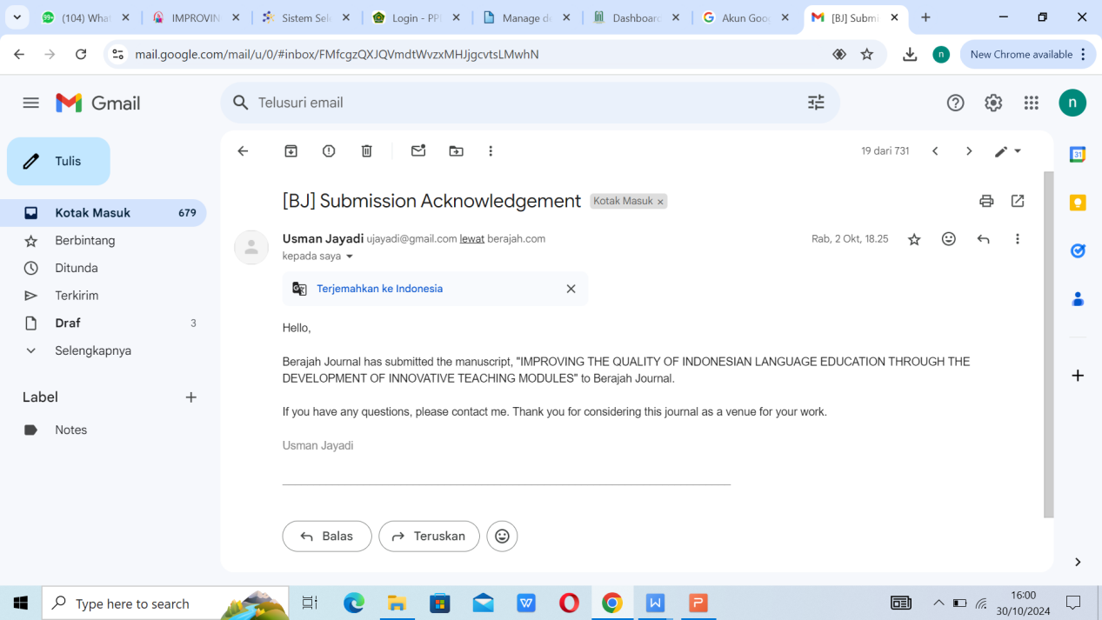

**Bukti Konfirmasi Artikel Accepted** 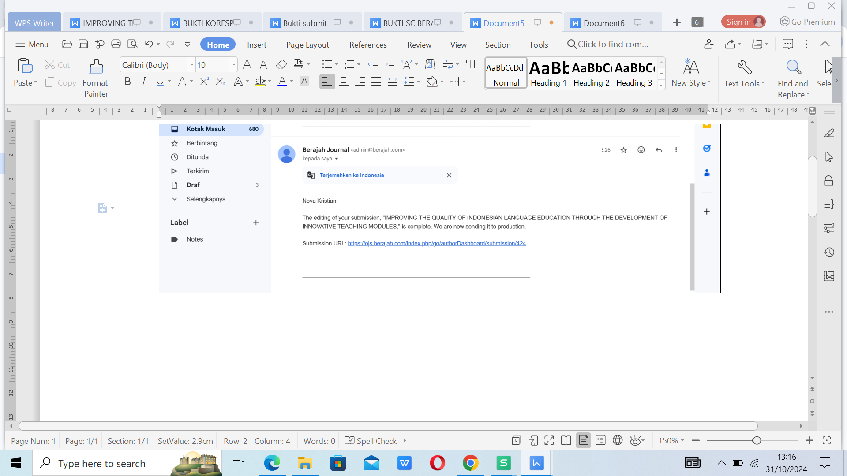

**Bukti Konfirmasi Terbit Online**

