**BUKTI KORESPONDENSI**

**ARTIKEL JURNAL INTERNASIONAL BEREPUTASI**

Judul Artikel : Analysis of the effect of Islamic Leadership and Job Satisfaction on sharia engagement and employee performance of Islamic Banks in indonesia

Jurnal : Cogent Business & Management , 2024, Volume 11,

No. 1, Hlm. 2362772.

Penulis : Ahmad sodiq, Ririn Tri, Imron Mawardi

|  |  |  |
| --- | --- | --- |
| No. | Perihal | Tanggal |
| 1. | Bukti konfirmasi submit paper dan artikel yang disbumit | 1 Mei 2022 |
| 2. | Bukti konfirmasi paper accepted | 29 April 2024 |
| 3. | Bukti konfirmasi paper published | 2 Juli 2024 |

1. **Bukti Konfirmasi Submit Paper yang Disubmit (1 Mei 2022)**

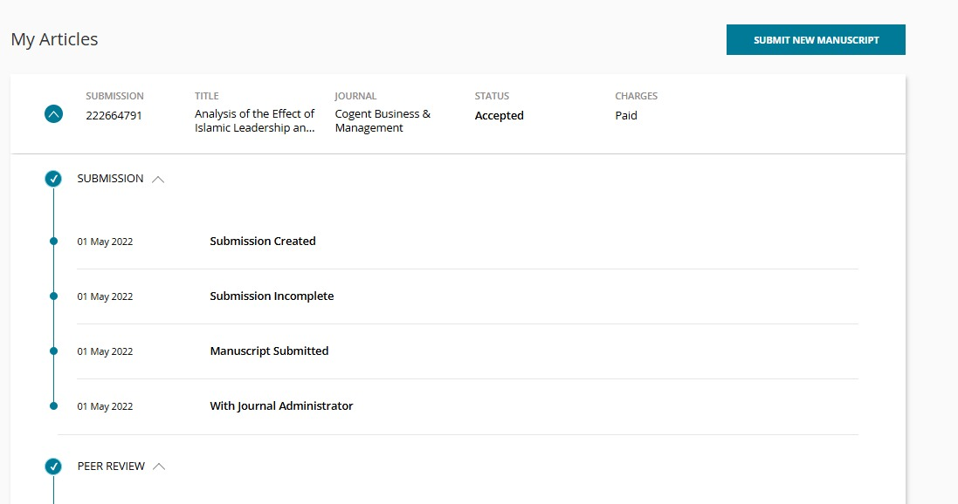

1. **Bukti Konfirmasi Paper Accepted (29 April 2024)**



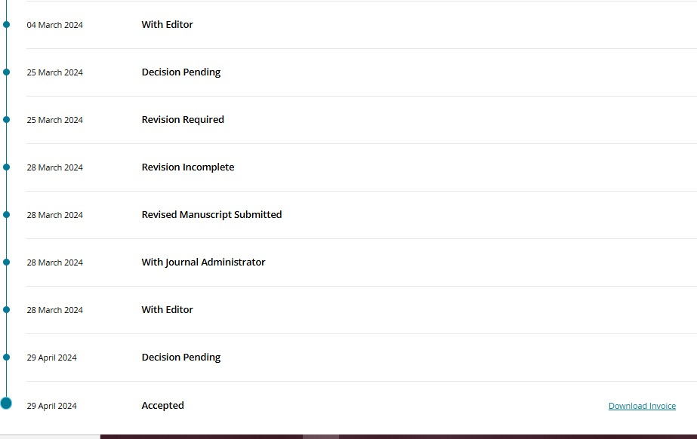

1. **Bukti Konfirmasi Paper Published (2 Juli 2024)**

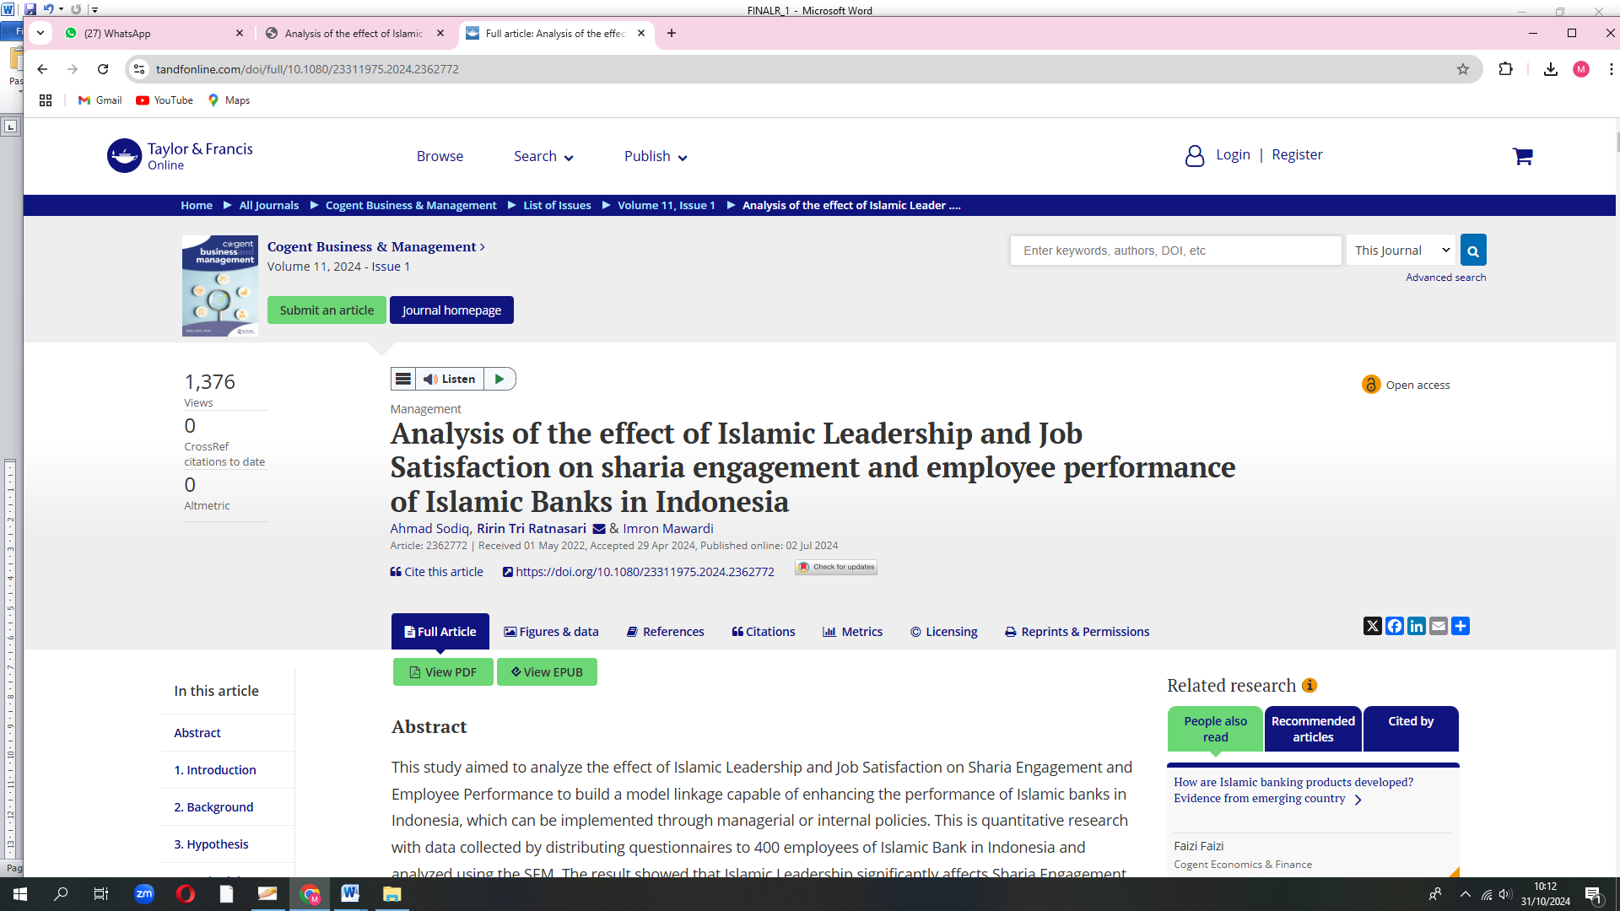

**Analysis of the Effect of Islamic Leadership and Job Satisfaction on Sharia Engagement and Employee Performance of Islamic Banks in Indonesia**

Ahmad Sodiq

*Sharia Economics Doctoral Student - Faculty of Economics and Business- Universitas Airlangga- Indonesia*

[*ahmad.sodiq-2017@pasca.unair.ac.id*](mailto:ahmad.sodiq-2017@pasca.unair.ac.id)

Ririn Tri Ratnasari

*Department of Sharia Economics-Faculty of Economics and Business-Universitas Airlangga-Indonesia*

[*ririnsari@feb.unair.ac.id*](mailto:ririnsari@feb.unair.ac.id)

Imron Mawardi

*Department of Sharia Economics-Faculty of Economics and Business-Universitas Airlangga-Indonesia*

[*ronmawardi@feb.unair.ac.id*](mailto:ronmawardi@feb.unair.ac.id)

*Correspondence Author:*

[*ririnsari@feb.unair.ac.id*](mailto:ririnsari@feb.unair.ac.id)

**Abstract-** This study aimed to analyze the effect of Islamic Leadership and Job Satisfaction on Sharia Engagement and Employee Performance to build a model linkage capable of enhancing the performance of Islamic banks in Indonesia, which can be implemented through managerial or internal policies. This is quantitative research with data collected by distributing questionnaires to 400 employees of Islamic Bank in Indonesia and analyzed using the SEM. The result showed that Islamic Leadership significantly affects Sharia Engagement and Job Satisfaction. Job satisfaction also has a significant effect on Sharia Engagement, and Sharia Engagement has a significant effect on Employee Performance. Meanwhile, Islamic Leadership and Job Satisfaction do not have the ability to significantly impact Employee Performance. The relationship between these variables shows that the Islamic Leadership model alone is not enough to improve Employee Performance. Its implementation tends to affect Job Satisfaction and increase Sharia Engagement, thereby affecting Employee Performance. Meanwhile, the indicator of Belief in Supervision from Allah SWT, has the smallest loading factor value. It indicates that the ukhrawi dimension was not properly implemented. This is a significant task for Islamic banking in Indonesia to be perceived as a product label and an integral dimension of employees. Study limits: Focus on specific variables, excluding factors like internal marketing and employee welfare. Data covers a three-year period for Sharia Banking employees, not fully capturing relationships for those with less experience. Neglects cultural aspects in Islamic banking management, offering an incomplete view of work culture in Indonesian Islamic banks.

**Keywords-** Islamic Leadership, Job Satisfaction, Sharia Engagement, Employee Performance, Islamic Banking

1. **Introduction**

Islamic banking is a business institution that operates in accordance with sharia principles. Therefore, asides from obtaining material benefits, its main goal is the *ukhrawi*. Thisis realized through applying business ethics that are in accordance with Islamic law (Tiby & Grais, 2015), such as the prohibition of interest (*riba*), financing companies that produce illicit goods, and investing in securities that are not included in the Sharia criteria.

As the largest Muslim country globally, Indonesia is a potential market for Islamic banking. Therefore, various policies have been implemented by the government to improve the performance of this business institution. By 2024, Indonesia is targeted to become the center of the world's Islamic economy, with the inclusion of strengthening the Islamic finance sector as the second of the 4 focuses of the Indonesian Islamic Financial Architecture Masterplan (MAKSI) from 2019 to 2024 (Bappenas, 2018). However, Non-Performing Financing (NPF) and Return of Assets (ROA) are still homework for Islamic banking. Based on data from the OJK, in the last 10 years the NPF of sharia banking was still relatively high and the ROA ratio of sharia banking was no better when compared to conventional banks in the same period (OJK), 2023). This shows that the performance of sharia banking is still below that of conventional banking (OJK, 2023).

The main attributes needed to improve the performance of Islamic banks include human resources, productive attitudes and behaviors, and managerial skills ​(Dharma, 2018). Therefore, the 2 aspects of operational management capabilities and moral character in accordance with Islamic values are attributes that need to be possessed by every Islamic Bank HR to achieve the proclaimed targets.

Improving employee performance in accordance with good management is mainly realized through leadership style. Nasution et al. (2020) reported that this requires more than maximizing 1 of the antecedent variables. Many components have an increasingly significant effect on employee performance. Xanthopoulou et al. (2009) stated that good management aims to develop a strong culture within the organization or company.

Stairs and Galpin (2006) stated that the development of quality relationships with colleagues significantly affects employee engagement. Meanwhile, a transformative leader’s action triggers a positive socio-emotional climate (Xanthopoulou et al., 2009).

Employee engagement is a measure of the company's success in handling problems regarding human resource management (Buil et al., 2019). It also involves the transcendental realm (*habluminallah*) or Sharia commitment, which has great potential to spur employee performance.

The Islamic leadership model is not a guarantee to improve employee performance. This is in line with Sani and Maharani Ekowati (2020) that it has an indirect effect. To determine the impact of human resource management in these banks, it is necessary to ascertain the variables that have both direct and indirect effects. Ratnasari (2014) discovered that internal marketing and Islamic leadership impact employee performance. However, this is affected by the application of appropriate Sharia values.

According to Eliyana et al. (2019), the transformative leadership model directly and significantly affects job satisfaction. However, it has an insignificant impact on performance when it is intervened by employee commitment. Buil et al. (2019) reported that employee engagement fully mediates the relationship between transformational leadership and employee behavior and partially mediates that between their performances.

The earlier mentioned research stated that employee performance is affected by leadership, job satisfaction, and employee engagement. As an institution which management is based on the Islamic concept, these banks are inseparable from certain habits because work culture is affected by values, spiritual beliefs, and some form of rituals (Schein, 2004). Therefore, it is impossible to ignore the accompanying Sharia aspects in examining the effect of employee performance.

The major problem faced is how to motivate sharia engagement through Islamic leadership and other variables. None of the preliminary research comprehensively examined the antecedents of employee performance and Islamic values inherent in the human resources organization as an inseparable unit. This shows that there is a need for improvement in embracing appropriate work ethics and culture, which has both worldly and hereafter orientation. Accordingly, the objective of this research is to "build a model that links Islamic Leadership, Job Satisfaction, and Sharia Engagement to improve Employee Performance in Islamic banks."

Referring to the description of the condition of sharia banking in Indonesia, the challenge for sharia banking in Indonesia is how to improve the performance of sharia banks through proper management of Human Resources (HR) in accordance with Islamic values. Meanwhile, until now there has been no research that has examined the antecedents of Islamic bank employee performance in a comprehensive manner, namely as a unit that cannot be separated from Islamic values, whether inherent in the organization or the human resources who work in it. This shows that there is still room for strategic efforts to improve the performance of Islamic bank employees in Indonesia. Therefore, it is important to build a model link between Islamic leadership, sharia engagement and job satisfaction to be able to improve the performance of sharia banking employees in Indonesia which can be implemented through managerial policies or other policies.

Practically, this research also has benefits in helping Islamic banking make better decisions. With a better understanding of the subject of this research, Islamic banking can identify, address and prevent problems related to improving employee performance. This will help sharia banking to develop employee performance improvement strategies that are built on Islamic principles, thereby providing a positive impact on the development of the bank to achieve better overall performance.

1. **Background**
   1. **Islamic Leadership**

Leadership is interpreted as an emotional process developed through social influence, for instance, an individual’s ability to ask for help and support from others to fulfill certain tasks (Jennifer, 2000). Stoner et al. (1995) described it as a process that directly affects the activities of its members.

Asrar-ul-Haq and Anwar (2018) distinguished the notion of leadership into 2 (two) models or concepts, namely as a process and an attribute. As a process, it is usually focused on the leaders’ behaviors, in which they use their power to strengthen and affirm organizational goals. They also motivate their employees, subordinates, or the people being led, to achieve set goals and help create a productive culture.

Meanwhile, as attributes, leadership is interpreted as a collection of characteristics that a leader needs to possess. This indicates they need to have the ability to influence someone’s behavior (others) without using violence or physical coercion to be accepted (Asrar-ul-Haq & Anwar, 2018).

Leadership is realized from the process or the dynamics of social organization or interaction (Meyer & Allen, 1997). Meanwhile, without a leader, the group is bound to experience disintegration. Their absence makes it difficult for the subordinates to achieve set goals.

The leadership process and managerial activities such as planning, directing, organizing, and controlling are inseparable (Fiedler, 1967). However, Robbins and Judge (2007) reported that management closely relates to the strategy adopted to solve problems and overcome changes. This clarifies that leadership is closely related to the company's vision. Management is also associated with applying the leader’s strategy.

Likewise, Mullins (2005) stated that management has a close relationship with planning, organizing, directing, and controlling the activities carried out by its employees. Leadership focuses more on communicating, motivating, and promoting them to act optimally to realize planned goals (Herianingrum et al., 2019).

According to the Islamic view, it is referred to as "*Wilayah*," "*Imamah*," and "*Khilafah*." Islamic leadership does not depend on legitimate traditional authorities, rather it is subject to a rational-legal system based on unity, the recognition of one God, and the exemplary life of Prophet Muhammad. Therefore, it is important to improve the external or "ethical" characterization by respecting the leadership prototype stated in the Qur'an, Sunnah, and Hadith (Almoharby & Neal, 2013).

The Islamic leadership model guides, directs, and drives both the leader and the members towards the path blessed by Allah SWT (Moghimi, 2018). In accordance with the understanding of Islam, its orientation is solely for the pleasure of Allah SWT.

The spiritual-based leadership concept is a development of the existing model with more specific values relating to Islam (Fry, 2003). This is important and has been in existence for more than 1500 years. In fact, since the emergence of Prophet Muhammad, SAW presumed to be responsible for its implementation, based on guidance from the Qur'an and Sunnah.

Leadership is interpreted as a form of sacrifice and trust that needs to be properly maintained (Dent, Higgins & Wharff, 2005). It is not described as the arbitrariness to act, rather it has the authority to protect, serve and act fairly. This leadership model is based on trust, sincerity, and justice (Almoharby & Neal, 2013).

Galanou & Farrag (2018) reported that Islamic leadership is positively and significantly related to perceived effectiveness and innovative outcomes. In addition, the findings reveal that it is positively correlated with transformational, ethical, and authentic leadership styles and negatively related to the transactional type.

Based on the aforementioned theoretical review, it was concluded that Islamic leadership is the ability to influence employees to achieve set goals by management based on the norms of the Qur'an and Hadith as well as the behavior of the Prophet SAW in daily practice.

* 1. **Job Satisfaction**

Employees feel job satisfaction due to certain underlying factors (Nasution et al., 2020). They are usually comfortable and highly loyal, which is perceived as a reflection of their feelings towards their work (Schermerhorn et al., 2012). It depends on the individual’s nature and the job situation (Ratnasari, Gunawan, bin Abu Talib, et al., 2020). Each employee experiences a different level of job satisfaction based on their interests and expectations (Nelson & Quick, 2012).

Davis (2010) described job satisfaction as a feeling to provide support. Wexley and Yuki (1998) defined it as the way employees feel about themselves, and this is determined by the job and certain circumstances.

Along with the rapid technological development, all kinds of job equipment are manufactured to accelerate and simplify mechanisms to provide better and quality production, although, human resources play an important role. Therefore, no matter the planning, organization, or supervision, assuming employees fail to carry out their duties sincerely without coercion, the company tends not to get the desired results (Meyer & Allen, 1997).

Fortunately, when associated with Islamic values, job satisfaction triggers certain feelings such as patience, gratitude, and sincerity *(Al-Aidaros, Shamsudin & Idris, 2013)*. In reality, these 3 are closely related to problems that often arise at work, specifically job satisfaction.

Working with sincerity, patience, and gratitude is not a guarantee to increase output. However, as a process, the application of these 3 aspects adds more value. By being sincere accompanied with a sense of patience and gratitude, a certain satisfactory level is obtained rather than only output.

Any work based on insincerity, impatience, and ingratitude causes employees to be unable to properly complete their duties, irrespective of the fact that the output and target are met. However, the outcome brings about feelings of anger and fatigue. These 3 aspects offer a positive and motivating aura to the employees and even those around them (Nasution et al., 2020).

Employees need to be able to accept both success and failure to discharge certain tasks. Therefore, they must always be grateful and not compare themselves with the upper classes (Tri Ratnasari et al., 2018).

In this era of job competition, sincerity, patience, and gratitude are perceived as a challenge and certainly difficult to realize. Zain, Darus & Ramli (2015) stated that for individuals to achieve success and become more productive at work, they need to achieve the above attributes.

Nasr (1984) stated that gratitude maximizes potential regarding a perfect physique. The senses given by Allah SWT need to be properly utilized by humans. The conscious state of self-possession is perceived as a form of gratitude or generally as effectively and efficiently utilized gifts.

The right attitude is to be patient and sincere while paying attention to certain potentials, completely understanding the condition, not being absorbed in the shackles of sadness and excessive pleasure, not easily discouraged or giving up in some circumstances, thereby resulting in stress which finally leads to negative behavior and the intension to harm oneself and even others (Sedianingsih et al., 2019). This simply implies a patient attitude full of creativity, optimism, courage, and determination (Nasr, 1984). It also leads to employees’ awareness, allowing them to make certain decisions. This is influenced by the creation of an ideal work environment.

Based on the earlier mentioned description, it was concluded that job satisfaction is not merely a material appreciation or promotion given by the workplace. However, it is characterized by a sense of patience, sincerity, and gratitude in an Islamic perspective.

* 1. **Sharia Engagement**

According to Khan (2016), employee engagement is a combination of cognitive and emotional antecedent variables in the workplace. This linear function involves its members, thereby ensuring the organization functions as expected (Harter, Schmidt & Hayes, 2002). A sense of engagement is also perceived through positive behavior related to enthusiasm or mental strength, dedication, and absorption (Rameshkumar, 2020).

Engagement is a comprehensive concept affected by several factors, including work culture, communication between employees within the organization, managerial and leadership models that generate trust and appreciation and boost the company’s reputation (Lockwood, 2007). Therefore, employee engagement is interpreted as a two-way relationship between superiors and employees, as well as a positive attitude towards the workplace and its values. These employees realize that improving their performance is for the organization's benefit.

Employee engagement is also affected by certain attributes, such as integrity, building good communication in the internal sector, and updating the work culture. A positive relationship is described as a condition where employees have a special connection with the work environment, enabling them to adopt all necessary measures and contribute optimally to the organization's progress (Rameshkumar, 2020).

Employee engagement is also related to the mood, personality, and actions executed in the workplace, as well as developing a consistent relationship with the company’s performance (Macey et al., 2009). It involves understanding one's behavior in a firm.

Sharia engagement is a one-level development, and to understand this concept, it is necessary first to examine its nature or purpose in an organization. Ali and Al-Kazemi (2007) stated that the Sharia law consists of internal and external aspects, which includes universal Islamic moral principles on how individuals are expected to behave, mode of worship, etc.

The principle promoted by Islam is accountability which is strengthened by trust and justice related to social life and business (Rindjin, 2008). Beekun and Badawi (2005) stated that the concept of engagement from an Islamic point of view is as follows:

1. The different characteristics of the organization, in this case, are those that are in accordance with sharia principles.
2. Some social norms and Islamic ethics are generalized and serve as a reference for individuals to act according to their beliefs and responsibilities.
3. The sense of togetherness exhibited by the organization, management, employees, and customers is following sharia principles.
4. Trust from the community is evidenced by the increasing number of new branch offices.

Meanwhile, according to the Islamic perspective, the main aim of these organizations is to be merciful (Beekun & Badawi, 2005). This goal is normatively based on Islamic beliefs and the actual reason behind the creation of humans. Irrespective of the fact that these are abstract, some are practically inspired by the values ​​of the main goal (Ratnasari, Gunawan, Mawardi, et al., 2020). Ethical regulations are implemented to ensure that efforts to realize main and operative goals are properly executed (Ali & Al-Kazemi, 2007).

Referring to the nature of justice, Islamic ethics functions as a source used to distinguish right from wrong (Ratnasari et al., 2021). Sharia law does not only bring someone closer to God, rather it also facilitates the development of a just society and individuals that can maximize their potential and welfare (Beekun & Badawi, 2005).

Based on the earlier mentioned description, it was concluded that sharia engagement is an individual's attachment to the organization, whether physically, emotionally, or spiritually based on belief, balance or fairness, freedom, and responsibility. The concept of sharia engagement is a one-level development of employee engagement concept, which emerges due to the work system, the formed ubudiah and Allah SWT responsibility.

* 1. **Employee Performance**

Employee performance is a record of the outcome of the respective job functions or activities within a certain period. Therefore, its result is based on effective productivity (Bernardin & Russell, 2013). It is also described as an employee’s achievement or success at work, in terms of realizing the set target by the company's management which needs to be accounted for before the leadership.

A business organization has interdependencies that are interrelated with each other. Meanwhile, employees are part of the organizational structure, and they play a major role in achieving set goals (Dharma, 2018).

According to Tri Ratnasari & N (2020) employee performance aids the company to realize its achievements. Human resource management is also important in terms of achieving the desired outcome. The enjoyable activities and strong psychological ownership factor have a significant effect (Nasution et al., 2020).

Human resource management greatly determines the extent of performance, which shows that reliable managers affect the social exchange process (Santoso et al., 2020). Meanwhile, successful organizations usually employ individuals willing to work beyond expectations (Widiastuti et al., 2019). In this dynamic world of work, several tasks are increasingly being carried out, therefore, there is a need for teamwork and flexibility (Dharma, 2018).

It is expected of a Muslim to possess an ethical spirit (Mustika et al., 2020). Besides, as a leadership demand, work is perceived as a form of worship in which all behavior is supervised by Allah SWT and held accountable in the afterlife (Bhatti et al., 2016). The demand for good performance does not only arise from the company’s SOPs or supervisors but the awareness of a transcendental element (*habluminallah*) that needs to be created in every work activity (Sedianingsih et al., 2018).

As a consequence of the perfection offered by Allah SWT, humans are always expected to work. From an Islamic perspective, employee performance involves science and technology (Rana & Malik, 2016). Therefore, Allah SWT mandates that humans possess a thorough understanding and ensure that it benefits other creatures, as stated in the Quran Surah As-Zummar verse 9, which essentially distinguishes between knowledgeable and ignorant people.

Employee performance is realized when some individuals actualize their work functions by paying attention to the values of Islamic teachings (Nasution et al., 2020). This is because it is perceived as a belief based on strong moral principles and the motivation to realize the expected outcome (Ratnasari, Gunawan, Septiarini, et al., 2020).

Apart from the indicators above, in Islam, employee performance is similar to the conventional concept. The only difference is that a Muslim seeks the pleasure of Allah SWT and embraces the virtue of quality and wisdom from the results obtained. Moreover, assuming these 2 attributes are work sources, then an ideal performance tends to be realized (Bhatti et al., 2016).

Based on the aforementioned theoretical basis, the starting point for improved performance is when employees are engaged, supported by Buil, Martínez, and Matute (2019). Meanwhile, a transformative leadership model is needed to foster engagement (Herianingrum et al., 2016). According to Schein (2004), work culture is affected by spiritual values ​​or beliefs and rituals, while the key factor is the leader.

The theoretical leadership model or style also affects other aspects such as job satisfaction (Eliyana, Ma’arif & Muzakki, 2019). As an institution that adheres to the concept of sharia, Islamic banking needs to be perceived as a unit that offers certain products, as implemented by the HR management.

In viewing the antecedents of employee performance, it is also inseparable from the implemented sharia concept, namely the Islamic leadership. This theoretically leads to character and work culture, such as a sense of job satisfaction, resulting in sharia and employee engagement. The emergence of these attributes theoretically triggers employee performance.

1. **Hypothesis**

The following is a hypothesis built from several theories and results of previous research and used as test material in this research:

H1: Islamic leadership has a significant influence on sharia engagement at Sharia Banks in Indonesia.

H2: Islamic leadership has a significant effect on job satisfaction at Sharia Banks in Indonesia.

H3: Islamic leadership has a significant effect on employee performance at Sharia Banks in Indonesia.

H4: Job satisfaction has a significant effect on sharia engagement at Sharia Banks in Indonesia.

H5: Job satisfaction has a significant effect on employee performance at Sharia Banks in Indonesia.

H6: *Sharia engagement has a significant effect on employee performance at Sharia Banks in Indonesia.*

1. **Methodology and sample description**
   1. **Method**

The approach used in this research is a quantitative approach. This quantitative approach focuses on hypothesis testing and data analysis through statistical measurements and analysis. The aim of this approach is to solve existing problems in research.

The new model was developed based on an existing theory. Statistical analysis was carried out using SEM (Structural Equation Modeling)*. Hair et al. (2014)* described it as a statistical technique used to analyze the relationship between latent constructs and their indicators, as well as direct measurement error. This model directly investigates several dependent and independent variables.

SEM prioritizes the interactive modeling, where the relationship between the independent variables, nonlinearity, measurement, and correlated error terms, including dependent multiple latents, are determined using several indicators. Furthermore, 1 or 2 adjustable latent variables are measured with existing indicators. Based on the aforementioned description, SEM is also used as an alternative compared to multiple regression, path, factor, covariance, and time-series analyses (Byrne, 2010).

Another advantage is its ability to measure a latent variable indirectly with the estimated attribute realized with the model is assumed to have a relationship with the variable in question (latent variable). Therefore, it is explicitly used to discern the unreliable measurement, although theoretically, the model's structural relationships between latent variables were precisely determined (Millan & S, 2010). This research also used IBM SPSS Amos 20.0.0 (Build 817) to provide an index and assess whether the obtained information properly fits the suggested model.

* 1. **Data and Measurements**

The population that is the focus of this research is all employees from 12 Indonesian Sharia Commercial Banks (BUS). For this research, the samples or respondents used were employees of Sharia Commercial Banks throughout Indonesia who had worked for at least the last 3 years. The number of samples used in this research was 400 respondents.\. The sample selection required respondents to have worked for at least 3 years with the aim of ensuring that employees who were respondents had a comprehensive understanding and experience of the management philosophy contained in the strategies implemented by their superiors. Apart from that, respondents in this study will also be classified based on their position, namely ordinary employees and managers (branch heads).

The questionnaires used for the two groups of respondents will be different from each other but remain coherent. This approach is taken to ensure that the data collected is appropriate to the real situation in the field and obtains relevant information from each employee group. However, the regression output for both data from ordinary employee respondents or leaders will be one. Because in this research, the two research subjects were both sharia banking employees. Therefore, the questionnaire that will be prepared in the research will be prepared in an integrated and coherent manner even though it is aimed at different respondents.

This research focuses on Sharia Commercial Banks (BUS) because they have separated their activities and operational costs from conventional banks which are usually involved in ribawi activities. Even though each Sharia Commercial Bank (BUS) may have different management arrangements, they all have the same obligation to apply Islamic principles in their management. Therefore, studying Sharia Commercial Banks (BUS) specifically can provide deeper insight into the implementation of Islamic principles in the banking context. So, even though each Sharia Commercial Bank (BUS) has different management governance, with the research approach adopted in this study, namely looking at the antecedents of Islamic banking employee performance from an Islamic perspective, this will not be an obstacle in researching the antecedents of employee performance at 12 banks. General Sharia (BUS).

In this research, the sample selection of 400 respondents met the criteria for the minimum sample size recommended in the Structural Equation Model (SEM) analysis method. According to Hair et al., (2014), the minimum sample size required for structural equation modeling is between 200 and 400 respondents. With a sample size of 400, this research can provide adequate statistical power to test the relationship between the variables observed in the model. Meanwhile, according to Bentler & Chou, (1987), a minimum ratio of 5 respondents per observed variable is recommended for a normal distribution when a latent variable has several indicators (observed variables), while a minimum ratio of 10 respondents per observed variable is recommended for other distributions. By referring to this suggestion, it can be applied as a rule of thumb that the sample size required for Maximum Likelihood (ML) estimation is a minimum of 5 respondents for each observed variable in the model, while Weighted Least Square (WLS) estimation requires a minimum of 10 respondents for each observed variable. .

Taking into account the number of observed variables (indicators) of 26 in this study, using the Maximum Likelihood assumption and the previous rule of thumb which recommends a minimum ratio of 5 respondents per observed variable, the required sample size is 26 x 5 = 130 respondents. Thus, the sample size of 400 respondents used in this study exceeds the minimum limit required for Structural Equation Model (SEM) analysis. Thus, the sample size used in the research meets the requirements and is adequate for the analysis carried out.

Meanwhile, the distribution of samples for each Islamic bank can be seen in the table below:

**Table 1**

**Distribution of Respondents of**

**Islamic Banks Employee in Indonesia**

|  |  |  |  |  |
| --- | --- | --- | --- | --- |
| **No** | **Bank Name** | **Number of Employees** | **Percentage** | **Number of Respondents** |
| 1 | PT. Bank Muamalat Indonesia | 2968 | 6% | 24 |
| 2 | PT. Bank Syariah Indonesia | 20.094 | 40,9% | 164 |
| 3 | PT. Bank Victoria Syariah | 169 | 0,3% | 1 |
| 4 | PT. Bank Mega Syariah | 1.129 | 2,3% | 9 |
| 5 | PT. Bank Panin Dubai Syariah | 624 | 1,2% | 5 |
| 6 | PT. Bank BCA Syariah | 554 | 1,1% | 5 |
| 7 | PT. Bank Jabar Banten Syariah | 937 | 1,9% | 8 |
| 8 | PT. Bank Maybank Syariah Indonesia | 6.887 | 14% | 56 |
| 9 | PT. Bank Syariah Bukopin | 549 | 1,1% | 5 |
| 10 | PT. Bank Aceh Syariah | 2.014 | 4,1% | 16 |
| 11 | PT. Bank Tabungan Pensiunan Syariah | 11.988 | 24% | 98 |
| 12 | PT. Bank BPD Nusa Temggara Barat Syariah | 1.157 | 2,3% | 9 |
| **Total** | | **49.070** | **100%** | **400** |

Source: Data processed (2022)

Based on statistical data from the Central Statistics Agency (BPS) which shows that the number of sharia banking offices in Indonesia in 2022 will be 2,023 offices, this research will focus the sample on two types of employees, namely managers (branch heads) and ordinary employees (Central Statistics Agency, 2022). It can be assumed that the number of managers (branch heads) of sharia banking in Indonesia is 2,023 or 4.1% of the total number of sharia banking employees in Indonesia (49,070 employees). If this research uses 400 respondents/sample, then the minimum sample size for managers (branch heads) is 16 samples/respondents.

* 1. **Model Development**

The model was developed based on existing theory and empirical research. Sharia engagement is an instrument adopted to successfully apply work culture and values through Islamic leadership, which leads to increased employee performance. The conceptual framework consisted of 5 important parts with 9 hypotheses to be tested. The SEM model comprises of 1 latent exogenous variable, namely Islamic Leadership (ξ1), and 3 endogenous attributes, namely Job Satisfaction (η1), Sharia Engagement (η2), and Employee Performance (η3). Table 3.1 shows comprehensive indicators of latent variables.

**Table 2**

**Development of Research Variable Indicators**

|  |  |  |
| --- | --- | --- |
| **Variables** | **Indicators** | **Sources** |
| (X1)  *Islamic Leadership* | (X1): Consistent | HR. Abu Hurairah, Dent, *et al.,* (2005). |
| (X2): Fair | Almoharby & Neal (2013) |
| (X3): Wise | Almoharby & Neal (2013), QS. Al-A’raf:43 |
| (X4): Exemplary | Moghimi (2018), Dent *et al.*, (2005) |
| (Y2)  *Job Satisfaction* | (Y1): Opportunity to advance | Nasr (1984), Schermerhorn, *et* *al*, 2012. |
| (Y2): Good working conditions/environment | Nelson & Quick (2012), Morrow *et* *al*., (1988) |
| (Y3): Motivation from the leader | Zain *et al.* (2015) |
| (Y4): Wage/salary | Nasution & Rafiki (2019) |
| (Y3)  *Sharia Engagement* | (Y1): Work Ethic | Rameskhumar (2019), Gibson et al., (2000), Xanthopoulou *et al.,* ( 2009), QS. At-Taubah: 105. |
| (Y2): Responsible Freedom | Rindjin, (2008), QS. Az-Zumar:39 |
| (Y3): Belief in Supervision from Allah SWT | Ali & Al-Kazemi (2007), QS. At-Taubah: 105 |
| (Y4)  *Employee Performance* | (Y1): Work Quality | Bernardin & Russell (2013), Robbins & Judge (2007) |
| (Y2): Initiative | Bernardin & Russell (2013), Rana & Malik (2016) |
| (Y3): Personal Quality | Rana & Malik (2016), Gibson et al., (2000) |

* 1. **Research Stages**

SEM analysis comprises at least 5 stages (Schumacker & Lomax, 2004), namely Model Specification, Identification, Estimation, Fitness Tests, and Respecification. Ascarya and Rahmawati (2018) explained the five stages of SEM analysis as follows:

First is the model specification phase, where the research problems or questions within the SEM framework need to experience a thorough theoretical basis, previous reviews, in-depth interviews, and focus group discussions with experts in various fields. The designed output of the complete model comprising of one structural and several exogenous and endogenous latent variables is based on a strong theoretical basis and strong expert opinion. The variables used are Islamic leadership, job satisfaction, as well as employee and sharia engagement, including employee performance.

The second stage, Model Identification, involves testing the designed SEM by comparing the number of parameters and the acquired data to ensure that it is either identified or overidentified (not under-identified). Then, the questionnaire was designed, followed by a survey to determine the number of respondents that fit the criteria. The result from the numerously completed questionnaires was compiled to obtain relevant information used for estimation. This stage serves as a guide and material for getting into data mining for Islamic Commercial Bank employees in Indonesia.

The third stage is Model Estimation, where various analyses were carried out, including the normality, multicollinearity, and outliers assumption tests. Then, the SEM model was designed by adopting a specific computer program syntax, namely SEM AMOS, measurement, and structural models (when the measurement model has met the requirements).

The fourth stage is the Fitness Test, where the results of GOF (goodness of fit) are estimated through the measurement and structural models. This includes the overall model fit, analysis of the measurement, and structural fit models. The results are several goodnesses of fit indexes, including X2/df; 2) P-value, RMSEA, and AGFI. The fifth phase is model respecification, where the measurement and structural models are analyzed separately or integrated, the initial hypotheses are evaluated. At the same time, the numbers are translated, and the results are compared with previous research. In-depth results are obtained in this stage, while the SEM model is critically analyzed and examined scientifically. In this case, the relationship between the variables, namely Islamic Leadership, Employee Performance, Job Satisfaction, and Sharia Engagement, was determined.

1. **Main results and discussion**
   1. **Respondent Description**

The 400 respondents are characterized as follows:

**Table 3**

**Based on Gender**

|  |  |  |  |
| --- | --- | --- | --- |
| **No** | **Gender** | **Total** | **Percentages** |
| 1 | Male | 209 | 50,2% |
| 2 | Female | 191 | 47,7% |
| Total | | 400 | 100% |

Source: Data processed (2022)

Table 4.2 shows that the percentage of male and female respondents is similar with 209 or 50.2% and 191 or 47.7%, respectively.

**Table 4**

**Based on Education Level**

|  |  |  |  |
| --- | --- | --- | --- |
| **No** | **Education** | **Total** | **Percentage** |
| 1 | Senior High School/Equivalent | 28 | 7% |
| 2 | Bachelor | 343 | 85.7% |
| 3. | Master | 29 | 7,2% |
| Total | | 400 | 100% |

Source: Data processed (2022)

Based on table 4.3, 343 or 85.7% of the respondents have a Bachelor's (S1) education level. Meanwhile, 29 of them, or 7.2%, have a Master's (S2) degree, while 28 or 7% possess High School (SMA) educational level.

**Table 5**

**Based on Career Path**

|  |  |  |  |
| --- | --- | --- | --- |
| **No** | **Position** | **Total** | **Percentage** |
| 1 | Manager | 62 | 15,5% |
| 2 | Ordinary Employee | 338 | 84,5% |
| Total | | 400 | 100% |

Source: Data processed (2022)

Based on career paths, ordinary employees are the largest respondents with 338 or 84.5%, while there are only 62 managers, which is equivalent to 15.5%.

* 1. **Evaluation of the Measurement Model**

Evaluation of the measurement model was carried out in 3 stages, namely testing its suitability (Goodness of Fit), convergent validity (observing the loading factor), and construct reliability.

* + 1. **The Measurement Model’s Goodness of Fit**

In the first stage, the goodness of fit test was used to determine the accurate aspects and indicators of the construct. An evaluation test regarding the suitability of the model. This is based on several criteria, including the goodness of fit index (GOFI) obtained from the data processing. Figure 4.1 is the path diagram of the AMOS SEM output measurement model.

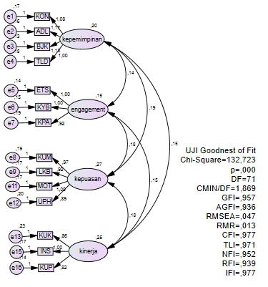

**Figure 1**

**Path Diagram of Measurement Model**

In accordance with the diagram χ2 = 132,273, df = 71 with a significance level of 0,000. This indicates that it is smaller than 0.05, however, other criteria, such as, CMIN, GFI, AGFI, RMSEA, RMR, CFI, TLI, NFI, RFI, and IFL = 1,869, 0,97, 0,936, 0,047, 0,013, 0,977, 0,971, 0,952, 0,939, and 0,977, respectively, were proven to be good fit. This is because these values ​​are in accordance with the recommended values, namely CMIN/DF ≤ 2,00, GFI ≥ 0,90, AGFI ≥ 0,90, RMSEA ≤ 0,08, RMR ≤ 0,05, CFI ≥ 0,90, TLI ≥ 0,90, NFI ≥ 0,90, RFI > 0,90, IFI > 0,90, GFI = 0,846 (Hair et al., 2014).

Based on Figure 4.1, 10 (GOFI) criteria had already met the goodness of fit values, namely CMIN, GFI, AGFI, RMSEA, RMR, CFI, TLI, NFI, RFI, IFI. According to Hair et al. (2014), the use of relatively 4 to 5 goodness of fit criteria is considered reasonable in assessing the feasibility of the model, as long as each of them, namely absolute, incremental, and parsimony fit indices, is represented. Therefore, the existing measurement is presumed to be fit and used to explain the data obtained in this research.

* + 1. **Convergent Validity**

The first convergent validity is determined by the value of the loading factor, which describes the extent to which the aspects and indicators are related to each construct. This has been summarized in the following table.

**Table 6**

***Loading Factor Value***

|  |  |  |  |
| --- | --- | --- | --- |
| **Variables** | **Aspects/Indicators** | ***Loading Factor Value*** | **Description** |
| *Islamic Leadership*  (KI) | Consistent (KON) | 0,734 | Valid |
| Fair (ADL) | 0,812 | Valid |
| Wise (BJK) | 0,797 | Valid |
| Exemplary (TLD) | 0,763 | Valid |
| *Job Satisfaction*  (KK) | Opportunity to advance (KUM) | 0,784 | Valid |
| Good working conditions/environment (LKB) | 0,754 | Valid |
| Motivation from the leader (MOT) | 0,757 | Valid |
| Wage/salary (UPH) | 0,718 | Valid |
| *Sharia Engagement*  (SE) | Work Ethic (ETS) | 0,624 | Valid |
| Responsible Freedom (KYB) | 0,703 | Valid |
| Belief in Supervision from Allah SWT (KPA) | 0,721 | Valid |
| *Employee Performance*  (KK) | Work Quality (KUK) | 0,772 | Valid |
| Initiative (INS) | 0,663 | Valid |
| Personal Quality (KUP) | 0,736 | Valid |

Source: Result of SEM AMOS. Data Processed. 2022.

Based on the path diagram and Table 4.5, all aspects and indicators have a loading factor value greater than 0.50 (Hair et al., 2014). This shows that they met convergent validity. It simply means that all aspects and indicators have a good relationship and accurately measure each construct.

* + 1. **Construct Reliability**

The construct reliability is calculated by the square of the total value (sum) of standard loading divided by the square of the total standard loading plus the sum error, as shown in Table 4.6

**Table 7**

***Construct Reliability Value***

|  |  |
| --- | --- |
| **Variables** | ***Composite Reliability Value*** |
| *Islamic Leadership* (KI) | 0,858 |
| *Experience Quality* (EXQ) | 0,840 |
| *Destination Satisfaction* (DS) | 0,724 |
| *Employee Performance*(KK) | 0,768 |

Source: Results of SEM AMOS. Data Processed. 2022

This shows that the construct reliability generated by each construct is greater than 0.70 (Hair et al., 2014). These results mean that the dimensions and indicators are reliable and consistently used to measure the construct.

* 1. **Evaluation of Structural Model**

A goodness of fit test was conducted to obtain a complete structural equation used to evaluate the hypotheses.

* + 1. **Structural Model’s Goodness of Fit Test**

This test was used to determine the fitness of the structural model. It refers to the built framework and several goodnesses of fit index (GOFI) criteria generated from data processing. The following is an overview of the structural model framework from the AMOS SEM output.

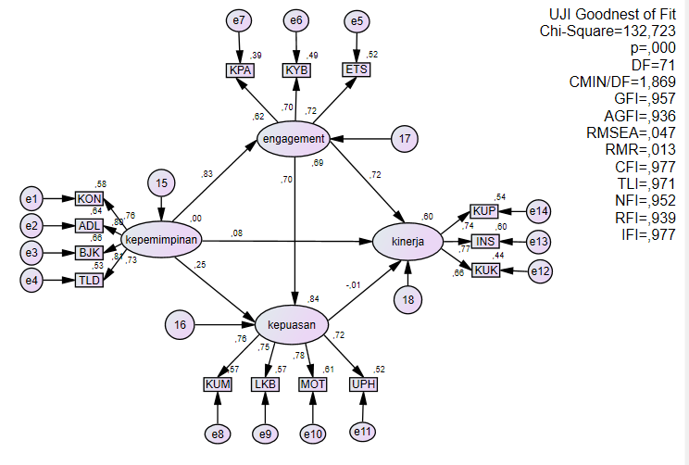

**Figure 2**

**Path Diagram of Structural Model**

Based on the path diagram in figure 4.2, it is evident that χ2 = 132,723, df = 71 with a significance level of 0.000. This shows that it is smaller than 0.05. However, for other criteria, such as, CMIN, GFI, AGFI, RMSEA, RMR, CFI, TLI, NFI, RFI, and IFL = 1.869, 0.957, 0.936, 0.047, 0.013, 0.977, 0.971, 0.952, 0.939, and 0.977, respectively, are presumed to be good fit. This is due to the fact that these values are in accordance with the recommended ones, namely CMIN/DF ≤ 2,00, GFI ≥ 0,90, AGFI ≥ 0,90, RMSEA ≤ 0,08, RMR ≤ 0,05, CFI ≥ 0,90, TLI ≥ 0,90, NFI≥ 0,90, RFI > 0,90, IFI > 0,90, GFI = 0,846 (Hair et al., 2014).

Based on the goodness of fit index (GOFI), 10 of the criteria met the good fit value, namely CMIN, GFI, AGFI, RMSEA, RMR, CFI, TLI, NFI, RFI, IFI. The fulfillment of approximately 4 to 5 of them is used to assess the feasibility of the model (Hair et al., 2014). Therefore, the existing measurement is presumed to be a good fit used to explain the data obtained in this research.

* + 1. **Multicollinearity Test Between Variables**

A multicollinearity test between the variables was carried out on 6 proposed relationships using t-count and p-value at a significance level (α) of 5% or 0.05. The results prove that through the Critical Ratio (C.R) and probability (P). However, when the C.R and P are ≥ 1.967 and ≤ 0.05, respectively, then a significant effect exists between the variables. In contrast, assuming the C.R and P are ≤ 1.967 and ≥ 0.05, respectively, it simply means that an insignificant effect exists between the variables (Hair et al., 2011). The following multicollinearity test results are shown in Table 4.7.

**Table 8**

**Multicollinearity Test Between Variables**

|  |  |  |  |  |
| --- | --- | --- | --- | --- |
| **No.** | **Effect** | **C.R** | **P** | **Description** |
| 1 | Islamic Leadership-----> Sharia Engagement | 2,554 | 0,011 | *Significant* |
| 2 | Islamic Leadership -----> Job Satisfaction | 12,566 | *** | *Significant* |
| 3 | Islamic Leadership -----> Employee Performance | 0,633 | 0,526 | *Insignificant* |
| 4 | Job Satisfaction -----> Sharia Engagement | 6,251 | *** | *Significant* |
| 5 | Job Satisfaction -----> Employee Performance | -0,043 | 0,966 | *Insignificant* |
| 6 | Sharia Engagement -----> Employee Performance | 2,617 | 0,009 | *Significant* |

Based on this table, Islamic leadership has a significant effect on Sharia Engagement (2,554,C.R ≥ 1,967; 0,011,P ≤ 0,05), and job satisfaction (12,566,C.R ≥ 1,967; ***,P ≤ 0,05). Interestingly, Job satisfaction has a positive effect on Sharia Engagement (6,251,C.R ≥ 1,967; ***,P ≤ 0,05) and this in turn has a significant impact on Employee Performance in accordance with the following critical ratio and probability values (2,617,C.R ≥ 1,967; 0,009,P ≤ 0,05). Islamic Leadership and Job Satisfaction has an insignificant effect on employee performance (0,633, C.R ≤ 1,967; 0,526, P ≥ 0,05) and (-0,043, C.R ≤ 1,96 ; 0,966, P ≥ 0,05), respectively.

* 1. **Discussion**

Based on SEM analysis, Islamic leadership significantly affects Sharia Engagement. Irrespective of the fact that this research emphasizes the aspects of Islamic values, the results are in line with Xanthopoulou et al. (2009) that transformative leaders affect employee engagement.

As part of a transformative style, Islamic leadership triggers a positive socio-emotional climate, affecting employees’ sense of engagement at their workplace. It builds quality relationships with co-workers due to the significant impact on employee engagement (Stairs & Galpin, 2006). Islamic leadership also has a significant effect on job satisfaction. The results of this research are consistent with Eliyana, Ma'arif, and Muzakki (2019) that a transformative leadership model has a direct and significant impact on job satisfaction.

This shows that a leader plays an important and substantial role in fostering a sense of engagement and satisfaction, which positively affects companies, specifically Islamic banks. Schein (2004) stated that the key to a successful organization is to ensure its members have a sense of belonging.

Islamic leadership indicator that has a significant effect on sharia engagement and job satisfaction deal with a sense of fairness and the ability to behave fairly. This is evident from the loading factor value of the 2 indicators, which is higher compared to the consistent and exemplary attributes. Based on this research, the exemplary attitude alone is not a guarantee that maximizes the leader’s role. It is proven by the exemplary indicator's least loading factor value compared to the others.

Meanwhile, Job Satisfaction has a positive effect on Sharia Engagement. This is consistent with Wirawan, Jufri, and Saman (2020) that this variable significantly affects employee engagement. Besides, job satisfaction has been proven to be a mediator because it substantially aids employees in developing a sense of engagement in their respective organizations.

The indicator that plays an important role in boosting sharia engagement is the leaders’ motivation, as depicted by the highest loading factor value. This also emphasizes that they can trigger job satisfaction to increase sharia engagement in an Islamic banking institution. In addition, Opportunity for Advancement and Good Work Environment is further indicators for achieving this attribute. Wages and salaries are not guaranteed to achieve job satisfaction as indicated by the smallest loading factor value compared to other indicators.

Meanwhile, Sharia Engagement has a significant effect on employee performance. This is consistent with Pattnaik and Sahoo (2020) that engagement affects work creativity and completion or employee performance. It also further confirms that sharia engagement needs to be instilled by the management, specifically in the Islamic banking industry, considering that experimentally it has a positive effect on employee performance.

The sense of engagement instilled in employees is a measure of the company's success in dealing with problems regarding human resource management (Buil, Martínez & Matute, 2019). Moreover, it tends to reach the transcendental realm (*habluminallah*), or in other words, sharia engagement has great potential to spur employee performance. Since this concept is a development that is 1 level higher than employee engagement.

However, assuming employee engagement only has a worldly orientation, it is presumed to have a hereafter acclimatization in the sharia concept. Referring to Hayati and Caniago (2012), although this research indirectly examined sharia engagement, the results show that an Islamic work ethic with a worldly and hereafter orientation has a large effect on job satisfaction, and this improves employee performance. The indicator that affects this attribute is the work ethic, as proven by the highest loading factor value. Responsible Freedom was also used to realize a sense of sharia engagement. Meanwhile, Belief in Supervision from Allah SWT is not a guarantee to boost this attribute. This shows that the *ukhrawi* dimension of Islamic banking employees in Indonesia was not properly implemented. It is quite unfortunate considering that the hereafter dimension needs to be a product label and an integral aspect of employees.

This research discovered that Islamic leadership and job satisfaction had an insignificant effect on employee performance. These results contradict Ratnasari (2014) stated that it positively affects employee performance that applies Islamic values. This is reinforced by Eliyana, Ma'arif, and Muzakki (2019), that Transformational leadership has a significant and direct effect on job satisfaction and employee performance.

The most dominating employee performance indicator is Initiative, proven by the highest loading factor value, followed by Personal Quality. Meanwhile, work quality does not guarantee increased employee performance.

This is consistent with the research carried out by Sani and Maharani Ekowati (2020), that Islamic leadership does not directly affect employee performance. However, this is certainly a separate finding and opens up opportunities for further research.

Islamic Leadership, Job Satisfaction, Sharia Engagement, and Employee Performance are interrelated. Islamic Leadership has an indirect effect on Employee Performance and significantly impacts Job Satisfaction and Sharia Engagement. This also have an impact on Employee Performance.

Meanwhile, Belief in Supervision from Allah SWT is not a guarantee to improve employee sharia engagement. This shows that the *ukhrawi* dimension was not properly implemented. It is certainly a huge task for Islamic banking in Indonesia because it needs to be perceived as a product label and as a dimension that is inseparable from employees.

1. **Conclusions**

The research results found that Islamic Leadership has a significant impact on sharia involvement and job satisfaction. Job satisfaction also significantly influences sharia involvement, while sharia involvement also has a significant impact on employee performance. However, the Islamic Leadership variable does not significantly influence employee performance, and the Job Satisfaction variable also does not have a significant impact on employee performance. The relationship between these variables shows that the Islamic Leadership model alone is not enough to improve employee performance at Sharia Banks in Indonesia. Nevertheless, optimizing and implementing Islamic Leadership can strengthen job satisfaction and increase sharia involvement, which in turn will have a positive impact on employee performance at Sharia Banks in Indonesia.

Meanwhile, the indicator of sharia engagement, namely Belief in Supervision from Allah SWT, has the smallest loading factor value compared to others. It indicates that the *ukhrawi* dimension was not properly implemented. This is a significant task for Islamic banking in Indonesia because it needs to be perceived as a product label and an integral dimension of employees.

This study has limitations, including: This study is only limited to the research variables. Therefore, this study cannot reflect other antecedents of employee performance outside these variables such as internal marketing variables, employee welfare and so on. This study uses cross section or one shot data over a period of ≥ 3 (three) years of employees working in Sharia Banking. Thus, the results of this study cannot yet reflect an assessment of all the roles of variable relationships that have worked for less than 3 (three) years. This study is only able to explain the data quantitatively without any qualitative explanation from the subjects studied regarding the results of the data analysis obtained. This study also ignores or does not assume the culture that exists in each Islamic banking management studied. Therefore, this study cannot comprehensively reflect the dimensions of work culture that exist in each Islamic bank in Indonesia.

**Author Contributions**: Conceptualization, Ahmad Sodiq. and Ririn Tri Ratnasari.; methodology, Ahmad Sodiq.; software, Ahmad Sodiq.; validation, Imron Mawardi., and Ririn Triratnasri.; formal analysis, Ahmad Sodiq.; investigation, Ririrn Triratnasari.; resources, Imran Mawardi.; data curation, Imron Mawardi; writing—original draft preparation, Ahmad Sodiq; writ-ing—review and editing, Ririn Triratnasari.; visualization, Imron Mawardi; supervision, Imron Mawardi.; project administration, Ririrn Triratnasari.; funding acquisition, Ririrn Triratnasari.

**Funding**: This research was funded by MINISTRY OF RESEARCH AND TECHNOLOGY OF THE REPUBLIC OF INDONESIA.

**References**

(OJK), O. J. K. (2023). *Data Statistik Perbankan Syariah*. https://www.ojk.go.id/

Al-Aidaros, A.-H., Mohd. Shamsudin, F., & Md. Idris, K. (2013). Ethics and Ethical Theories from an Islamic Perspective. *International Journal of Islamic Thought*, *4*(1), 1–13. https://doi.org/10.24035/ijit.04.2013.001

Ali, A. J., & Al-Kazemi, A. A. (2007). Islamic work ethic in Kuwait. *Cross Cultural Management: An International Journal*, *14*(2), 93–104. https://doi.org/10.1108/13527600710745714

Almoharby, D., & Neal, M. (2013). Clarifying Islamic perspectives on leadership. *Education, Business and Society: Contemporary Middle Eastern Issues*, *6*(3–4), 148–161. https://doi.org/10.1108/EBS-02-2011-0008

Ascarya, & Rahmawati, S. (2018). Analysis of the determinants of micro enterprises graduation. *Journal of Islamic Economics, Banking and Finance*, *14*(1), 12–60. https://doi.org/10.12816/0051166

Asrar-ul-Haq, M., & Anwar, S. (2018). The many faces of leadership: Proposing research agenda through a review of literature. *Future Business Journal*, *4*(2), 179–188. https://doi.org/10.1016/j.fbj.2018.06.002

Bappenas. (2018). *Masterplan Arsitektur Keuangan Syariah Indonesia (MAKSI)*. Bappenas.

Beekun, R. I., & Badawi, J. A. (2005). Balancing ethical responsibility among multiple organizational stakeholders: The Islamic perspective. *Journal of Business Ethics*, *60*(2), 131–145. https://doi.org/10.1007/s10551-004-8204-5

Bentler, P. M., & Chou, C. P. (1987). Practical Issues in Structural Modeling. *Sociological Methods & Research*, *16*(1), 78–117. https://doi.org/10.1177/0049124187016001004

Bhatti, O. K., Aslam, U. S., Hassan, A., & Sulaiman, M. (2016). Employee motivation an Islamic perspective. *Humanomics*, *32*(1), 33–47. https://doi.org/10.1108/H-10-2015-0066

Buil, I., Martínez, E., & Matute, J. (2019). Transformational leadership and employee performance: The role of identification, engagement and proactive personality. *International Journal of Hospitality Management*, *77*(June 2018), 64–75. https://doi.org/10.1016/j.ijhm.2018.06.014

Byrne, B. M. (2010). *Structural Equation Modeling with AMOS: Basic Concepts, Applications, and Programming* (2nd ed.). Routledge Taylor & Francis Group.

Davis, K. (2010). *Organizational Behavior – Human Behavior at Work* (13th ed.). Mcgraw Hill Company.

Dent, E. B., Higgins, M. E., & Wharff, D. M. (2005). Spirituality and leadership: An empirical review of definitions, distinctions, and embedded assumptions. *Leadership Quarterly*, *16*(5), 625–653. https://doi.org/10.1016/j.leaqua.2005.07.002

Dharma, Y. (2018). The effect of work motivation on the employee performance with organization citizenship behavior as intervening variable at bank aceh syariah. *Emerald Reach Proceedings Series*, *1*, 7–12. https://doi.org/10.1108/978-1-78756-793-1-00065

Eliyana, A., Ma’arif, S., & Muzakki. (2019). Job satisfaction and organizational commitment effect in the transformational leadership towards employee performance. *European Research on Management and Business Economics*, *25*(3), 144–150. https://doi.org/10.1016/j.iedeen.2019.05.001

Fiedler, F. E. (1967). *A theory of leadership effectiveness*. McGraw-Hill.

Fry, L. W. (2003). Toward a theory of spiritual leadership. *Leadership Quarterly*, *14*(6), 693–727. https://doi.org/10.1016/j.leaqua.2003.09.001

Galanou, A. & Farrag, D. A. (2018). Towards the distinctive Islamic mode of leadership in business. *The Eletronic Library*, *34*(1), 1–5.

Hair, J. F. J., W.C., B., Babin, B. J., & Anderson, R. E. (2014). *Multivariate data analysis* (7th ed.). Person Education Limited.

Harter, J. K., Schmidt, F. L., & Hayes, T. L. (2002). Business-unit-level relationship between employee satisfaction, employee engagement, and business outcomes: A meta-analysis. *Journal of Applied Psychology*, *87*(2), 268–279. https://doi.org/10.1037/0021-9010.87.2.268

Hayati, K., & Caniago, I. (2012). Islamic Work Ethic: The Role of Intrinsic Motivation, Job Satisfaction, Organizational Commitment and Job Performance. *Procedia - Social and Behavioral Sciences*, *65*(ICIBSoS), 272–277. https://doi.org/10.1016/j.sbspro.2012.11.122

Herianingrum, S., Drasmawita, F., Tri Ratnasari, R., & Fadlillah, H. (2016). The Social Function Of Imi’s In The Exemption Of Micro Business Loans. *Opcion Journal*, *July*, 1–23.

Herianingrum, S., Tri Ratnasari, R., Widiastuti, T., Mawardi, I., Cahya Amalia, R., & Fadhlillah, H. (2019). The Impact of Islamic Bank Financing on Business * Entrepreneurship and Sustainability Issues. *Entrepreneurship and Sustainability Issues*, *7*(1), 133–145.

Jennifer, M. (2000). Emotions and leadership : The role of emotional intelligence. *Human Relations*, *53*(8), 1027–1055.

Khan, T. N. (2016). *Islamic banks Service Innovation Quality : conceptual model*. *8*(July), 287–306. https://doi.org/10.15408/aiq.v8i2.3161

Lockwood, N. R. (2007). Leveraging Employee Engagement for Competitive Advantage. *Journal of Society for Human Resource Management Research Quarterly*, *1*(1), 1–12.

Macey, W. H., Schneider, B., Barbera, K. M., & Young, S. A. (2009). *Employee Engagement: Tools for Analysis, Practice, and Competitive Advantage*. Valtera Corporation. https://doi.org/10.1002/9781444306538

Meyer, J. P., & Allen, N. J. (1997). *Commitment in the workplace: Theory, research, and application.* Thousand Oaks, CA: Sage.

Millan, M. J. H., & S, S. (2010). *Research in Education*. Pearson Education.

Moghimi, S. M. (2018). Leadership Styles in Islamic Management. In *Organizational Behavior Management*. https://doi.org/10.1108/978-1-78769-677-820181009

Mullins, L. J. (2005). *Management and Organisational Behaviour. England*. Pearson Education Limited.

Mustika, H., Eliyana, A., Agustina, T. S., & Ratnasari, R. T. (2020). Determinants of innovation capability in the islamic banking. *Systematic Reviews in Pharmacy*, *11*(3), 382–387. https://doi.org/10.5530/srp.2020.3.47

Nasr, S. (1984). Islamic work ethics. *Journal of Hamdard Islamicus*, *7*(4), 25–35.

Nasution, F. N., Ekonomi, F., Utara, U. S., & Rafiki, A. (2020). *Islamic work ethics , organizational commitment and job satisfaction of Islamic banks in Indonesia*. *55*(2), 195–205. https://doi.org/10.1108/RAUSP-01-2019-0011

Nelson, D. L., & Quick, J. C. (2012). *Organizational behaviour: Science, the real world, and you* (8th ed). Mason: OH.

Pattnaik, S. C., & Sahoo, R. (2020). Employee engagement, creativity and task performance: role of perceived workplace autonomy. *South Asian Journal of Business Studies*, *10*(2), 227–241. https://doi.org/10.1108/SAJBS-11-2019-0196

Rameshkumar, M. (2020). Employee engagement as an antecedent of organizational commitment – A study on Indian seafaring officers. *Asian Journal of Shipping and Logistics*, *36*(3), 105–112. https://doi.org/10.1016/j.ajsl.2019.11.003

Rana, H. M., & Malik, S. M. (2016). Human resourRana, H. M., & Malik, S. M. (2016). Human resource management from an Islamic perspective: a contemporary literature review. International Journal of Islamic and Middle Eastern Finance and Management, 9(1), 109–124. https://doi.org/doi.org/10. *International Journal of Islamic and Middle Eastern Finance and Management*, *9*(1), 109–124. https://doi.org/doi.org/10.1108/IMEFM-01-2015-0002

Ratnasari, R. T. (2014). *Kepemimpinan Islam dan Pemasaran Internal terhadap Kinerja Serta Kesejahteraan Karyawan Bank Islam di Jawa Timur*. Universitas Airlangga.

Ratnasari, R. T., Gunawan, S., bin Abu Talib, J., Herianingrum, S., Widiastuti, T., & Septiarini, D. F. (2020). The Moderating Effects of Gender between Patient Intimacy, Trust, and Loyalty. *International Journal of Innovation, Creativity and Change*, *12*(10), 1–16.

Ratnasari, R. T., Gunawan, S., Septiarini, D. F., Rusmita, S. A., & Kirana, K. C. (2020). Customer satisfaction between perceptions of environment destination brand and behavioural intention. *International Journal of Innovation, Creativity and Change*, *10*(12), 472–487.

Rindjin, K. (2008). *Etika Bisnis dan Implementasinya*. : PT Gramedia Pustaka Utama.

Robbins, S. P. & , Judge, T. (2007). *Organizational behavior. Upper Saddle River*. N.J: Pearson/Prentice Hall.

Sani, A., & Maharani Ekowati, V. (2020). Spirituality at work and organizational commitment as moderating variables in relationship between Islamic spirituality and OCB IP and influence toward employee performance. *Journal of Islamic Marketing*, *11*(6), 1777–1799. https://doi.org/10.1108/JIMA-08-2018-0140

Santoso, A., Erdawati, Ratnasari, R. T., Palupiningtyas, D., & Balaka, M. Y. (2020). Determinants of social media use by handicraft industry of Indonesia and its impact on export and marketing performance: An empirical study. *International Journal of Innovation, Creativity and Change*, *12*(9), 1–21.

Schein, E. H. (2004). *Organizational culture and leadership*. Josney-Bass.

Schermerhorn, J. R., Osborn, R. N., Uhl-Bien, M., & Hunt, J. G. (2012). *Organizational behaviour; experience, grow, contribute* (12th ed). NJ: John Wiley and Sons.

Schumacker, R. E., & Lomax, R. G. (2004). *A Beginner’s Guide to Structural Equation Modeling. Second Edition* (2nd ed.). Lawrance Erlbaum Associates, Inc. Pub.

Sedianingsih, Ratnasari, R. T., Prasetyo, A., & Hendarjatno. (2019). Antecedents of recommendation and repurchase intention on medical tourism. *Opcion*, *35*(Special Issue 23), 1277–1300.

Sedianingsih, Ratnasari, R. T., Prasetyo, A., & Mawardi, I. (2018). Determinant of intention to check-up back to doctors at public hospital. *International Journal of Engineering and Technology(UAE)*, *7*(3), 31–32. https://doi.org/10.14419/ijet.v7i3.21.17088

Stairs, M., & Galpin, M. (2006). Retention on a knife edge: The role of employee engagement in talent management. *Selection & Development Review*, *22*(22), 19–23.

Stoner, J.A.F., Freeman, R.E., Gilbert, D. R. J. (1995). *Management*. Prentice-Hall International.

Tiby, AMR. M.EI., & Grais, W. (2015). *Islamic finance and economic development (risk management, regulation, and corporate covernence),*. John Wiley & Sons, Inc.

Tri Ratnasari, R., Gunawan, S., Qudzi Fauzi, M., & Fitrisia Septiarini, D. (2018). Patient Intimacy and Innovation Development to Improve Health Service Performance. *International Journal of Engineering & Technology*, *7*(2.29), 338. https://doi.org/10.14419/ijet.v7i2.29.13649

Wexley, K. N., & Yuki, L. A. (1998). *Organizational Behavior and Personal Pyschology, Pyschology*. Richard D. Irwin, Inc.

Widiastuti, T., Kirana, K. C., Ratnasari, R. T., Insani, T. D., & Robani, A. (2019). Measuring the corruption measurement model (CMM) based on maqasid shariah framework. *Humanities and Social Sciences Reviews*, *7*(2), 282–286. https://doi.org/10.18510/hssr.2019.7233

Wirawan, H., Jufri, M., & Saman, A. (2020). The effect of authentic leadership and psychological capital on work engagement: the mediating role of job satisfaction. *Leadership and Organization Development Journal*, *41*(8), 1139–1154. https://doi.org/10.1108/LODJ-10-2019-0433

Xanthopoulou, D., Bakker, A. B., Demerouti, E., & Schaufeli, W. B. (2009). Work engagement and financial returns: A diary study on the role of job and personal resources. *Journal of Occupational and Organizational Psychology*, *82*(1), 183–200. https://doi.org/10.1348/096317908X285633

**Corresponding Author**:

Ririn Tri Ratnasari can be contacted at: [ririnsari@feb.unair.ac.id](mailto:ririnsari@feb.unair.ac.id)