## BUKTI KORESPONDENSI

**ARTIKEL JURNAL NASIONAL BEREPUTASI**

#### Judul artikel

#### Jurnal

: Development Of Superior And Quality Islamic Primary Schools: A Review Of The Learning Process And Provision Of Infrastructure

#### : Mudarris Journal of Education, 2024, volume 7 (2)

Penulis : Sukron Ma’mun

|  |  |  |
| --- | --- | --- |
| No. | Perihal | Tanggal |
| 1. | Bukti konfirmasi submit artikel dan artikel yang  disbumit | 5 Okt 2024 |
| 2. | Bukti konfirmasi artikel accepted | 31 Okt 2024 |
| 3. | Bukti konfirmasi artikel published online | 1. Nov 2024 |

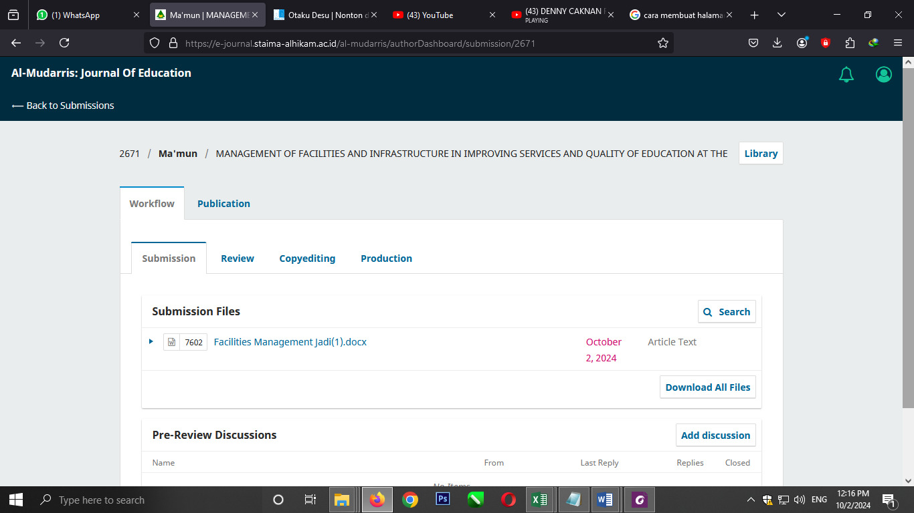

**Volume 7 Nomor 2 in 2024**

**MANAGEMENT OF FACILITIES AND INFRASTRUCTURE IN IMPROVING SERVICES AND QUALITY OF EDUCATION AT THE AL-AZHAR PAGERWOJO LEADING MADRASAH**

**Syukron Ma’mun1,**

**1**Dosen UIN Sayyid Ali Rahmatullah, Tulungagung

e-mail: SukronMa'mun@uinsatu.ac.id *1

**Abstract**

Madrasah is an Islamic Educational Institution that is able to maintain its existence in carrying out its functions. Madrasah is also obliged to improve its quality to maintain its sustainability. Therefore, the management of facilities and infrastructure is aimed at improving the services of the madrasah. This study aims to describe the infrastructure management activities carried out by the Al-Azhar Superior Madrasah in order to improve education services and quality, what obstacles are faced in the implementation process, and solutions taken to anticipate existing obstacles. This research is qualitative in nature with the type of case study at the Al-Azhar Superior Madrasah. This research uses participatory observation methods, in-depth interviews and documentation studies in data mining. Data analysis uses the Miles, Huberman and Saldana techniques. The management of facilities and infrastructure at the Al-Azhar Superior Madrasah has been carried out quite well in terms of planning, procuring, maintaining, and inventorying the facilities and infrastructure in the madrasah environment, which has proven to be able to improve services which ultimately improve the quality of education, as evidenced by the increasing quality of its output. The constraints are that there is a lack of funds and administrative staff. The solutions that have been implemented by the Al-Azhar Superior Madrasah to solve the existing problems are: 1) Procurement must be in accordance with the Madrasah Work Plan that has been prepared, 2) Organization must be carried out in accordance with the madrasah's duties and functions, 3) Control of procurement and use of facilities and infrastructure must be carried out with previously decided procedures, so that supporting documents are complete. The role of each stakeholder determines the quality of education in terms of facilities and infrastructure at the Al-Azhar Superior Madrasah.

**Keywords:** *Management of Facilities, Services, Quality Education*

**INTRODUCTION**

A manager is someone who works through others by coordinating their activities to achieve organizational goals(Setia & Nasrudin, 2020). In an educational institution, the person who carries out the managerial function is the leader/chairman/head of the educational institution(Farooq et al., 2007). This means that a leader of an educational institution must be a source of activities and responsible for the results achieved in learning activities, working together with other parties involved in the learning process(Yamin, 2023).

One of the things that a manager must pay attention to is the quality of an Islamic educational institution. Because all management of educational components is always oriented towards achieving quality (Nurmayuli, 2022). All educational and learning programs and activities in educational institutions are essentially directed at achieving quality(Chandra et al., 2018). In essence, the goal of educational institutions is to create and maintain customer satisfaction and in TQM customer satisfaction is determined by the stakeholders of the educational institution (Al-rsa’i et al., 2024). However, the quality of an educational institution is not only determined by the quality of learning alone, but is also influenced by how the educational institution is able to manage its human resources (Sinta, 2019).

Schools and madrasah are educational institutions as a place where educational activities take place or are carried out(Bilgiler et al., 2023). One of the components that is very important for the implementation of the education process in the independent curriculum era is the teacher, namely as a facilitator in the learning process(Wibowo et al., 2023), where the teacher is able to act as a director and also facilitate learning. In organizing education to produce an effective and efficient teaching and learning process, facilities and infrastructure are needed(Rizki & Fahkrunisa, 2022). Equipment in the form of buildings, libraries, and tools used when studying in class are closely related to the quality of the school. Especially when using teaching aids, aids such as in teaching physics, biology, anatomy, or geography. Infrastructure is an indirect tool that functions to achieve goals in education, including location, place, school buildings, while facilities such as direct tools that function to achieve educational goals, including rooms, books, libraries, laboratories. The education process does require facilities or equipment, and all equipment or facilities must be provided according to needs. According to Ananda and Banurea, as quoted by Manurung(2020), there are two types of maintenance of facilities and infrastructure in schools, namely daily maintenance and periodic maintenance. Daily maintenance is usually carried out by staff who are assigned tasks and responsibilities for the facility. For example, for facilities at SDI which must be maintained every day so that their performance is maintained when used by students. Periodic maintenance is maintenance that is carried out periodically according to a programmed schedule. The schedule is made based on the interests of the treatment of the maintenance object, for example, the need for oil changes, how many working hours, resetting moving parts every how many months and so on. In this periodic maintenance, we know that there is weekly, monthly, and annual maintenance(Chkheidze, 2023). The activity carried out to monitor school facilities and infrastructure is evaluation. The process of evaluating facilities and infrastructure is a process of collecting and presenting information for consideration in making decisions about the facilities and infrastructure used(Al Faruq et al., 2024). Through this method, it will be known which facilities or infrastructure need to be repaired, purchased new, or deleted.

The minimum criteria that must be possessed by formal schools, both from Elementary Schools/Islamic Elementary Schools (SD/MI), and especially in the Al-Azhar Superior Madrasah include classrooms, library rooms, computer laboratory rooms, MIPA laboratory rooms, leadership rooms, teacher rooms, administration rooms, places of worship, counseling rooms, UKS rooms, student organization rooms, toilets, warehouses, circulation rooms, and sports areas. So far, infrastructure management activities have not been carried out consistently considering that from year to year, infrastructure management activities seem to only flow following the previous year's flow(Pribudhiana et al., 2021; Yuniarti et al., 2023). There are management functions that are not carried out due to time and cost constraints(Imaduddin et al., 2022; Kolesar, 2008). In addition, the rare involvement of school residents in the procurement process is one of the problems in infrastructure management in this madrasah.

This study aims to describe the infrastructure management activities carried out by the Al-Azhar Superior Madrasah in order to improve education services and quality, what obstacles are faced in the implementation process, and solutions taken to anticipate existing obstacles.

**METHODS**

The research that the researcher conducted was located at the Al-Azhar Pagerwojo Leading Madrasah with an interpretive or post-positivistic paradigm(Bogdan & Biklen, 1997). This research has the nature of interpreting data in the form of words or expressions that are not in the form of numbers. This research uses a qualitative approach which has narrow and in-depth characteristics and characteristics. So researchers try to explore data in depth regarding a research problem(Mar, 2003). This qualitative also has the characteristic of the important role of the researcher as the key instrument of this research. So, in this case, the researcher, in addition to his role as a data extractor, also acts as a data interpreter during the research and also as a data mining instrument(Sherman & Webb, 2005).

This research has a type of case study research with a single case study type with the characteristics of the case studied(Bassey, 1999), namely spiritual service leadership to build institutional culture which is used to improve the quality of education in this Islamic boarding school which is carried out in depth. This particular case is at the Al-Azhar Pagerwojo Leading Madrasah because that Madrasah is sufficient to have adequate facilities and be able to support improving the quality of education because it can be used to improve educational services.

This research was located at the Al-Azhar Pagerwojo Leading Madrasah because of the various unique features contained in it. The Al-Azhar Pagerwojo Leading Madrasah is a fairly good and effective madrasah and also has many facilities that support the implementation of learning. The implementation of the learning system uses a full day system.

The data source in this research is in the form of a place, namely the Al-Azhar Pagerwojo Leading Madrasah, the person, namely the ustadzah Yamini and Ustadz Mudi’in, a paper, namely a document about the Al-Azhar Pagerwojo Leading Madrasah such as the Al-Azhar Pagerwojo Leading Madrasah bulletin, a website that discusses the Al-Azhar Pagerwojo Leading Madrasah. It is hoped that this data source will be able to become an accurate and strong data source and be able to become the main informant in this research(Daymon & Holloway, 2005).

This research was carried out using data mining techniques in the form of in-depth interviews (Seidman, 2006)which are useful for extracting data regarding the expressions and words of madrasah headmaster and ustadz regarding management of facilities and infrastructure in improving services and quality of education. Participatory observation was also carried out to explore data regarding the phenomenon of Al-Azhar Pagerwojo Leading Madrasah culture which is able to survive amidst the quite sad developments in society. The next technique is documentation study which functions to strengthen data about the management of facilities and infrastructure in improving services and quality of education Al-Azhar Pagerwojo Leading Madrasah.

This research uses data analysis techniques developed by Miles, Huberman and Saldana(2014), with the sequence of condensing data, presenting data, drawing conclusions. Data condensation is carried out by simplifying, abstracting and selecting and sorting the data that has been obtained and then displaying the data that is considered correct. Data presentation is carried out by presenting data, both the results of in-depth interviews, participant observation and also condensed documentation studies(Kumar, 2016). Conclusions are drawn by generalizing the data that has been obtained and then processing it into research findings.

The data that has been obtained is then filtered by checking the validity of the research data, namely 1) Credibility which is carried out by triangulation, both technical triangulation and data source triangulation(Creswell, 2014). Technical triangulation is carried out by cross-checking data taken using in-depth interviews, participant observation and documentation studies. Does the data obtained produce findings or generalizations of findings that are the same or almost the same? Triangulation of data sources was carried out by cross-checking data sourced from Headmaster, with that sourced from ustadz, and also from management of facilities and infrastructure in improving services and quality of education administrators. 2) Dependability is carried out through discussions with dependent auditors, namely friends of researchers and senior researchers. The researcher's friend who became the discussion partner was Dr. Muhammad Fathurrohman, M.Pd.I, while the senior researcher who became a discussion partner and dependent auditor was Prof. Dr. H. Munardji, M.Ag. 3) Transferability is carried out by checking whether the research results obtained can be applied to locations that have similar characteristics(Mertens, 2009). 4) Confirmability is carried out with the researcher together with the research team(Patton, 2015). Return again to the management of facilities and infrastructure in improving services and quality of education to confirm whether the research findings that have been obtained are appropriate or not.

**RESULTS AND DISCUSSION**

The planning phase of facilities and infrastructure at the Al-Azhar superior madrasah is a step to determine the need for facilities and infrastructure based on existing conditions. The planning phase goes through several series of activities such as madrasah coordination meetings, determining madrasah programs, and determining the need for madrasah facilities and infrastructure. Madrasah coordination meetings must be attended by the head of the madrasah, teachers, and TU staff. The coordination meeting process is led by the head of the madrasah and continued with teachers and TU staff who provide input to each other in order to reach an agreement.

The phase of organizing facilities and infrastructure (organizing) carried out by the madrasah based on the documentation data obtained is known the structure of the management design and job descriptions that are adjusted according to the Decree of the Head of Madrasah No. 427/2024 concerning the Allocation of Tasks for the Al-Azhar superior madrasah and details of each task given. In the Decree, there is an explanation of staff and teachers.

The next phase is procurement. Procurement at the Al-Azhar superior madrasah is carried out by identifying the needs that will be held. When the research was conducted, the school's priority was madrasah sanitation.

The maintenance phase of facilities and infrastructure in the superior madrasah al-Azhar environment functions to ensure that the facilities and infrastructure in the madrasah are durable. Through routine maintenance, it will be possible to save expenses to replace facilities and infrastructure that can be damaged if not maintained. In the end, funds can be diverted to other more urgent needs. So far, maintenance has been carried out by staff, where the staff is directly responsible to the head of TU. Maintaining the cleanliness of facilities and infrastructure every day is carried out by cleaning staff. This activity is one of the routine activities carried out by the madrasah so that facilities and infrastructure remain in good condition. The process of removing facilities and infrastructure in the superior madrasah al-Azhar is carried out by removing obsolete items so that there is no accumulation of goods resulting in a lack of space or storage space. The sale of goods and the selection of goods are the phases of removal in the superior madrasah al-Azhar. The removal is carried out by the school itself. Based on an interview with one of the staff, it was stated that usually the removal of goods is carried out internally, namely by announcing it in the WhatsApp group first so that if there are school residents who might need it, they can buy it at a relatively affordable price. The inventory phase at the superior madrasah al-Azhar was carried out based on the decision of the Education Personnel of the Ministry of National Education in 2007 and the Directorate General of Improving the Quality of Educators. This activity already has a kind of SOP itself so that it only needs to follow the rules and procedures.

The inventory activity is carried out by checking the condition of the goods and counting the goods in the madrasah. The last is to make a report on the number and condition of facilities and infrastructure to the education office. Based on the presentation of the results of information through interviews, documentation, and observations, information was obtained about several problems. First, regarding the repair and maintenance of facilities and infrastructure which require relatively large funds so that sometimes the previous year's plan is still lacking. Furthermore, regarding the lack of administrative staff who understand the regulations related to facilities and infrastructure due to the lack of training organized by the office.

Based on the research results, the implementation of infrastructure management at the Al-Azhar Superior Madrasah has four phases, namely planning, organizing, implementing, and controlling(Setiaji et al., 2023). The planning phase is the beginning of every activity, including in infrastructure management. Good planning will anticipate problems that can arise, such as purchasing errors or waste. The infrastructure planning process begins with a coordination meeting. This meeting is held at the beginning of each semester involving representatives from several elements, namely internal and external parties. Internal is represented by teachers and external is usually attended by the madrasah committee. Through this activity, work procedures can be determined to procure the required infrastructure. Organization in infrastructure management activities is led by the head of the madrasah or coordinator. In this madrasah, the infrastructure coordinator who organizes includes managing the needs of facilities and infrastructure and reporting the results to the head of the madrasah. This coordinator will of course also be responsible for his work to the highest leader in the madrasah, namely the head of the madrasah. The role of the head of the madrasah is important because his job is to ensure that the strategic activities of the madrasah infrastructure run smoothly(Nasiruddin et al., 2024). The implementation phase in this context is the procurement process for facilities and infrastructure that has been previously decided by a plenary meeting involving various elements (Hasnadi, 2021; Rahayu & Fitria, 2024). The head of the madrasah and the treasurer, as well as the goods manager or facilities and infrastructure officer, report to the facilities and infrastructure coordinator to immediately purchase or make a tender for the goods that are needed.

The inventory phase is carried out based on the rules or regulations that have been set by the relevant education office so that the madrasah only needs to follow the procedure so that the inventory process of facilities and infrastructure meets standard(Elfina, 2022)s. The latest application developed by the Ministry of Education and Culture has also currently accommodated inventory interests, namely the Dapodik application(Bararah, 2020). The obstacles during the implementation of planning for facilities and infrastructure in improving services are that materials for the needs analysis are still very limited so that planning for facilities and infrastructure has not been optimal so far. In terms of organization, several staff who are assigned tasks have not carried them out with their respective dutie(Khairani Afiefa & Santosa, 2024)s. In terms of implementation, there is still a lack of funding sources in the process of implementing facilities and infrastructure at the Al-Azhar Leading Madrasah, as well as administrative staff who are lacking in personnel (especially personnel in managing facilities and infrastructure). Facilities and infrastructure are a support for the activeness of the teaching and learning process. These items will not remain in good condition, but over time will lead to damage, destruction and even extinction. However, so that these facilities and infrastructure do not quickly become damaged or destroyed, good maintenance efforts are needed from the users(Rosnaeni, 2019). Maintenance is a continuous activity to ensure that existing educational facilities and infrastructure remain in good condition and ready for use. Maintenance is an activity with the provision of costs included in the overall school budget and is intended for the continuity of "building", "equipment", and "furniture", including the provision of costs for repair and restoration purposes, as well as replacement(Amelia et al., 2022; Sutisna & Effane, 2022). The need for good maintenance of buildings, furniture and school equipment is due to the damage actually starting from the first day the building, furniture and equipment were received from the contractor, seller or buyer of the facilities, then followed by the extinction process, even though good maintenance has been carried out on the facilities during their use(Zurainan et al., 2021). According to the time of maintenance activities on buildings and equipment and school furniture can be divided into maintenance that is carried out every day and maintenance that is carried out periodically(Almaida & Fahmi, 2023).

The paradigm contains basic attributes, namely relevant to the needs of society and users of graduates, having an academic atmosphere in the implementation of study programs(Setiawan et al., 2022), institutional commitment from leaders and staff towards effective and productive organizational management, sustainability of study programs, and selective program efficiency based on feasibility and adequacy(Norfatin et al., 2024). These dimensions have a very strategic position and function to design and develop efforts to organize quality education that is oriented towards the future.

**CONCLUSION**

The management of facilities and infrastructure at the Al-Azhar Superior Madrasah has been carried out quite well in terms of planning, procuring, maintaining, and inventorying the facilities and infrastructure in the madrasah environment, which has proven to be able to improve services which ultimately improve the quality of education, as evidenced by the increasing quality of its output. The constraints are that there is a lack of funds and administrative staff. The solutions that have been implemented by the Al-Azhar Superior Madrasah to solve the existing problems are: 1. Procurement must be in accordance with the Madrasah Work Plan that has been prepared, 2. Organization must be carried out in accordance with the madrasah's duties and functions, 3. Control of procurement and use of facilities and infrastructure must be carried out with previously decided procedures, so that supporting documents are complete. The role of each stakeholder determines the quality of education in terms of facilities and infrastructure at the Al-Azhar Superior Madrasah. For example, parents of students do not only play a role in providing financial support or physical donations, but must be able to do more. Community participation is considered good if it is involved in the management of the madrasah. Synergy between all parties in the madrasah needs to be realized in order to work together to improve services to students so that in the end they can improve the quality of education.

**REFERENCES**

Al Faruq, M. S. S., Rozi, M. A. F., & Sunoko, A. (2024). Implementation of the Juran Trilogy in Improving the Quality of Islamic Higher Education. *Al-Hayat: Journal of Islamic Education*, *8*(1), 169. https://doi.org/10.35723/ajie.v8i1.420

Almaida, D. K., & Fahmi, I. (2023). Peran Kepala Sekolah Dalam Manajemen Sarana Dan Prasarana Pendidikan di SDN Cibuntu 04. *Jurnal Ilmiah Wahana Pendidikan*, *2023*(25), 273–279. https://doi.org/10.5281/zenodo.10426461

Al-rsa’i, M. S., Waswas, D., Altawarah, A., & Al-Rowad, F. (2024). Evaluating the Quality of Teaching Performance among Jordanian Teachers in Light of Certain Demographic Variables. *Lnternational Electronic Journal of Elementary Education*. https://doi.org/10.26822/iejee.2024.332

Amelia, D. J., Anshory, I., & Herviani, V. K. (2022). Analysis of facilities management on inclusion education school in Batu City. *Journal of Science and Education (JSE)*, *2*(2), 99–110. https://doi.org/10.56003/jse.v2i2.110

Bararah, I. (2020). Pengelolaan Sarana Dan Prasarana Pendidikan Dalam Meningkatkan Kualitas Pembelajaran. *Jurnal MUDARRISUNA*, *10*(2). https://doi.org/10.22373/jm.v10i2.7842

Bassey, M. (1999). *CASE STUDY RESEARCH IN EDUCATIONAL SETTINGS*. Open University Press.

Bilgiler, S., Dergisi, E. A., & Sujaya, K. (2023). Principals’ Perception on the Quality of Online Learning in MTs in Ciamis District in the Post Pandemic. *Journal of Social Studies Education Research*, *14*(2). www.jsser.org

Bogdan, R. C., & Biklen, S. K. (1997). *Qualitative Research for Education*. Allyn & Bacon Boston.

Chandra, T., Ng, M., & Chandra, S. (2018). The Effect of Service Quality on Student Satisfaction and Student Loyalty: An Empirical Study. *Journal of Social Studies Education Research Sosyal Bilgiler Eğitimi Araştırmaları Dergisi*, *9*(3), 109–131. www.jsser.org

Chkheidze, S. (2023). Facility Management in Education. In *American International Journal of Business Management (AIJBM) ISSN* (Vol. 6, Issue 06). www.aijbm.com

Creswell, J. W. (2014). *RESEARCH DESIGN Qualitative, Quantitative, and mixed methods approaches SECOND EDITION*. Routledge.

Daymon, C., & Holloway, I. (2005). *Qualitative Research Methods in Public Relations and Marketing Communications*. Routledge.

Elfina, E. (2022). The Importance of Facilities and Infrastructure Management in School. *Enrichment: Journal of Management*, *12*(2), 1971–1975.

Farooq, M., Akhtar, M. S., Ullah, Sz., & Memon, R. (2007). Application Of Total Quality Management In Education. *Journal of Quality and Technology Management*, *III*, 87–97.

Hasnadi. (2021). Manajemen Sarana Dan Prasarana Pendidikan. *BIDAYAH : Studi Ilmu-Ilmu Keislaman*, *12*(2). https://ejournal.staindirundeng.ac.id/index.php/bidayah

Imaduddin, I., Putra, H., Tukiyo, T., Wahab, A., & Nurulloh, A. (2022). The Effect Of Servant Leadership On The Quality Of Education Through The Characteristics Of Millennial Teachers. *Al-Tanzim: Jurnal Manajemen Pendidikan Islam*, *6*(4), 1092–1102. https://doi.org/10.33650/al-tanzim.v6i4.4069

Khairani Afiefa, N., & Santosa, H. (2024). Management of Facilities and Infrastructure in Public Senior High School (SMAN) 71 Jakarta. *Eduvest-Journal of Universal Studies*, *4*(9), 7628–7637. http://eduvest.greenvest.co.id

Kolesar, P. J. (2008). Juran’s Lectures to Japanese Executives in 1954: A Perspective and Some Contemporary Lessons. *Quality Management Journal*, *15*(3), 7–16. https://doi.org/10.1080/10686967.2008.11918191

Kumar, P. (2016). Quality of Quality Definitions-An Analysis. *Article in International Journal of Scientific Engineering and Technology*. https://doi.org/10.17950/ijset/v5s3/304

Manurung, R., Harapan, E., & Suharyadi, A. (2020). Manajemen Sarana Prasarana di Sekolah Dasar Negeri 1 Kota Prabumulih. *Jurnal Ilmiah Administrasi*, *2*(2), 168–177.

Mar, A. B. (2003). *Qualitative Research in Sociology*. Sage Publication.

Mertens, D. M. (2009). *Research and Evaluation in Education and Psychology_ Integrating Diversity With Quantitative, Qualitative, and Mixed Methods*. Sage Publications.

Miles, M. B. H. A. M. & S. J. (2014). *Qualitative Data Analysis, A Methods Sourcebook* (3rd ed.). Sage Publications.

Nasiruddin, Fauzi, A., & Hidayat, W. (2024). Manajemen Sarana Prasarana Dalam Meningkatkan Kualitas Lembaga Pendidikan. *Journal on Education*, *06*(03).

Norfatin, S., Abdullah, B., Salwana Binti Alias, B., & Norazmi Bin Nordin, M. (2024). The Impact Of Facilities Management Among School Leaders On Special Need Students’s Achievement: A Review. *Theory and Practice*, *2024*(4), 10017–10020. https://doi.org/10.53555/kuey.v30i4.6168

Nurmayuli, N. (2022). The Management of Facilities and Infrastructures in Educational Institution. *Idarah (Jurnal Pendidikan Dan Kependidikan)*, *6*(1), 87–102. https://doi.org/10.47766/idarah.v6i1.92

Patton, M. Q. (2015). *Qualitative Research & Evaluation Methods*. SAGE Publications.

Pribudhiana, R., Bin Don, Y., & Bin Yusof, M. R. (2021). Determining the influence of teacher quality toward teacher readiness in implementing Indonesian education policy. *Eurasian Journal of Educational Research*, *2021*(93), 373–390. https://doi.org/10.14689/EJER.2021.93.18

Rahayu, M., & Fitria, H. (2024). Management of Educational Facilities and Infrastructure in Improving the Learning Process. *Journal of Social Work and Science Education*, *5*(2), 588–597.

Rizki, R. A., & Fahkrunisa, L. (2022). Evaluation of Implementation of Independent Curriculum. In *Journal of Curriculum and Pedagogic Studies (JCPS)* (Vol. 1, Issue 4). https://e-journal.lp2m.uinjambi.ac.id/ojp/index.php/jcps

Rosnaeni. (2019). Manajemen Sarana Prasarana Pendidikan. *Jurnal Balai DIklat Keagamaan*, *8*(1).

Seidman, I. (2006). *Interviewing as Qualitative Research: A Guide for Researchers in Education and the Social Sciences*. Teachers college press.

Setia, R., & Nasrudin, D. (2020). School management: The optimization of learning facilities to improve the quality of vocational schools. *Jurnal Pendidikan Vokasi*, *10*(2). https://doi.org/10.21831/jpv.v10i2.29981

Setiaji, K., Nurkhin, A., & Raharjo, T. H. (2023). Training On The Implementation Of Independent Curriculum Learning For Teachers In Sekolah Indonesia Jeddah. *Indonesian Journal of Devotion and Empowerment*, *5*(2).

Setiawan, I., Helmi, B., Sari, I. E. P., & Saputra, R. (2022). Analysis Of Facilities And Infrastructure Management Government Sports Institutions. *Journal Management of Sport*, *1*(1). https://jurnal.stokbinaguna.ac.id/index.php/JSSB

Sherman, R., & Webb, R. (2005). *Qualitative Reserch in Education: Focus and methods*. Routledge.

Sinta, I. M. (2019). Manajemen Sarana Dan Prasarana. *Jurnal Islamic Education Manajemen*, *4*(1), 77–92. https://doi.org/10.15575/isema.v3i2.5645

Sutisna, N. W., & Effane, A. (2022). Fungsi Manajemen Sarana dan Prasarana. *Karimah Tauhid*, *1*(2).

Wibowo, S. E., Saptono, B., Hastomo, A., Herwin, & Ardiansyah, A. R. (2023). The Challenges of Implementing the Independent Curriculum in Indonesian Language Learning in Elementary School High Classes. *Jurnal Ilmiah Sekolah Dasar*, *7*(3), 536–545. https://doi.org/10.23887/jisd.v7i3.59167

Yamin, Moh. (2023). Learning Management in Salaf Islamic Boarding Schools. *At-Tadzkir: Islamic Education Journal*, *2*(1), 25–36. https://doi.org/10.59373/attadzkir.v2i1.10

Yuniarti, I., Annur, S., & Zainuri, A. (2023). Management Of Educational Facilities And Infrastructure In Schools. *Proceeding of International Conference on Education, Society and Humanity*, *01*(01).

Zurainan, A. M., Mat Nazir, E. N., & Md Sabri, S. (2021). The Impact of Facilities Management on Students’ Academic Achievement. *Jurnal Intelek*, *16*(1), 27–39. https://doi.org/10.24191/ji.v16i1.361

2 Bukti konfirmasi artikel accepted

. 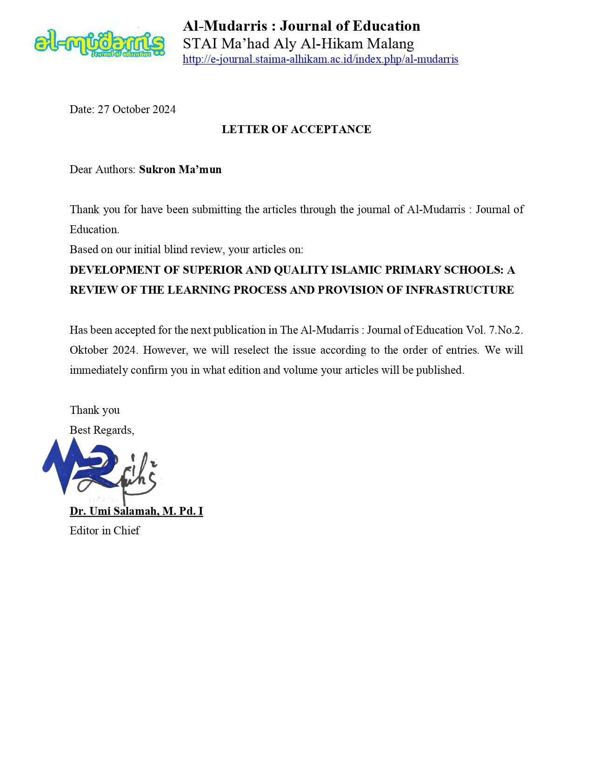 1/1

3. Bukti konfirmasi artikel published online

