**KORESPONDENSI ARTIKEL DIGITAL MARKETING**

1. **Proses Submission**

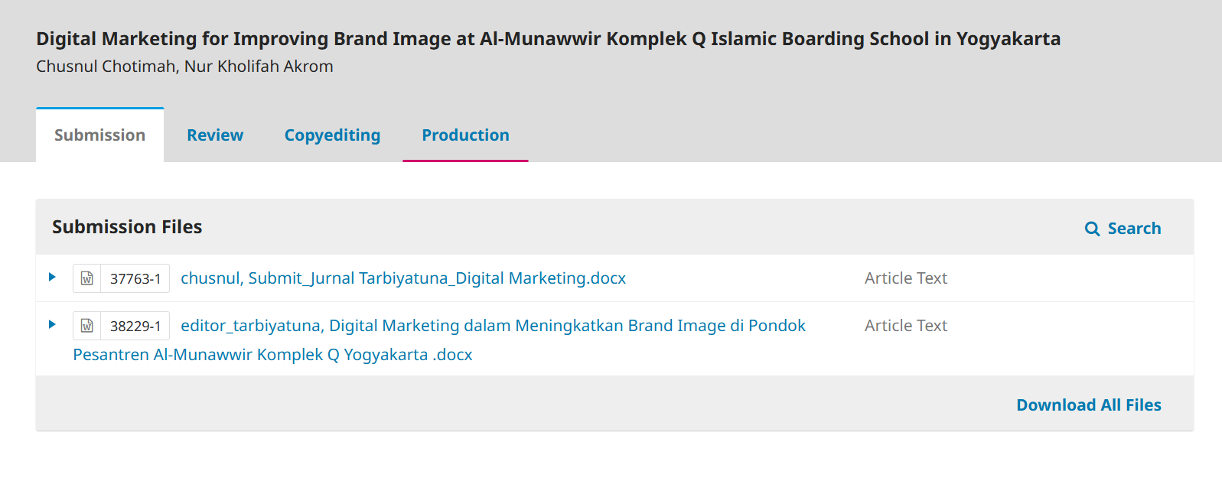

1. [Link submit jurnal Tarbiyatuna_Digital Marketing](https://docs.google.com/document/d/1AAMFG-0R3CTj9MPrJY9e5bX-g50RH95r/edit?usp=sharing&ouid=116228891526271462299&rtpof=true&sd=true)
2. [Link editor_tarbiyatuna, Digital Marketing dalam Meningkatkan Brand Image](https://docs.google.com/document/d/1k8AGB6Kjys-k0XIZHeor9aKodm3Et_o8/edit?usp=sharing&ouid=116228891526271462299&rtpof=true&sd=true)
3. **Pre-Review**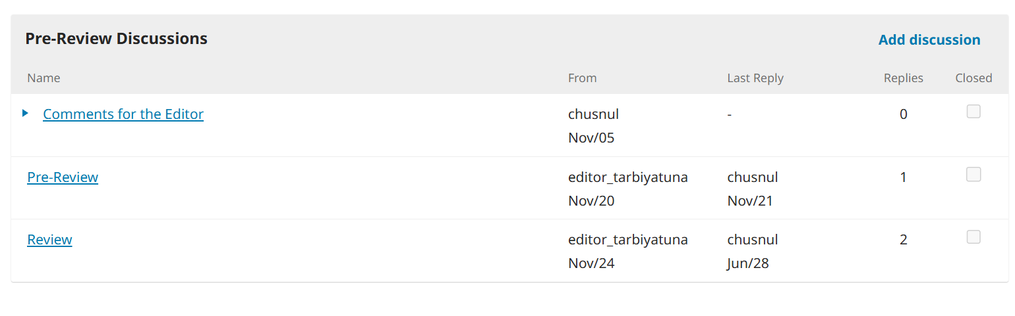

**Participants**

* Irham Nugroho (editor_tarbiyatuna)
* Chusnul Chotimah (chusnul)

**Messages**

|  |  |
| --- | --- |
| Terimakasih atas ketertarikan untuk publikasi di jurnal kami. Sebagaimana tertuang dalam peer-review policy, jurnal kami menerima submission setiap saat, namun demikian, jadwal terbit berdasarkan urutan yang telah selesai review dan copyediting.  Sebelum artikel kami lanjutkan proses Pre-Review, apakah author bersedia;   1. Author bersedia mengikuti ragkaian proses seperti yang tertuang di journal Policy Tarbiyatuna? 2. Author bersedia melakukan proofreading di lembaga proofread profesional (yang telah ditunjuk Jurnal Tarbiyatuna) dengan biaya proofread dibebankan author, ketika artikel sudah dinyatakan diterima editor? 3. Artikel yang dinyatakan accepted akan di publish setelah menyelesaikan Author fee seperti pada ketentuan <https://journal.unimma.ac.id/index.php/tarbiyatuna/AuthorFee> | editor_tarbiyatuna Nov 20 |

1. **Review**

**Participants**

* Irham Nugroho (editor_tarbiyatuna)
* Chusnul Chotimah (chusnul)

**Messages**

| Note | From |
| --- | --- |
| Dear authors,  Thank you for your submission to Jurnal Tarbiyatuna. We have received your article and read carefully. To improve the quality of your manuscript, we conduct an article review and appoint the potential reviewers. In addition, we also offer the suggested potential reviewers with the criteria attached and we will consider the suggestion.  Thank you, |  |

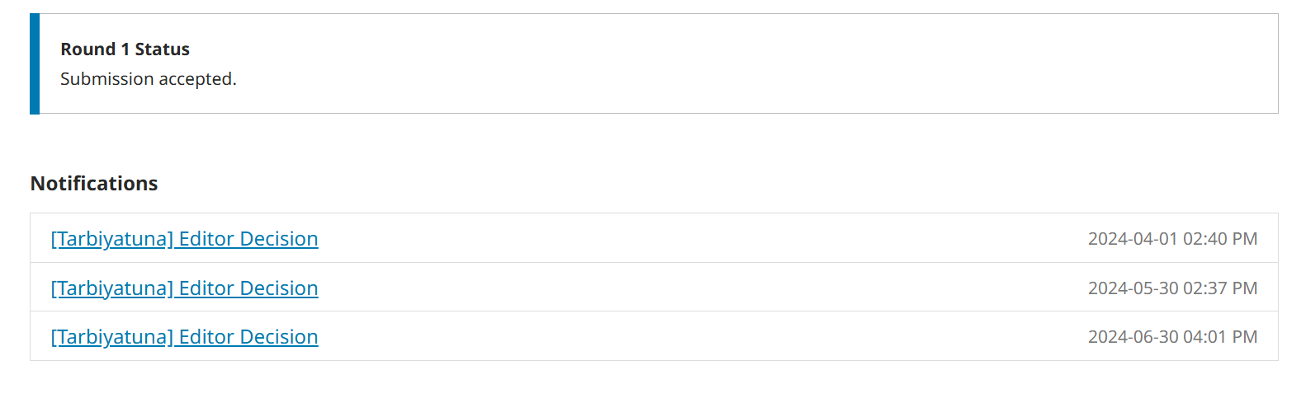

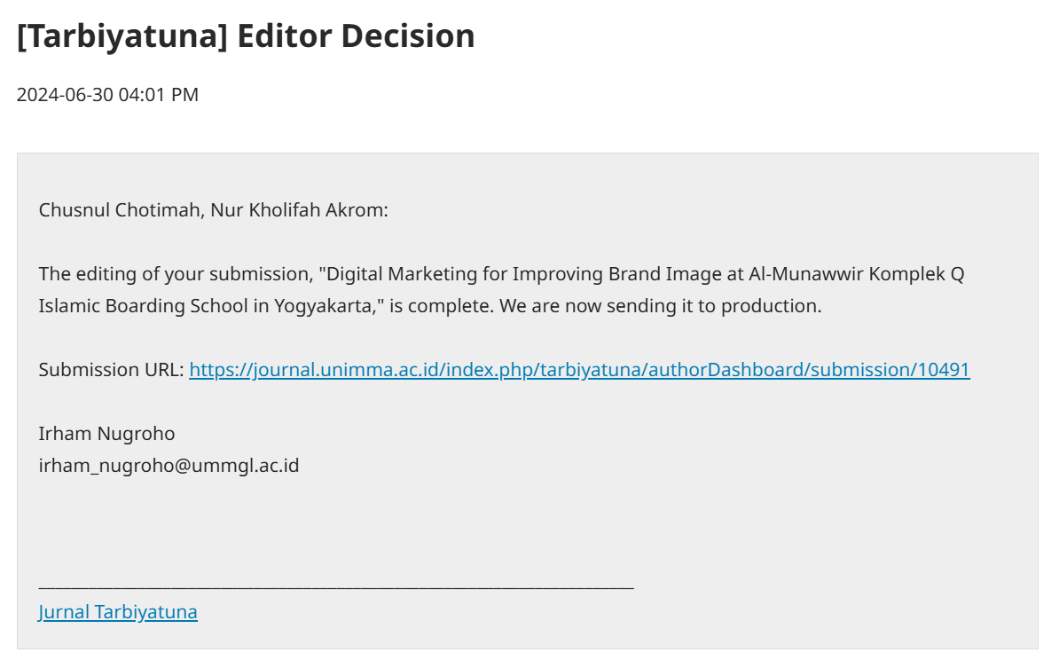

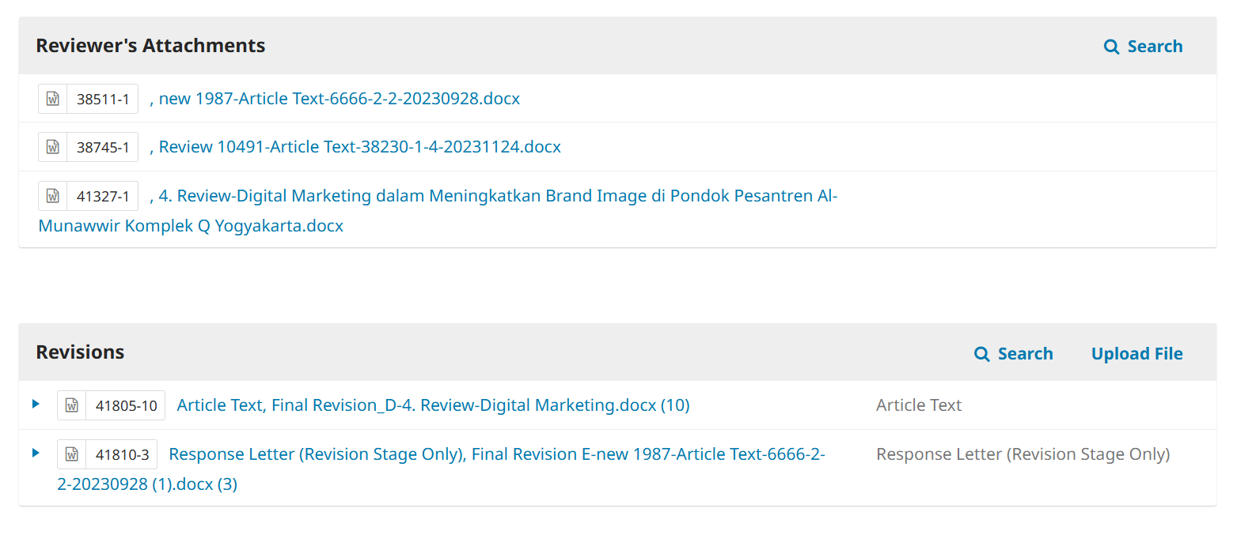

* + 1. [Link new 1987-Article Text 6666-2-2-20030928.docx](https://docs.google.com/document/d/1grL8-GckXWPp4f13ekDiBSA1mE--l-Oo/edit?usp=sharing&ouid=116228891526271462299&rtpof=true&sd=true)
    2. [Link Review 10491-Article Text-38230-1-4-20231124.docx](https://docs.google.com/document/d/11PGA33KTa1rJNIKOpWXjNlrs3QZEUmBc/edit?usp=sharing&ouid=116228891526271462299&rtpof=true&sd=true)
    3. [Link 4. Review-Digital Marketing dalam Meningkatkan Brand Image di Pondok Pesantren Al-Munawwir Komplek Q Yogyakarta.docx](https://docs.google.com/document/d/1Xwg5CUFxXUeGY_DoBIcXqWjGlhxZm-St/edit?usp=sharing&ouid=116228891526271462299&rtpof=true&sd=true" \o "41327-1)
    4. [Link Article Text, Final Revision_D-4. Review-Digital Marketing.docx (10)](https://docs.google.com/document/d/1h8YW0MxTLViFHdbuwBuk1iim8CZt1q4Y/edit?usp=sharing&ouid=116228891526271462299&rtpof=true&sd=true)
    5. [Link Response Letter (Revision Stage Only), Final Revision E-new 1987-Article Text-6666-2-2-20230928](https://docs.google.com/document/d/1h8YW0MxTLViFHdbuwBuk1iim8CZt1q4Y/edit?usp=sharing&ouid=116228891526271462299&rtpof=true&sd=true)