**BIBLIOGRAPHY**

Arikunto, Suharsimi. 2010.*Penelitian Tindakan Kelas.* Jakarta: Bumi Aksara

Arikunto, Suharsimi. 2002. *Procedure Penelitian*. Jakarta : PT. Rineka cipta

Arikunto, Suharsimi. 1997. Dasar-Dasar Evaluasi Pendidikan. Jakarta: Bumi Aksara

Brown, H. Douglas. 2001. *Teaching by Principles An Interactive Approach to Language Pedagogy Second Edition.* San Francisco State University

Brown, H. Douglas. 1997. *Teaching by Principles: An Interactive Approach to Language Paedagogy.* San Francisco: Prentice-Hall, Inc.

Buzan, Tony. 2007. *Buku Pintar Mind Map untuk Anak : Agar Anak Mudah Menghafal dan Berkonsentrasi*. Jakarta. PT. Gramedia Pustaka Utama

Buzan, Tony. 2005. *Buku Pintar Mind Map*. Jakarta. PT. Duta Prima

Buzan, Tony. 2004. *How to Mind Map: Mind Map untuk meningkatkan kreativitas* . Jakarta. PT. Gramedia Pustaka Utama

Buzan, T. 1993. *Radiant Thinking Book.* (online) <http://www.york.ca/NR/rdonlyres/lwi3dahfj3fxej6s3mecfavkvitaiqo5qr65x5dnohbxwojyr4jpucn75batnneipfmp5apgz4kymanoldrnkut2dg/An+Explanation+of+Mind+Mapping.pdf>, acceced on April5th 2012

Creswell, John.W. 2012.*Educational Research. (planning, conduting, and evaluating quantitative and qualitative research)* Boston : Pearson Education, Inc.

Chaer, Abdul. 1994. *Linguistik Umum.* Jakarta: PT Rineka Cipta

Davis, Martin. 2010. *Concept Mapping, Mind Mapping, and Argument Mapping*. Australia , Parkville : University of Melbourne

David, Harris P, *Testing as a Second Language,* New Delhi: Tate McGraw – Hill and Media Office, 1974.

Elliot, J. 1991. *Action Research for Educational Change.* Philadelphia: Open University Press

English Department State Islamic College of Tulungagung. 2011. *Thesis writing* *guideline.* Tulungagung.

Harmer, J.2001 *The practice of English Language Teaching,* (England: Pearson education limited Press).

Harmer, Jeremy. *How to Teach English,* (England addition Wesley Longman Limited 1998).

Harris, David, P. 1977. *Teaching English as a Second Language*, Singapore: Mc. Graw-Hill.

Heaton, J.B. 1978. *Writing English Language Test*. Longman Handbooks for Language Teachers. New York: Longman inc

Hornby, As. 1995. *“Oxford Learner’s Ocked Dictionary”,* New York: Oxford, University Press.

Kemmis & Mc. Taggart. 1982. *The Action Research Planner*, Melbourne, Victoria : Deakin University Press.

Manser, Martin H. 1990. *Oxford Learner’s Dictionary.* New York: UniversityPress.

Nunan, D. 1989. *Understanding Language Classrooms.* Dydney: Macquarie University.

Nunan, D. 1999. *Second Language Teaching and Learning,* Usa: International Thoruson, Publishing Company.

Nunan, David. 1988, *The Learner-Centred Curriculum.* Cambridge University Press

Nunan, D. 2003. *Practical English Language Teaching.* America: McGraw Hill.

Nunan, D. 1991. *Language Teaching Methodology.* Sydney: Macquarie University.

Richards, Jack. C. and Willy A. Renandya, *Methodology in Language Teaching,* Cambridge: University Press, 2002.

Riduwan, 2005. *Skala Pengukuran Variabel-variabel Penelitian*. Bandung : Alfabeta, CV.

Robin, McTaggart, *Action Research a Short Modern Hystory*, Deakin: University, 1988.

Syakur, 1987. Language Testing and Evaluation. Surakarta : Sebelas Maret University Pres.

Tarigan, Guntur H, 1990. *Pengajaran Bahasa,* Bandung: Angkasa Bandung.

Thornby, Scoot. 2005. *How to Teach Speaking*, Longman, Essex, England : Pearson Education Limited.

________, *Teaching Strategies and Practices in Human Society and Its Environment.*

[http://www.lkdsb.net/program/elementary/intermediate/di/files/21Strategies%28Mind%20Mapping%29.teaching strategies and practice.pdf](http://www.lkdsb.net/program/elementary/intermediate/di/files/21Strategies%28Mind%20Mapping%29.teaching%20strategies%20and%20practice.pdf), acceced on April 15th 2012

Ur, Peny. 1991 .*A course in Language Teaching (practice and theory).*Cambridge : Cambridge University Press

Vidal, R.V.V 2004. *Creative Tool Book.* (online) <http://www2.imm.dtu.dk/~rvvv/CPPS/5Chapter5creatools.pdf>, acceced on April 7th 2012

Water, Adams, Steffen.2004. *Action Research in Education*, (online), <http://www.triangle.co.uk/ear>, accessed on March 14th2012

Weir J. Cryl, *Communicative Language Testing*, New York: Practice-Hall International; 1990.

**Appendix 1**

**Speaking test in Preliminary-Test**

**My Self**



What is your name?

Where do you live?

67

What do you want to be?

**Appendix 2**

**Scoring Guide in Preliminary-test**

|  |  |  |  |
| --- | --- | --- | --- |
| **No** | **Possible Answer** | **Note Remark** | **Score** |
| 1 | * My name is Rudy * Rudy * I name want Rudy * *(Do not answer)* | * The students’ answer is accordance with the key answer or similar (Name is free). * The students’ answer is not completely accordance with the key answer. * The students’ answer is wrong (not in accordance with the key answer) or errors in grammar * The students do not answer. | 3  2  1  0 |
| 2 | * I live on Jl. Basuki Rahmad no. 123 Tulungagung * Jl. Basuki Rahmad 123 Tulungagung * I in Tulungagung      * *(Do not answer).* | - The students’ answer is accordance with the key answer or similar.(Address is free)  - The students’ answer is not completely accordance with the key answer.  - The students’ answer is wrong (not in accordance with the key answer) or errors in grammar.  - The students do not answer. | 3  2  1  0 |
| 3 | * I want to be a nurse * Nurse * I am twelve years old * *(Do not answer).* | - The students’ answer is accordance with the key answer or similar. (Job is free)  - The students’ answer is not completely accordance with the key answer.  - The students’ answer is wrong (not in accordance with the key answer) or errors in grammar.  - The students do not answer. | 3  2  1  0 |

**Appendix 3**

**Preliminary- test Score**

|  |  |
| --- | --- |
| **Sum of True** | **Score** |
| 9 | 100 |
| 8 | 89 |
| 7 | 78 |
| 6 | 67 |
| 5 | 56 |
| 4 | 44 |
| 3 | 33 |
| 2 | 22 |
| 1 | 11 |
| 0 | 0 |

|  |
| --- |
| ***Scores:***  Sum of Score Earned X 100%  Maximum Score |

**Appendix 4 Detailed Scoring Board in Preliminary- test**

|  |  |  |  |  |  |  |  |  |
| --- | --- | --- | --- | --- | --- | --- | --- | --- |
| **No** | **Name** | **Question** | | | **Total Score** | **Grade** | **Remark** | |
|  | **1** | **2** | **3** |  |  | **Passed** | **Failed** |
| 1 | AWP | 3 | 2 | 1 | 6 | 67 |  | √ |
| 2 | AMV | 3 | 2 | 2 | 7 | 78 | √ |  |
| 3 | AD | 2 | 3 | 1 | 6 | 67 |  | √ |
| 4 | ADP | 3 | 2 | 1 | 6 | 67 |  | √ |
| 5 | ATP | 3 | 3 | 1 | 7 | 78 | √ |  |
| 6 | BDS | 3 | 1 | 3 | 7 | 78 | √ |  |
| 7 | DFS | 3 | 2 | 3 | 8 | 89 | √ |  |
| 8 | DPS | 2 | 2 | 2 | 6 | 67 |  | √ |
| 9 | DPA | 3 | 3 | 3 | 9 | 100 | √ |  |
| 10 | EDS | 3 | 3 | 2 | 8 | 89 | √ |  |
| 11 | EK | 3 | 2 | 2 | 7 | 78 | √ |  |
| 12 | FKT | 2 | 2 | 2 | 6 | 67 |  | √ |
| 13 | FNW | 3 | 2 | 2 | 7 | 78 | √ |  |
| 14 | GBB | 2 | 2 | 2 | 6 | 67 |  | √ |
| 15 | HK | 2 | 2 | 1 | 5 | 56 |  | √ |
| 16 | IP | 3 | 2 | 3 | 8 | 89 | √ |  |
| 17 | IN | 3 | 2 | 2 | 7 | 78 | √ |  |
| 18 | HIS | 2 | 2 | 2 | 6 | 67 |  | √ |
| 19 | KL | 3 | 3 | 3 | 9 | 100 | √ |  |
| 20 | LE | 2 | 2 | 2 | 6 | 67 |  | √ |
| 21 | MHNB | 3 | 2 | 3 | 8 | 89 | √ |  |
| 22 | MW | 2 | 2 | 2 | 6 | 67 |  | √ |
| 23 | MVF | 3 | 3 | 2 | 8 | 89 | √ |  |
| 24 | MZ | 2 | 2 | 2 | 6 | 67 |  | √ |
| 25 | MAN | 2 | 2 | 2 | 6 | 67 |  | √ |
| 26 | MREP | 3 | 2 | 2 | 7 | 78 | √ |  |
| 27 | NI | 3 | 2 | 1 | 6 | 67 |  | √ |
| 28 | PR | 3 | 2 | 3 | 8 | 89 | √ |  |
| 29 | RS | 3 | 3 | 1 | 7 | 78 | √ |  |
| 30 | RPP | 2 | 2 | 2 | 6 | 67 |  | √ |
| 31 | SA | 2 | 2 | 2 | 6 | 67 |  | √ |
| 32 | SH | 3 | 2 | 2 | 7 | 78 | √ |  |
| 33 | SID | 3 | 2 | 3 | 8 | 89 | √ |  |
| 34 | TPW | 2 | 2 | 2 | 6 | 67 |  | √ |
| 35 | MW | 2 | 2 | 2 | 6 | 67 |  | √ |
| 36 | YB | 3 | 2 | 2 | 7 | 78 | √ |  |
| 37 | YAY | 2 | 2 | 2 | 6 | 67 |  | √ |
| 38 | YU | 3 | 3 | 2 | 8 | 89 | √ |  |
| 39 | YFSS | 3 | 3 | 3 | 9 | 100 | √ |  |

**Appendix 5**

**LESSON PLAN OF CYCLE 1**

School : SMPN 3 Kedungwaru

Subject : English

Class / Semester : VII / 2

Time Allotment : 4 x 40’

Skill : Speaking

Theme : My Family’s Activities

Standard Competence : To express the meaning in simple transactional and interpersonal conversation to interact with the environment

Basic Competence : To express the use of meaning in transactional conversation (to get things done) and interpersonal (social) using a variety of written language accurately, fluently, and thank to interact with the environment

Indicator : 1. The students are able to express Oral information

2. The students are able to ask and answer a variety of information orally

3. The students are able to describe Mind Mapping Pictures used simple present tense by theme “ Family’s Activities”

**Karakter peserta didik yang diharapkan :**  Respect

Speak up

Creative

Diligence

Responsibility

1. **Learning Objectives**

Students are expected able to :

1. Express Oral information

2. Ask and answer a variety of information orally

3. Describe Mind Mapping Pictures used simple present tense by theme “ Family’s Activities”

1. **Learning Material**

**Simple Present Tense**

Simple Present Tense is used to declare the eventh or activity happening at the moment. Simple present is also used to express a fact or something that accurs repeatedly in the present.

The Formula :

(+) positif : S + V1 (s/es)

(-) negative : S + DO/DOES + NOT + V1

(?) introgative :DO/DOES + S + V1 ?

NOTE :

For : I, WE, YOU, THEY used DO

For : SHE, HE, IT, AHMAD, ERIK use DOES

* Example of positive sentence :
* I drink coffee
* She drinks coffee
* We drink coffee
* Example of Negative Sentence:
* I do not drink coffee
* She does not drink coffee
* We do not drink coffee
* John does not learn English
* Example of Introgative Sentence:
* Do you drink coffee?
* Does she drink coffee?
* Does Ahmad drink coffee?

1. **Teaching Metdod/Technique**

Mind Mapping Technique

1. **Learning Activities**

**Meeting 1**

|  |  |  |
| --- | --- | --- |
| NO | **Learning Procedure** | **Time Allotment** |
| 1. | Pre-Teaching   1. Aperseption  * The teacher check the students readness to follow the learning process.. * Greeting * The teacher check attendance list the students  1. Motivation  * The teacher give motivation to the students * The teacher inform the material that will be delivered to achieve competency | 10 minutes |
| 2. | Whilst-Teaching   1. Exploration  * The teacher explains a little about the simple present tense and the formula * The teacher explains about the Mind Mapping technique * The teacher presents some interesting pictures by theme “Family’s Activities” * The teacher guide students to actively discuss the pictures  1. Elaboration  * The students learn about the material * The students discuss about the pictures with their group  1. Confirmation  * The teacher asks to the students to give the impression of feedback about the difficulties in dealing with the matter * The teacher give instructions to the students who have difficulty in learning process * The teacher gave assignment home to tried of practice speaking and preparing the evaluation of the material * The teacher to motivate students who are passive in the teaching and learning process | 60 minutes |
| 3. | Post-Teaching   * The teacher guide the students to further practice speaking and interacting in English * The teacher give conclusion about the content that has been learned * The teacher ask to the students to difficulties in teaching and leaning process * The students give competence to the next meeting * The teacher closes the teaching and learning process | 10 minutes |

**Meeting 2**

|  |  |  |
| --- | --- | --- |
| **NO** | **Learning Procedure** | **Time Allotment** |
| 1. | Pre-Teaching   1. Aperseption  * The teacher check the students readness to follow the learning process.. * Greeting * The teacher check attendance list the students  1. Motivation  * The teacher give motivation to the students * The teacher reviewing a little about the matter before * The teacher inform the material that will be delivered to achieve competency | 10 minutes |
| 2. | Whilst-Teaching   1. Exploration  * The teacher explains detaild about the Mind Mapping technique again * The teacher presents some interesting pictures by theme “Family’s Activities” * The teacher guide students to actively discuss the pictures * The teracher asks the students to tell and explains about their mind mapping pictures in front of the class  1. Elaboration  * The students learn about the material * The students discuss about the pictures with their group * The students tell and explains obout their mind mapping pictures in front of the class  1. Confirmation  * The teacher give instructions to the students who have difficulty in learning process * The teacher to motivate students who are passive in the teaching and learning process | 65 minutes |
| 3. | Post-Teaching   * The teacher guide the students to further practice speaking and interacting in English * The teacher give conclusion about the content that has been learned * The teacher ask to the students to difficulties in teaching and leaning process * The teacher closes the teaching and learning process | 5 minutes |

1. **Instructional Media**

Work sheet of Mind Mapping Pictures

Dictionary

Handout

1. **Assessment**

Technique : performance assessment

Form of assessment : oral test ( the assessment is based on students perfomence when presenting the mind map pictures in front of the class)

Rubric

|  |  |  |  |
| --- | --- | --- | --- |
| **NO** | **Aspect** | **Score** | **Criteria** |
| 1 | Pronunciation | 3  2  1  0 | Acceptable and readable  Different but acceptable  Unclear pronunciation  No utterance |
| 2 | Fluency | 3  2  1  0 | Speak fluently, no significant pause  Speak well enough, pause here and there speak unclearly  No utterance |
| 3 | Vocabulary | 3  2  1  0 | Key diction, supporting diction,additional  Supporting diction, additional diction  Supporting diction  No utterance |
| 4 | Grammar | 3  2  1  0 | Clause, phrasing order appropriate  Clause OK, phrasing order not OK  Clause and phrasing order not OK  No utterance |
| 5 | Comprehension | 3  2  1  0 | Understanding the conversation and answer all the questions correctly  Answering the questions correctly  Answering small of questions  No utterance |

|  |
| --- |
| ***Scores:***  Sum of Score Earned X 100%  Maximum Score |

Tulungagung, 16 April 2012

Practitioner

**YENY TRI INDARWATY**

**NIM: 3213083120**

**Appendix 6**

**My family’s activities**



**Speaking Test in Cycle 1**

Sunday

**Sunday**

**Saturday**

Tuesday

Thursday

Wednesday

78

The students are asked to speak up and develop their ideas based the Mind Mapping with Family’s Activities as a theme

**Appendix 7**

**Scoring Guide in Cycle 1**

|  |  |  |  |
| --- | --- | --- | --- |
| **NO** | **Aspect** | **Score** | **Criteria** |
| 1 | Pronunciation | 3  2  1  0 | Acceptable and readable  Different but acceptable  Unclear pronunciation  No utterance |
| 2 | Fluency | 3  2  1  0 | Speak fluently, no significant pause  Speak well enough, pause here and there speak unclearly  No utterance |
| 3 | Vocabulary | 3  2  1  0 | Key diction, supporting diction,additional  Supporting diction, additional diction  Supporting diction  No utterance |
| 4 | Grammar | 3  2  1  0 | Clause, phrasing order appropriate  Clause OK, phrasing order not OK  Clause and phrasing order not OK  No utterance |
| 5 | Comprehension | 3  2  1  0 | Understanding the conversation and answer all the questions correctly  Answering the questions correctly  Answering small of questions  No utterance |

**Appendix 8**

**Scoring in Cycle 1**

|  |  |
| --- | --- |
| **Sum of True** | **Score** |
| 15 | 100 |
| 14 | 93 |
| 13 | 87 |
| 12 | 80 |
| 11 | 73 |
| 10 | 67 |
| 9 | 60 |
| 8 | 53 |
| 7 | 47 |
| 6 | 40 |
| 5 | 33 |
| 4 | 27 |
| 3 | 20 |
| 2 | 13 |
| 1 | 7 |
| 0 | 0 |

|  |
| --- |
| ***Scores:***  Sum of Score Earned X 100%  Maximum Score |

**Appendix 9**

**Detailed Scoring Board in Cycle 1**

|  |  |  |  |  |  |  |  |  |  |  |  |
| --- | --- | --- | --- | --- | --- | --- | --- | --- | --- | --- | --- |
| **No** | **Name** |  | | **Aspect** | | | | **Total** | **Grade** | **Remark** | |
|  | **Pron** | **Flu** | | **Voc** | **Gra** | **Com** | **Score** |  | PPassed | Fi Filed |
| 1 | AWP | 2 | 2 | | 3 | 2 | 2 | 11 | 73 | √ |  |
| 2 | AMF | 2 | 3 | | 3 | 2 | 2 | 12 | 80 | √ss √ |  |
| 3 | AD | 2 | 2 | | 3 | 2 | 1 | 10 | 67 |  | √ √ |
| 4 | ADP | 2 | 2 | | 3 | 2 | 1 | 10 | 67 |  | √ √ |
| 5 | ATP | 2 | 2 | | 3 | 2 | 2 | 11 | 73 | √ |  |
| 6 | BDS | 2 | 3 | | 2 | 2 | 2 | 11 | 73 | √ |  |
| 7 | DFS | 3 | 3 | | 3 | 2 | 2 | 13 | 87 | √ |  |
| 8 | DPS | 3 | 2 | | 3 | 1 | 2 | 11 | 73 | √ |  |
| 9 | DPA | 3 | 3 | | 3 | 3 | 3 | 15 | 100 | √ |  |
| 10 | EDS | 3 | 3 | | 3 | 1 | 2 | 12 | 80 | √ | S |
| 11 | EK | 2 | 3 | | 2 | 2 | 2 | 11 | 73 | √ |  |
| 12 | FKT | 2 | 2 | | 3 | 1 | 2 | 10 | 67 |  | √ √ |
| 13 | FNW | 2 | 3 | | 2 | 2 | 2 | 11 | 73 | √ |  |
| 14 | GBB | 2 | 3 | | 2 | 2 | 2 | 11 | 73 | √ |  |
| 15 | HK | 1 | 2 | | 2 | 1 | 2 | 8 | 53 |  | √ √ |
| 16 | IP | 2 | 2 | | 3 | 2 | 2 | 11 | 73 | √ |  |
| 17 | IN | 2 | 3 | | 3 | 2 | 2 | 12 | 80 | √ |  |
| 18 | HIS | 2 | 2 | | 3 | 2 | 1 | 10 | 67 |  | √ |
| 19 | KL | 3 | 3 | | 3 | 3 | 3 | 15 | 100 | √ |  |
| 20 | LE | 2 | 2 | | 2 | 2 | 2 | 10 | 67 |  | √ |
| 21 | MHNB | 2 | 2 | | 3 | 3 | 1 | 11 | 73 | √ |  |
| 22 | MW | 2 | 2 | | 3 | 2 | 1 | 10 | 67 |  | √ |
| 23 | MVF | 3 | 2 | | 3 | 2 | 2 | 12 | 80 | √ |  |
| 24 | MZ | 2 | 1 | | 2 | 1 | 2 | 8 | 53 |  | √ |
| 25 | MAN | 2 | 2 | | 2 | 2 | 1 | 9 | 60 |  | √ |
| 26 | MREP | 3 | 2 | | 3 | 2 | 1 | 11 | 73 | √ |  |
| 27 | NI | 3 | 3 | | 2 | 2 | 1 | 11 | 73 | √ |  |
| 28 | PR | 2 | 2 | | 3 | 3 | 2 | 12 | 80 | √ |  |
| 29 | RS | 2 | 3 | | 2 | 2 | 2 | 11 | 73 | √ |  |
| 30 | RPP | 3 | 2 | | 2 | 2 | 2 | 11 | 73 | √ |  |
| 31 | SA | 1 | 2 | | 3 | 1 | 1 | 8 | 53 |  | √ |
| 32 | SH | 1 | 2 | | 3 | 2 | 1 | 9 | 67 |  | √ |
| 33 | SID | 3 | 2 | | 3 | 2 | 2 | 12 | 80 | √ |  |
| 34 | TPW | 2 | 2 | | 2 | 1 | 2 | 9 | 67 |  | √ |
| 35 | WM | 2 | 2 | | 3 | 2 | 2 | 11 | 73 | √ |  |
| 36 | YB | 2 | 3 | | 2 | 2 | 2 | 11 | 73 | √ |  |
| 37 | YAY | 2 | 2 | | 2 | 1 | 2 | 9 | 67 |  | √ |
| 38 | YU | 2 | 2 | | 3 | 2 | 2 | 11 | 73 | √ |  |
| 39 | YFSS | 3 | 3 | | 3 | 2 | 2 | 13 | 87 | √ |  |

**Appendix 10**

**LESSON PLAN CYCLE 2**

School : SMPN 3 Kedungwaru

Subject : English

Class / Semester : VII / 2

Time Allotment : 4 x 40’

Skill : Speaking

Theme : Birthday Party

Standart kompetensi : To express the meaning in simple transactional and interpersonal conversation to interact with the environment

Kompetensi Dasar : To express the use of meaning in transactional conversation (to get things done) and interpersonal (social) using a variety of written language accurately, fluently, and thank to interact with the environment

Indikator : 1. The students can to express Oral information

2. The students are ask and answer a variety of information orally

3. The students can describe of Mind Mapping Pictures used simple past tense by theme “ Birthday Party”

**Karakter peserta didik yang diharapkan :** Respect

Speak up

Creative

Diligence

responsibility

1. **Learning Objectives**

Students are expected able to :

1. Express Oral information

2. Ask and answer a variety of information orally

3. Describe of Mind Mapping Pictures used simple past tense by theme “ Birthday Party”

1. **Materi Pembelajaran**

**Simple present tense**

Past tense is a sentence to express events in the distant past, (past here is not meant to be a long time ago, but the event is over whether it's 2 hours ago, 2 days ago, etc.)

The Formula :

(+) Positif : S + V2

(-) Negative : S + DID + NOT + V1

(?) Introgative : DID + S + V1 ?

* The Example of Sentence 1 *:*

(+) Ani saw her standing there yesterday

*(-)* Ani did not see her standing there yesterday

(?) did Ani see her standing there yesterday ?

* The Example of Sentence 2 :

(+) My father bought this car last year

(-) My father did not buy this car last year

(?) did My father buy this car last year?

1. **Teaching Method/Technique**

Mind Mapping Technique

1. **Learning Activities**

**Meeting 1**

|  |  |  |
| --- | --- | --- |
| **NO** | **Learning Procedure** | **Time Allotment** |
| 1. | Pre-Teaching   1. Aperseption  * The teacher check the students readness to follow the learning process.. * Greeting * The teacher check attendance list the students  1. Motivation  * The teacher give motivation to the students * The teacher inform the material that will be delivered to achieve competency | 10 minutes |
| 2. | Whilst-Teaching   1. Exploration  * The teacher explains a little about the simple past tense and the formula * The teacher explains detail about the Mind Mapping technique using mini pictures * The teacher presents some interesting pictures by theme “Birthday Party” * The teacher give some vocabulary about the theme and give an example of pronuciation * The teacher guide students to actively discuss the pictures  1. Elaboration  * The students learn about the material * The students discuss about the pictures with their group * The students follow the teacher about pronunciation * The students draws mini pictures in every branchs of mind mapping pictures  1. Confirmation  * The teacher asks to the students to give the impression of feedback about the difficulties in dealing with the matter * The teacher give instructions to the students who have difficulty in learning process * The teacher gave assignment home to tried of practice speaking and preparing the evaluation of the material * The teacher to motivate students who are passive in the teaching and learning process | 65 minutes |
| 3. | Post-Teaching   * The teacher guide the students to further practice speaking and interacting in English * The teacher give conclusion about the content that has been learned * The teacher ask to the students to difficulties in teaching and leaning process * The students give competence to the next meeting * The teacher closes the teaching and learning process | 5 minutes |

**Meeting 2**

|  |  |  |
| --- | --- | --- |
| **NO** | **Leraning Procedure** | **Time Allotment** |
| 1. | Pre-Teaching   1. Aperseption  * The teacher check the students readness to follow the learning process.. * Greeting * The teacher check attendance list the students  1. Motivation  * The teacher give motivation to the students * The teacher reviewing a little about the matter before * The teacher inform the material that will be delivered to achieve competency | 5 minutes |
| 2. | Whilst-Teaching   1. Exploration  * The teacher explains detailed about the Mind Mapping technique again * The teacher presents some interesting pictures by theme “Birthday Party” using mini pictures * The teacher guide students to actively discuss the pictures * The teracher asks the students to tell and explains about their mind mapping pictures in front of the class  1. Elaboration  * The students learn about the material * The students discuss about the pictures with their group * The students tell and explains obout their mind mapping pictures in front of the class  1. Confirmation  * The teacher give instructions to the students who have difficulty in learning process * The teacher to motivate students who are passive in the teaching and learning process | 65 minutes |
| 3. | Post-Teaching   * The teacher guide the students to further practice speaking and interacting in English * The teacher give conclusion about the content that has been learned * The teacher ask to the students to difficulties in teaching and leaning process * the teacher asked the students a few things about learning English * The teacher closes the teaching and learning process | 10 minutes |

1. **Instructional Media**

Work sheet of Mind Mapping Pictures

Dictionary

Handout

1. **Assessment**

Technique : performance assessment

Form of assessment : oral test ( the assessment is based on the performence when presenting the mind map pictures in front of the class)

|  |  |  |  |
| --- | --- | --- | --- |
| **NO** | **Aspect** | **Score** | **Criteria** |
| 1 | Pronunciation | 3  2  1  0 | Acceptable and readable  Different but acceptable  Unclear pronunciation  No utterance |
| 2 | Fluency | 3  2  1  0 | Speak fluently, no significant pause  Speak well enough, pause here and there speak unclearly  No utterance |
| 3 | Vocabulary | 3  2  1  0 | Key diction, supporting diction,additional  Supporting diction, additional diction  Supporting diction  No utterance |
| 4 | Grammar | 3  2  1  0 | Clause, phrasing order appropriate  Clause OK, phrasing order not OK  Clause and phrasing order not OK  No utterance |
| 5 | Comprehension | 3  2  1  0 | Understanding the conversation and answer all the questions correctly  Answering the questions correctly  Answering small of questions  No utterance |

|  |
| --- |
| ***Scores:***  Sum of Score Earned X 100%  Maximum Score |

Tulungagung, 23 April 2012

Practitioner

**YENY TRI INDARWATY**

**NIM: 3213083120**

**Appendix 11**

**Speaking Test in Cycle 2**

**Birthday Party**



The students are asked to speak up and develop their ideas based the Mind Mapping with Bithday Party as a theme

88

**Appendix 12**

**Scoring Guide in Cycle 2**

|  |  |  |  |
| --- | --- | --- | --- |
| **NO** | **Aspect** | **Score** | **Criteria** |
| 1 | Pronunciation | 3  2  1  0 | Acceptable and readable  Different but acceptable  Unclear pronunciation  No utterance |
| 2 | Fluency | 3  2  1  0 | Speak fluently, no significant pause  Speak well enough, pause here and there speak unclearly  No utterance |
| 3 | Vocabulary | 3  2  1  0 | Key diction, supporting diction,additional  Supporting diction, additional diction  Supporting diction  No utterance |
| 4 | Grammar | 3  2  1  0 | Clause, phrasing order appropriate  Clause OK, phrasing order not OK  Clause and phrasing order not OK  No utterance |
| 5 | Comprehension | 3  2  1  0 | Understanding the conversation and answer all the questions correctly  Answering the questions correctly  Answering small of questions  No utterance |

**Appendix 13**

**Scoring in Cycle 2**

|  |  |
| --- | --- |
| **Sum of True** | **Score** |
| 15 | 100 |
| 14 | 93 |
| 13 | 87 |
| 12 | 80 |
| 11 | 73 |
| 10 | 67 |
| 9 | 60 |
| 8 | 53 |
| 7 | 47 |
| 6 | 40 |
| 5 | 33 |
| 4 | 27 |
| 3 | 20 |
| 2 | 13 |
| 1 | 7 |
| 0 | 0 |

|  |
| --- |
| ***Scores:***  Sum of Score Earned X 100%  Maximum Score |

|  |  |  |  |  |  |  |  |  |  |  |  |
| --- | --- | --- | --- | --- | --- | --- | --- | --- | --- | --- | --- |
| **No** | **Name** |  | | **Aspect** | | | | **Total** | **Grade** | **Remark** | |
|  | **Pron** | **Flu** | | **Voc** | **Gra** | **Com** | **Score** |  | Passed | Fi Filed |
| 1 | AWP | 2 | 2 | | 3 | 2 | 2 | 11 | 73 | √ |  |
| 2 | AMF | 2 | 3 | | 3 | 2 | 2 | 12 | 80 | √ |  |
| 3 | AD | 2 | 2 | | 2 | 2 | 2 | 10 | 67 |  | √ |
| 4 | ADP | 2 | 2 | | 3 | 2 | 1 | 10 | 67 |  | √ |
| 5 | ATP | 2 | 2 | | 3 | 2 | 2 | 11 | 73 | √ |  |
| 6 | BDS | 2 | 3 | | 2 | 2 | 2 | 11 | 73 | √ |  |
| 7 | DFS | 3 | 3 | | 3 | 3 | 2 | 14 | 93 | √ |  |
| 8 | DPS | 3 | 2 | | 3 | 1 | 2 | 11 | 73 | √ |  |
| 9 | DPA | 3 | 3 | | 3 | 2 | 3 | 14 | 93 | √ |  |
| 10 | EDS | 3 | 3 | | 3 | 3 | 2 | 14 | 93 | √ |  |
| 11 | EK | 2 | 2 | | 3 | 2 | 2 | 11 | 73 | √ |  |
| 12 | FKT | 3 | 2 | | 2 | 1 | 2 | 10 | 67 |  | √ |
| 13 | FNW | 2 | 3 | | 2 | 2 | 2 | 11 | 73 | √ |  |
| 14 | GBB | 2 | 2 | | 3 | 2 | 2 | 11 | 73 | √ |  |
| 15 | HK | 2 | 2 | | 2 | 1 | 1 | 8 | 53 |  | √ |
| 16 | IP | 2 | 3 | | 2 | 2 | 2 | 11 | 73 | √ |  |
| 17 | IN | 3 | 3 | | 3 | 3 | 2 | 14 | 93 | √ |  |
| 18 | HIS | 3 | 2 | | 2 | 2 | 1 | 10 | 67 |  | √ |
| 19 | KL | 3 | 3 | | 3 | 3 | 3 | 15 | 100 | √ |  |
| 20 | LE | 2 | 2 | | 3 | 2 | 2 | 11 | 73 | √ |  |
| 21 | MHNB | 3 | 2 | | 3 | 2 | 2 | 12 | 80 | √ |  |
| 22 | MW | 3 | 2 | | 2 | 2 | 2 | 11 | 73 | √ |  |
| 23 | MVF | 3 | 3 | | 2 | 2 | 2 | 12 | 80 | √ |  |
| 24 | MZ | 2 | 1 | | 2 | 2 | 1 | 8 | 53 |  | √ |
| 25 | MAN | 2 | 2 | | 3 | 2 | 1 | 10 | 67 |  | √ |
| 26 | MREP | 2 | 3 | | 2 | 2 | 2 | 11 | 73 | √ |  |
| 27 | NI | 3 | 2 | | 3 | 2 | 2 | 12 | 80 | √ |  |
| 28 | PR | 3 | 3 | | 3 | 2 | 2 | 13 | 87 | √ |  |
| 29 | RS | 2 | 3 | | 2 | 2 | 2 | 11 | 73 | √ |  |
| 30 | RPP | 3 | 2 | | 3 | 1 | 2 | 11 | 73 | √ |  |
| 31 | SA | 2 | 2 | | 2 | 2 | 2 | 10 | 67 |  | √ |
| 32 | SH | 2 | 3 | | 2 | 2 | 2 | 11 | 73 | √ |  |
| 33 | SID | 2 | 3 | | 2 | 3 | 2 | 12 | 80 | √ |  |
| 34 | TPW | 2 | 2 | | 2 | 2 | 2 | 10 | 67 |  | √ |
| 35 | WM | 3 | 2 | | 3 | 2 | 2 | 12 | 80 | √ |  |
| 36 | YB | 2 | 3 | | 2 | 2 | 2 | 11 | 73 | √ |  |
| 37 | YAY | 2 | 3 | | 2 | 2 | 2 | 11 | 73 | √ |  |
| 38 | YU | 3 | 2 | | 3 | 1 | 2 | 11 | 73 | √ |  |
| 39 | YFSS | 3 | 3 | | 2 | 2 | 2 | 12 | 100 | √ |  |

**Appendix 14**

**Detailed scoring board in cycle 2**

**Appendix 15**

**Timetable of Classroom Action Research**

|  |  |  |
| --- | --- | --- |
| **No.** | **Activities** | **Date and Time** |
| 1. | Pre- research | April 17th 2012 at 10 a.m – finished |
| 2. | Preliminary Study | April 19th 2012 at 11.20.-12.40 a.m. |
| 3. | Cycle 1- meeting 1 | April 24th 2012 at 11.20- 12.40 a.m. |
| 4. | Cycle 1- meeting 2 | April 26th 2012at 11.20- 12.40 a.m. |
| 5. | Cycle 2- meeting 1 | April 27th 2012 at 08.50- 09.50 a.m. |
| 6. | Cycle 2- meeting 2 | May 1st 2012 at 11.20- 12.40 a.m. |

**Appendix 16**

**Teacher’s Observation Sheet 1**

Cycle : 1

Observer : Suprihatin, S.Pd

Give a check (v) in the column based on your observation!

|  |  |  |  |
| --- | --- | --- | --- |
| **Activity** | **Indicator** | **Yes** | **No** |
| Opening Activities | 1. Asking greeting to the students 2. Asking the students to pray together 3. Asking about the students’ condition today 4. Check the students’ attendance |  |  |
| Core Activities | 1. Doing BKOF 2. Explaining about the lesson that will learn 3. Giving an interesting media 4. Acting a demonstration as an example to the students 5. Motivating the students to discuss in group using the target language 6. Guiding the students during the learning process |  |  |
| Opening Activities | 1. Giving home assignments 2. Giving conclusions 3. Giving suggestions 4. Saying “see you” or “good bye” to close the lesson today |  |  |

**Appendix 17**

**Teacher’s Observation Sheet 2**

Cycle : 2

Observer : Suprihatin, S.Pd

Give a check (v) in the column based on your observation!

|  |  |  |  |
| --- | --- | --- | --- |
| **Activity** | **Indicator** | **Yes** | **No** |
| Opening Activities | 1. Asking greeting to the students 2. Asking the students to pray together 3. Asking about the students’ condition today 4. Check the students’ attendance |  |  |
| Core Activities | 1. Doing BKOF 2. Explaining about the lesson that will learn 3. Giving an interesting media 4. Acting a demonstration as an example to the students 5. Motivating the students to discuss in group using the target language 6. Guiding the students during the learning process |  |  |
| Opening Activities | 1. Giving home assignments 2. Giving conclusions 3. Giving suggestions 4. Saying “see you” or “good bye” to close the lesson today |  |  |

**Appendix 18**

**Students’ Observation Sheet 1**

Cycle : 1

Observer : Suprihatin, S.Pd

Write the numbers of students on the column!

|  |  |  |  |
| --- | --- | --- | --- |
| **Activities** | **Indicator** | **Yes** | **No** |
| Opening Activities | 1. Answering the greeting of the teacher 2. Praying together 3. Answering the teacher’s questions | 38  39  32 | 2  0  7 |
| Core Activities | 1. Paying attention to the teacher’s explanation 2. Answering the teacher’s questions 3. Discussing in group using the target language 4. Demonstrating the speaking test orally in front of the class | 31  26  31  39 | 8  13  8  0 |
| Closing Activities | 1. Asking the teacher about the lesson that unclear 2. Paying attention to the teacher’s conclusions and suggestions 3. Replaying to the teacher with saying “see you too” or “ bye- bye “ | 12  37  39 | 27  2  0 |

**Appendix 19**

**Students’ Observation Sheet 2**

Cycle : 2

Observer : Suprihatin, S.Pd

Write the numbers of students on the column!

|  |  |  |  |
| --- | --- | --- | --- |
| **Activities** | **Indicator** | **Yes** | **No** |
| Opening Activities | 1. Answering the greeting of the teacher 2. Praying together 3. Answering the teacher’s questions | 37  38  35 | 3  1  4 |
| Core Activities | 1. Paying attention to the teacher’s explanation 2. Answering the teacher’s questions 3. Discussing in group using the target language 4. Demonstrating the speaking test orally in front of the class | 35  30  35  39 | 4  9  4  0 |
| Closing Activities | 1. Asking the teacher about the lesson that unclear 2. Paying attention to the teacher’s conclusions and suggestions 3. Replaying to the teacher with saying “see you too” or “ bye- bye “ | 26  37  39 | 13  2  0 |

**Appendix 20**

**Questionnaires**

* 1. Do you think that English is Important for your live?

|  |  |  |
| --- | --- | --- |
| Answer | Total of students | Percentage (%) |
| Yes | 19 | 48.71% |
| No | 20 | 51.29% |

Criteria of interpretation score: Average

* 1. Do you interesting using Mind Mapping technique in learning speaking?

|  |  |  |
| --- | --- | --- |
| Answer | Total of students | Percentage (%) |
| Yes | 27 | 69.23 % |
| No | 12 | 30.77% |

Criteria of interpretation score: Strong

* 1. Do you feel enjoyable during the learning process by using mini picture of mind map sheet?

|  |  |  |
| --- | --- | --- |
| Answer | Total of students | Percentage (%) |
| Yes | 35 | 89.74% |
| No | 4 | 10.26 % |

Criteria of interpretation score: Very strong

* 1. Do you think that Mind Mapping technique can improve your speaking ability?

|  |  |  |
| --- | --- | --- |
| Answer | Total of students | Percentage (%) |
| Yes | 31 | 79.48 % |
| No | 8 | 20.52% |

Criteria of interpretation score: Very Strong

* 1. Do you think that the speaking ability depend on the speaking habit?

|  |  |  |
| --- | --- | --- |
| Answer | Total of students | Percentage (%) |
| Yes | 32 | 82.05 % |
| No | 7 | 17.95 % |

Criteria of interpretation score: Very Strong

**Appendix 21**

**Pictures of Teaching Learning Activities**

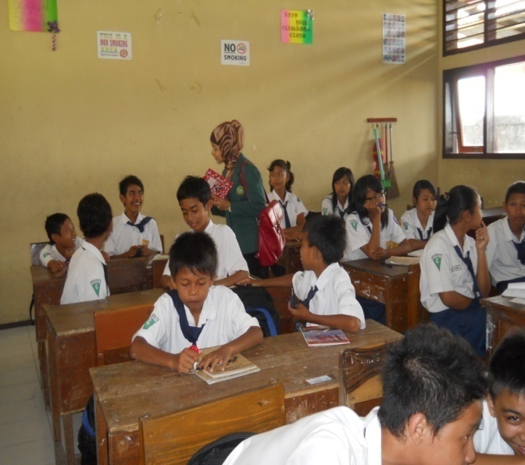

**The researcher doing prelimninary test. She asks the students to answer some questions as preliminary test.**

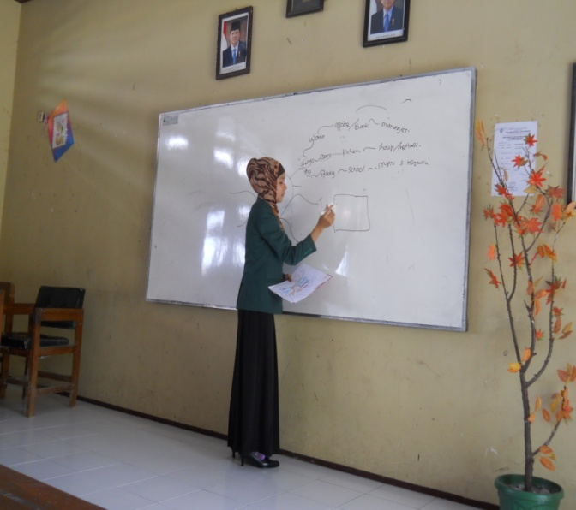

**The researcher explains about Mind Mapping in front of the class**.

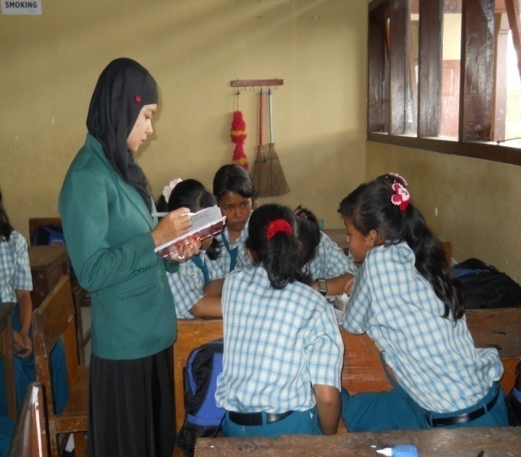

**The students disccuss about Mind Mapping in the first time with the theme “Family’s Activities”. The researcher guided them.**

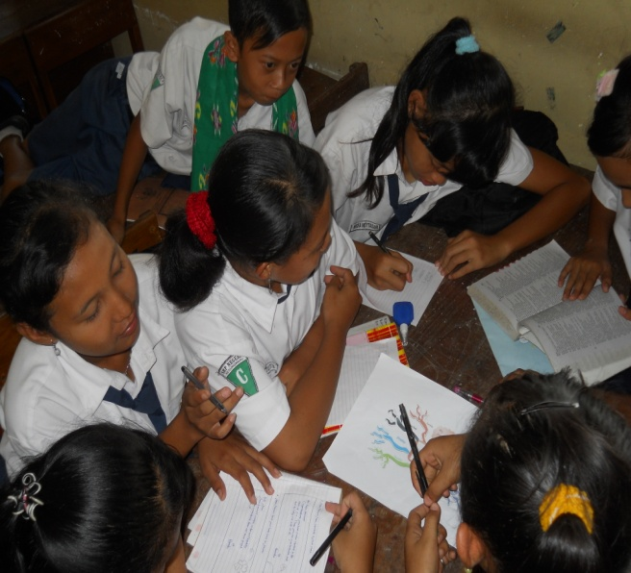

**The students are doing the assigment in group and prepare it to present in front of the class.**

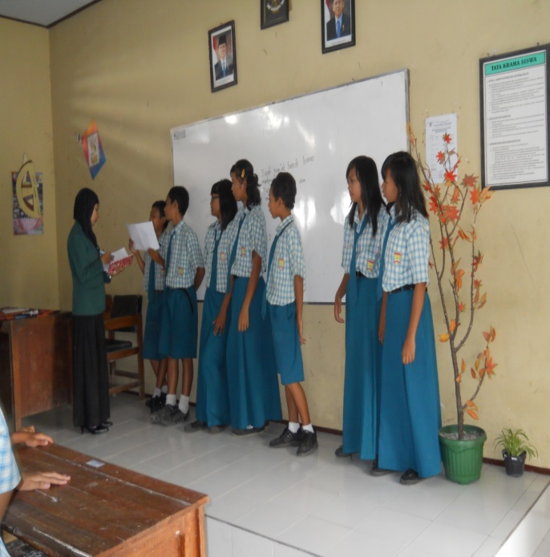

**The students practice to speak based on their mind mapping. They do it individually but they stand in group. The researcher appreciate their action.**

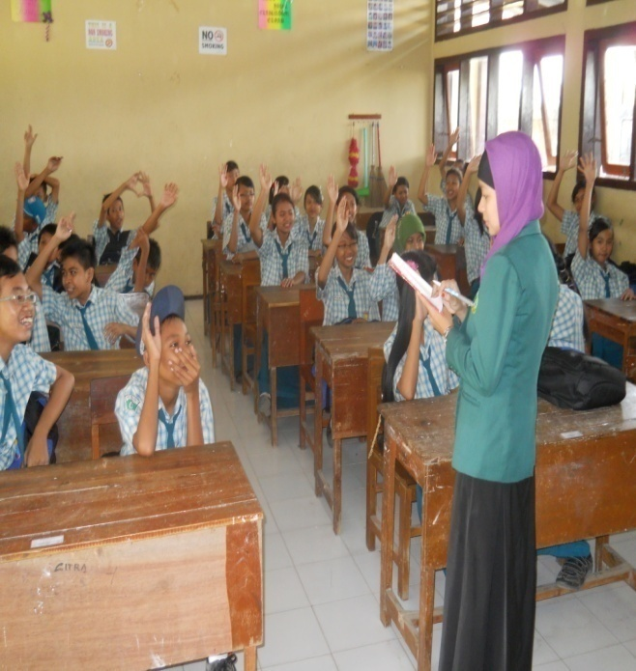

**The researcher doing questionaire. She used questionaires sheet to get the data about the reason of the students using mind mapping during teaching and learning proccess.**

**CURRICULUM VITAE**

Name : Yeny Tri Indarwaty

Birthday : Tulungagung, 11th of March 1990

Registered Number : 3213083120

Address : Plosokandang - Kedungawru- Tulungagung

Sex : Female

Phone Number : 085649697555

Religion : Islam

Marital Status : Student

Department : Islamic Education Department

Program : English Education Program ( TBI )

Background of the Study :

* + - 1. TK Siti Khodijah
      2. SDN 1 Plosokandang
      3. SMP Negeri 1 Kedungwaru
      4. SMA Negeri Rejotangan
      5. STAIN Tulungagung

**CURRICULUM OF AUTHORSHIP**

Name : Yeny Tri Indarwaty

Plate, Date of birth : Tulungagung, 11th of March 1990

Registered Number : 3213083120

Address : Plosokandang-Kedungwaru-Tulungagung

Departement : Islamic Education Departement (Tarbiyah)

Program : Tadris Bahasa Inggriss

State that thesis entitles the use of Mind Mapping Technique to improve the students speaking ability in SMP Negeri 3 Kedungwaru Tulungagung is truly my original work. It does not incorporate any materials previously written or published by another person, except those indicated in quotations and references. Due to the fact, I’m the only pear son responsibility for the thesis if there is any an objection or claim from other.

Tulungagung, June 16th 2012

Writer

**Yeny Tri Indarwaty**

**NIM. 3213083120**