**TEACHING SPEAKING USING ENGLISH SHORT STORY AS TEACHER STRATEGY TO THE TENTH GRADE STUDENTS**

**AT SMAN 1 SRENGAT ACADEMIC YEAR 2013/2014**

**THESIS**



**Arranged by:**

**NINIS ARHANDANI**

**NIM: 3213103025**

**ENGLISH EDUCATION PROGRAM**

**DEPARTMENT OF ISLAMIC EDUCATION**

**STATE ISLAMIC INSTITUTE (IAIN) TULUNGAGUNG**

**July 2014**

**TEACHING SPEAKING USING ENGLISH SHORT STORY AS TEACHER STRATEGY TO THE TENTH GRADE STUDENTS**

**AT SMAN 1 SRENGAT ACADEMIC YEAR 2013/2014**

**THESIS**

**Presented to**

**State Islamic Institute (IAIN) of Tulungagung in partial fulfillment of the requirements for the degree of Sarjana Pendidikan Islam**

**in English Education Program**



**Arranged by:**

**NINIS ARHANDANI**

**NIM: 3213103025**

**ENGLISH EDUCATION PROGRAM**

**DEPARTMENT OF ISLAMIC EDUCATION**

**STATE ISLAMIC INSTITUTE (IAIN) TULUNGAGUNG**

**July 2014**

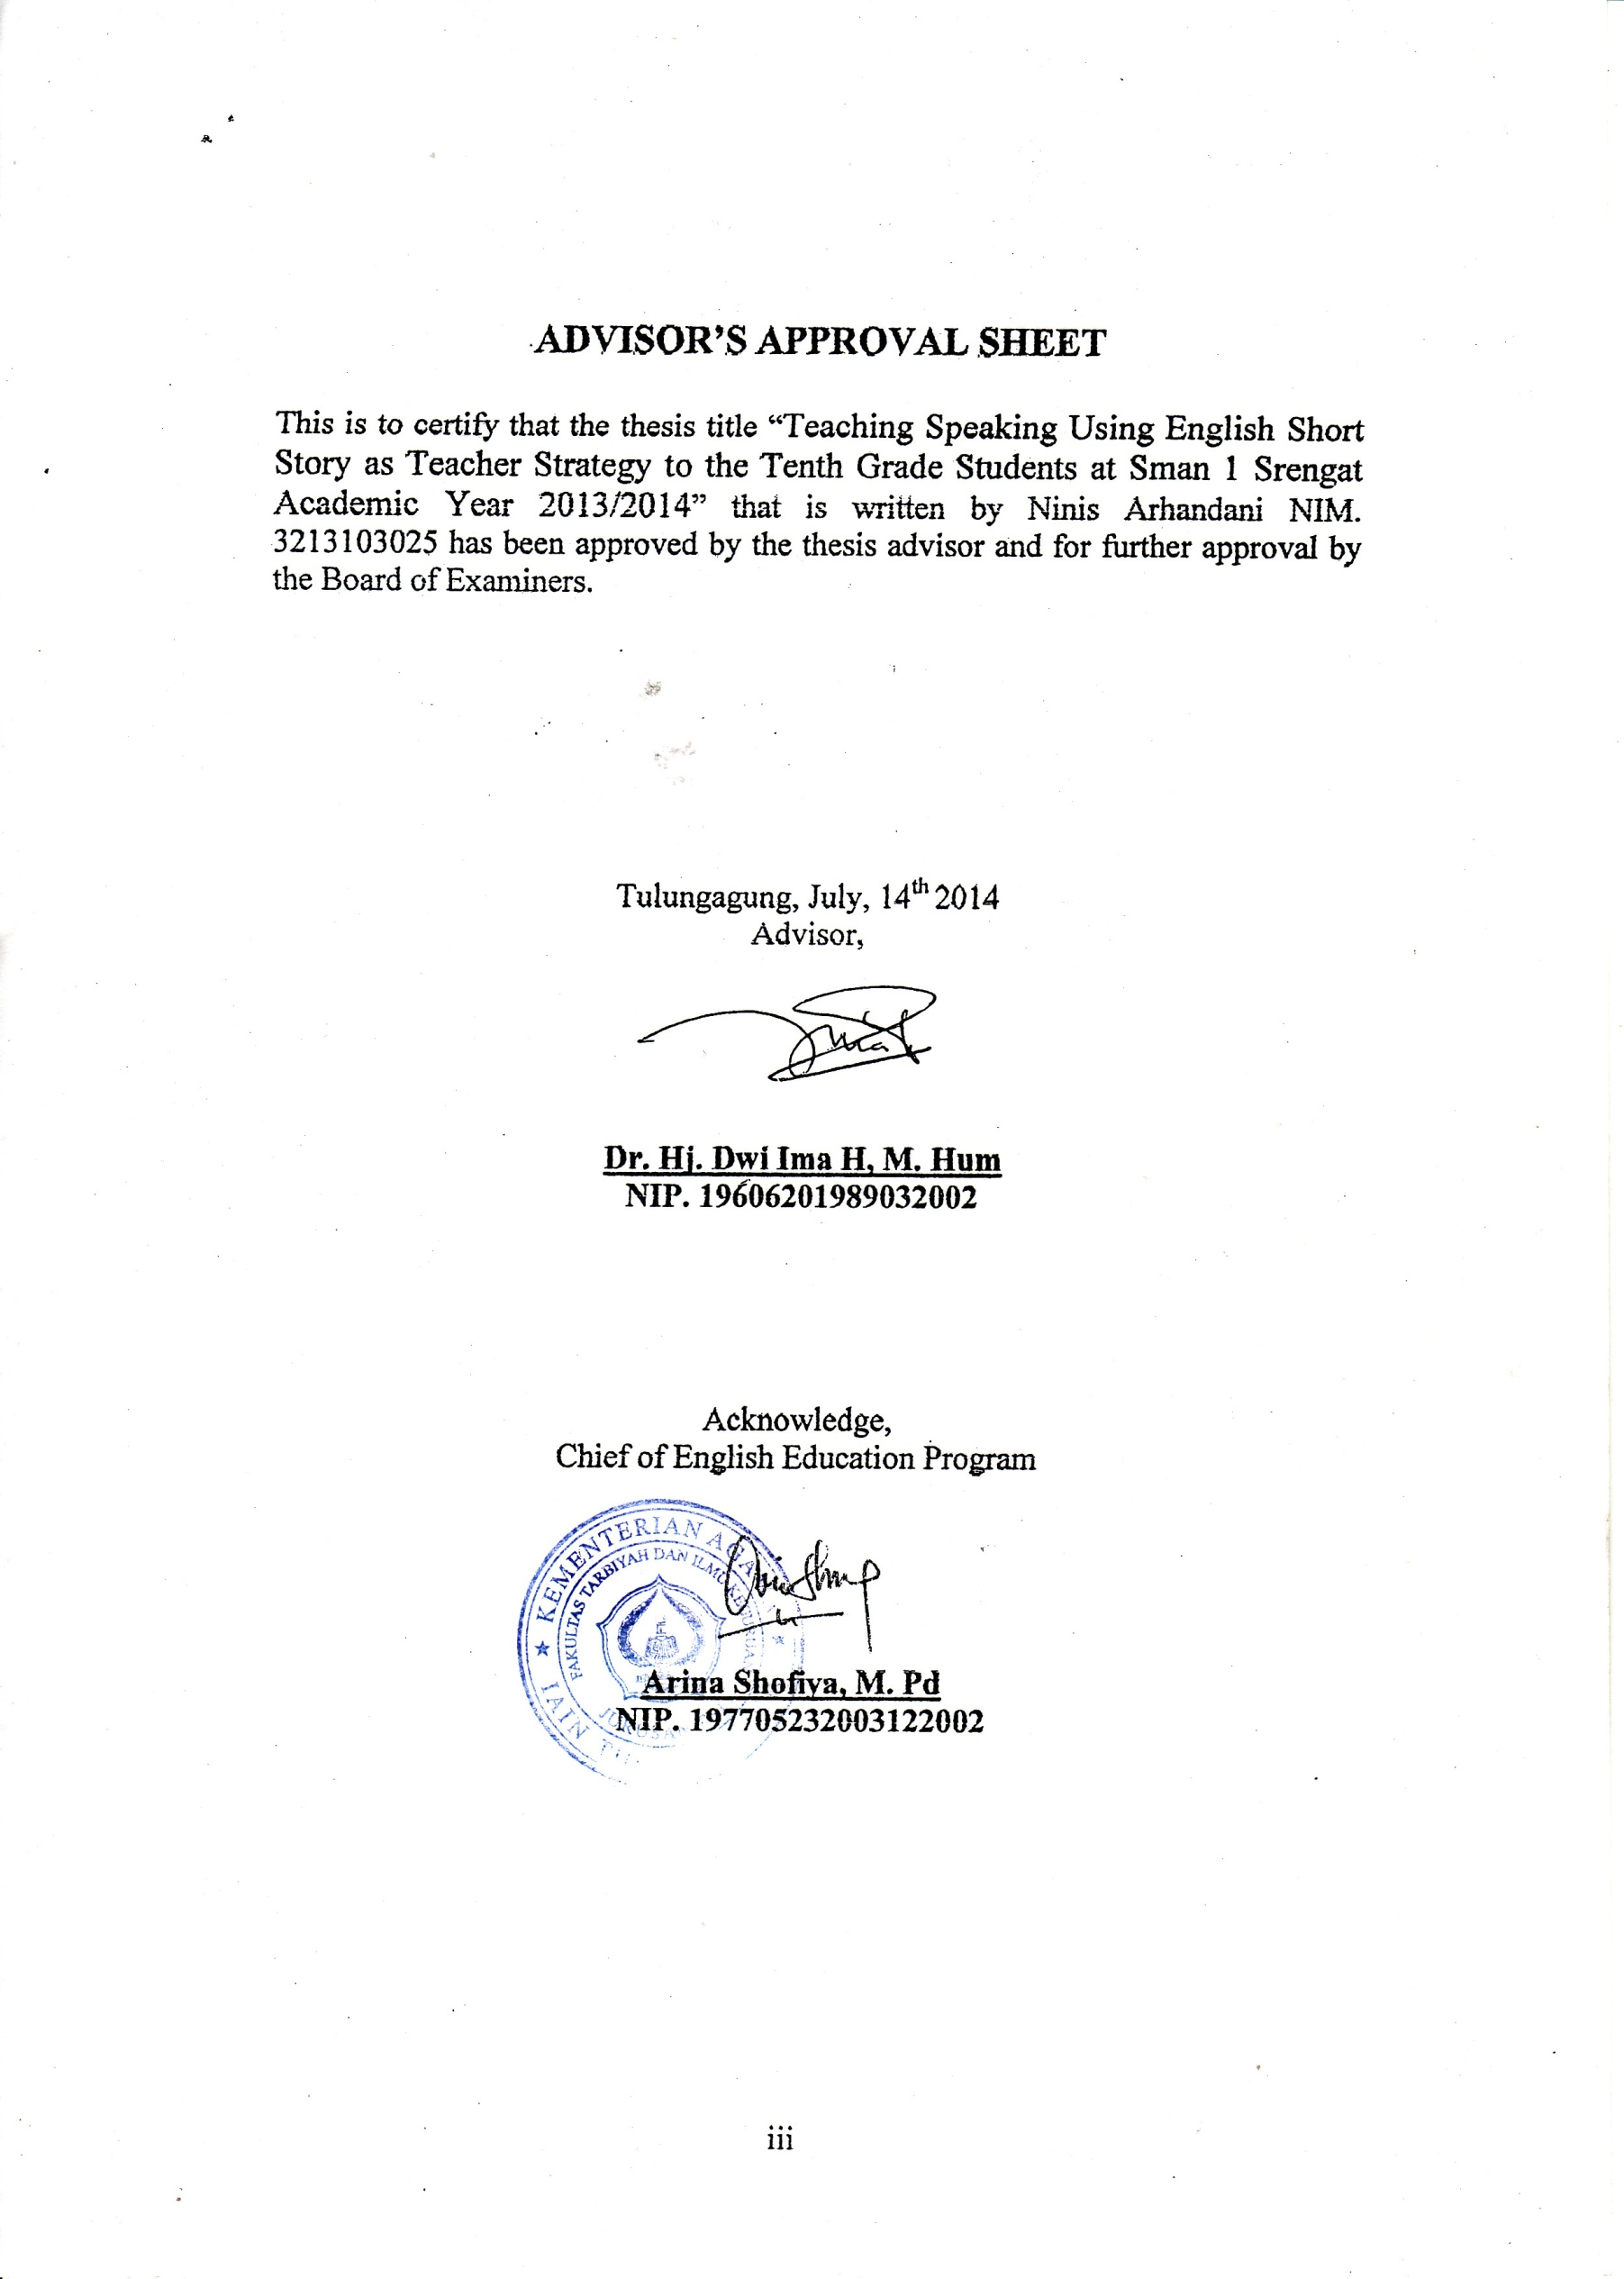

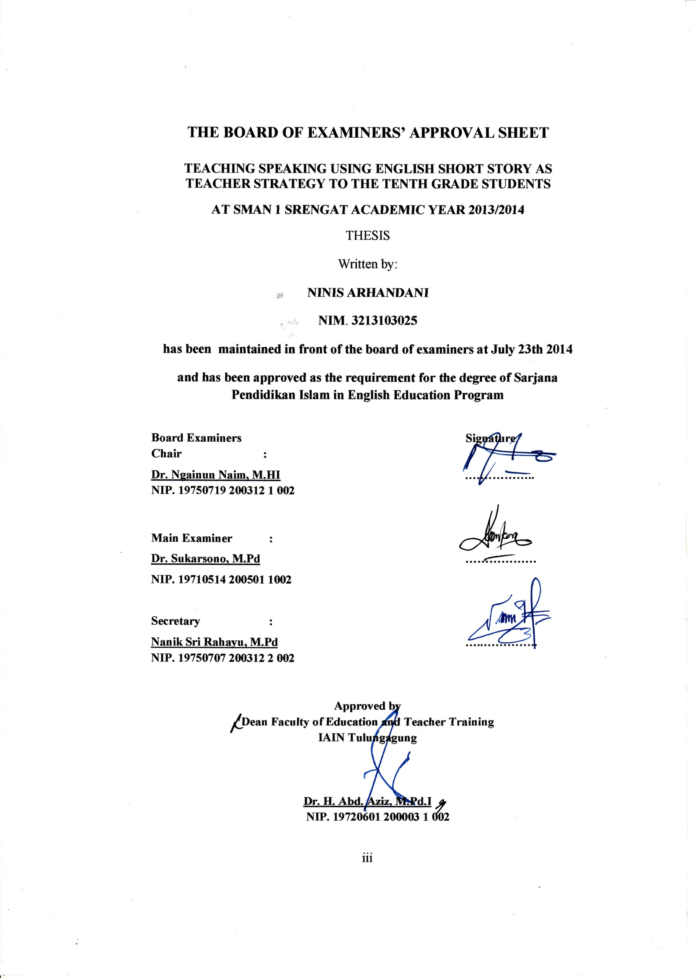

**TABLE OF CONTENTS**

Cover ii

Advisor Approval Sheet iii

Board of Examiners’ Approval Sheet iv

Table of Contents v

Motto viii

Dedication ix

Declaration of Authorship x

Abstract xi

Acknowledgement xiii

List of Appendices xv

CHAPTER I INTRODUCTION 1

* 1. Background of the Research 1
  2. Research Problem 6
  3. Objective of the Research 7
  4. Significance of the Research 7
  5. Scope and Limitation of the Research 8
  6. Definition of Key Terms 9

CHAPTER II REVIEW OF RELATED LITERATURE 10

1. The Nature of Speaking 10
   1. Meaning of Speaking 10
   2. Components of Speaking 11
2. The Nature of Teaching Speaking 13
   1. Meaning of Teaching Speaking 13
   2. Purpose of Teaching Speaking 15
   3. Teacher’s Strategies in Teaching Speaking 19
   4. Teacher and Learners’ Role in Speaking Activities 21
   5. Speaking Activities 22
   6. Learners Process in Learning Speaking 29
   7. Learners Problem in Learning Speaking 29
3. The Nature of Short Story 31
   1. Meaning of Short Story 31
   2. Characteristic of Short Story 31
   3. Components of Short Story 32
   4. Generic Structure of Short Story 33
   5. The use of Short Story 33

CHAPTER III RESEARCH METHOD 36

1. Research Design 36
2. Setting and Subject of the Research 37
3. Data and Data Sources 37
4. Method of Collecting Data and Instruments 40
5. Validity of Data 42
6. Data Analysis 44
7. Trustworthiness 45

CHAPTER IV RESEARCH FINDINGS 48

* 1. Data Presentations 48

1. The Teacher Strategy in Teaching Speaking by Using English Short Story 48

2. The Students’ Response as They Are Taught by English Short

Story 52

* 1. Data Findings 54
     1. The Teacher Strategy in Teaching Speaking by Using English Short Story 61
     2. The Students’ Response as They Are Taught by English Short

Story 62

CHAPTER V DISCUSSIONS 63

1. Discussion on The teacher Strategy in Speaking by Using English Short Story ............…………………..………………...............................63
2. Discussion on The Students’ Response as They Are Taught by English Short Story...........................................................................................65

CHAPTER VI CONCLUSIONS AND SUGGESTIONS 67

* + 1. Conclusions 67
    2. Suggestions 67

BIBLIOGRAPHY ............................................................................................. 68

APPENDICES 70

CURICULUM VITAE 125

**MOTTO**

***success is not given for ONE who IS fortune. But success is given to oNe who IS being struggle with the effort and pray.***

**DEDICATION**

**I dedicate this thesis to:**

**My beloved parents, Moh. Ramin and (Almh) Sri Suhantini, unlimited thank for your pure affection, endless love,**

**And pray, so I can finish my study**

**You are my everything; you are my best I ever had,**

**My beloved sister, Raya Arsita Febriani,**

**Thank for your support, motivation, and pray**

**I love you,**

**My spiritual teachers, Mr. Hadi Pramono, Gus Charir M. Fairuza, and Teteh Niken Mayasari, thank for guidance and suggestion,**

**All crew of Sultan Agung 78 who always makes me happy every day,**

**My beloved friends, Ani Febriana, Nurul Fatimah, Marrisa N.D, Hengky Triwijaya, Yunita D.W, Nova Siwi and Rita Sofwan**

**I love you guys**

**All my great lectures in English Department and State Islamic Institute (IAIN) of Tulungagung, thank for your guiding**

**You live in my mind and hearth,**

**All my best friends in TBI A classLet’s dream, and Make our dreams come true…,**

**All my best friends in KKN, Nala, Nastiti, Muslihah, Rifqy, Ela, Imarilis, Mimin**

**Be better and better, guys**

**All of my friends in English Department and my beloved almamater**

**State Islamic Institute (IAIN) of Tulungagung**

**DECLARATION OF AUTHORSHIP**

Name : Ninis Arhandani

Sex : Female

Place, Date of Birth : Blitar, June 04, 1992

Address : Dsn. Jatinom RT 05/Rw 01, Ds. Jatilengger, Kec. Ponggok, Kab. Blitar

Department : Education Program of IAIN Tulungagung

Program : English Education Program

Registered Number : 3213103025

Phone Number : 085704189199

States that thesis “Teaching Speaking Using English Short Story As Teacher Strategy To The Tenth Grade Students At Sman 1 Srengat Academic Year 2013/2014” is truly my original work, it does not incorporate any material previously written or published by other person except those indicated in quotation and bibliography. Due to the part, I am the only person responsible for the thesis any injections claim for others.

Tulungagung, July 14th 2014

Ninis Arhandani

**ABSTRACT**

Arhandani, Ninis. Registered Number Student, 3213103025. 2014. *Teaching Speaking Using English Short Story as Teacher Strategy to the Tenth Grade Students at SMAN 1 Srengat Academic Year 2013/2014*. Thesis. English Education Program. State Islamic Institute (IAIN) of Tulungagung. Advisor: Dr. Hj. Dwi Ima H., M.Hum.

Keywords: speaking, teaching speaking, English short story.

Speaking is one of communication path used by people to talk with others. People use speaking to communicate their thought to others. In the way of speaking, it cannot separate from teaching process. Teaching speaking is kind of activity in spreading knowledge of speaking skill. By teaching speaking, teachers can help learners improve their speaking and overall oral competency. Then, teaching speaking with the short story is a good strategy in supporting speaking practical application. The applying teaching speaking with the English short story as teacher strategy in SMAN 1 Srengat is not the first experience, but, for the first grade, it needed to be conduct to make learners’ outcomes as good as learning goals stated.

The research problems in this study are: 1) how is the teacher stategy in teaching speaking English with the English short story to the tenth grade students at SMAN 1 Srengat? 2) How is the students’ response as they are taught by using English short story?

Further, formulation of the research objectives in this thesis are: 1) to know teacher stategy in teaching speaking English with the English short story to the tenth grade students at SMAN 1 Srengat. 2) To know the students’ response as they are taught by using English short story.

The research design in this study is qualitative design with descriptive qualitative. The setting of this research is in SMAN 1 Srengat and the subjects are the English teacher and 10 learners who are asked about teaching speaking by using English Short Story as teacher strategy and students’ process in and after that activity. Data was collected by observation and interviews. This researh conduct human as the instrument. Meanwhile, for analyzing data used reduction, display and conclusion by obeying qualitative design.

From the result of the study, it can be concluded that teaching speaking using short story as teacher strategy to the tenth grade students runs well with its own natural way and it makes students respond to the activities as the part of teacher strategy in teaching speaking.

**ABSTRAK**

Arhandani, Ninis. Nomor Induk Mahasiswa, 3213103025. 2014. *Teaching Speaking Using English Short Story as Teacher Strategy to the Tenth Grade Students at SMAN 1 Srengat Academic Year 2013/2014*. Skripsi. Tadris Bahasa Inggris. Institut Agama Islam Negeri (IAIN) Tulungagung. Pembimbing: Dr. Hj. Dwi Ima H., M.Hum.

**Kata kunci**: berbicara, mengajar berbicara, cerita pendek berbahasa Inggris.

Berbicara merupakan salah satu cara komunikasi yang digunakan oleh orang-orang untuk berbicara dengan orang lain. Orang menggunakan langkah berbicara untuk berkomunikasi pemikiran mereka kepada orang lain. Dalam berbicara, tidak dapat terpisah dari proses pengajaran. Pengajaran berbicara adalah jenis kegiatan dalam menyebarkan pengetahuan tentang keterampilan berbicara. Dengan mengajar berbicara, guru dapat membantu siswa meningkatkan berbicara dan kompetensi lisan secara keseluruhan. Kemudian, mengajar berbicara dengan isi cerita pendek dalam kegiatan menceritakan kembali cerita yang baik dapat mendukung berbicara secara aplikasi praktis. Ajaran menerapkan berbicara dengan isi cerita pendek sebagai strategi guru di SMAN 1 Srengat bukanlah pengalaman yang pertama, namun, untuk tingkat pertama perlu dilakukan untuk membuat hasil belajar peserta didik sebaik tujuan yang telah ditetapkan.

Rumusan masalah dalam penelitian ini adalah: bagaimana strategi guru dalam mengajar berbicara dengan menggunalan cerita pendek berbahasa Inggris di SMAN 1 Srengat, khususnya pada siswa kelas sepuluh (X)? Bagaimana respon siswa ketika diajar dengan menggunakan cerita pendek berbahasa Inggris?

Selanjutnya, perumusan tujuan penelitian dalam tesis ini adalah: 1) untuk mengetahui strategi guru dalam mengajar berbicara dengan menggunalan cerita pendek berbahasa Inggris di SMAN 1 Srengat, khususnya pada siswa kelas sepuluh (X). 2) Untuk mengetahui respon siswa ketika diajar dengan menggunakan cerita pendek berbahasa Inggris.

Penelitian ini menggunakan desain penelitian kualitatif dengan desain deskriptif kualitatif. Setting atau latar dari penelitian ini adalah di SMAN 1 Srengat, dengan subyek adalah guru bahasa Inggris dan 10 peserta didik. Data dikumpulkan melalui observasi dan wawancara. Dan menempatkan diri penulis sebagai *human instrument* dalam penelitian ini. Sementara itu, untuk menganalisis data yang digunakan adalah reduksi, display dan kesimpulan sebagaimana tercantum dalam desain penelitian kualitatif.

Hasil penelitian ini menunjukkan bahwa pengajaran berbicara dengan cerita pendek berbahasa Inggris yang digunakan oleh guru berjalan dengan baik and pengajaran berbicara bahasa Inggris dengan menggunakan cerita pendek juga baik terhadap respon untuk meningkatkan proses belajar peserta didik.

**ACKNOWLEDGMENTS**

In the name of Allah SWT, the Most Gracious, and the Most Merciful, peace is upon to the lord who guided our Prophet Muhammad SAW, the most appropriate track and shed light upon the most straightened course. Allah’s blessing and peace be upon him and his family in the course of companion and geniality.

Eventually, due His Charity, the researcher was able to finish this thesis entitled “Teaching Speaking Using English Short Story as Teacher Strategy to the Tenth Grade Students at SMAN 1 Srengat Academic Year 2013/2014” as partial fulfillment of the requirements for the degree of Sarjana Pendidikan Islam in English Education Program Department of Institute Islamic State (IAIN) of Tulungagung.

In this chance, the writer would like to express the gratitude to the honorable:

1. Dr. Maftukhin, M. Ag, as the principal of State Islamic Institute (IAIN) of Tulungagung.
2. Dra. Hj. Dwi Ima H, M. Hum, as the writer’s advisor in writing in this thesis due to her valuable guidance as well as her constructive suggestion. Without her help and devotion of time, the completion of this thesis is supposed to be impossible.
3. Dr. Susanto, M.Pd as my advisor since semester one up to know.
4. All lectures of State Islamic Institute (IAIN) of Tulungagung for their guidance and knowledge have been obtained during the researcher were studying in State Islamic Institute (IAIN) of Tulungagung.
5. Parents and sister who always pray, train and love in all their life.

The researcher is aware that this thesis is full of shortcoming or far from being perfect. Therefore of researcher hopes constructive suggestions and critics, which make this thesis much better. Finally, the writer prays to Allah, may this thesis be useful and may Allah bless us. Amen.

Tulungagung, July 14th 2014

The Writer

**LIST OF APPENDICES**

|  |  |  |
| --- | --- | --- |
| Appendix | 1 | Interview Guiding |
| Appendix | 2 | Transcript of Interviews |
| Appendix | 3 | Observation Guiding |
| Appendix | 4 | Field notes |
| Appendix | 5 | Lesson Plans |
| Appendix | 6 | Scoring Sheet |
| Appendix | 7 | Correspondences |
|  |  |  |